Install Java and Eclipse latest version

And

Download Oracle from

<http://www.mediafire.com/file/n1adn19ub58sujw/OracleXE.exe>

Install the Oracle with OracleXE.exe

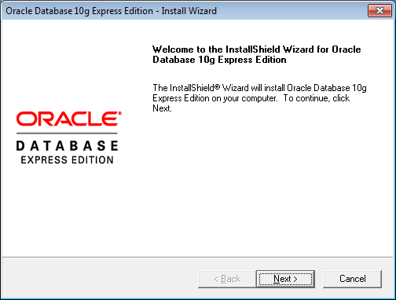

Press Next

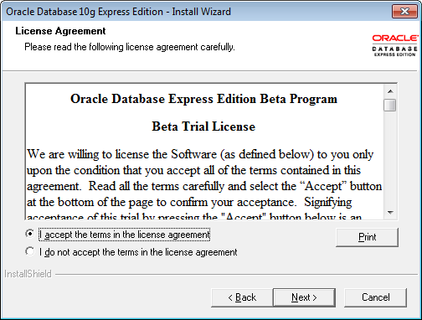

Accept and Next

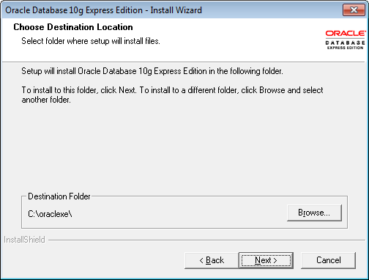

Next

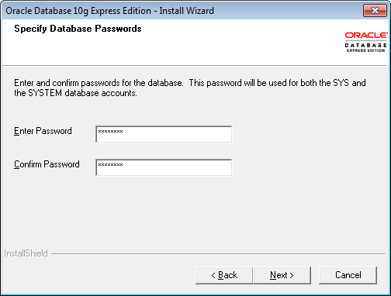

Enter password as 12345678 and Next

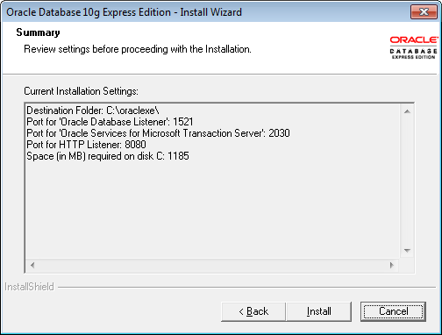

Note Port numbers 8080, 2030, 1521 and Install

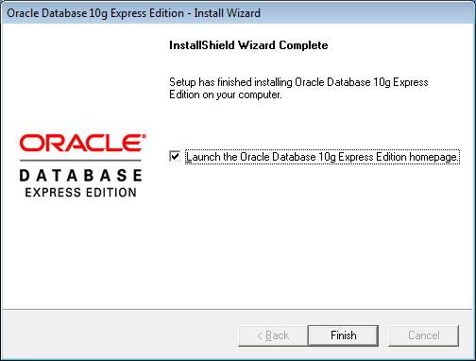

Finish

Now we need to create the database at SQL Command Line with system as username and 12345678 as password



Create table using the following command

CREATE TABLE user905(name VARCHAR(200) unique, password VARCHAR(200), email VARCHAR(200), country VARCHAR(200));

Once java and Eclipse installed

Open eclipse and import the project

Right click the project ->Run As -> Run on Server

It will ask you to configure the Tomcat server,

Don’t forget to configure the tomcat HTTP/1.1 Port number as 8081

Then open <http://localhost:8081/Curd/index.html>