GCP CLOUD COMPOSER
Apache Airflow | Architecture + 2 Hands-on DAGs
Short, beginner-friendly training notes

1. What are Airflow and Cloud Composer?
Apache Airflow is a workflow orchestration tool. You define a workflow as a DAG (Directed Acyclic Graph), where tasks are connected by dependencies. Cloud Composer is Google Cloud’s managed service for running Apache Airflow.
Easy way to explain: Airflow decides what should run and when; the task runtime does the work; Airflow tracks the result.

2. Airflow architecture — visual overview
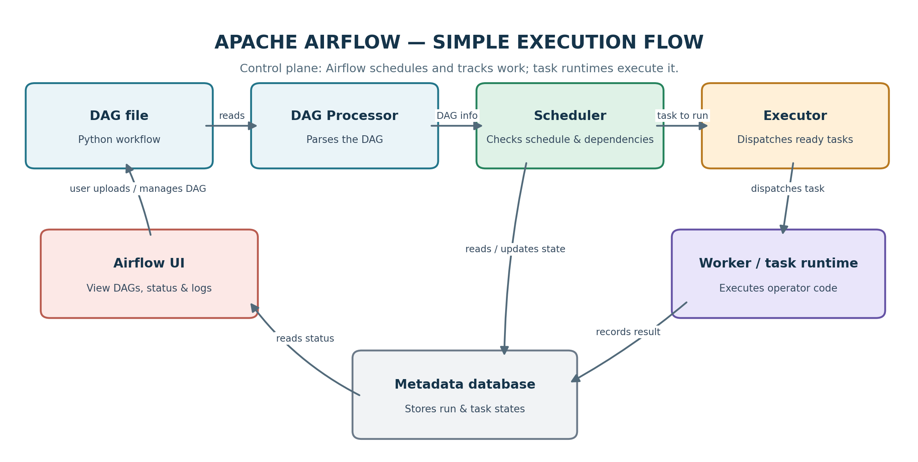
Simple flow: DAG file → DAG Processor → Scheduler → Executor → Worker/task runtime. The metadata database stores workflow/task state, while the UI helps users monitor runs and logs.
Component | Explain it simply
DAG file | Python file that describes tasks, order and schedule.
DAG Processor | Reads and parses DAG files so Airflow can understand the workflow.
Scheduler | Checks schedules and dependencies, then identifies tasks ready to run.
Executor | Coordinates how ready tasks are sent for execution.
Worker / task runtime | Runs the task code, such as a Python function or a cloud operation.
Metadata database | Stores DAG-run and task status, scheduling information and other Airflow metadata.
Airflow UI | Lets you trigger runs, view task status and open logs.

Interview tip: The scheduler decides what is ready; the executor coordinates task execution; workers/task runtimes execute the code. Exact execution details depend on the Airflow version and executor configured in the Composer environment.

3. DAG 1 — Start → Hello World → End
Goal: demonstrate three tasks and a Python callable. Trigger manually in the Airflow UI.
from datetime import datetime

from airflow import DAG
from airflow.operators.empty import EmptyOperator
from airflow.operators.python import PythonOperator

def say_hello():
print("Hello World")

with DAG(
dag_id="training_hello_world_dag",
start_date=datetime(2025, 1, 1),
schedule=None,
catchup=False,
tags=["training"],
) as dag:

start = EmptyOperator(task_id="start")

hello_world = PythonOperator(
task_id="hello_world",
python_callable=say_hello,
)

end = EmptyOperator(task_id="end")

start >> hello_world >> end

Explain: EmptyOperator marks the start/end. PythonOperator calls say_hello(). The print output appears in the hello_world task logs.

4. DAG 2 — Pass a value using XCom
Goal: one Python task returns a small value; the next task pulls it from XCom. PythonOperator stores the returned value under the XCom key return_value by default.
from datetime import datetime

from airflow import DAG
from airflow.operators.empty import EmptyOperator
from airflow.operators.python import PythonOperator

def produce_message():
return "Hello from the producer task"

def consume_message(ti):
message = ti.xcom_pull(
task_ids="produce_message",
key="return_value",
)
print(f"Received through XCom: {message}")

with DAG(
dag_id="training_xcom_between_tasks_dag",
start_date=datetime(2025, 1, 1),
schedule=None,
catchup=False,
tags=["training", "xcom"],
) as dag:

start = EmptyOperator(task_id="start")

producer = PythonOperator(
task_id="produce_message",
python_callable=produce_message,
)

consumer = PythonOperator(
task_id="consume_message",
python_callable=consume_message,
)

end = EmptyOperator(task_id="end")

start >> producer >> consumer >> end

Task | What happens
start | Marks the beginning.
produce_message | Returns a message; Airflow pushes it to XCom.
consume_message | Pulls the producer’s return_value using ti.xcom_pull().
end | Runs after the consumer succeeds.

XCom rule: use it for small values such as IDs, file paths or row counts—not large datasets or DataFrames. Store large data in GCS/BigQuery and pass a reference.

5. Run the examples in Cloud Composer
- Save each script as a separate .py file.
- Upload both files to the Composer environment’s DAGs folder/location.
- Open the Airflow UI and check that both DAGs appear without import errors.
- Trigger each DAG manually because schedule=None.
- Open the Graph/Grid view and task logs; find “Hello World” in DAG 1 and the received message in DAG 2.

6. Quick interview revision
Question | Short answer
What is a DAG? | A workflow graph of tasks and dependencies with no cycles.
Scheduler vs executor? | Scheduler identifies ready tasks; executor coordinates their execution.
What does a worker do? | Executes the task’s operator code.
What is XCom? | A way for tasks to exchange small values within Airflow.
Where do you debug a failed task? | Check task state and logs, imports, dependencies, configuration and IAM permissions.

Trainer summary: Use the diagram first, walk through DAG 1, then show how DAG 2 passes a value through XCom.

