WEEK 1 REPORT
Data Cleaning and Preliminary Analysis using R
YUVA Intern – Virtual R Data Analyst Internship
Student Name: T Harish
Registration No.: RA2531005010007
GitHub Repository: ___________________________
Dataset: UCI Adult / Census Income Dataset

1. Objective
The objective of Week 1 is to acquire a public dataset, inspect its structure, handle missing values and duplicates, identify potential outliers, encode categorical variables, apply normalization where appropriate, and conduct preliminary exploratory analysis. The UCI Adult Income dataset was selected because it contains numerical and categorical variables, missing entries, a binary target, and sufficient complexity for practical R data analysis.

2. Dataset Overview
The Adult Income dataset contains demographic, education, employment, and financial attributes. The target is annual income grouped into <=50K and >50K. The working file used here is the UCI adult.data training portion with 32,561 raw observations and 15 columns after assigning variable names.
Variable | Type | Purpose
age | Numeric | Age in years
workclass | Categorical | Employment sector
fnlwgt | Numeric | Final sampling weight
education | Categorical | Education level
education_num | Numeric | Numeric education representation
marital_status | Categorical | Marital category
occupation | Categorical | Occupation
relationship | Categorical | Relationship category
race | Categorical | Race category
sex | Categorical | Sex category
capital_gain / loss | Numeric | Financial variables
hours_per_week | Numeric | Weekly working hours
native_country | Categorical | Country category
income | Categorical | Target class

3. Data Cleaning and Preprocessing

3.1 Missing values
The raw data contained missing entries represented by question marks in workclass, occupation, and native_country. After converting those entries to NA and applying na.omit(), the cleaned dataset contained 30,139 complete observations. The post-cleaning column-wise NA check returned zero missing values.
adult_raw <- read.csv("Data/adult.data", header = FALSE,
na.strings = "?", strip.white = TRUE)
colnames(adult_raw) <- c("age","workclass","fnlwgt","education",
"education_num","marital_status","occupation","relationship","race",
"sex","capital_gain","capital_loss","hours_per_week",
"native_country","income")
adult_clean <- na.omit(adult_raw)
dim(adult_clean)
colSums(is.na(adult_clean))

3.2 Duplicate check
The cleaned data contained 24 exact duplicate rows according to duplicated(). They were explicitly identified and documented. They were retained for this Week 1 descriptive report because the available evidence did not establish them as erroneous records; any later modeling pipeline should test both retained and deduplicated versions as a sensitivity check.
duplicate_count <- sum(duplicated(adult_clean))
duplicate_count
# Result: 24

3.3 Categorical encoding
Categorical fields were converted to factors so that R frequency tables, grouped visualizations, and later statistical models could treat them as categorical predictors.
factor_cols <- c("workclass","education","marital_status","occupation",
"relationship","race","sex","native_country","income")
adult_clean[factor_cols] <- lapply(adult_clean[factor_cols], factor)
str(adult_clean)

3.4 Outlier screening
Boxplots were used for age and hours_per_week. Several observations fell outside the central whisker ranges, particularly at extreme ages and unusual weekly hours. These observations were retained rather than automatically deleted because extreme values can be legitimate people or work schedules.
boxplot(adult_clean$age, main="Age Outlier Check", ylab="Age")
boxplot(adult_clean$hours_per_week,
main="Hours per Week Outlier Check",
ylab="Hours per Week")

3.5 Normalization
Min-max normalization was defined for later scale-sensitive modeling while keeping the original variables unchanged for interpretation.
normalize01 <- function(x) {
(x - min(x, na.rm=TRUE)) /
(max(x, na.rm=TRUE) - min(x, na.rm=TRUE))
}
adult_normalized <- adult_clean
adult_normalized$age <- normalize01(adult_clean$age)
adult_normalized$education_num <- normalize01(adult_clean$education_num)
adult_normalized$hours_per_week <- normalize01(adult_clean$hours_per_week)

4. Descriptive Statistics
Variable | Min | Q1 | Median | Mean | Q3 | Max
age | 17 | 28 | 37 | 38.44 | 47 | 90
fnlwgt | 13769 | 117628 | 178417 | 189795 | 237605 | 1484705
education_num | 1 | 9 | 10 | 10.12 | 13 | 16
capital_gain | 0 | 0 | 0 | 1093 | 0 | 99999
capital_loss | 0 | 0 | 0 | 88.44 | 0 | 4356
hours_per_week | 1 | 40 | 40 | 40.93 | 45 | 99
The mean age was 38.44 years and the median was 37. Hours worked had a median of 40 and a mean of 40.93. Capital gain and capital loss were highly right-skewed because most observations were zero while a small number had large values.

5. Initial Exploratory Findings
The cleaned data contained 75.09539% observations in the <=50K group and 24.90461% in the >50K group. Education showed large differences in the share of observations above $50K: Bachelor's 42.17%, Master's 56.46%, Doctorate 74.67%, and Professional School 74.91%.
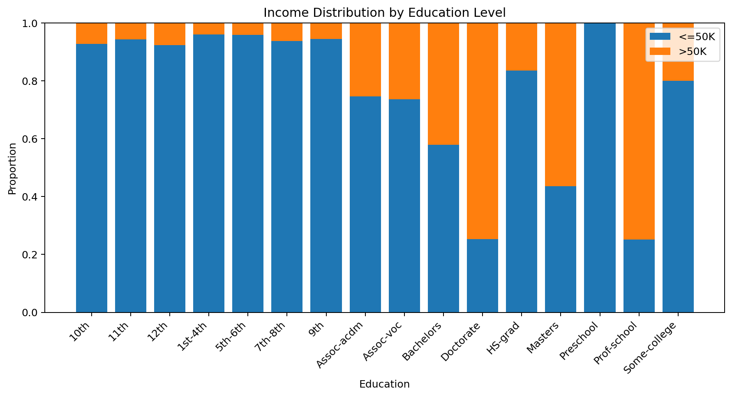
Figure 1. Income-group proportions within education categories.
Workclass also differed substantially. The >50K share was 55.87% for self-emp-inc, 38.71% for federal-gov, 29.46% for local-gov, 26.90% for state-gov, 28.58% for self-emp-not-inc, and 21.89% for private.
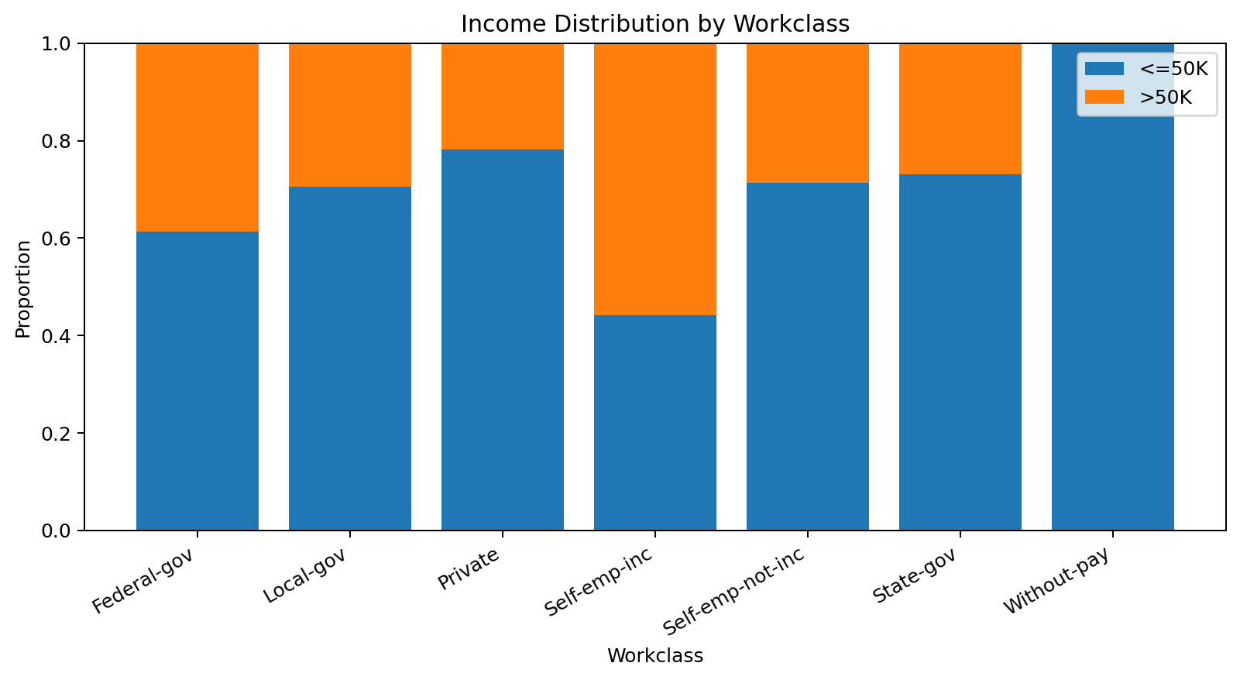
Figure 2. Income-group proportions within workclass categories.
The dataset contained 9,773 female and 20,366 male observations. The gender visualization showed a larger >50K proportion for males than females; this is a descriptive association and not evidence of causation.
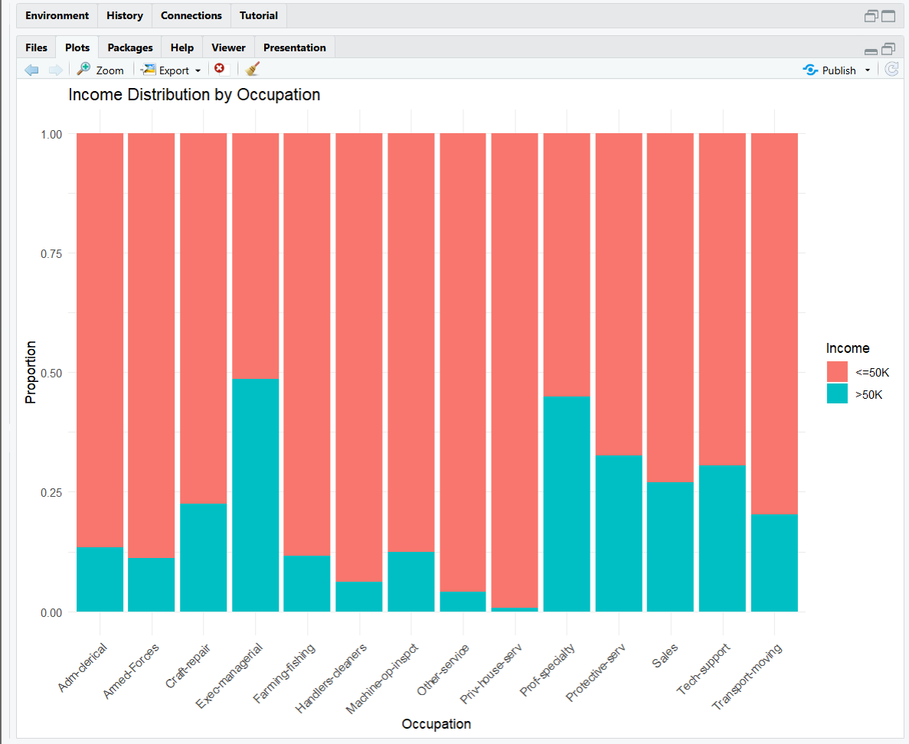
Figure 3. RStudio output: income distribution by occupation.

6. Conclusion
Week 1 produced a structured cleaned dataset suitable for further visualization, statistical testing, and predictive modeling. Missing values were removed, categorical variables were encoded as factors, duplicates were checked, outliers were screened, and a separate normalized copy was defined. The strongest preliminary patterns involved education, workclass, occupation, age, working hours, and income.

7. Submission Note
Before submission, replace the GitHub placeholder with the actual public repository URL. Keep the original dataset, the R script, and generated plots in the repository so the evaluator can reproduce the workflow.
Dataset source: UCI Machine Learning Repository – Adult dataset: https://archive.ics.uci.edu/dataset/2/adult

