WEEK 2 REPORT
Data Visualization and Insight Communication using R
YUVA Intern – Virtual R Data Analyst Internship
Student Name: T Harish
Registration No.: RA2531005010007
GitHub Repository: ___________________________
Dataset: UCI Adult / Census Income Dataset

1. Objective
Week 2 focuses on transforming the cleaned Adult Income dataset into a set of clear visualizations and communicating the analytical story to a non-technical audience. The same dataset is retained to maintain continuity with Week 1.

2. Visualization Strategy
The visualization plan uses categorical comparisons, composition charts, frequency charts, and an occupation-level view. Proportional stacked bars are used when the question is about the share of income classes within a category; count bars are used when the question is about dataset composition.

3. Overall Income Composition
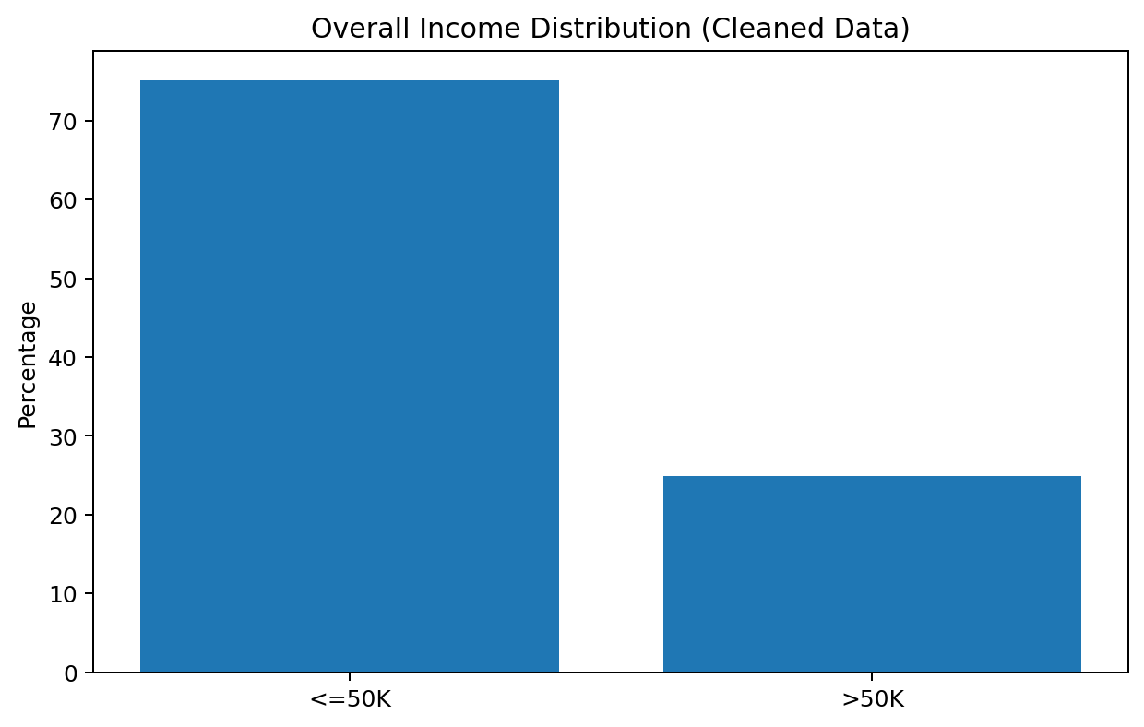
Figure 1. Overall income-class composition after cleaning.
Approximately three quarters of the cleaned observations are in the <=50K class. This imbalance matters for later predictive modeling because raw accuracy can look strong even when a model performs poorly on the >50K minority class.

4. Education and Income
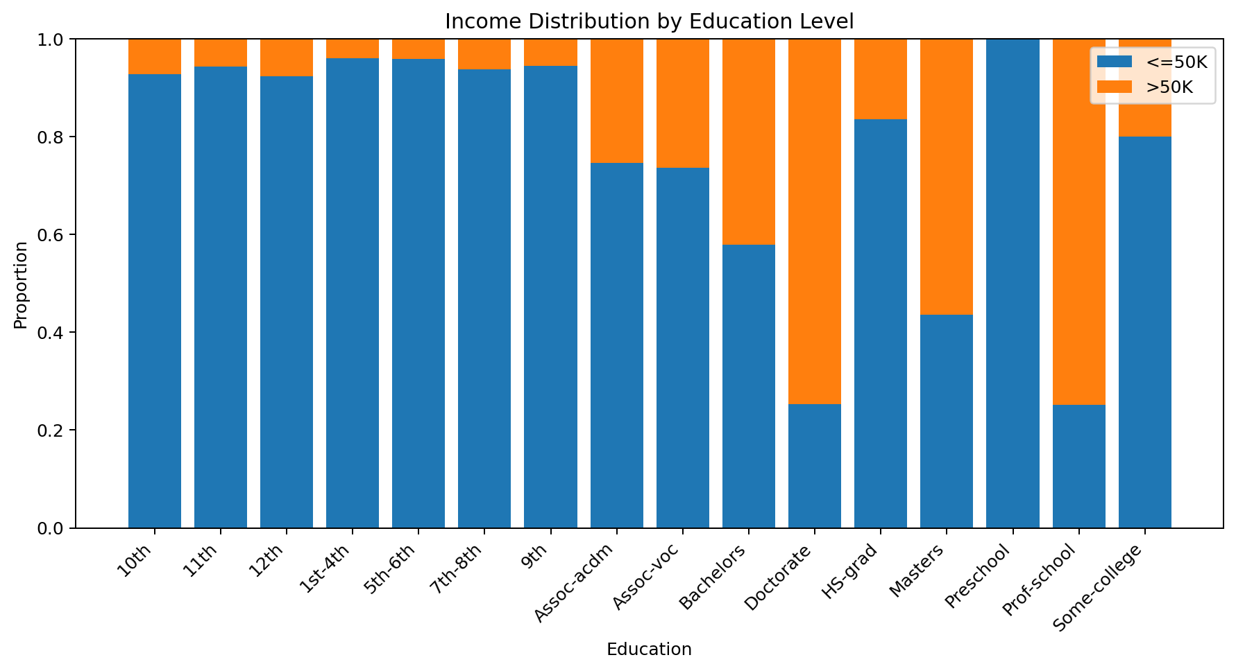
Figure 2. Income composition by education level.
The visualization shows a clear upward pattern in the >50K share as educational attainment increases. The >50K proportion is 42.17% for Bachelor's, 56.46% for Master's, 74.67% for Doctorate, and 74.91% for Professional School. Lower-schooling categories generally have much smaller >50K shares.

5. Workclass and Income
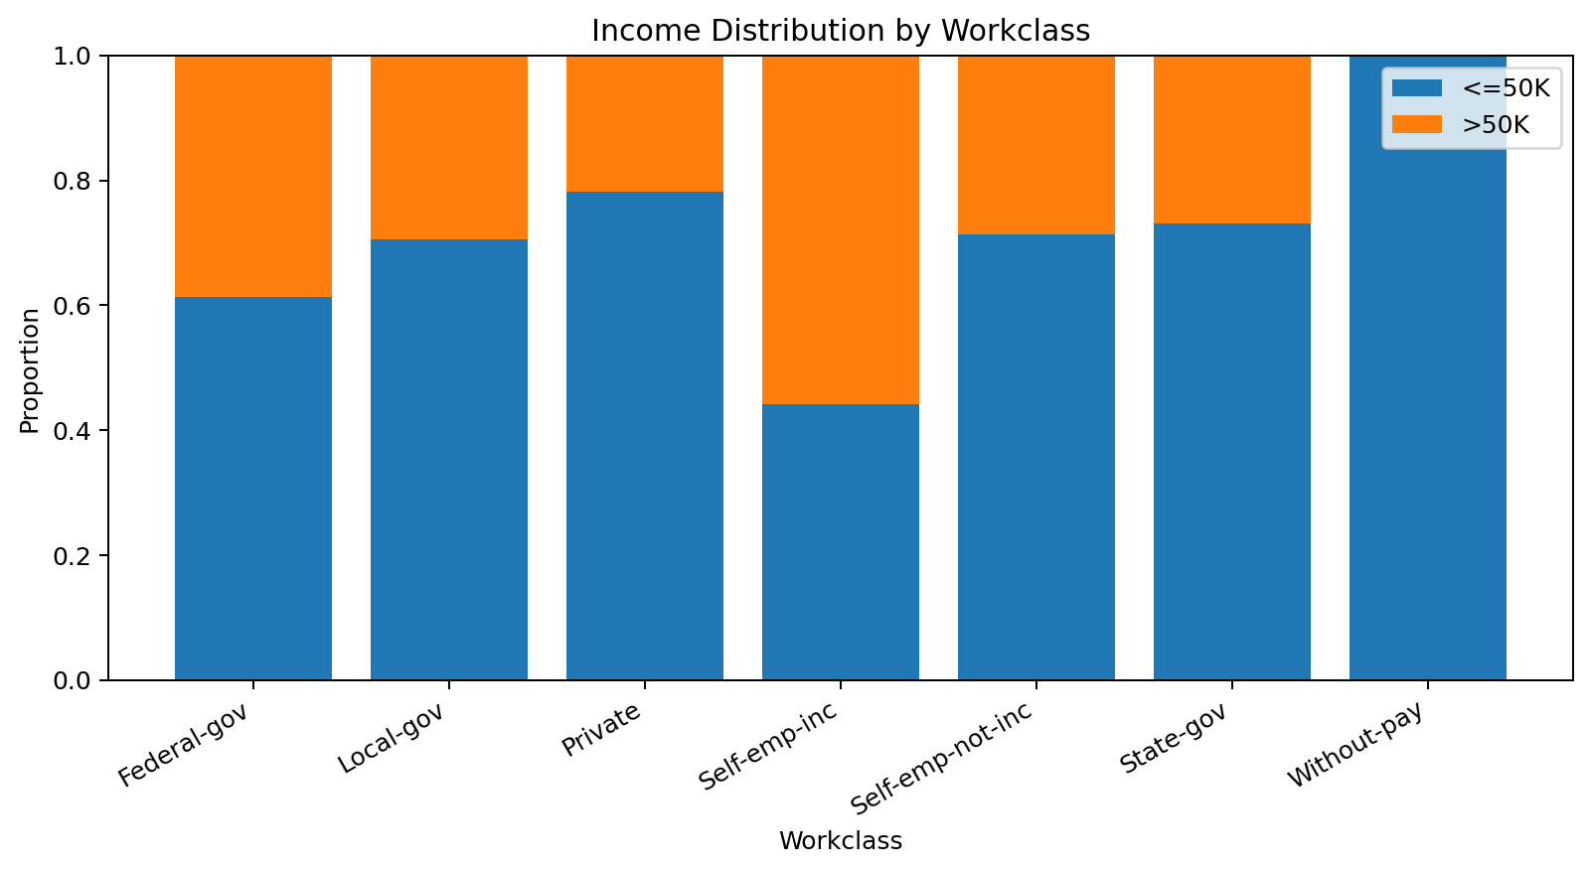
Figure 3. Income composition by workclass.
Self-employed incorporated workers have the largest >50K share among the listed workclass categories, while private-sector workers form the largest group by volume. The chart separates category size from income composition, preventing a small category from being mistaken for the largest contributor to the dataset.

6. Dataset Composition
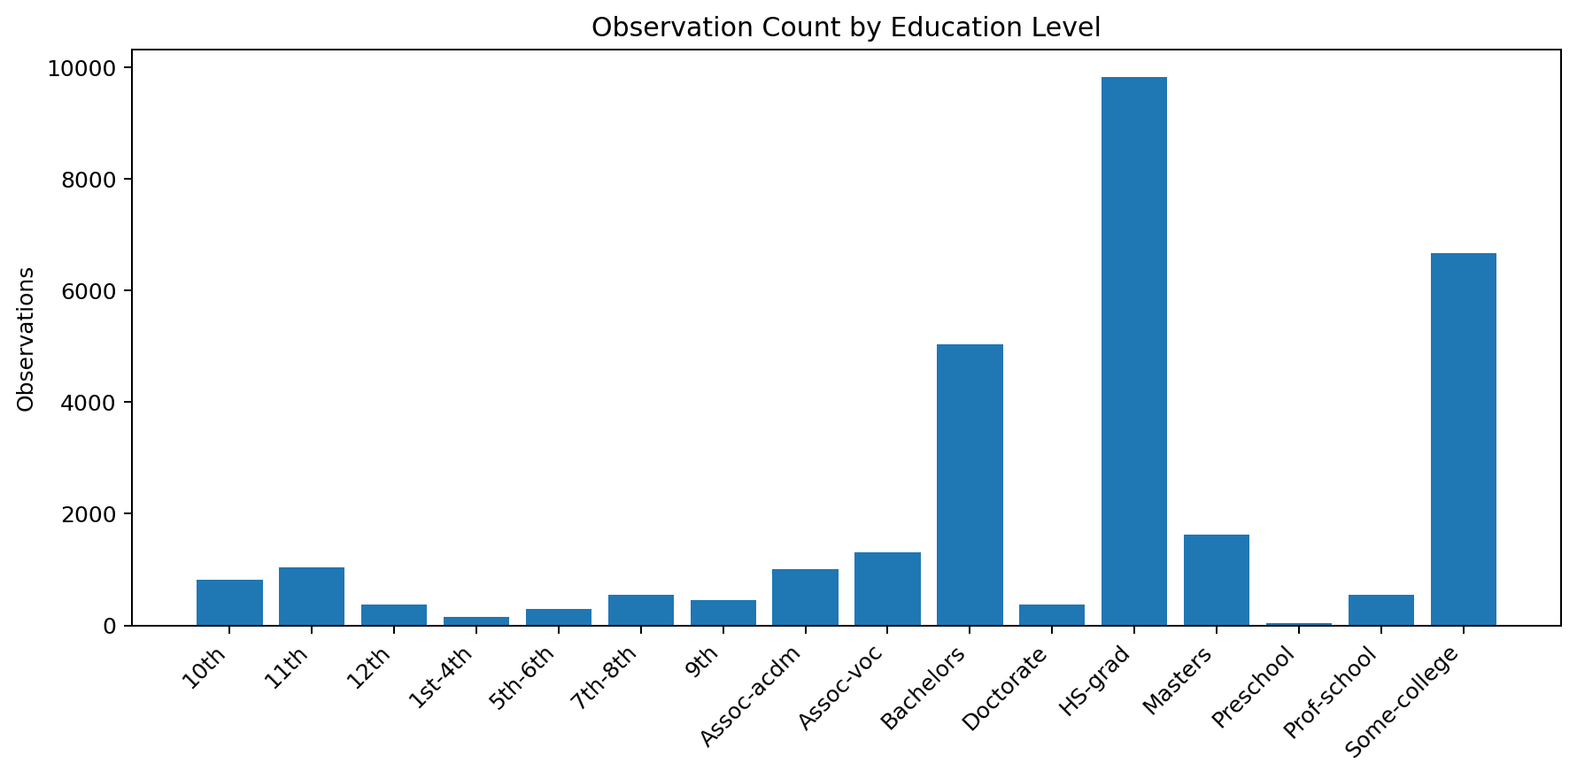
Figure 4. Observation count by education level.
HS-grad and Some-college are the two largest education groups in the cleaned data. This context is important when interpreting percentage charts because some categories, such as Preschool, have very small sample sizes.
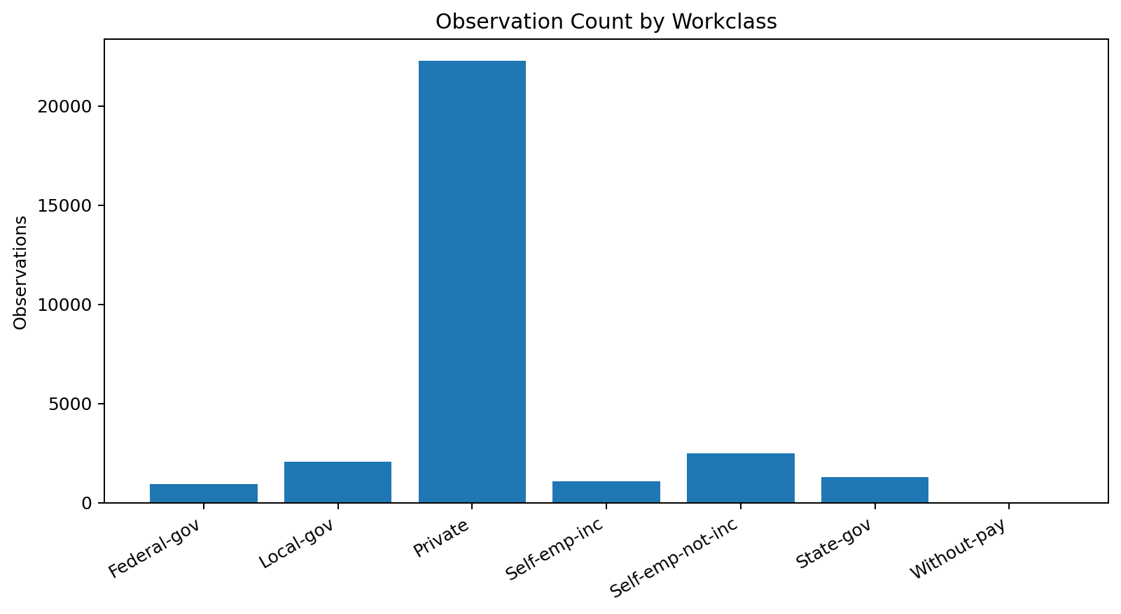
Figure 5. Observation count by workclass.
Private employment dominates the cleaned dataset by count. Federal, state, and local government categories are smaller, while Without-pay contains only 14 observations.

7. Higher-Income Share
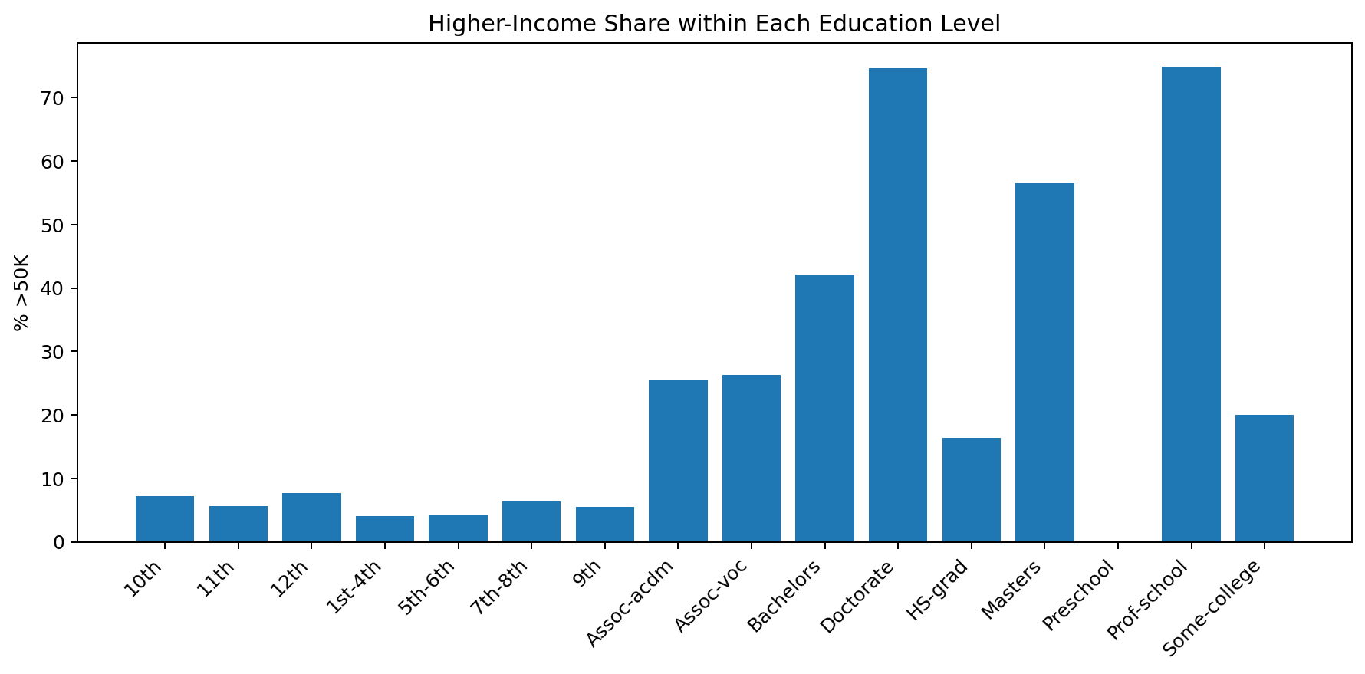
Figure 6. Share of observations above $50K within each education category.
This chart answers a different question from the count chart: it compares the conditional share of >50K observations within each education category. The distinction between count and proportion is essential for accurate storytelling.

8. Occupation Visualization
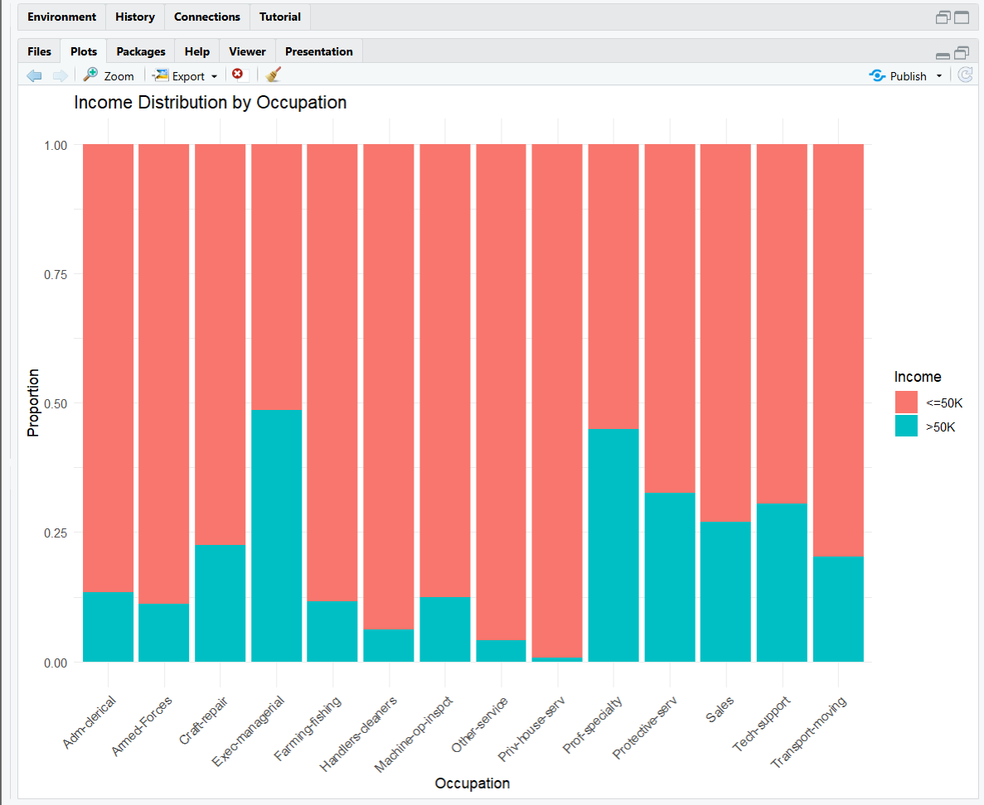
Figure 7. RStudio occupation visualization from the Week 1 workflow.
The occupation plot shows substantial differences across job categories. Executive-managerial and professional-specialty categories have visibly larger >50K portions, while several service and manual occupations have smaller >50K portions.

9. R Code
library(ggplot2)
ggplot(adult_clean, aes(education, fill=income)) +
geom_bar(position="fill") +
labs(title="Income Distribution by Education Level",
x="Education", y="Proportion") +
theme_minimal() +
theme(axis.text.x=element_text(angle=45, hjust=1))
ggplot(adult_clean, aes(workclass, fill=income)) +
geom_bar(position="fill") +
labs(title="Income Distribution by Workclass",
x="Workclass", y="Proportion") +
theme_minimal()

10. Communication Summary
The visual story is consistent across several dimensions: the target is imbalanced, education has a strong descriptive association with income, workclass composition is highly uneven, and occupation categories differ visibly in their income mix. These observations motivate formal statistical tests and predictive modeling in Week 3.

11. Conclusion
The Week 2 visualizations convert the cleaned dataset into an understandable analytical narrative. The selected charts emphasize composition, category differences, and conditional proportions while avoiding the common mistake of confusing category size with income rate.

