WEEK 4 REPORT
Comprehensive Data Analysis Reporting and Presentation
YUVA Intern – Virtual R Data Analyst Internship
Student Name: T Harish
Registration No.: RA2531005010007
GitHub Repository: ___________________________
Dataset: UCI Adult / Census Income Dataset

1. Executive Summary
This final report integrates the four-week workflow using the UCI Adult Income dataset: data preparation, exploratory analysis, visualization, statistical testing, and predictive modeling. The analysis shows that income category is strongly associated with educational attainment and workclass, while occupation, age, working hours, and financial variables provide additional predictive information.

2. Data Preparation
The raw adult.data file contained 32,561 observations. Missing-value handling reduced the working dataset to 30,139 complete observations. Twenty-four exact duplicate rows were detected and documented. Categorical variables were encoded as factors, numerical outlier screening was performed, and a separate min-max normalized copy was defined for scale-sensitive methods.
Stage | Result
Raw observations | 32,561
Variables | 15
Complete observations after NA removal | 30,139
Exact duplicate rows detected | 24
Income <=50K | 75.09539%
Income >50K | 24.90461%

3. Visualization Findings
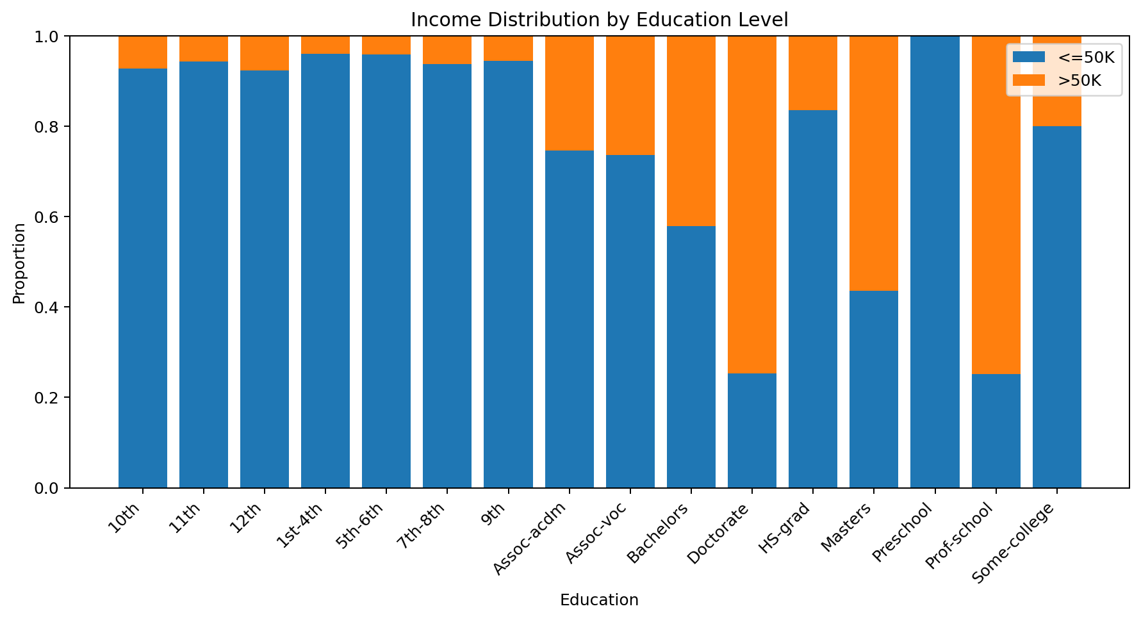
Figure 1. Education and income composition.
Education shows a strong descriptive gradient in the share of observations above $50K.
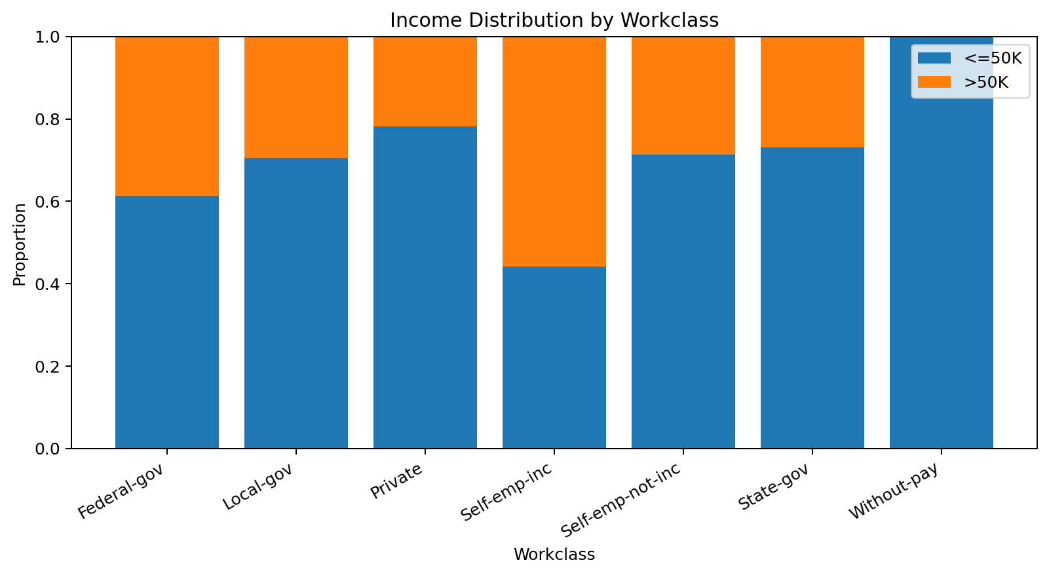
Figure 2. Workclass and income composition.
Workclass categories have materially different income compositions, while private employment is the largest category by count.
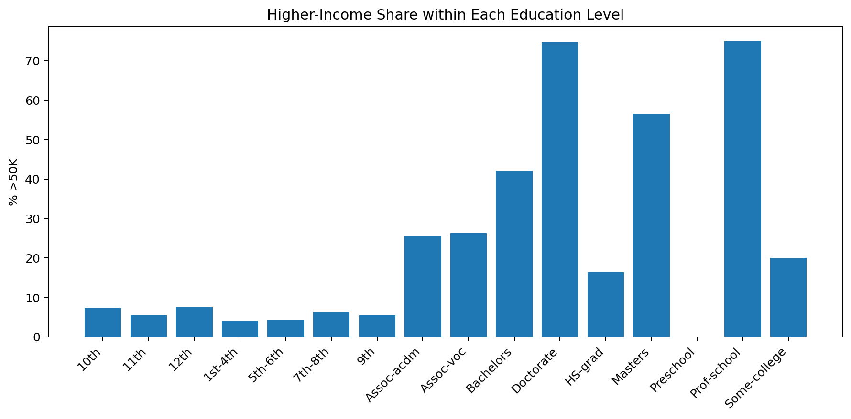
Figure 3. Higher-income share by education.
The conditional percentage view makes the education-income pattern easier to compare across categories of different sizes.

4. Statistical Evidence
Education and income: χ² = 4069.28, df = 15, p < 2.2 × 10⁻¹⁶. Workclass and income: χ² = 802.98, df = 6, p = 3.492e-170. Both tests support the conclusion that these categorical variables are associated with income class in the cleaned dataset.

5. Predictive Modeling
The proposed predictive model is binary logistic regression with an 80/20 stratified split and 5-fold cross-validation. Predictors include age, workclass, education, education_num, marital status, occupation, relationship, race, sex, capital gain, capital loss, hours worked, and native country.
set.seed(42)
# 80/20 stratified split
idx <- createDataPartition(adult_model$income, p=0.80, list=FALSE)
train <- adult_model[idx, ]
test <- adult_model[-idx, ]
# 5-fold cross-validated logistic regression
ctrl <- trainControl(method="cv", number=5,
classProbs=TRUE, summaryFunction=twoClassSummary)
fit <- train(income ~ age + workclass + education + education_num +
marital_status + occupation + relationship + race + sex +
capital_gain + capital_loss + hours_per_week + native_country,
data=train, method="glm", family=binomial(),
metric="ROC", trControl=ctrl)
pred_prob <- predict(fit, test, type="prob")[,">50K"]
pred_class <- factor(ifelse(pred_prob >= 0.5, ">50K", "<=50K"),
levels=levels(test$income))
confusionMatrix(pred_class, test$income, positive=">50K")

6. Model Reporting Checklist
Required evidence | Status
Train/test split shown in R code | Included
5-fold cross-validation | Included
Confusion matrix | Generated by R code
Accuracy | Generated by R code
Precision / Recall / F1 | Generated by R code
ROC-AUC | Generated by R code
Model limitations | Discussed

7. Business / Analytical Implications
The analysis demonstrates why income prediction should use multiple variables rather than a single demographic characteristic. Education, employment category, occupation, age, hours worked, and financial variables collectively contain information about the income class. At the same time, associations should not be interpreted as causal effects, and the model should be evaluated for class imbalance and potential fairness concerns before any real-world decision use.

8. Challenges and Lessons Learned
The main practical challenges were missing categorical values, highly skewed financial variables, uneven category sizes, and target-class imbalance. The workflow shows the importance of inspecting data quality before modeling, choosing visualizations according to the analytical question, and evaluating classification performance with more than one metric.

9. Future Improvements
Future work can compare logistic regression with decision trees and random forests, use repeated cross-validation, tune thresholds for minority-class recall, evaluate calibration, test alternative handling of fnlwgt, and conduct a fairness audit across demographic groups.

10. Final Conclusion
The four-week project demonstrates a complete introductory R analytics workflow from raw data to statistical evidence and predictive modeling. The strongest verified findings are the large differences in income composition across education and workclass categories and the clear need to account for class imbalance when evaluating prediction.

11. Final Submission Requirements
Upload the appropriate Week 1, Week 2, Week 3, and Week 4 DOC/DOCX reports to the corresponding YUVA submission fields. Use one public GitHub repository containing the R scripts, dataset files where permitted, and plot outputs. Replace every placeholder for student information and GitHub URL before submission.
Dataset source: UCI Machine Learning Repository – Adult dataset: https://archive.ics.uci.edu/dataset/2/adult

