AI-Assisted Financial Risk Profiling and Personalized Investment Decision Support: A Tool-Orchestrated Agent with Provenance-Aware Retrieval
[Author Name 1], [Author Name 2], [Author Name 3]
Department of Business Administration
Auxilium College (Autonomous), Vellore, Tamil Nadu, India
[author.email]@auxiliumcollege.edu.in

Abstract— Individuals frequently have access to financial information without an effective mechanism for converting it into personalized investment insight. This paper presents an AI-assisted financial decision-support system that separates deterministic financial computation from AI-generated explanation. The system derives financial indicators (savings rate, expense ratio), classifies risk tolerance using a structured questionnaire, and maps the resulting profile to an investment category using a fixed lookup table. A large language model (LLM) agent orchestrates six specialized tools -- financial analysis, risk assessment, goal analysis, investment matching, live mutual-fund lookup, and platform lookup -- and is constrained to never compute a number itself. A provenance-aware retrieval layer supplies the agent with authoritative structured facts and a lexically ranked set of prior conversation turns, each tagged with its source, so that current data cannot be silently overridden by older conversational text. The system is implemented with a FastAPI/PostgreSQL backend, a React frontend, and a Groq-hosted LLM with function calling. We evaluate the deterministic analytics and rule-based classification layers on a synthetic dataset of 240 generated financial profiles, obtaining 100% agreement between independently recomputed and system-reported indicators, and report the resulting distribution across risk categories and investment recommendations. The architecture demonstrates a practical, auditable pattern for combining structured financial analytics with LLM-based explanation while keeping numerical outputs independently verifiable.
Keywords— financial analytics; risk profiling; investment decision support; LLM agents; tool calling; retrieval-augmented generation; explainable AI; FinTech
I. INTRODUCTION
The growing availability of digital financial data gives individuals access to income, expenditure, savings, and investment information, but access does not imply the ability to interpret this information or translate it into an investment decision. Financial analytics can convert raw figures into interpretable indicators such as savings rate and expense ratio, while structured risk questionnaires can characterize an individual's tolerance for investment uncertainty. Large language models (LLMs) offer a further opportunity: analytical output can be explained in natural language rather than left as an unlabeled number.
A naïve approach would let an LLM read a user's financial data and generate a recommendation directly. This is undesirable in a financial context because language models are not guaranteed to compute correctly, may hallucinate figures, and provide no separation between deterministic fact and generated text. This paper instead presents an architecture in which all numerical computation -- savings, risk score, and category matching -- is performed by deterministic, independently testable code, and the LLM is restricted to a tool-calling role: selecting which analytical function to invoke and explaining its output.
The contributions of this paper are: (1) a tool-orchestrated agent architecture that provably separates numeric computation from language generation; (2) a lightweight, provenance-aware retrieval layer that supplies the agent with authoritative structured facts alongside relevance-ranked conversational memory, each explicitly tagged with its source; and (3) an evaluation of the deterministic analytics and classification layers on a synthetic dataset of 240 profiles, including a functional-consistency check and the resulting distribution of risk categories and recommendations.
II. RELATED WORK AND RESEARCH GAP
Risk profiling for automated investment advice has been studied extensively in the robo-advisory literature. So et al. [4] analyzed 180 questions across 20 commercial risk questionnaires and found no standardized set of factors, motivating structured, content-validated instruments. Gaspar and Oliveira [6] show that robo-advisor questionnaires are often vague and that platforms rarely disclose their profiling methodology, while Boreiko and Massarotti [5] find that robo-advised portfolios can be systematically conservative relative to investors' stated risk tolerance. These studies motivate a transparent, explicitly documented mapping from questionnaire response to risk category, which this paper adopts.
A parallel literature addresses explainability in financial AI. Bussmann et al. [1] use Shapley values to explain peer-to-peer lending credit risk models, and recent surveys [2], [3] catalogue explainability techniques across credit scoring, fraud detection, and financial forecasting, consistently identifying the tension between model accuracy and interpretability as a central open problem. This paper sidesteps that tension for the numerical layer by using deterministic, rule-based computation rather than a learned model, and reserves the LLM strictly for explanation.
On the agent side, Mialon et al. [9] survey language models augmented with external tools, and Gao et al. [7] and Singh et al. [8] survey retrieval-augmented generation (RAG) and agentic RAG architectures respectively, noting that grounding generation in retrieved, attributable evidence reduces unsupported claims. Most RAG evaluations target open-domain or scientific question answering; comparatively little published work evaluates provenance-tagged retrieval specifically in a single-tenant personal-finance setting, where stale conversational memory could otherwise contradict a user's most recent financial profile. This is the gap the retrieval layer in Section III-E targets.
Capability | Basic Finance App | Generic AI Chatbot | Proposed System
Financial calculations | Yes | Unreliable | Yes (deterministic)
Risk profiling | Limited | Variable | Structured & fixed
Tool-based AI processing | No | Limited | Yes (6 tools)
Source-tagged retrieval | No | No | Yes
Personalized explanation | Limited | Yes | Yes
TABLE I. COMPARISON OF CONVENTIONAL AND PROPOSED APPROACHES
III. SYSTEM DESIGN
A. Financial Analytics
Given monthly income I and expenses E, the system computes monthly savings S = I − E, savings rate SR = (S / I) × 100, and expense ratio ER = (E / I) × 100. Investment capacity is the residual after a user's planned monthly investment is subtracted from savings, floored at zero.
B. Risk Assessment
An n-question risk instrument (each item scored 1–5) yields a total score R = Σqᵢ. Category boundaries are proportional to the maximum attainable score (5n): scores at or below 44% of maximum are classified Conservative, scores up to 72% of maximum are classified Moderate, and higher scores are classified Aggressive. Expressing the cut points as a percentage of the maximum keeps the classification consistent if the number of questions changes.
C. Investment Category Matching
Risk category and investment horizon (bucketed as short, <5 years, or long, ≥5 years) are combined through a fixed lookup table rather than a learned model, so that the same inputs always yield the same recommendation and can be audited independently of the LLM.
Risk Profile | Short Horizon (<5 yr) | Long Horizon (≥5 yr)
Conservative | Liquid Funds & Fixed Deposits | Conservative Hybrid / Debt Funds
Moderate | Balanced Hybrid Funds | Balanced Advantage / Index Funds
Aggressive | Large-Cap Equity Funds | Multi-Cap & Growth Equity Funds
TABLE II. INVESTMENT CATEGORY MAPPING
D. Tool-Orchestrated AI Agent
The agent is instructed never to compute, estimate, or invent a financial number; every number in its response must originate from a tool call. It has access to six tools: (1) financial_analysis, (2) risk_assessment, (3) goal_analysis, (4) investment_matching, which must be called after (2) and (3), (5) fund_lookup, which queries a live, free mutual-fund data API (mfapi.in) rather than allowing the model to invent a fund name, and (6) platform_lookup, which returns a curated, explicitly non-authoritative list of investment platforms. The agent loop is a standard function-calling loop: the LLM selects zero or more tools, the backend executes them deterministically, results are appended to the conversation, and the loop repeats until the model returns a final natural-language answer with no further tool calls.
E. Provenance-Aware Retrieval Layer
Before each agent call, a retrieval step assembles two kinds of context. First, authoritative facts -- the user's current financial profile, latest risk assessment, and latest recommendation -- are attached directly and marked as authoritative. Second, a small set of prior advisor conversations is retrieved using lexical token-overlap between the current query and each stored exchange, combined with a linear recency bonus that decays over one year, and the top-k (default 4) are attached as supporting, non-authoritative memory. Every fact and memory item returned to the agent is tagged with a source label (financial_profile, risk_assessment, recommendation, or conversation), which is surfaced back to the frontend for auditing. This ordering -- authoritative facts first, ranked memory second, both explicitly labeled -- is intended to prevent an outdated conversational statement from silently overriding the user's current financial data, a failure mode not addressed by naive full-history-in-context approaches.
IV. SYSTEM ARCHITECTURE AND IMPLEMENTATION
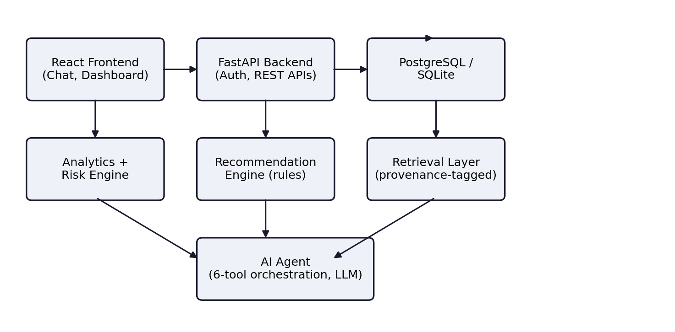
Fig. 1. System architecture: React frontend, FastAPI backend, deterministic analytics/risk/recommendation engines, provenance-tagged retrieval layer, and the tool-orchestrated LLM agent.
Layer | Technology
Frontend | React (Vite)
Backend / API | Python, FastAPI
Database | PostgreSQL (SQLite for local dev)
Data processing | Pandas, NumPy
Agent / LLM | Groq-hosted LLM, function calling
External data | mfapi.in (live mutual-fund data)
TABLE III. TECHNOLOGY STACK
The database stores five entities -- Users, Financial_Profile, Risk_Assessment, Recommendations, and Conversations -- with Conversations providing the pool from which the retrieval layer draws prior exchanges. Input validation rejects negative or missing financial values before they reach the analytics layer.
V. EXPERIMENTAL EVALUATION
A. Synthetic Dataset
Because the deployed system has not yet accumulated real user data, we generated a synthetic dataset of N = 240 profiles for controlled testing of the deterministic layers. Age was drawn uniformly from [22, 58], monthly income from ₹20,000–₹180,000, expenses as 35–90% of income, planned investment as 10–80% of residual savings, investment horizon from 1–20 years, financial goal sampled uniformly from four categories, and eight risk-questionnaire responses sampled uniformly from {1..5} per question. Each profile was passed through the same analytics, risk-scoring, and matching functions used by the production backend.
B. Functional Consistency
Each profile's savings rate was independently recomputed outside the system and compared to the system-reported value. All 240 profiles matched exactly (0 discrepancies), confirming that the deployed analytics functions are arithmetically consistent with their specification.
Test | Result
Profiles evaluated | 240
Independent recompute mismatches | 0 / 240
Profiles with negative savings | 0 / 240
Mean savings rate | 36.6%
TABLE IV. FUNCTIONAL VALIDATION ON THE SYNTHETIC DATASET
C. Risk Category and Recommendation Distribution
Fig. 2 shows the resulting risk-category distribution: 13 profiles (5.4%) Conservative, 194 (80.8%) Moderate, and 33 (13.8%) Aggressive. Because questionnaire responses were sampled uniformly rather than drawn from a realistic population, this result is primarily a diagnostic of the classifier's boundary placement rather than a claim about real investors.
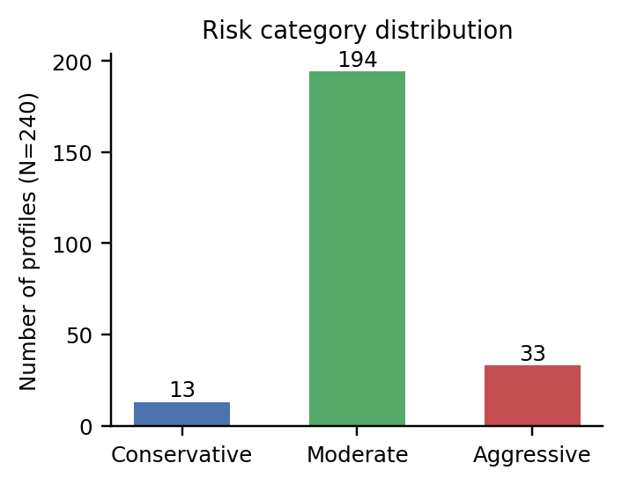
Fig. 2. Risk category distribution over 240 synthetic profiles.
Under uniform random responses, the current 44%/72% cut points concentrate 81% of the population in the Moderate band. This is a direct, reproducible consequence of the width of the middle band relative to the tails and is a useful finding in its own right: it indicates that the classification boundaries should be calibrated against a normed instrument or pilot population before deployment, rather than left at the illustrative values used here. Table V shows the corresponding recommended-category distribution, obtained by joining each profile's risk category with its horizon bucket via Table II.
Recommended Category | Profiles | %
Balanced Advantage / Index Funds | 162 | 67.5%
Balanced Hybrid Funds | 32 | 13.3%
Multi-Cap & Growth Equity Funds | 27 | 11.3%
Conservative Hybrid / Debt Funds | 13 | 5.4%
Large-Cap Equity Funds | 6 | 2.5%
TABLE V. RECOMMENDED INVESTMENT CATEGORY DISTRIBUTION (N=240)
D. Planned Human-Subject Evaluation
The AI agent's explanation quality, and the recommendation's perceived relevance, require human judgment and were not assessed in this synthetic-data study. A subsequent phase will collect Likert-scale ratings (1–5) for risk alignment, goal alignment, explanation clarity, and factual consistency from domain-informed reviewers, following the protocol outlined in Section VII.
VI. SECURITY, PRIVACY, AND RESPONSIBLE AI
The system restricts data collection to fields required for analysis, applies authenticated access and hashed password storage, and validates all numeric input before it reaches the analytics layer. The agent's system prompt explicitly forbids presenting fund or platform results as endorsements or as guaranteed outcomes, and requires the model to state that its output is decision support rather than licensed financial advice. Because retrieval separates authoritative structured facts from conversational memory, a prompt-injection attempt embedded in a past conversation cannot silently overwrite the user's current financial profile -- though adversarial-robustness testing of this property is left to future work.
VII. LIMITATIONS AND FUTURE WORK
First, this evaluation uses synthetic, uniformly sampled data rather than real or realistically distributed profiles; the risk-category skew reported in Section V-C should not be read as a claim about actual investor populations. Second, risk-category boundaries were illustrative and require calibration against a validated instrument. Third, explanation quality and recommendation relevance require a human-subject study, planned as a five-point Likert evaluation with domain-informed reviewers across risk alignment, goal alignment, clarity, and factual consistency. Fourth, the retrieval layer's lexical ranking is a deliberately simple, reproducible baseline; an embedding-based ranker is a natural next comparison condition, evaluated on retrieval precision@k and unsupported-number rate. Finally, longitudinal evaluation is needed to assess whether recommendations remain appropriate as a user's financial situation evolves.
VIII. CONCLUSION
This paper presented an architecture for AI-assisted financial decision support that keeps numerical computation deterministic and auditable while using an LLM agent purely for tool orchestration and explanation, supported by a provenance-aware retrieval layer that distinguishes authoritative current facts from historical conversational memory. Evaluation on a synthetic dataset of 240 profiles confirmed exact functional consistency between independently recomputed and system-reported financial indicators, and surfaced a concrete, actionable finding -- that the current risk-classification boundaries require calibration -- that would not have been visible without running the pipeline end to end. The architecture provides a practical basis for further evaluation with real users and a validated risk instrument.
REFERENCES
[1] N. Bussmann, P. Giudici, D. Marinelli, and J. Papenbrock, "Explainable AI in Fintech Risk Management," Frontiers in Artificial Intelligence, vol. 3, art. 26, 2020.
[2] W. J. Yeo, W. Van Der Heever, R. Mao, E. Cambria, R. Satapathy, and G. Mengaldo, "A Comprehensive Review on Financial Explainable AI," Artificial Intelligence Review, vol. 58, 2024.
[3] M. T. Mohsin and N. B. Nasim, "Explaining the Unexplainable: A Systematic Review of Explainable AI in Finance," arXiv:2503.05966, 2025.
[4] M. K. P. So et al., "Robo-Advising Risk Profiling through Content Analysis for Sustainable Development in the Hong Kong Financial Market," Sustainability, vol. 13, no. 3, art. 1306, 2021.
[5] D. Boreiko and F. Massarotti, "How Risk Profiles of Investors Affect Robo-Advised Portfolios," German Journal, 2020.
[6] R. M. Gaspar and M. Oliveira, "Robo Advising and Investor Profiling," FinTech, vol. 3, no. 1, pp. 108-125, 2024.
[7] Y. Gao, Y. Xiong, X. Gao, K. Jia, J. Pan, Y. Bi, Y. Dai, J. Sun, and H. Wang, "Retrieval-Augmented Generation for Large Language Models: A Survey," arXiv:2312.10997, 2024.
[8] A. Singh, A. Ehtesham, S. Kumar, T. T. Khoei, and A. V. Vasilakos, "Agentic Retrieval-Augmented Generation: A Survey on Agentic RAG," arXiv:2501.09136, 2025.
[9] G. Mialon et al., "Augmented Language Models: A Survey," arXiv:2302.07842, 2023.
[10] "AI integration in financial services: a systematic review of trends and regulatory challenges," Humanities and Social Sciences Communications, Nature, 2025.

