

SCHOOL OF COMPUTER SCIENCE AND ENGINEERING
MACSE513 - Computer Networks-Project Review –0

Team Name: NullRoute

Batch Size | Reg No | Name | Title of the Project
3 | 25MAI1003 | Vishal | Intelligent Network Traffic Classification and QoS Recommendation System
 | 25MAI1004 | Vishwa J
 | 25MAI1019 | Harish V

Abstract:

In modern computer networks, diverse applications such as web browsing, video streaming, file transfer, and background services compete for limited network resources. Efficient management of network performance requires an understanding of traffic behavior and appropriate Quality of Service (QoS) strategies. This project focuses on the design and implementation of an intelligent network traffic classification and QoS recommendation system to support effective network performance management.

The proposed system captures network traffic from a local area network and analyzes packet-level characteristics such as protocol type, packet size, flow duration, and traffic rate. Based on these characteristics, the system classifies network traffic into different application categories such as web traffic, multimedia traffic, file transfer traffic, and background traffic. Classification is performed using rule-based intelligent logic derived from standard networking principles.

Once traffic is classified, the system applies QoS decision logic to recommend suitable priority levels for different traffic categories. These recommendations help in understanding how network resources can be efficiently allocated to improve overall performance. The project does not enforce traffic control on the live network but focuses on analysis, recommendation, and performance evaluation.

The system further evaluates network performance metrics such as bandwidth utilization, packet distribution, and delay characteristics before and after applying QoS recommendations in a simulated environment. The results are visualized using graphs and reports to provide meaningful insights into network behavior. This project helps in understanding core computer networking concepts such as traffic classification, QoS, network monitoring, and performance analysis.

Modules Used in the Project:

1. Network Traffic Capture Module
- Captures live network packets from the LAN environment
- Collects packet-level information such as source/destination IP, ports, protocol, and packet size
- Stores captured data for further analysis

2. Feature Extraction Module
- Extracts meaningful features from raw packet data
- Identifies flow-based attributes such as traffic rate and duration
- Converts raw data into structured datasets

3. Traffic Classification Module
- Classifies network traffic into application categories
- Uses rule-based intelligent logic based on protocol and traffic behavior
- Distinguishes between web, multimedia, file transfer, and background traffic

4. QoS Recommendation Module
- Assigns recommended priority levels to each traffic category
- Defines QoS strategies based on application importance
- Does not enforce traffic control on the live network

5. Performance Evaluation Module
- Analyzes network performance metrics
- Compares traffic behavior with and without QoS recommendations
- Measures bandwidth usage and packet distribution

6. Visualization and Reporting Module
- Displays results using graphs and charts
- Provides insights into traffic patterns and QoS impact

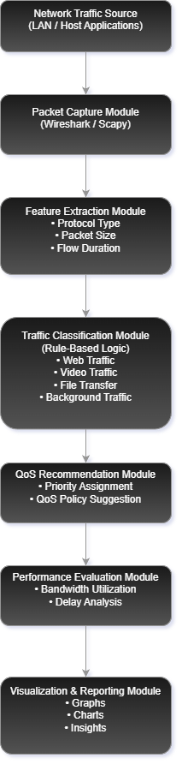
Architectural Diagram:

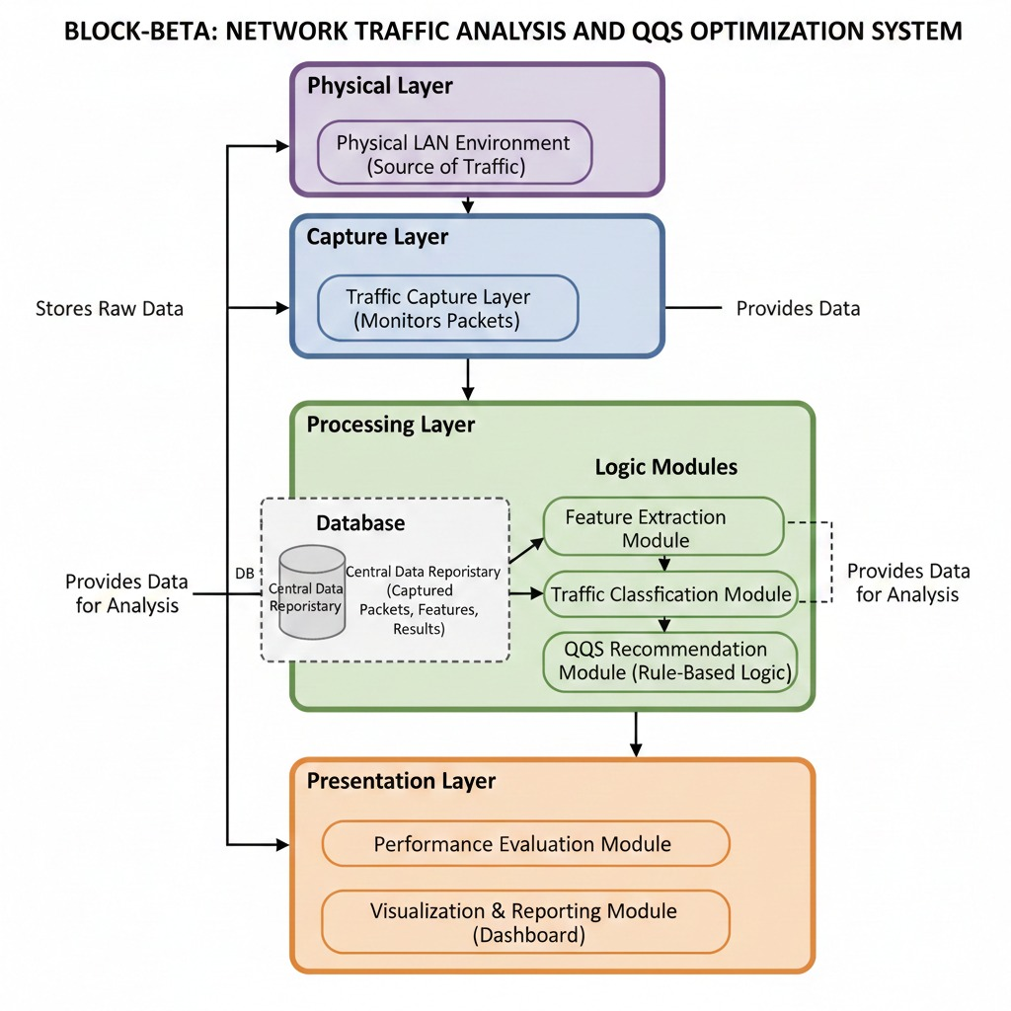

The system architecture consists of a traffic capture layer that monitors network packets from the LAN environment. Captured packets are processed by the feature extraction module, which converts raw packet data into structured flow information. The traffic classification module analyzes this data and categorizes traffic based on application behavior. The QoS recommendation module assigns suitable priority levels for different traffic categories based on predefined networking rules. Finally, the performance evaluation and visualization modules analyze and present the results, enabling informed understanding of network traffic behavior and QoS effectiveness.
Concepts Applied in the Project:

- Computer Networks and TCP/IP Protocol Suite
- Network Traffic Analysis
- Flow-Based Traffic Classification
- Quality of Service (QoS) Concepts
- Bandwidth Utilization and Performance Metrics
- Network Monitoring and Evaluation

Platform & Language Used:

Component | Technology
Operating System | Linux (Ubuntu)
Programming Language | Python
Packet Capture Tool | Wireshark (Traffic Capture)
Data Processing | Python (CSV handling)
Visualization | Matplotlib
Development Tools | VS Code / PyCharm

