**Advanced Lead Filters Module of Perfex CRM**

**Author : Sejal Infotech**

**Description:**

**SI Lead Filters** allows you to create dynamic filters for Leads in Perfex CRM, This can be used to generate different kind of reporting for your use.

This module is user friendly, quick and easy to install and use.

You can create filters and save them, by your given name, as filter Templates, to use them in future.

This module saves time of user in generating different reports from Lead filter because, Once filter is saved as Template, then that template can be used any time, in future.

Only allowed Staff members can use this Module.

**Steps to Use:**

**1. Quick Install:**

You will get si_lead_filters.zip file in All files Directory. You can use this zip file to Install this module in Perfex CRM.

Go to Perfex CRM->SETUP-> Modules.

Upload Module zip file and click Install button.

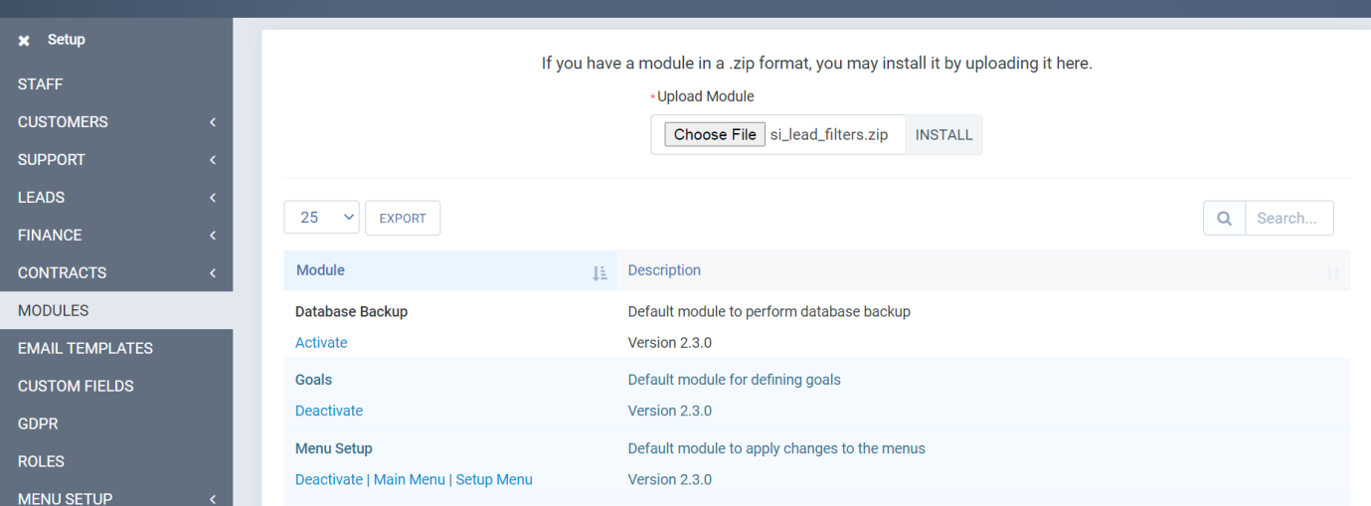

You will be able to see 'SI Lead Filters' Module in list of Modules.

Click on Activate it.

That's it.

**2. Give rights to Users to access this Module**

Admin can give rights to Users or Role who want to allow to use this module.

Click SETUP-> Roles->edit Role, and select Si Lead Filters for that role. So all users having that role will be able to use this module.

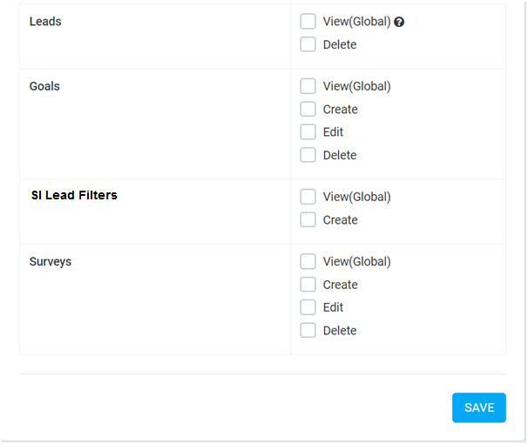

Check SI Lead filters View and Create and save changes.

**3. Use from Menu "SI Lead Filters"**

User will be see this module in Menu called "SI Lead Filters", if that user has permission to access this module.

Click on Menu->SI Lead Filters->Lead Filters, to apply different filters on Lead and generate report of it.

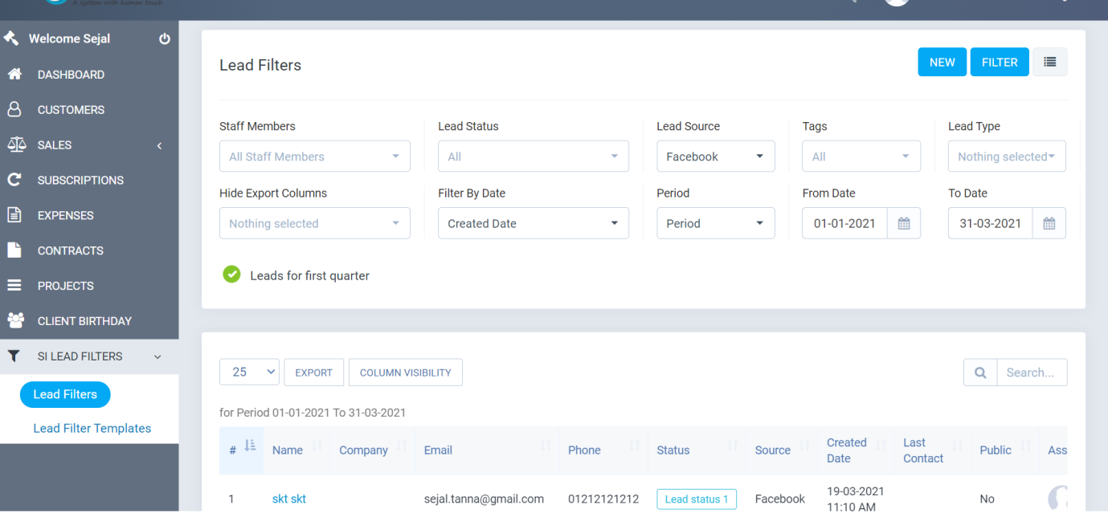

If you want to save that Filter for future Use then, Click checkbox in "Save as Filter Template" and add Filter Template Name, then Click on "Filter" Button on top. So this filter will be saved as filter Template and user will be able to access that filter in future.

User can manage his saved List of Templates, by clicking on Menu-> SI Lead Filters->Lead Filter Templates.

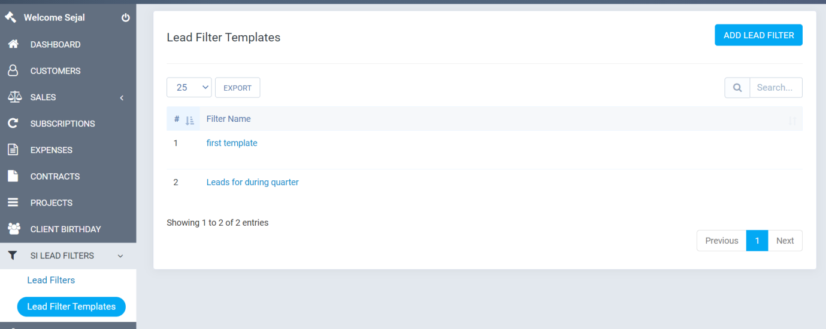

From Lead Filter Templates, user can click on View to see all that filtered data Report, so no need to apply filters again, and thus saves time.

**4. How to Remove this Module**

If you want to remove this module, then Goto SETUP->Modules->SI Lead Filters and click on Deactivate it. So this module will be disable for all.

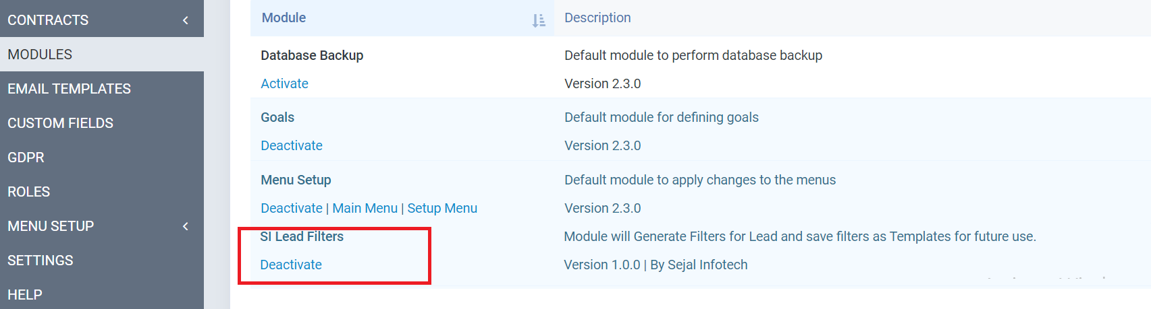

Thanks. I hope you will enjoy using this Module....