DHANANI PRIVATE EQUITY GROUP
Salesforce CRM Implementation
End-to-End Technical Solution Design

Version 1.3 | Prepared by Avanza Solutions
Updated: Diagrams Redesigned, Einstein Analytics removed, Native Dashboards and Reports only
Confidential & Proprietary

Table of Contents

1. Executive Summary 4
2. Object Model: Broker & Investor — Account vs Contact Decision 5
3. Native Data Protection & Sensitive Field Security 9
4. System Architecture Overview 13
5. Core Module: Acquisitions 16
6. Core Module: Transaction Management 22
7. Core Module: Disposition 29
8. Core Module: Investor Relations (IR) 34
9. IR: Share Transfer Functionality 47
10. Data Model & Entity Relationship Diagram 51
11. Workflow Automation & Lifecycle 55
12. Financial Integration — Plaid Architecture 59
13. Document Management Strategy 65
14. Security, Access & Role Matrix 69
15. Integration Architecture — Avanza Service Bus (ASB) 71
16. Implementation Roadmap 77

1. Executive Summary

This document defines the comprehensive end-to-end technical solution for the Salesforce CRM implementation at Dhanani Private Equity Group (DPEG). Version 1.1 incorporates six key updates: explicit object conversion points at every stage transition, a definitive Account/Contact model for both Brokers and Investors, Share Transfer functionality for the IR module, Plaid-based financial integration replacing direct bank API configurations, Salesforce-native document storage for IR, and a clarified OneDrive strategy (links only, no integration).

1.1 v1.1 Update Summary
Change | Section | Description
Object conversion callouts | Sections 5–8 | Every stage where a Salesforce object is converted to another is explicitly highlighted
Broker & Investor object model | Section 2 | Definitive Account vs Contact decision for Brokers and Investors with full IR entity/contact model
Share Transfer functionality | Section 9 | Full IR share transfer workflow — investor-to-investor transfer of investment units
Plaid-based bank integration | Section 12 | Plaid replaces direct bank API for contributions and distributions
IR document upload to Salesforce | Section 13 | IR team uploads documents directly to Salesforce Files; portal exposes them to investors
OneDrive: links only, no integration | Section 13 | OneDrive links stored manually in Salesforce; no integration required
Native data protection (v1.3) | Section 3 | Salesforce Shield removed; native platform encryption, field-level security and masking defined for all sensitive fields
Avanza Service Bus (ASB) (v1.3) | Section 15 | All external system integrations route through ASB middleware; Lambda references replaced throughout

2. Object Model: Broker & Investor — Account vs Contact Decision

One of the most important architectural decisions in this Salesforce implementation is whether to represent Brokers and Investors as Account records, Contact records, or both. This section provides the definitive answer for each persona, with clear reasoning.

2.1 The Standard Salesforce Pattern
Salesforce uses a two-tier model for organisations and people:
- Account — represents an organisation (company, firm, LLC, trust, partnership).
- Contact — represents an individual person, always linked to an Account.
The correct approach for DPEG is to use both — an Account for the organisation/entity and a Contact for each person at that organisation. This is the industry-standard pattern and unlocks the full power of Salesforce's relationship model.

2.2 Broker Object Model

Decision: Account (Brokerage Firm) + Contact (Individual Broker)
Object | Represents | Example | Key Fields
Account | The brokerage firm | CBRE, Marcus & Millichap, Cushman & Wakefield | Account_Type__c = 'Broker Firm', Total_Deals_Submitted__c, First_Deal_Date__c, Broker_Protection_Active__c
Contact | The individual broker person | John Smith at CBRE | Account lookup, Broker_License__c, Deals_Submitted__c, NDA_On_File__c, Last_Deal_Date__c

Why not Contact-only for Brokers?
- Broker protection and deduplication logic operates at the firm level (not just one person). Multiple contacts at the same firm must be tracked under one Account.
- Deal sourcing analytics (top broker firms, volume per firm) require Account-level roll-up fields.
- A broker may have multiple staff submitting deals — all tracked under one Account, each as a Contact.
- The standard Salesforce duplicate matching rule works on Account name + email domain to prevent duplicates at firm level.

NOTE: On Lead creation, the Broker Contact is looked up or created. On Lead conversion, a Broker Account (firm) + Contact (individual) are either matched to existing records or created. The Opportunity is then linked to both the Broker Contact and Broker Account.
OBJECT CONVERSION: Lead → Opportunity + Account (Broker Firm) + Contact (Broker Person) | On Lead conversion, the broker firm becomes the Account and the individual broker becomes the Contact linked to that Account.

2.3 Investor Object Model (IR Module)
The investor data model is more complex than brokers because an investor may have multiple legal investing entities, each entity may have multiple signers, and each entity participates in multiple investments. AppFolio represents this as Investor (person) → Investing Entity (legal entity) → Contacts (signers). The Salesforce equivalent is:

Four-Object Investor Model
Object | Type | Represents | AppFolio Equivalent | Key Fields
Account | Standard | The investor's legal investing entity (LLC, Trust, Corporation, Individual) | Investing Entity in AppFolio | Account_Type__c = 'Investing Entity', Entity_Type__c (LLC/Trust/Corp/Individual), Tax_ID_EIN__c, Total_Invested__c, Total_Distributed__c
Contact | Standard | An individual person — the investor themselves or a co-signer | Contact in AppFolio | Account lookup (to Investing Entity), Role__c (Primary/Secondary), SSN_Encrypted__c, Accreditation_Status__c, Portal_User__c, KYC_Complete__c
Investor__c | Custom | The relationship record that joins a person to their investor profile — KYC status, onboarding state, total portfolio summary | Investor profile in AppFolio | Contact__c (primary contact), Total_Committed__c, Total_Funded__c, Total_Distributed__c, Onboarding_Date__c, Active_Investor__c
Investing_Entity_Contact__c | Custom Junction | Links a Contact (signer) to an Account (investing entity) as Primary or Secondary signer — enables dual-signature workflow | Contact → Investing Entity link in AppFolio | Investing_Entity__c (Account), Contact__c, Signer_Role__c (Primary/Secondary), Signature_Required__c

Why Account for the Investing Entity (not a custom object)?
- Using standard Account for investing entities gives DPEG all built-in Salesforce capabilities: Activities, Chatter, related lists, duplicate management, sharing rules, and native Salesforce reports — all work natively on Account.
- Experience Cloud's standard sharing model is built around Account records — investors log into the portal and see their Account's related Investments, Distributions, and Documents without custom sharing logic.
- Multiple contacts (primary + secondary signers) can be linked to one Account using the standard Contact → Account relationship, matching AppFolio's behaviour exactly.
- Roll-up summary fields (total invested, total distributed) aggregate naturally on Account from child Investment__c records.

Why Contact for the Individual Investor Person?
- A real person (investor) is always a Contact in Salesforce — this is the standard pattern. The Contact holds personal details: name, email, phone, accreditation, KYC status, and Experience Cloud portal login.
- One person can be associated with multiple Investing Entities (Accounts) — e.g., John Smith is a signer for both Smith Family Trust and Smith Holdings LLC. This is handled via the Investing_Entity_Contact__c junction object.
- Marketing Cloud uses Contact records for campaign targeting — using Contact (not Account) ensures Faiz's investor blasts correctly target individuals.

The Complete IR Object Relationship
Level | Object | Represents | Linked To
Person | Contact | Individual investor or co-signer (SSN, accreditation, portal login, KYC) | Account via standard Contact→Account lookup
Profile | Investor__c | Portfolio summary record (total committed, funded, distributed, onboarding state) | Contact__c lookup — one per investor person
Entity | Account (Investing Entity) | Legal investing entity — LLC, Trust, Corp, Individual (EIN, bank via Plaid, roll-up totals) | Has many Contacts via Investing_Entity_Contact__c
Junction | Investing_Entity_Contact__c | Links a Contact to an Account as Primary or Secondary signer | Contact__c + Investing_Entity__c; Signer_Role__c picklist
Investment | Investment__c | Confirmed funded investment — amount, equity %, distributions, cost basis | Account (Investing Entity) + Offering__c
Finance Out | Distribution__c | Single ACH/check distribution to investor (Plaid ACH status tracked) | Investment__c Master-Detail
Finance In | Contribution__c | Incoming wire or ACH — Plaid matched, partial agg., entity name verified | Investment__c Master-Detail
Documents | IR_Document__c | Portal-accessible document — K-1, statement, report (Salesforce Files) | Offering__c or Investment__c lookup
NOTE: One investor person (Contact) can have MANY Investing Entities (Accounts). One Investing Entity can have up to two signers (Primary + Secondary). All Experience Cloud portal access is granted to the Contact record.

Worked Example
Record | Type | Name/Value | Notes
Contact | Standard | Bawan Patel | Primary signer — has Experience Cloud portal login
Contact | Standard | Rose Patel | Secondary signer — also has portal access
Account | Standard (Investing Entity) | Ronak LLC | Entity_Type__c = LLC; EIN = XX-XXXXXXX
Investing_Entity_Contact__c | Junction | Bawan → Ronak LLC | Signer_Role__c = Primary
Investing_Entity_Contact__c | Junction | Rose → Ronak LLC | Signer_Role__c = Secondary
Investment__c | Custom | Ronak LLC → Gallery Up Arts Offering | Amount_Funded__c = $200,000
Distribution__c | Custom | Ronak LLC — Q1 Distribution | ACH to Ronak LLC bank account; $8,400

3. Native Data Protection & Sensitive Field Security

DPEG's Salesforce implementation uses Salesforce's native, out-of-the-box platform capabilities for all sensitive data protection requirements. Salesforce Shield Platform Encryption is NOT used. All data protection is achieved through a combination of native field-level security, restricted profiles, view masking, and platform-standard controls — all available without additional licences.

3.1 Sensitive Data Inventory — What Needs Protection
Data Element | Object / Field | Sensitivity Level | Protection Required
Investor Social Security Number (SSN) | Contact.SSN__c | Critical — PII | Restricted field access + masked display
Entity Tax ID / EIN | Account.Tax_ID_EIN__c | Critical — PII/Financial | Restricted field access + masked display
Plaid Access Token | Investing_Entity__c.Plaid_Access_Token__c | Critical — Security credential | Stored in Named Credentials; field hidden from all UI profiles
Bank Account Number (last 4 only) | Investing_Entity__c.Bank_Account_Last4__c | Sensitive — Financial | Read-only display field; full number never stored
Investor Accreditation Documents | Salesforce Files on Contact | Sensitive — Regulatory | File-level sharing: accessible only to IR team + the investor
Distribution Amounts (per investor) | Distribution__c.Amount__c | Sensitive — Financial | Field-level security: visible only to IR Manager, Finance, Principals
Investment Amount | Investment__c.Amount_Funded__c | Sensitive — Financial | Field-level security: IR Manager, Finance, Principals, and the investor (via portal)
Commitment Amount | Commitment__c.Committed_Amount__c | Sensitive — Financial | IR team + Principals only; not visible to IR Associate by default
Broker Commission / Fees | Opportunity.Broker_Fee__c | Sensitive — Business | Acquisitions team + Principals only
Loan Terms / Interest Rate | Loan__c.Rate__c, Loan__c.Loan_Amount__c | Sensitive — Financial | Transaction Lead + Finance + Principals only
Closing Wire Amount | Transaction__c.Final_Wire_Amount__c | Sensitive — Financial | Transaction Lead + Finance + Principals only

3.2 Native Protection Mechanisms
Salesforce provides the following native controls — no Shield licence required:

3.2.1 Field-Level Security (FLS)
Field-Level Security controls which profiles can see, edit, or are completely hidden from a field. This is configured on each field's security settings and applied per profile.
Field | Object | Who Can See | Who Can Edit | Hidden From
SSN__c | Contact | IR Manager only | IR Manager only | All other profiles including IR Associate, Acquisitions, PM
Tax_ID_EIN__c | Account | IR Manager, Finance, Principals | IR Manager only | IR Associate, Acquisitions, PM, Portal investors
Amount__c | Distribution__c | IR Manager, Finance, Principals | IR Manager, Finance | IR Associate (read summary only), Acquisitions, PM
Amount_Funded__c | Investment__c | IR Manager, Finance, Principals, Investor (portal — own record) | IR Manager, Finance | IR Associate (view summary), Acquisitions, PM
Plaid_Access_Token__c | Investing_Entity__c | System/Apex only (no UI visibility) | System/Apex only | All UI profiles — field not on any page layout
Final_Wire_Amount__c | Transaction__c | Transaction Lead, Finance, Principals | Transaction Lead | IR team, Acquisitions, PM

3.2.2 View Masking — SSN and Tax ID
For SSN and EIN fields, Salesforce native masking is applied using a custom formula field pattern. The actual value is stored in a restricted field; a companion formula field displays a masked version (e.g., ***-**-6789) on page layouts and list views.
Field | Type | Formula / Config | Who Sees What
SSN__c (actual) | Text — restricted | FLS: IR Manager only. NOT on any page layout except IR Manager's Contact view. | IR Manager: full value. All others: field hidden
SSN_Masked__c (display) | Formula (Text) | '***-**-' & RIGHT(SSN__c, 4) — read-only on all layouts | IR team, Principals, Investor (own portal): ***-**-6789
Tax_ID_EIN__c (actual) | Text — restricted | FLS: IR Manager + Finance only. Not on standard layouts. | IR Manager, Finance: full EIN. All others: hidden
Tax_ID_Masked__c (display) | Formula (Text) | '**-***' & RIGHT(Tax_ID_EIN__c, 4) | IR team, Principals, Investor (own portal): **-***6789
Bank_Account_Last4__c | Text (display only) | Populated by Plaid — last 4 digits only. Full number never stored in Salesforce. | IR Manager, investor (own portal): XXXX-1234

3.2.3 Named Credentials for API Secrets
All external API credentials (Plaid API keys, ASB tokens, CoStar API key, Placer.ai key) are stored exclusively in Salesforce Named Credentials — never in custom fields, custom metadata, or hardcoded in Apex. Named Credentials are:
- Not visible to any user in the UI — only accessible to Apex code via callouts.
- Managed by System Administrators only; stored encrypted in Salesforce's credential store.
- Rotatable without code changes — update the Named Credential and all Apex callouts immediately use the new token.
- Audited — all accesses logged in Salesforce Setup Audit Trail.

3.2.4 Platform-Standard Encryption at Rest
All Salesforce data is encrypted at rest using AES-256 by the Salesforce platform as a standard capability (not Shield). This applies to all custom objects, fields, and files stored in Salesforce — including Salesforce Files (ContentDocument). No additional configuration is required.

3.2.5 Salesforce Files Access Control
Investor documents stored in Salesforce Files are protected at the content level:
- ContentDocumentLink controls which record the file is shared with — investors can only see files linked to their own Account (Investing Entity) or Investment__c records.
- Experience Cloud enforces object-level and record-level sharing — portal users cannot browse or search for other investors' documents.
- IR_Document__c records (which reference the file) are only shared with the investor if their Investing Entity is an active participant in the referenced Offering.

3.2.6 OWD (Organisation-Wide Defaults) & Sharing Rules
Object | OWD Setting | Sharing Rule | Rationale
Contact (Investor) | Private | Shared to IR team via Role Hierarchy; investors see only own Contact via portal | Investors must not see other investors' personal details
Account (Investing Entity) | Private | Shared to IR team; investor portal user sees own Account only | Entity financial data is confidential
Investment__c | Private | IR team via Role; investor portal user sees own records via ownership | Investment amounts are sensitive
Distribution__c | Private | IR Manager + Finance via Role; investor sees own via portal owner rule | Distribution amounts per investor are confidential
Commitment__c | Private | IR team via Role; investor sees own via portal owner rule | Commitment details are financial PII
Opportunity (Deal) | Private | Role hierarchy — Acquisitions, Transaction, Principals | Deal financials not visible to IR or PM by default
Transaction__c | Private | Transaction Lead role + Principals | Closing wire amounts restricted
IR_Document__c | Private | Shared to investor via Criteria-Based Sharing Rule on Offering participation | K-1 and financial statements are investor-specific

3.3 Data Protection by Module — Where It Applies
Module | Sensitive Data Points | Protection Applied
IR — Investor Onboarding | SSN, EIN, accreditation docs, KYC documents | FLS on SSN/EIN; masked display formula; Salesforce Files with IR-only access until KYC approved
IR — Commitments | Committed amount, bank details for wiring | FLS: IR Manager + Finance + Principals; investor sees own amount on portal only
IR — Financial (Plaid) | Plaid Access Token, bank routing/account | Named Credentials for token; bank number NEVER stored — Plaid token only; last 4 displayed via formula
IR — Distributions | Per-investor distribution amounts | FLS: IR Manager, Finance, Principals; Distribution__c OWD = Private; investor sees own via portal ownership
IR — Share Transfers | Transfer amount, cost basis | FLS same as Investment__c; Share_Transfer__c OWD = Private; both parties see their own records only
Acquisitions | Broker commission, deal financials | FLS on fee fields: Acquisitions team + Principals; OWD Private on Opportunity
Transaction | Wire amounts, loan terms, earnest money | FLS: Transaction Lead + Finance + Principals; OWD Private on Transaction__c and Loan__c
Disposition | Sale price, IRR, proceeds | FLS: Finance (Ali) + Principals; OWD Private on Disposition__c

3.4 Audit Trail & Monitoring
- Field History Tracking (native, no Shield) enabled on: Investment__c (Amount_Funded, Status), Distribution__c (Amount, ACH_Status), Commitment__c (Status, Amount), Share_Transfer__c (Status, Approval_Status), Transaction__c (Stage, Final_Wire_Amount).
- Salesforce Setup Audit Trail: all administrative changes (profile edits, FLS changes, Named Credential updates) logged and retained for 180 days natively.
- Login History (native): all user logins, IP addresses, and browser details retained for 6 months.
- Salesforce Event Monitoring (available in Enterprise Edition): API usage logs, report exports, and login anomalies tracked without Shield.
NOTE: Salesforce Shield Platform Encryption is NOT used in this implementation. All protection is achieved through native FLS, OWD/sharing rules, Named Credentials, masked formula fields, and platform-standard AES-256 encryption at rest. This is sufficient for DPEG's requirements and avoids the additional Shield licence cost.

4. System Architecture Overview

The DPEG Salesforce platform follows a hub-and-spoke integration model. Salesforce CRM acts as the central hub. External systems connect as spokes through the Avanza Service Bus (ASB) — Avanza's managed middleware and ETL platform. Salesforce is a read and display layer for external operational data — no write-back to Yardi or Procore. Financial flows (contributions and distributions) run through Plaid's universal bank integration layer, also orchestrated via ASB.

3.1 High-Level Architecture Diagram
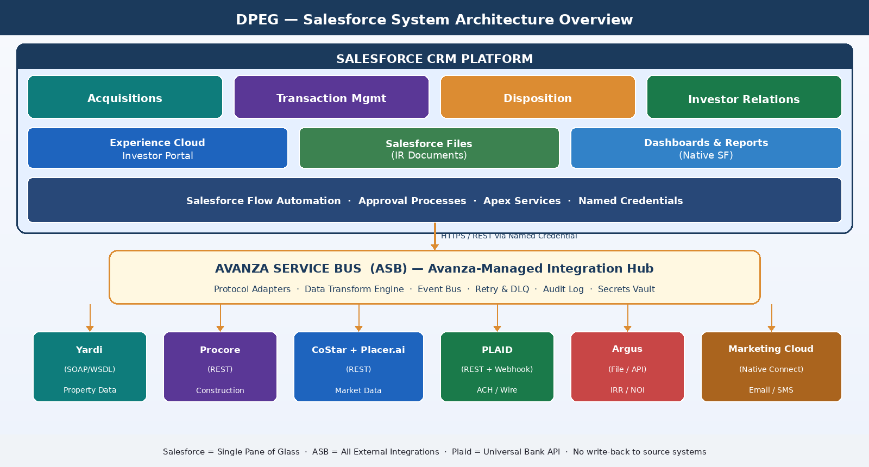
Figure 1: DPEG Salesforce System Architecture - Salesforce Platform, ASB Integration Hub and External Systems

4.2 Key Architecture Decisions in v1.3
Decision | Chosen Approach | Reason
Middleware / ETL | Avanza Service Bus (ASB) | All external integrations route through ASB — DPEG's standard Avanza-managed integration platform
Bank integration for ACH | Plaid (universal layer) | One Plaid integration works with all banks — no reconfiguration needed when DPEG opens a new bank account
Sensitive data protection | Native FLS + OWD + Named Credentials + masking | Salesforce Shield not used; all protection achieved via native platform controls
Document storage (IR) | Salesforce Files (native) | IR team uploads to Salesforce directly; portal serves files to investors natively
OneDrive | Manual link storage only | No integration — SF stores the OneDrive URL as a text field; staff paste links manually
Investor entity model | Account (entity) + Contact (person) | Standard SF pattern; enables native portal sharing, roll-ups, and MC targeting
Broker model | Account (firm) + Contact (person) | Broker protection logic operates at firm level; multi-contact per firm supported

5. Core Module: Acquisitions

The Acquisitions module manages the full deal sourcing pipeline from initial contact through principal approval and handoff to Transaction and IR teams.

4.1 Acquisitions & Deal Lifecycle
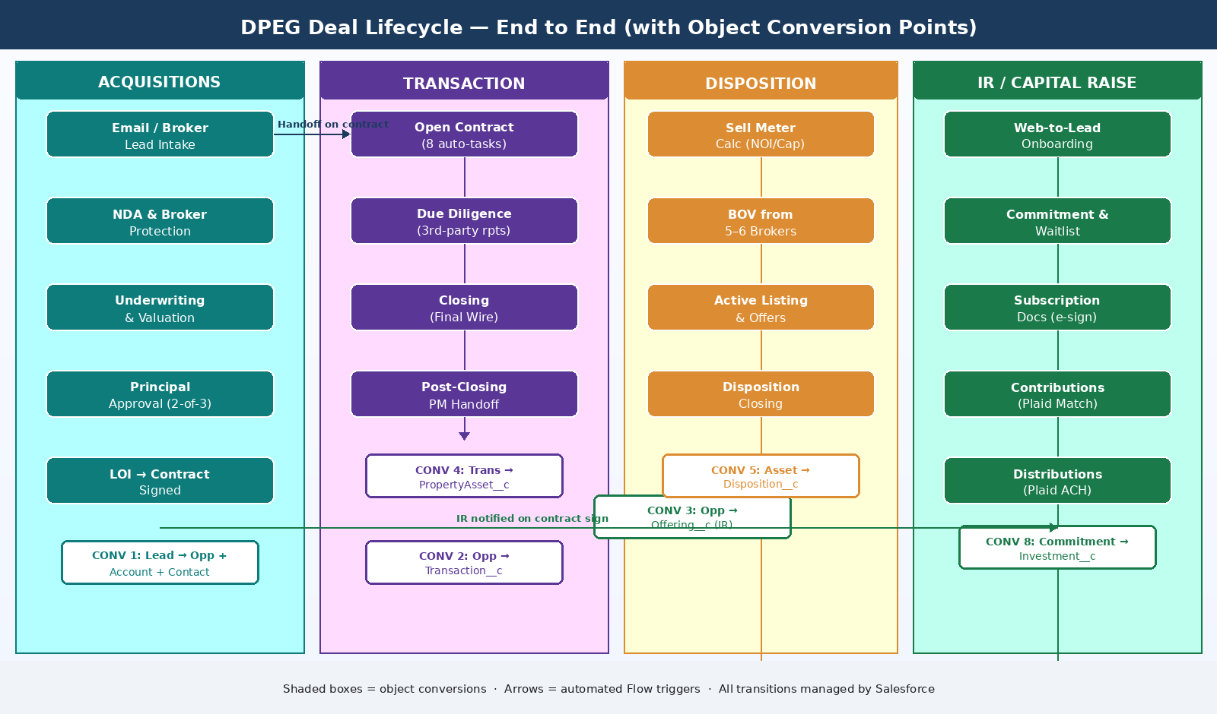
Figure 2: DPEG End-to-End Deal Lifecycle - Acquisitions, Transaction, Disposition and IR with Object Conversion Points

4.2 Object Conversion Points

Conversion 1: Lead → Opportunity
OBJECT CONVERSION: Lead → Opportunity + Account (Broker Firm) + Contact (Broker Person) | Triggered when Junior qualifies the deal and converts the Lead. The broker firm becomes an Account; the broker person becomes a Contact linked to that Account. The new Opportunity is linked to both.
The conversion happens at Stage 1 → Stage 2 (NDA). Junior clicks Convert on the Lead record. Salesforce:
- Checks for existing broker Account (by firm name/domain) — matches or creates new Account with Account_Type__c = Broker Firm.
- Checks for existing broker Contact (by email) — matches or creates new Contact linked to the Account.
- Creates Opportunity in 'NDA Pending' stage with all Lead fields mapped across.
- Auto-creates Property__c record from address fields.

Conversion 2: Opportunity → Transaction__c
OBJECT CONVERSION: Opportunity (stage = Under Contract) → Transaction__c record | Triggered automatically by Flow when Contract_Signed__c is checked on the Opportunity. A new Transaction__c is created and linked to the Opportunity. The Opportunity remains open — it is NOT converted; it moves to 'Contracted' stage. Transaction__c takes over as the operational record.

Conversion 3: Opportunity → Offering__c (IR trigger)
OBJECT CONVERSION: Opportunity (stage = Under Contract) → Offering__c record (IR module) | Simultaneously with Transaction__c creation, a Flow auto-creates an Offering__c record in IR. This seeds the capital raise with deal data (purchase price, target raise, deal type). Faiz's team is notified and the Offering moves to 'Draft' status for IR to finalise before launch.

4.3 Stage-Wise Breakdown

Stage 1: Deal Sourcing & Email Intake
Item | Detail
Entry Criteria | Email, web form, or direct broker submission received
Activities | Email-to-Lead auto-capture; broker dedup check; Lead assigned to Junior
Owner | Junior (Acquisitions Lead)
Objects Active | Lead, Account (Broker — looked up), Contact (Broker — looked up)
Automation | Email parser creates Lead; duplicate rule flags same property+broker within 30 days; inactivity alert at 7 days
Exit Criteria | Lead qualified (address, asset type, asking price); Junior initiates conversion

Stage 2: NDA & Broker Protection
Item | Detail
Entry Criteria | Lead converted (see Conversion 1 above)
Objects Active | Opportunity (NDA Pending), Account (Broker Firm), Contact (Broker Person), Property__c
Activities | NDA sent; broker first-submission date stamped; NDA signed date logged
Automation | Flow stamps Broker_First_Submission_Date__c; alert on same broker + same deal resubmission
Exit Criteria | NDA signed; deal advanced to Underwriting stage

Stage 3: Underwriting & Valuation
Item | Detail
Entry Criteria | NDA signed; Opportunity stage = Underwriting
Objects Active | Opportunity, Property__c, Underwriting_Result__c, Market_Data__c
Activities | External Excel model on OneDrive used by Junior; results (CoC return, IRR %) entered into Underwriting_Result__c in SF; CoStar + Placer.ai data auto-pulled
Note | Underwriting engine stays in Excel on OneDrive. Salesforce captures the output only.
Automation | ASB market-data-connector calls CoStar and Placer.ai APIs on schedule; populates Market_Data__c on the Opportunity via Salesforce REST API
Exit Criteria | Underwriting result recorded; Opportunity submitted for Principal approval

Stage 4: Principal Review & Approval
Item | Detail
Entry Criteria | Opportunity stage = Principal Review
Objects Active | Opportunity, Underwriting_Result__c
Activities | Two-of-three principal approval (Nikil, Ali, Nick); decision recorded
Automation | Salesforce Approval Process; rejection requires Rejection_Reason__c; notification via Chatter + email
Exit Criteria | Approved → LOI stage; Rejected → Closed Lost + reason logged

Stage 5: LOI & Under Contract
Item | Detail
Entry Criteria | Principal approval granted; Opportunity stage = LOI Issued
Objects Active | Opportunity, Property__c
Activities | LOI submitted; PSA negotiated; fully executed contract stored (OneDrive link in SF)
Automation | On Contract_Signed__c = TRUE: (1) Opportunity stage → Under Contract; (2) see Conversions 2 & 3 above — Transaction__c and Offering__c auto-created; (3) Danish + Faiz notified
Exit Criteria | Executed contract on file; Transaction__c and Offering__c created; handoff complete

6. Core Module: Transaction Management

Transaction Management covers the operational lifecycle from contract execution through closing and post-closing property handoff. It replaces Danish's 60–70 step Excel checklist.

5.1 Object Conversion Points in Transaction

Conversion 4: Transaction__c → Property_Asset__c
OBJECT CONVERSION: Transaction__c (stage = Closed Won) → Property_Asset__c record | At closing confirmation, the Property__c from Acquisitions is promoted to a Property_Asset__c record representing an owned asset under management (AUM). The Transaction__c is closed. Property_Asset__c becomes the long-term operational record used by Property Management, Disposition, and IR.

5.2 Stage-Wise Breakdown

Stage 1: Open Contract
Item | Detail
Entry Criteria | Transaction__c auto-created from Opportunity (Conversion 2); stage = Open Contract
Objects Active | Transaction__c, Critical_Date__c (auto-created × 4), Title_Company__c, Task (auto-created × 8)
Key Tasks | Upload executed contract (OneDrive link in SF); open title; send open-title email; verify wire instructions (phone — fraud prevention); initiate earnest money wire; confirm funds transfer; create OneDrive property folder; log URL in Document_Link__c
Owner | Danish (Transaction Lead)
Automation | Flow auto-creates 8 tasks, 4 Critical_Date__c records (Contract Date, Feasibility End, Hard Money, Closing Date), Title_Company__c stub
Exit Criteria | Title opened; earnest money funded; critical dates confirmed

Stage 2: Due Diligence
Item | Detail
Entry Criteria | Stage = Due Diligence; feasibility period active
Objects Active | Transaction__c, Vendor__c (×4), Loan__c, Critical_Date__c, Document_Link__c, Task
Key Tasks | Order PCR, Phase 1 environmental, appraisal; collect seller DD package (within 5 days); create loan package; send to bankers; legal review of leases; respond to DD findings
Owner | Danish + team members
Automation | Vendor__c records auto-created per report type; critical date alerts at 14/7/3/1 days; escalation to principals if Feasibility End approaches without status update
Exit Criteria | All DD reports received; loan term sheet received; money goes hard

Stage 3: Closing
Item | Detail
Entry Criteria | DD cleared; stage = Closing
Objects Active | Transaction__c, Critical_Date__c, Task, Document_Link__c
Key Tasks | Review final closing statement; verify taxes and prorated rent; principal + legal sign-off; initiate final wire to title; confirm funding; receive keys
Owner | Danish + Principals + Legal
Automation | Final wire task requires two-person confirmation (Danish + Principal); on wire confirmed: Transaction stage = Closed Won; triggers Conversion 4 (→ Property_Asset__c)
Exit Criteria | Final wire confirmed; Transaction stage = Closed Won; Property_Asset__c created

Stage 4: Post-Closing
Item | Detail
Entry Criteria | Transaction__c stage = Closed Won; Property_Asset__c created (Conversion 4)
Objects Active | Property_Asset__c, Task, IR Offering__c
Key Tasks | Notify PM (Shakeel / Daniel Ambrose) to transfer utilities and send tenant welcome letters; update Offering__c status in IR to 'Active Fundraising'; upload asset to DPEG website
Owner | Danish → Shakeel / Daniel Ambrose + Faiz
Automation | Flow auto-creates PM Handoff task; notifies Shakeel; updates Offering__c
Exit Criteria | PM team operational; IR Offering live; all post-closing tasks complete

5.3 Critical Dates Tracker
Date Type | Alert Thresholds | Escalation
Contract Date | None (historical anchor) | None
Feasibility End Date | 14, 7, 3, 1 days before | If no status update by T-3: alert Danish + Principals
Hard Money Date | 7, 3, 1 days before | If not confirmed by T-1: alert Danish + Ali (CFO)
Closing Date | 21, 14, 7, 3, 1 days before | If no wire confirmation by T-1: alert Danish + Principals
Loan Application Deadline | 14, 7 days before | If incomplete by T-7: alert Danish + assigned banker contact

7. Core Module: Disposition

The Disposition module manages the sale of owned assets from identifying the optimal sell timing through broker management, offer tracking, and final closing.

6.1 Object Conversion Points in Disposition

Conversion 5: Property_Asset__c → Disposition__c
OBJECT CONVERSION: Property_Asset__c (Sell Meter = GREEN / Principal decision) → Disposition__c record | When principals decide to sell a property, a Disposition__c record is created from the Property_Asset__c. The asset stays in AUM (Property_Asset__c remains active) until the sale closes. Disposition__c tracks the full sale process. Property_Asset__c is deactivated only at Conversion 6.

Conversion 6: Disposition__c → Property_Asset__c deactivated
OBJECT CONVERSION: Disposition__c (stage = Closed / Sold) → Property_Asset__c status = Disposed | On disposition closing, the Property_Asset__c is marked Disposed and removed from the AUM dashboard. Investor proceeds distribution is triggered in the IR module.

6.2 Sell Meter Logic
Metric | Formula / Source | Threshold | Sell_Meter__c Result
Calculated_Value__c | NOI__c ÷ Market_Cap_Rate__c (formula field on Disposition__c) | ≥ Target_Sale_Price__c × 1.05 | GREEN — Sell Now
Calculated_Value__c | NOI__c ÷ Market_Cap_Rate__c | ≥ Target_Sale_Price__c × 0.95 | YELLOW — Approaching
Calculated_Value__c | NOI__c ÷ Market_Cap_Rate__c | < Target_Sale_Price__c × 0.95 | RED — Hold
NOI source | Yardi via ASB (nightly sync) | — | Feeds NOI__c on Disposition__c
Cap Rate source | CoStar via ASB (weekly sync) | — | Feeds Market_Cap_Rate__c on Disposition__c
Alert trigger | When Sell_Meter__c transitions to GREEN | — | Auto-notification to Ali (CFO) + Principals dashboard

6.3 Stage-Wise Breakdown

Stage 1: Disposition Readiness
Item | Detail
Entry Criteria | Sell_Meter__c = GREEN or principal manual decision
Objects Active | Property_Asset__c, Disposition__c (created — Conversion 5), Market_Data__c
Activities | Argus/Yardi data reviewed; CFO (Ali) reviews dashboard; principal disposition decision confirmed
Automation | When Sell_Meter__c flips to GREEN: automated notification to Ali + Principals dashboard
Exit Criteria | Disposition__c created; decision to proceed confirmed

Stage 2: Broker Outreach & BOV
Item | Detail
Entry Criteria | Disposition__c stage = BOV Outreach
Objects Active | Disposition__c, BOV_Response__c, Account (Broker Firm), Contact (Broker Person)
Activities | Disposition package sent to 5–6 brokers; BOV responses logged as BOV_Response__c; comparison generated
Automation | BOV deadline reminder; auto-comparison report when 3+ BOVs received
Exit Criteria | Broker selected; Broker_Listing__c created

Stage 3: Active Listing & Offers
Item | Detail
Entry Criteria | Broker selected; Broker_Listing__c = Active
Objects Active | Disposition__c, Broker_Listing__c, Disposition_Offer__c
Activities | Offer tracking; broker performance check every 2–3 weeks; offer comparison
Automation | 21-day no-offer alert to Junior; broker reassignment workflow
Exit Criteria | Acceptable offer; PSA signed

Stage 4: Disposition Closing
Item | Detail
Entry Criteria | PSA executed
Objects Active | Transaction__c (new disposition transaction), Property_Asset__c, IR Offering__c
Activities | Title coordination; closing statement review; proceeds received; Conversion 6 triggered
Automation | Property_Asset__c status = Disposed; IR notified to prepare investor proceeds distribution via Plaid ACH batch
Exit Criteria | Sale proceeds received; investors notified; Property_Asset__c deactivated

8. Core Module: Investor Relations (IR)

The IR module fully replaces AppFolio Investment Manager. The governing principle: every manual IR step is eliminated. The four-object investor model (Account + Contact + Investor__c + Investing_Entity_Contact__c) is defined in Section 2. This section covers the complete IR operational workflow.

7.1 Object Conversions in IR

Conversion 7: Lead → Investor Account + Contact + Investor__c
OBJECT CONVERSION: Lead (from Web-to-Lead investor form) → Account (Investing Entity) + Contact (Investor Person) + Investor__c | When a potential investor submits the website form, a Lead is created. The auto-onboarding Flow converts it into: (1) an Account for their investing entity, (2) a Contact for the individual, and (3) an Investor__c profile record. An Experience Cloud portal invitation is automatically sent.

Conversion 8: Commitment__c → Investment__c
OBJECT CONVERSION: Commitment__c (status = Funded — full amount reconciled via Plaid) → Investment__c record | When the Plaid wire matching engine confirms that the investor's committed amount has been fully received and reconciled, the Commitment__c status moves to Funded and a corresponding Investment__c record is automatically created. The Investment__c is the long-term ownership record used for distributions, reporting, and portal display.

7.2 IR Lifecycle
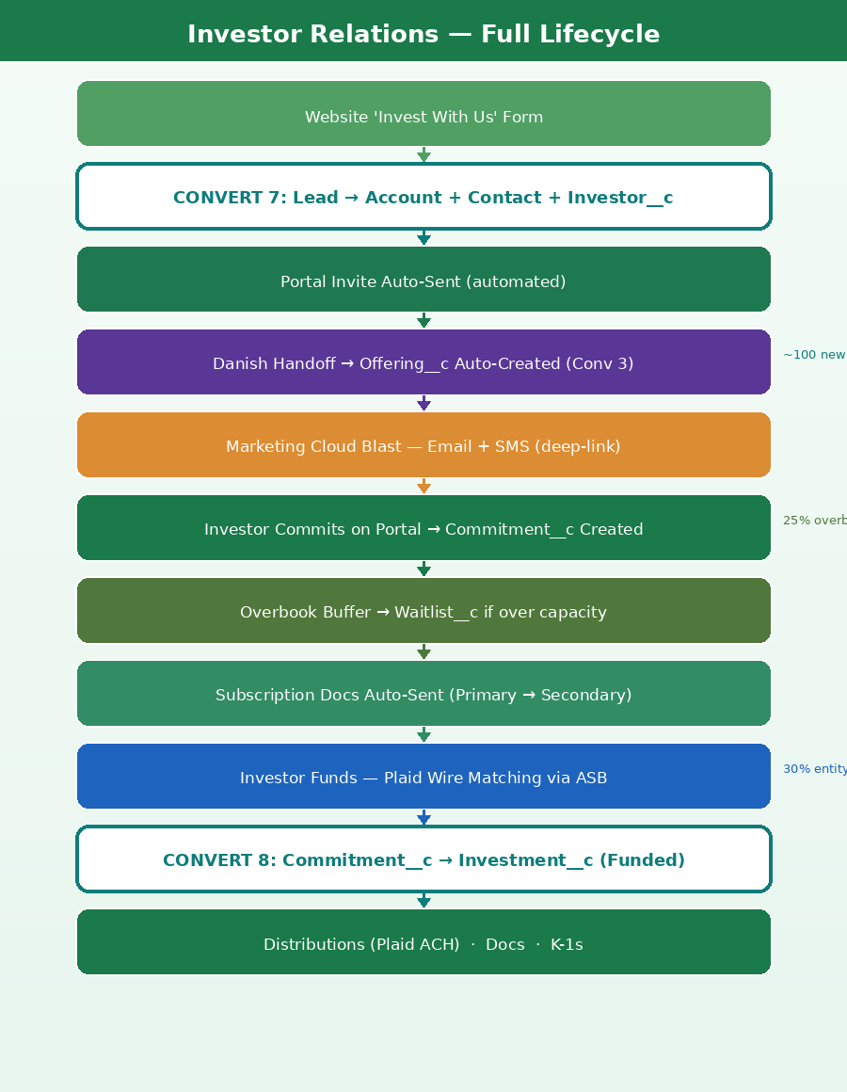
Figure 3: Investor Relations Full Lifecycle - Onboarding through Distributions

7.3 Investor Onboarding
Step | Action | Object | Automation vs AppFolio
1 | Investor submits website form | Lead (created via Web-to-Lead) | AppFolio: manual email to Faiz. Now: fully automated.
2 | Duplicate check | Lead — matching rules | Duplicate on email + phone; merge alert if exists
3 | Auto-conversion (Conversion 7) | Lead → Account + Contact + Investor__c | AppFolio: Faiz manually enters all data. Now: zero touchpoints.
4 | Investing entity setup | Account (Investing Entity) + Investing_Entity_Contact__c | Investor can add entity and signers via self-service portal task
5 | KYC / Accreditation | Contact.Accreditation_Status__c; document uploaded to SF Files | Investor uploads accreditation docs to portal. IR reviews and approves.
6 | Portal invite auto-sent | Contact → Experience Cloud user created | AppFolio: manual invite send. Now: auto-triggered on Investor__c creation.

7.4 Commitment Management & Waitlist
Step | Action | Automation
1 | Investor commits on portal | Commitment__c created; units counter on Offering__c decremented; real-time funding % updated
2 | Overbook buffer check | If Total_Committed > Target_Raise: commits go to Waitlist__c (default 25% buffer)
3 | Subscription docs auto-sent | Subscription_Doc__c created; e-signature sent to Primary Contact of Investing Entity
4 | Secondary signature | On Primary signature: doc auto-forwarded to Secondary signer (Investing_Entity_Contact__c.Signer_Role = Secondary)
5 | Both signed → Funding instructions | Subscription_Doc__c.Finalized = TRUE; auto-email with wiring instructions sent (entity name to use clearly specified)
6 | Cancellation → Waitlist promoted | If investor cancels: Commitment voided; top Waitlist__c position auto-promoted; subscription doc workflow restarts

7.5 Plaid Contribution Reconciliation
See Section 11 (Plaid Architecture) for full technical detail. Summary: when an investor wires funds, Plaid receives the transaction via webhook, matches it to the open Commitment__c using amount + entity name fuzzy matching, and triggers Conversion 8 when fully funded.

7.6 Distributions via Plaid
See Section 11. Summary: Faiz creates a distribution batch in Salesforce; principals approve; Plaid executes ACH to each investor's linked bank account. No platform cap; real-time ACH status tracking.

7.7 Document Management (IR)
See Section 12 for full detail. Summary: IR team uploads documents directly to Salesforce Files on the relevant Offering__c or Investment__c record. Portal automatically exposes these files to the relevant investors. No OneDrive integration required.

9. IR: Share Transfer Functionality

Share Transfer (also called Investment Transfer or Unit Transfer) allows an existing investor to transfer all or part of their investment units in a specific offering to another investor. This replicates a capability found in SponsorCloud and similar platforms. The IR team manages and approves all transfers.

8.1 Business Context
- An investor may need to transfer their units due to estate planning, ownership structure changes, or a private sale of their interest.
- DPEG must approve all transfers — investors cannot transfer without IR and principal consent.
- Partial transfers (e.g., transferring 50 of 100 units) must be supported.
- The transferring investor (Transferor) and receiving investor (Transferee) both need updated records in Salesforce and updated portal access.
- All financial history (original contribution amount, cost basis) must be preserved for tax purposes.

8.2 Share Transfer Objects
Object | Type | Key Fields | Purpose
Share_Transfer__c | Custom | Transferor_Investment__c, Transferee_Account__c (Investing Entity), Units_Transferred__c, Transfer_Amount__c, Transfer_Date__c, Status__c, Approval_Status__c, Transfer_Type__c (Full/Partial) | Master record for the transfer request
Transfer_Document__c | Custom | Share_Transfer__c, Document_Type__c (Transfer Agreement/Assignment), Signed_Date__c, SF_File_ID__c | Legal documents for the transfer — uploaded to Salesforce Files
Investment__c (Transferor) | Updated | Amount_Funded__c reduced, Units__c reduced, Status__c may → Partially Transferred or Fully Transferred | Transferor's investment record is updated
Investment__c (Transferee) | New or Updated | New Investment__c created for transferee at new investing entity; Amount_Funded__c, Units__c, Transfer_Source__c populated | New investment record for the receiving party

8.3 Share Transfer Workflow
Step | Action | Object / Trigger
1 | IR team creates Share_Transfer__c record (Transferor Investment, Transferee entity, units, date) | Share_Transfer__c created; validation rules fire
2 | System validates: Transferee Account exists; units ≤ available; Offering__c.Transfers_Permitted__c = TRUE | Validation Rules on Share_Transfer__c
3 | Transfer Agreement auto-generated and uploaded to Salesforce Files on the Share_Transfer__c record | Flow creates Transfer_Document__c; SF Files ContentDocument
4 | E-signature sent to Transferor's primary Contact; on signature, forwarded to Transferee's primary Contact | Flow triggers e-signature; Subscription_Doc pattern
5 | Both signatures received → Approval Process triggered: Faiz (IR Manager) reviews | Approval Process: IR Manager required; Principal if amount > threshold
6 | Rejected: Share_Transfer__c Status = Rejected; both parties notified | Record-Triggered Flow on Approval Rejection
7 | Approved: CONVERSION 9 executes — Transferor Investment__c updated (units reduced); new Investment__c created for Transferee | Flow + Apex on Approval Approval
8 | Share_Transfer__c Status = Completed; both parties notified via portal notification and email | Record-Triggered Flow on status change

8.4 Object Conversion in Share Transfer

Conversion 9: Investment__c (Transferor) → Updated Investment__c + New Investment__c (Transferee)
OBJECT CONVERSION: Investment__c (Transferor — approved transfer) → Investment__c (Transferor updated) + Investment__c (Transferee — new) | On transfer approval: the Transferor's Investment__c has Units__c and Amount_Funded__c reduced by the transferred amount. A new Investment__c is created for the Transferee's Investing Entity with Units__c and Amount_Funded__c equal to the transferred amount. Transfer_Source__c on the new record links back to the Share_Transfer__c for audit trail.

8.5 Key Business Rules
Rule | Logic | Enforcement
Transferee must be an existing investor or be onboarded first | Transferee_Account__c must exist as an Investing Entity in SF; if not, IR onboards them first (Conversion 7) | Validation rule on Share_Transfer__c
Partial transfer minimum | Minimum transfer: 1 unit or $50,000 (matches min investment threshold) | Validation rule: Units_Transferred__c >= 1 AND Transfer_Amount__c >= 50000
Offering must permit transfers | Offering__c.Transfers_Permitted__c must = TRUE | Validation rule on Share_Transfer__c creation
Tax cost basis preserved | Original_Cost_Basis__c on new Investment__c = pro-rata share of Transferor's original amount | Flow calculates and populates on transfer execution
Historical distributions unaffected | Past Distribution__c records remain linked to Transferor; only future distributions route to Transferee | No change to existing Distribution__c records; new distributions use new Investment__c
Transfer document required | Share_Transfer__c cannot move to Approved status without at least one signed Transfer_Document__c | Approval Process entry criterion check
Audit trail | Share_Transfer__c links to both old and new Investment__c records; complete history preserved | Transfer_Source__c and Transferred_From__c fields on Investment__c

8.6 Portal Experience for Transferee
- Once the new Investment__c is created, the Transferee's portal automatically shows the new investment under 'My Investments'.
- Future Distribution__c records are auto-linked to the new Investment__c → Transferee receives distributions directly.
- All future IR_Document__c records (reports, K-1) for the offering are shared with the Transferee via Experience Cloud sharing rules.
- The Transferee receives a portal notification: 'A new investment has been transferred to you from [Offering Name].'

10. Data Model & Entity Relationship Diagram

The complete DPEG data model spans four interconnected modules. The core lifecycle flows from Lead → Opportunity → Transaction__c → Property_Asset__c. The IR module runs in parallel: Lead → Account/Contact/Investor__c → Offering__c → Commitment__c → Investment__c → Distribution__c.

9.1 Entity Relationship Diagram
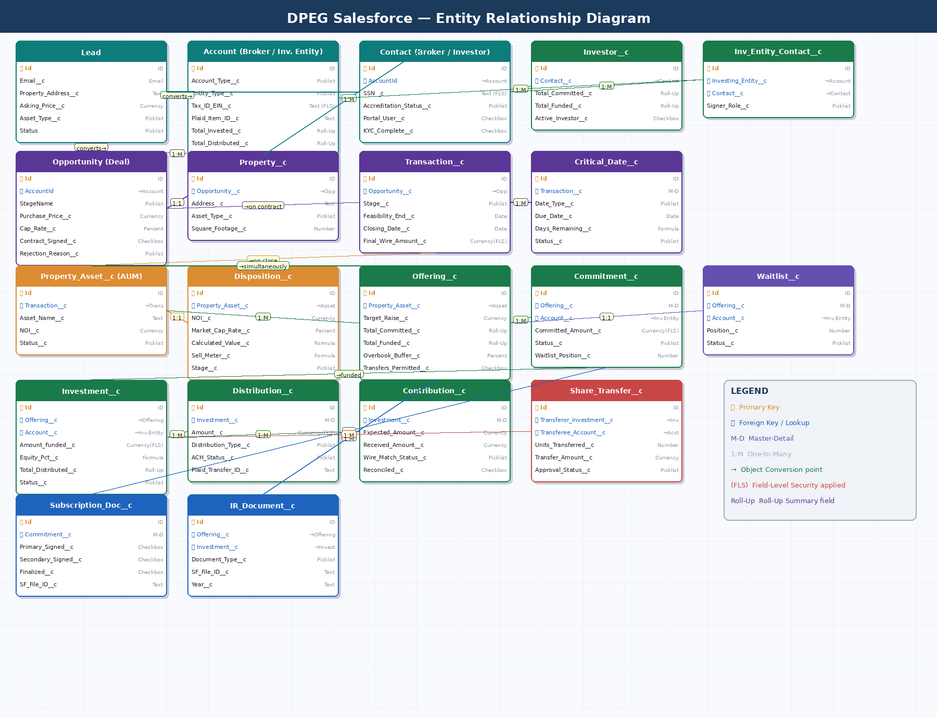
Figure 4: DPEG Complete Entity Relationship Diagram - All Objects, Relationships and Key Fields

9.2 All Conversion Points Summary
# | From | To | Trigger | Section
1 | Lead | Opportunity + Account (Broker Firm) + Contact (Broker Person) | Junior converts qualified lead | Sec 4
2 | Opportunity (Under Contract) | Transaction__c | Contract_Signed__c = TRUE — auto-Flow | Sec 4
3 | Opportunity (Under Contract) | Offering__c (IR) | Same trigger as #2 — simultaneous Flow | Sec 4
4 | Transaction__c (Closed Won) | Property_Asset__c (AUM) | Closing confirmed — auto-Flow | Sec 5
5 | Property_Asset__c | Disposition__c | Principal decision to sell | Sec 6
6 | Disposition__c (Closed) | Property_Asset__c status = Disposed | Sale closing confirmed | Sec 6
7 | Lead (IR form) | Account + Contact + Investor__c | Web-to-Lead auto-conversion Flow | Sec 7
8 | Commitment__c (Funded) | Investment__c | Plaid confirms full amount reconciled | Sec 7
9 | Investment__c (Transfer approved) | Updated Investment__c + New Investment__c | Approval Process approval | Sec 8

11. Workflow Automation & Lifecycle

All automation is built using Salesforce Flow (Record-Triggered, Scheduled, Screen Flows) supplemented by Apex classes for complex logic. No Process Builder is used.

10.1 Master Automation Inventory
Automation | Module | Trigger | Tool
Email-to-Lead (broker deals) | Acq | Inbound email to acquisitions@dpeg.com | Email-to-Lead + Flow
Broker dedup alert | Acq | Lead created with same broker + property | Duplicate Rule + Flow
Deal inactivity alert (7 days) | Acq | 7 days no activity on Lead/Opp | Scheduled Flow
Contract handoff → Transaction + Offering | Acq → Trans + IR | Contract_Signed__c = TRUE | Record-Triggered Flow
Transaction task auto-generate | Trans | Transaction__c created | Record-Triggered Flow
Critical date alerts (multi-threshold) | Trans | Daily — Days_Remaining__c formula | Scheduled Flow
Property_Asset__c create on closing | Trans | Transaction stage = Closed Won | Record-Triggered Flow
Sell Meter recalculate | Disp | NOI__c or Market_Cap_Rate__c changed | Record-Triggered Flow
BOV comparison auto-report | Disp | 3rd BOV_Response__c received | Record-Triggered Flow
Web-to-Lead investor form | IR | Website form submit | Web-to-Lead
IR Lead auto-conversion (Conversion 7) | IR | Lead created (IR source) | Record-Triggered Flow + Apex
Offering launch campaign | IR | Offering__c.Launch_Date__c reached | Scheduled Flow + Marketing Cloud
Commitment auto-create (portal) | IR | Portal form submit | Experience Cloud + Flow
Waitlist management | IR | Total committed > offering target + buffer | Record-Triggered Flow
Subscription doc dispatch | IR | Commitment__c status = Committed | Flow + e-signature tool
Secondary signature forward | IR | Primary_Signed__c = TRUE | Record-Triggered Flow
Plaid contribution reconcile | IR | Plaid webhook received | ASB plaid-wire-matcher → SF REST API
Investment__c create (Conversion 8) | IR | Contribution fully reconciled | Apex trigger
Distribution batch Plaid ACH | IR | Batch approved | Flow + Apex + Plaid API
Distribution notification to investor | IR | Distribution ACH_Status = Completed | Record-Triggered Flow
Document published to portal | IR | IR_Document__c created | Record-Triggered Flow
Share transfer validation + approval | IR | Share_Transfer__c created | Approval Process + Flow
Share transfer execution (Conversion 9) | IR | Transfer approval granted | Flow + Apex
K-1 auto-distribute | IR | Annual scheduled (January) | Scheduled Flow

12. Financial Integration — Plaid Architecture

Plaid is chosen as the universal bank integration layer for all contribution (inbound) and distribution (outbound) financial flows. The key advantage is that Plaid works with virtually all US financial institutions through a single, standardised API — meaning DPEG never needs to reconfigure or add new code when switching banks, opening new project-specific bank accounts, or when investors use different banks.

12.1 Why Plaid Instead of Direct Bank APIs
Criterion | Direct Bank APIs (JPMorgan/BofA/Wells Fargo) | Plaid (Recommended)
Bank coverage | One integration per bank — must reconfigure for each bank DPEG or investors use | 2,000+ US financial institutions through one API — any bank works immediately
Setup per new bank | Full API onboarding: bank agreement, OAuth setup, credential management, testing | Zero reconfiguration — new bank accounts work instantly through Plaid Link
Investor bank linking | Investors must use only the banks DPEG has integrated | Investors link any bank via Plaid Link (embedded UI) — industry-standard experience
ACH origination | Direct NACHA-formatted ACH via bank's proprietary API | Plaid Transfer API — standardised ACH origination across all banks
Contribution tracking | Requires webhook from each bank separately | Single Plaid webhook endpoint receives events from all connected accounts
Wire matching | Per-bank implementation; custom for each bank's payload format | Standardised Plaid transaction payload — one matching engine works for all
Maintenance burden | High — each bank's API may change independently; separate credentials to rotate | Low — Plaid manages bank connectivity; single credential set for DPEG
Cost | Negotiated per bank; ACH costs vary | Plaid Transfer: ~$0.25–$1.50 per ACH; bulk discounts available

12.2 Plaid Product Usage
Plaid Product | Purpose | Used For
Plaid Link | Embedded bank account linking UI — investor connects their bank via secure OAuth flow | Investors link their bank accounts on the Experience Cloud portal during onboarding
Plaid Auth | Retrieve validated routing and account numbers for linked bank accounts | Populate bank account details on Investing_Entity__c for ACH initiation
Plaid Transfer | Initiate ACH credits (distributions) and ACH debits (contributions) programmatically | Outbound distributions to investors; inbound contribution collection
Plaid Transactions | Retrieve transaction history for connected accounts | Monitor DPEG's bank accounts for incoming wires; feed wire matching engine
Plaid Webhooks | Real-time event notifications for transaction status changes | Update Distribution__c.ACH_Status__c in real time; trigger wire matching on receipt
Plaid Identity | Verify account holder name against investing entity name | Automated entity name verification — reduces 30% mismatch rate

12.3 Contributions & Distributions — Plaid Flow
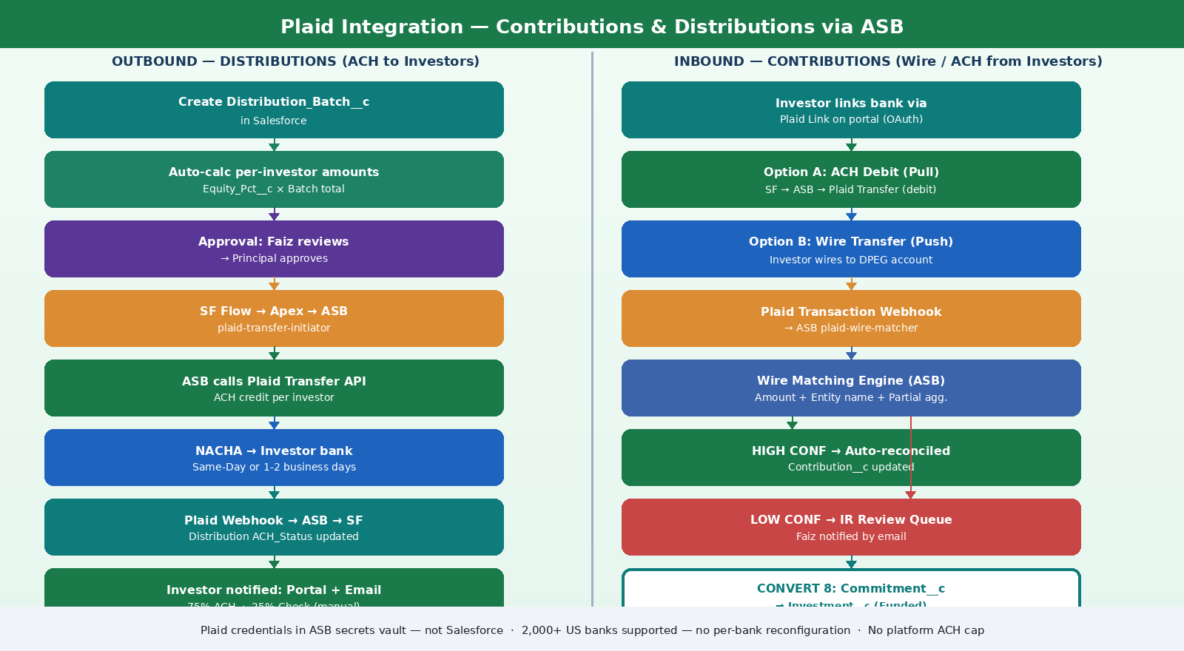
Figure 5: Plaid Financial Integration - Outbound Distributions and Inbound Contributions via ASB

12.5 Plaid Technical Implementation
Component | Implementation Detail
Plaid environment | Plaid Production for live transactions; Plaid Sandbox for all testing phases before go-live
ASB secrets vault | Plaid API keys (client_id, secret) stored exclusively in ASB secrets vault — not in Salesforce fields or Named Credentials
Salesforce Named Credential | SF holds a single Named Credential pointing to the ASB endpoint only — not to Plaid directly
ASB: plaid-transfer-initiator | ASB service that receives distribution batch payloads from Salesforce Apex, calls Plaid Transfer API per investor, returns transfer_id back to SF; stored on Distribution__c
ASB: plaid-wire-matcher | ASB service that receives Plaid transaction webhooks for incoming contributions; executes fuzzy entity name matching and partial wire aggregation; updates Salesforce Contribution__c via REST API
ASB: plaid-status-receiver | ASB service that receives Plaid transfer status webhooks (pending/posted/failed/returned); updates Distribution__c.ACH_Status__c in Salesforce via REST API
Investing_Entity__c fields | Plaid_Item_ID__c (reference to ASB-held token); Plaid_Account_ID__c; Bank_Name__c; Bank_Account_Last4__c (display only — no full number ever stored in SF)
Investor portal: bank linking | Plaid Link component embedded in Experience Cloud portal — investor completes OAuth flow; token stored in ASB; only the Item ID reference returned to SF
Adding new DPEG bank accounts | DPEG links new project bank account via Plaid Link in internal admin portal — zero Salesforce code change; ASB immediately recognises the new account
NOTE: If an investor does not link their bank via Plaid (approximately 25% currently use checks), the system generates a printable check request or initiates a manual ACH entry. Plaid handles the 75% ACH majority; checks are handled outside the system.

13. Document Management Strategy

Version 1.2 defines two distinct document storage strategies: (1) IR documents are uploaded directly to Salesforce Files and served to investors via the Experience Cloud portal — no external integration needed. (2) Other operational documents (transaction, legal, acquisitions) can optionally store OneDrive links in Salesforce as text fields — no OneDrive integration, no folder sync, no ASB connector required.

12.1 Document Storage by Module
Module | Document Types | Storage Approach | Investor Accessible?
IR — Investor Docs | PPM, subscription docs, K-1, quarterly reports, monthly statements, distribution notices | Salesforce Files (native) uploaded directly by IR team to Offering__c or Investment__c | Yes — via Experience Cloud portal
IR — Transfer Docs | Transfer Agreement, Assignment documents | Salesforce Files on Share_Transfer__c record | Yes — to transferor and transferee
Acquisitions | Offering memorandum, LOI, PSA, survey, leases, NDA | OneDrive link stored as Document_Link__c.OneDrive_URL__c (text field) — IR team pastes URL manually | No
Transaction | Executed contract, DD reports, loan package, closing statement, insurance | OneDrive link stored as Document_Link__c.OneDrive_URL__c (text field) — Danish pastes URL manually | No
Disposition | BOV packages, listing agreements, purchase agreement | OneDrive link stored on Disposition__c.Doc_Link__c (text field) | No

12.2 Salesforce Files for IR Documents
Salesforce Files (ContentDocument / ContentVersion) is the native document storage system. It is fully integrated with Experience Cloud portal sharing, requires no external integration, and is already included in the Salesforce licence.

How IR Team Uploads Documents
Step | Action | Object / Component
1 | IR team navigates to the relevant Offering__c or Investment__c record in Salesforce | Offering__c or Investment__c record page
2 | Clicks 'Upload Files' in the Files related list — standard Salesforce functionality | Salesforce Files component on page layout
3 | Selects file from their computer (PDF, Excel, Word, etc.) — uploads directly to Salesforce | ContentDocument created; ContentVersion with the file
4 | Tags the document: selects Document_Type__c (K-1, Report, Statement, PPM, etc.), Year__c, Period__c | IR_Document__c custom record auto-created by Flow on file upload
5 | Flow auto-creates IR_Document__c linking the ContentDocument to the Offering or Investment | IR_Document__c; ContentDocumentLink to Offering__c or Investment__c
6 | Experience Cloud portal automatically makes the file available to relevant investors | ContentDocumentLink shared via portal sharing rules
7 | Investor receives in-portal notification and email: 'New document available: [Document Name]' | Flow: Notification__c created; email sent to relevant Contact records

Investor Portal Document Access
- Investors log into the Experience Cloud portal and see a 'Documents' tab.
- Documents are filtered by their Account (Investing Entity) and the offerings they are invested in — they see only their own documents.
- Document types visible: K-1 (filtered by year), Quarterly Reports, Monthly Statements, Distribution Notices, Subscription Docs.
- Investors can download files directly from the portal — served from Salesforce Files.
- Large file support: Salesforce Files supports up to 2 GB per file.

12.3 Bulk Document Upload (300+ Monthly)
The IR team currently uploads 300+ documents manually per month across all active offerings. The bulk upload process in Salesforce is:
- IR team selects multiple files at once from their desktop (Ctrl+click) in the Files component — uploads in batch.
- Alternatively, IR team can use the Salesforce Bulk Upload page (custom Screen Flow) to tag all files for a specific Offering and document type at once.
- Flow auto-creates IR_Document__c records for each uploaded file.
- All documents for an offering are distributed to all investors in that offering simultaneously — no individual selection required.
NOTE: For K-1 documents which are per-investor (not per-offering), the IR team uploads each K-1 file to the specific Investment__c record for that investor. Flow tags it as Type = K-1 and Year = current year, and it appears in that investor's Documents tab only.

12.4 OneDrive: Links Only — No Integration
For non-IR documents (acquisitions, transactions, legal, disposition), the approach is:
- Files continue to live in OneDrive/SharePoint as they do today.
- When a document is relevant to a Salesforce record, the staff member copies the OneDrive sharing link and pastes it into the OneDrive_URL__c field on the relevant record (Document_Link__c, Transaction__c, Opportunity, etc.).
- Salesforce displays the link as a clickable URL — clicking opens the file in OneDrive/SharePoint in a new browser tab.
- No integration, no folder monitoring, no ASB connector, no Microsoft Graph API. Purely manual link management.
NOTE: This approach keeps implementation simple and avoids OneDrive integration complexity. If DPEG later decides to migrate all documents to Salesforce Files, this can be done as a future phase without redesigning the IR module.

14. Security, Access & Role Matrix

This section defines the Salesforce Profile and Permission structure for all DPEG users. Sensitive data protection — field-level security, masking formulas, Named Credentials, OWD and sharing rules — is fully specified in Section 3. Salesforce Shield is NOT used. All controls are native platform capabilities.

14.1 Profile & Permission Matrix
Profile | Users | Key Access | Restrictions
Acquisitions Rep | Junior | Lead, Opportunity, Property__c, Market_Data__c, Broker Account/Contact | No IR financial data; no Transaction stage changes; no investor sensitive fields
Transactions Lead | Danish | Transaction__c, Critical_Date__c, Vendor__c, Loan__c, Document_Link__c | Read-only on Acquisition Opportunities; no IR data; no investor financials
IR Manager | Faiz | All IR objects, Salesforce Files admin, Distribution batch approval, Share Transfer approval, SSN/EIN fields (FLS) | Cannot modify Transaction or Acquisition stage data
IR Associate | Simon | Investor__c, Account (Investing Entity), Contact, Commitment__c, IR_Document__c, Subscription_Doc__c | No distribution batch approval; no Share Transfer approval; no SSN/EIN/Tax ID fields
Finance / CFO | Ali | Disposition__c, Distribution__c (read), Plaid batch status, financial dashboards, Loan__c, Transaction financial fields | Read-only; cannot initiate or approve distributions
Principal | Nikil, Ali, Nick Sr. | All modules — dashboards, approval authority, executive views, masked financial summaries | Cannot permanently delete records; SSN/EIN masked to last 4 digits
Investor (Portal) | All investors | Own Account (Investing Entity), own Investment__c, own Distribution__c, own IR_Document__c, own Commitment__c — masked SSN/EIN on own record only | OWD Private — own records only; no other investor data ever visible
System Admin | Akber, Aftab (Avanza) | Full org during implementation; Named Credential management | Restricted post-go-live in Production; no direct data changes without change process

14.2 Sensitive Field Quick Reference
Full data protection configuration is defined in Section 3. The table below is a summary reference.
Field | Object | Native Protection | Visible To
SSN__c | Contact | FLS (IR Manager only) + masked formula field | IR Manager: full. Principals, investor (own): ***-**-XXXX
Tax_ID_EIN__c | Account | FLS (IR Manager + Finance) + masked display | IR Manager, Finance: full. Others: last 4 only
Plaid_Access_Token__c | Investing_Entity__c | Named Credential + FLS hidden from all UI profiles | Apex code only — no user ever sees this
Amount__c | Distribution__c | OWD Private + FLS (IR Manager, Finance, Principals) | Investors see own record amount via portal only
Amount_Funded__c | Investment__c | OWD Private + FLS (IR Manager, Finance, Principals) | Investors see own investment amount via portal only
Final_Wire_Amount__c | Transaction__c | FLS (Transaction Lead, Finance, Principals) | Hidden from IR, Acquisitions, PM profiles

14.3 Experience Cloud Portal Security
- OWD Private on all financial objects — investors access only their own records via Salesforce ownership and criteria-based sharing rules.
- Experience Cloud profile restricts object and field access to investor-relevant data only — all internal CRM records and fields are inaccessible from the portal.
- Salesforce Files served via ContentDocumentLink — investors can only download files explicitly linked to their Account or Investment records.
- Session timeout: 2 hours for portal users (configurable). Re-authentication required after timeout.
- Field History Tracking (native) enabled on: Investment__c, Distribution__c, Commitment__c, Share_Transfer__c, Transaction__c — all financial state changes logged.

15. Integration Architecture — Avanza Service Bus (ASB)

All external system integrations in the DPEG Salesforce platform are routed through the Avanza Service Bus (ASB) — Avanza's proprietary middleware and ETL platform. ASB acts as the central integration hub between Salesforce and all external systems, handling protocol translation, data transformation, error handling, retry logic, and event orchestration.
No direct peer-to-peer integrations are built between Salesforce and external systems. Every data flow passes through ASB, ensuring a consistent, auditable, and maintainable integration layer that DPEG does not need to manage individually.

15.1 What is the Avanza Service Bus (ASB)?
ASB is Avanza's managed integration platform deployed specifically for DPEG's implementation. It provides:
ASB Capability | Description
Protocol Adapter Layer | Translates between incompatible protocols — e.g., Yardi's SOAP/WSDL into REST JSON that Salesforce can consume via Apex callout
Data Transformation Engine | Maps and transforms field structures between source system schemas and Salesforce object schemas — no raw data passes directly
Event Bus / Message Queue | Asynchronous messaging ensures Salesforce is never directly coupled to external system availability; messages are queued and retried if a system is unavailable
Error Handling & DLQ | Failed messages routed to Dead Letter Queue (DLQ) with alerting to Avanza team; no silent failures
Retry Logic | Configurable retry policies per integration (e.g., Yardi: 3 retries with exponential backoff; Plaid webhooks: 5 retries)
Audit Logging | All integration events logged with timestamp, payload hash, source, destination, and status — retained for compliance and debugging
Secrets Management | External API credentials for all integrated systems stored and managed within ASB; Salesforce only holds a Named Credential to ASB itself
Scheduler | Timed integrations (Yardi nightly, CoStar weekly) managed by ASB scheduler — no Salesforce Scheduled Flows required for external data pulls

15.2 ASB Integration Architecture Diagram
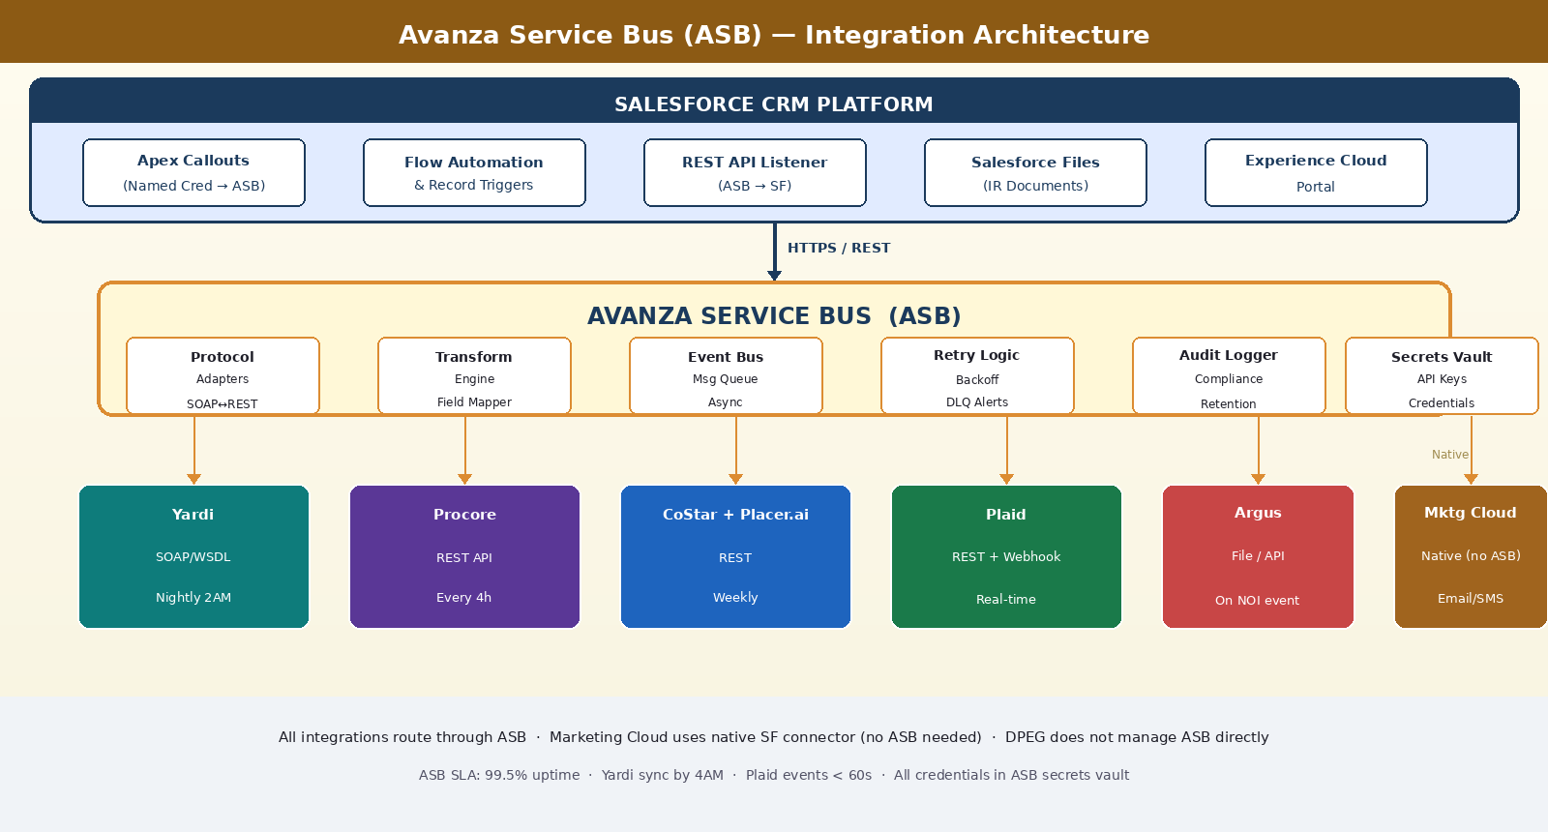
Figure 6: Avanza Service Bus (ASB) Architecture - Salesforce to External Systems via ASB Integration Hub

15.3 Integration Inventory
System | Protocol | Direction | ASB Handler | Trigger / Schedule | Fallback
Yardi | SOAP/WSDL | Inbound → SF | ASB SOAP Adapter → REST transform → SF REST API | Nightly 2:00 AM | CSV/SFTP export processed by ASB
Procore | REST API | Inbound → SF | ASB REST Connector → field map → SF REST API | Every 4 hours | Manual CSV upload via ASB file drop
CoStar | REST API | Inbound → SF | ASB REST Connector → Market_Data__c upsert | Weekly (Sunday midnight) | Manual data entry in SF
Placer.ai | REST API | Inbound → SF | ASB REST Connector → Market_Data__c visitor fields | Weekly (Sunday midnight) | Manual data entry in SF
Argus | File export / API | Inbound → SF | ASB file parser → Disposition__c NOI + IRR update | Event-driven on NOI file drop | Manual export + ASB file drop
Plaid | REST + Webhooks | Bidirectional | Outbound: SF Apex → ASB → Plaid Transfer API. Inbound: Plaid webhook → ASB → SF REST API update | Real-time (event-driven) | Manual ACH batch or check
Marketing Cloud | MC Connect (native) | Outbound from SF | Native SF Marketing Cloud Connect — does NOT route through ASB (native connector) | Event-triggered via Flow | Manual campaign send in MC
OneDrive | None | N/A | No integration — manual link entry only | Manual | N/A
NOTE: Marketing Cloud is the only integration that does NOT route through ASB. It uses Salesforce's native Marketing Cloud Connect (API-level connector built into Salesforce), which is the recommended approach and does not require middleware.

15.4 ASB Integration Details by System

15.4.1 Yardi → Salesforce (via ASB)
Item | Detail
ASB Handler | yardi-soap-adapter — polls Yardi SOAP endpoint using WSDL; transforms XML response to JSON; upserts to Salesforce via REST API
Data Synced | Property details (address, units, sq ft), Tenant records, Lease terms, NOI (Net Operating Income), occupancy rates
SF Objects Updated | Property_Asset__c, Tenant__c (custom), Lease__c (custom), Disposition__c.NOI__c
Trigger | ASB Scheduler: nightly 2:00 AM — full delta sync (changed records only)
Error Handling | Failed SOAP calls: 3 retries with 5-minute backoff; on final failure: DLQ alert to Avanza team + SF admin
Dependency | Yardi API module licensing must be confirmed by Shakeel with Yardi Account Manager. Fallback: CSV/SFTP export placed in ASB file drop zone

15.4.2 Procore → Salesforce (via ASB)
Item | Detail
ASB Handler | procore-rest-connector — polls Procore REST API for project updates; maps to Salesforce D&C project schema
Data Synced | Project milestone status, budget vs actual, % completion, change orders
SF Objects Updated | DC_Project__c (custom), linked to Property_Asset__c
Trigger | ASB Scheduler: every 4 hours
Error Handling | REST failures: 5 retries; DLQ alert on persistent failure

15.4.3 CoStar + Placer.ai → Salesforce (via ASB)
Item | Detail
ASB Handler | market-data-connector — calls CoStar REST API for cap rates and avg rent PSF; calls Placer.ai REST API for foot traffic and tenant rankings
Data Synced | Sub-market average rent PSF, market cap rate, visitor counts per day, top tenant rankings
SF Objects Updated | Market_Data__c (upserted by property sub-market + data date)
Trigger | ASB Scheduler: weekly Sunday midnight
Error Handling | API failures: 3 retries; if CoStar unavailable, last known data retained in SF with Data_Stale__c flag

15.4.4 Plaid (Bidirectional via ASB)
Item | Detail
Outbound (Distributions) | Salesforce Flow triggers Apex callout → ASB endpoint → ASB calls Plaid Transfer API → ACH initiated to investor bank
Inbound (Contributions) | Investor wire received → Plaid Transaction webhook fires → ASB receives webhook → Wire Matching Engine runs in ASB → Salesforce Contribution__c updated via REST API
ASB Plaid Handlers | plaid-transfer-initiator (outbound); plaid-wire-matcher (inbound contribution reconciliation)
Plaid Credentials | Stored in ASB secrets vault — not in Salesforce. SF holds only a Named Credential to the ASB endpoint
Status Updates | Plaid webhook status events (pending/posted/failed/returned) → ASB → SF Distribution__c.ACH_Status__c update
Error Handling | Transfer failures: ASB alerts IR Manager (Faiz) via email; Distribution__c.ACH_Status__c = Failed; retry available via manual re-trigger in SF

15.5 ASB Deployment & Management
Aspect | Detail
Hosting | ASB hosted and managed by Avanza on cloud infrastructure — DPEG does not manage servers or ASB configuration directly
Monitoring | Avanza team monitors ASB health, DLQ alerts, and integration failures; DPEG receives executive-level integration health dashboard in Salesforce
Credentials Rotation | All external API credentials (Yardi, CoStar, Placer.ai, Plaid) rotated in ASB without any Salesforce code changes
Adding New Integrations | New external systems onboarded by Avanza team adding an ASB connector — zero Salesforce code changes required for basic data sync integrations
SLA | ASB uptime SLA: 99.5% availability; nightly Yardi sync completed by 4:00 AM or alert issued; real-time Plaid events processed within 60 seconds
DPEG Access | DPEG team accesses integration status via a read-only ASB monitoring dashboard; Avanza team handles all configuration and troubleshooting

16. Implementation Roadmap

Phase | Duration | Modules | Key Deliverables
Phase 1 | Weeks 1–8 | Acquisitions + Transaction | Lead pipeline, broker Account/Contact model, Conversion 1 & 2 automation, Transaction tasks, critical date alerts
Phase 2 | Weeks 9–16 | Disposition + Property Mgmt | Disposition object, Sell Meter, BOV tracker, Property_Asset__c lifecycle, Yardi ASB connector (or CSV fallback)
Phase 3 | Weeks 17–26 | Investor Relations (core) | IR 4-object model, Experience Cloud portal, Web-to-Lead Conversion 7, commitment + waitlist, Subscription docs, SF Files document upload
Phase 4 | Weeks 27–34 | Plaid + Share Transfer | Plaid Link integration, Transfer API for distributions, Wire Matching Engine (Conversion 8), Share Transfer module (Conversion 9)
Phase 5 | Weeks 35–38 | UAT + Go-Live | UAT with Faiz, Danish, Junior; parallel run; AppFolio data migration to SF; go-live cutover

15.1 Open Items & Dependencies
Item | Owner | Dependency | Impact if Delayed
Plaid account linking setup | Faiz + Ali (CFO) | DPEG connects DPEG bank accounts to Plaid; Plaid production access approved | Phase 4 ACH distributions delayed; manual payments continue
Yardi API module licensing | Shakeel | Yardi Account Manager outreach | Phase 2 PM integration falls back to CSV/SFTP
AppFolio investor data export | Faiz | AppFolio export (investors, investments, historical docs) before go-live | Historical investor data not migrated
Marketing Cloud sending domain | Natalie (Marketing) | DKIM/SPF DNS config for investor email blasts | Launch blasts not deliverable at go-live
Experience Cloud branding assets | Faiz | DPEG brand guidelines, logo, colours for portal | Portal launches without DPEG branding
Offerings Transfers_Permitted field confirmation | Faiz | Faiz to confirm which offering types allow share transfers | Share transfer module cannot be configured without this policy

— End of Document —
Dhanani Private Equity Group | Salesforce CRM Implementation | Avanza Solutions | Confidential | v1.3

