# smiu

# Name: Haris Khalid ID: CSC-21F-038

# Name:Abdul Basit ID: CSC-21F-030 Course: Digital Image Processing

# YOLOv7

YOLOv7 stands for “You only look once”, it is used for the realtime object detection. It is designed to detect and classify objects in images or video frames with high accuracy while maintaining fast speed. Which makes it suitable for the real-time applications.

The main features of YOLOv7 are:

* Single Stage Architecture
* Training Enhancement
* Real-time performance

Advantages of the YOLOv7:

YOLOv7 is primarily known for its speed. Which allows to process the speed in real time. The main reason of this speed is the single stage architecture.

YOLOv7 can achieve high accuracy in the object detection.

**How to use it?**

YOLOv7 can be downloaded from the github repository, after doing some configurations like installing libraries, activating the YOLOv7. And choosing the model to be used from the YOLOv7. We can run the following command to start the object detection in image/video/webcam.

*python detect.py --weight yolov7.pt --conf 0.4 --img-size 640 --source 0.jpg*

The output of the above command is:



**Comparative study of Faster R-CNN and YOLOv7**

Faster R-CNN is considered to be slower than YOLOv7 mainly due to its architecture. Because Faster R-CNN has Two layer architecture. And YOLOv7 has One layer architecture, which makes it significantly faster than the Faster R-CNN

**Architecture of Faster R-CNN**

In the first layer of the Faster R-CNN we identify the region of the interest and then passes these interested regions to the Convolutional Neural Network. The outputted feature are then passed to a support vector machine (SVM) for the classification of object detected.

And lastly, to find the exact location of an object via box we use region based system. To find the location of the image we divide the entire image into the small blocks instead of the grid system. Which can be computationally expensive because to find the location of object in an image it takes nearly 47 seconds to convert. Which is not efficient solution for huge dataset.

**Architecture of YOLOv7**

YOLOv7 follows the single-stage object detection architecture where the entire image is processed in a single pass through the neural network. It allows the object detection in real-time.

YOLOv7 fixed most of the problems from the Faster R-CNN. Which is that it detects the location of object in an image via the box in the real-time. The main reason behind that is YOLOv7 converts the image into the grid

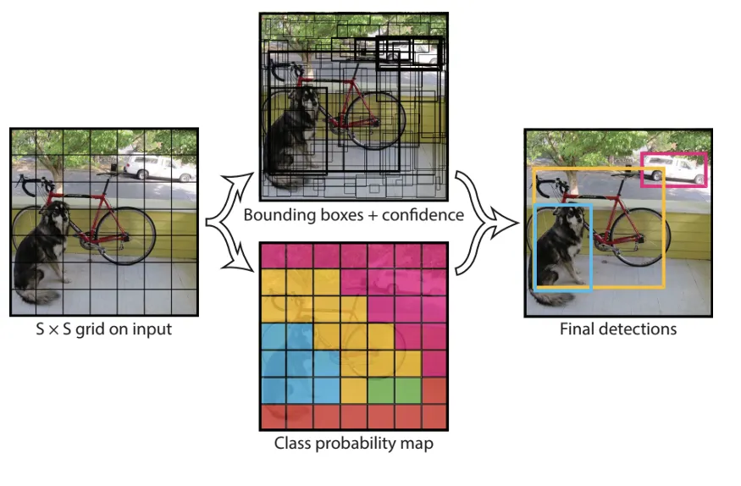

The limitation of YOLO algorithm is that it struggles with small objects in the image. The algorithm might not be able to detect very small objects in the image.