**Robustness-diagram-v1.0**

**ΟΝΟΜΑ ΑΜ**

ΕΒΕΛΙΝΑ ΣΕΝΗ 1080416

ΛΟΥΚΑΣ-ΑΛΕΞΙΟΣ ΧΡΗΣΤΙΔΗΣ 1090049

ΔΗΜΗΤΡΙΟΣ ΕΥΘΥΜΑΚΗΣ 1090054

ΜΙΛΤΙΑΔΗΣ-ΑΓΓΕΛΟΣ ΚΟΥΡΑΚΟΣ 1084621

ΧΑΡΑΛΑΜΠΟΣ ΚΩΝΣΤΑΝΤΑΚΟΠΟΥΛΟΣ 1090059

**Use case 1 (Edit Tenant)**

**Use case 2 (Upload Receipts)**

**Use case 3 (Create poll)**

**Use case 4 (Visit  Marketplace)**

**Use case 5 (Add announcement)**

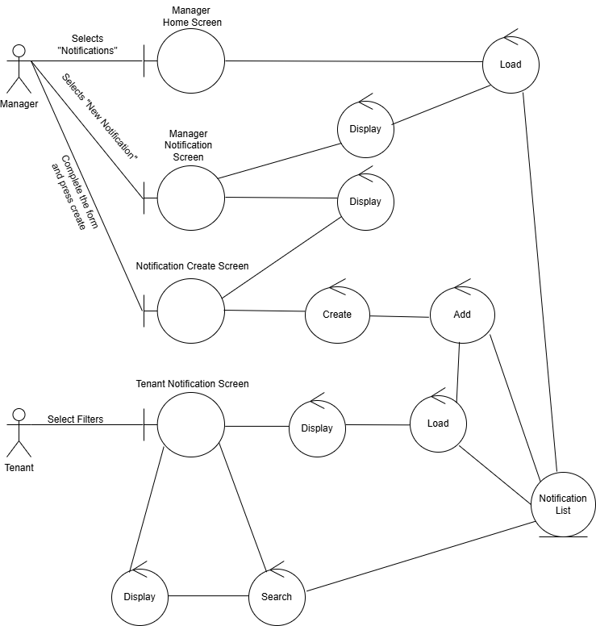

**Use case 6 (Add complaint)**

**Use case 7 (Add Maintenance)**

**Use case 8 (Payment)**

**Use case 9 (Shared Space Management)**

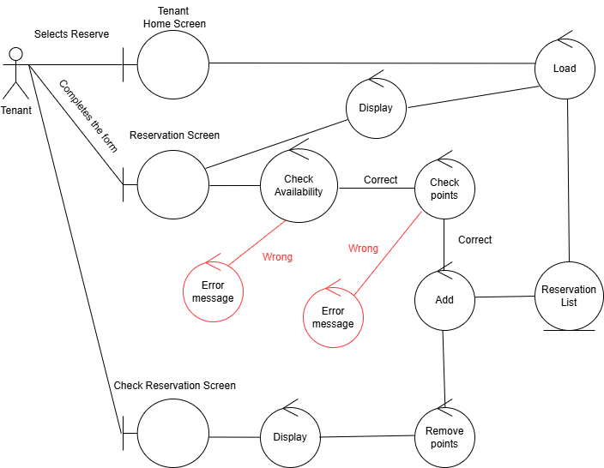

**Use case 10 (Lost & Found)**

Τα διαγράμματα δημιουργήθηκαν με το εργαλείο draw.io