C Tutorial

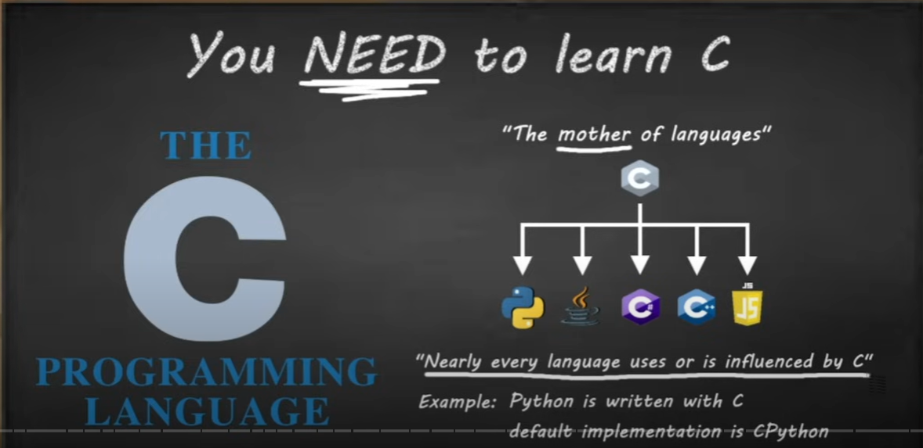
C is a middle level language. Middle level languages use less memory, are incredibly fast, but require more technical expertise to write code in. This is because the programmer has greater control over the machine’s resources in a middle level language.
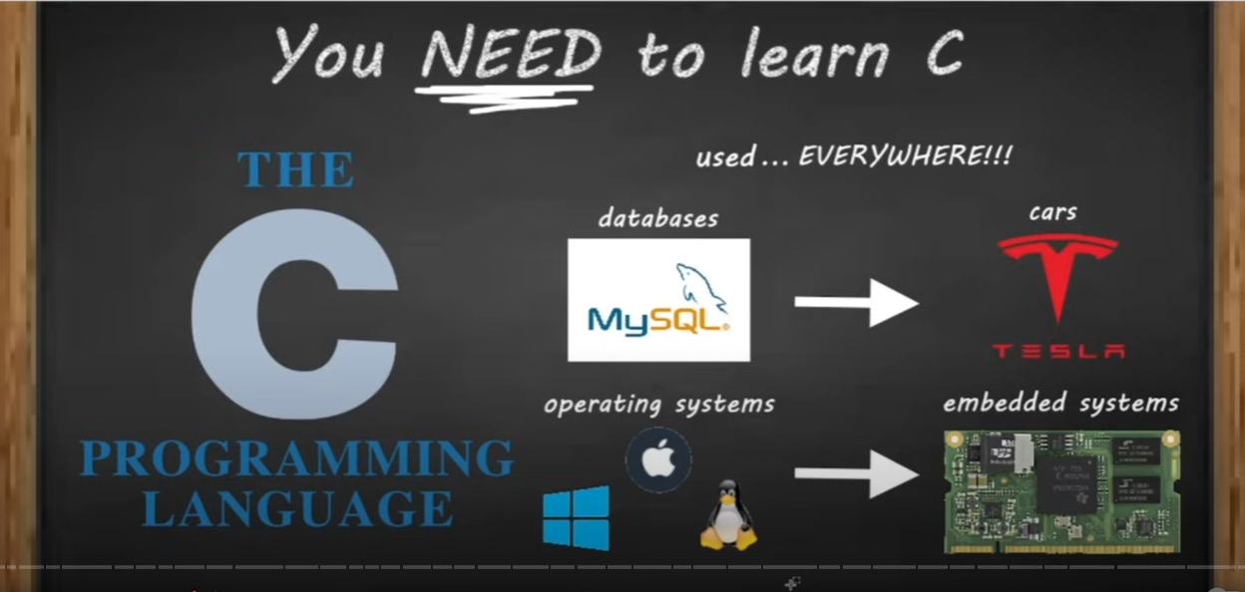
C is a multipurpose language used for a wide range of applications in the tech industry.
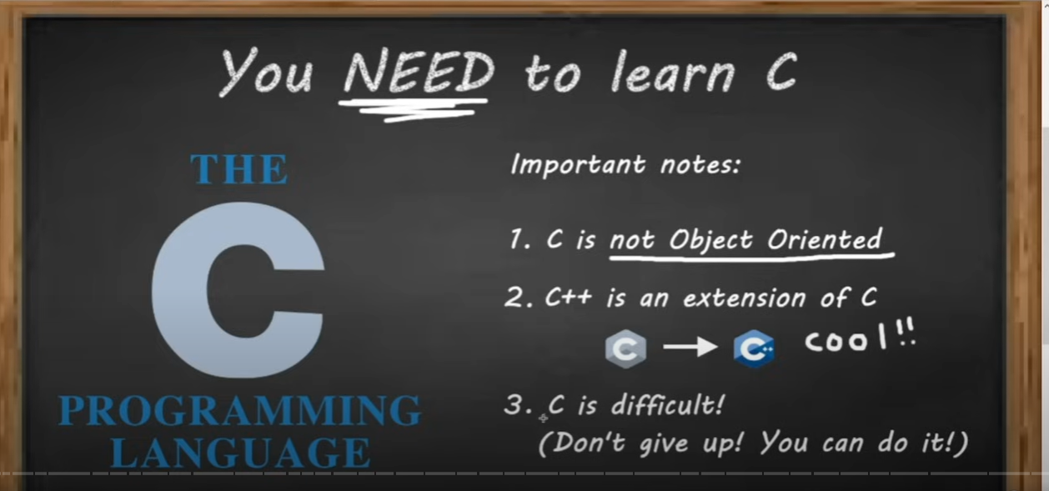
C is a procedural language. There’s no OOP functionality build in. For OOP, you can learn C++.
As C is a procedural language, all the code is written within functions. There is NO reserve word to declare a function in C. You simply declare the return type of your function, then add (){} brackets after your function’s name.
int main() {
return 0;
}
The main function should always be an integer type and return 0 by default. This is because if the main function exits with an error, the error code will be 1.

