Data structures in computer programming

Source of lecture: https://www.youtube.com/watch?v=RBSGKlAvoiM&t=1148
Source code on Github: https://github.com/williamfiset/Algorithms

Diagram of different data structures from GeeksforGeeks:

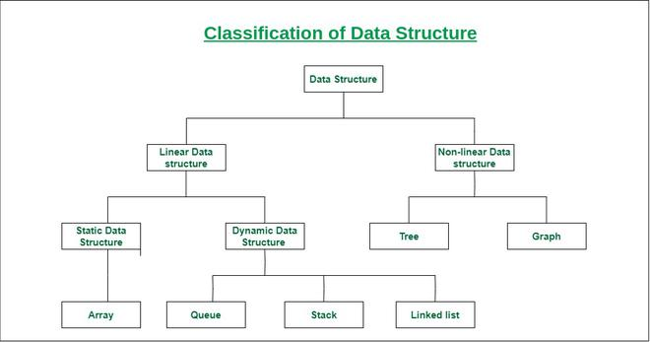
Figure 1:

Linear data structures:

1. Static arrays

- It is a fixed length container, containing n number of elements that are indexed from 0 to n-1.
- Indexable means each element in the array can be referenced with a number.
- Static arrays are contiguous chunks of memory – All memory addresses for elements in an array are adjacent to each other.
- Static array’s size immutable! Cannot insert, append or delete elements from it. Arrays in Python and JS are dynamic, not static, as the length of the array can be changed.
- Common uses for static arrays:
- - Storing and accessing sequential data
- - Temporarily storing objects
- - Used by IO routines as buffers.
- - Look-up tables.
- - To return multiple values from a function.
- - Used in dynamic programming to cache answers to subproblems.

2. Dynamic arrays

- Does everything a static array can, but can be resized.

3. Singly and doubly linked lists

What is a linked list?
A linked list is a sequential list of nodes that hold data, which point to other nodes also containing data. The last node in a linked list points to null. Each element in the linked list is not at contiguous memory locations. Therefore, pointers are needed to connect the memory location of one element in a linked list to another.

Common uses of linked lists:
- Used in list, queue and stack implementations.
- Great for creating circular lists, where the last node points to the first node.
- Can easily model real-world objects, such as trains.
- Used in separate chaining, in certain hash table implementations to deal with hashing collisions.
- Often used in the implementation of adjacency lists for graphs.

Terminology:

Head: The first node in a linked list.
Tail: The last node in a linked list.
Pointer: Reference to another node.
Node: An object containing data and pointer(s).

Difference between singly and double linked lists:

- Singly linked lists contain nodes that only hold a reference for the next node.
- In doubly linked lists, each node contains a reference to the previous and the next node. This allows for additions and deletions from both ends of the list.

Pros and cons of each:

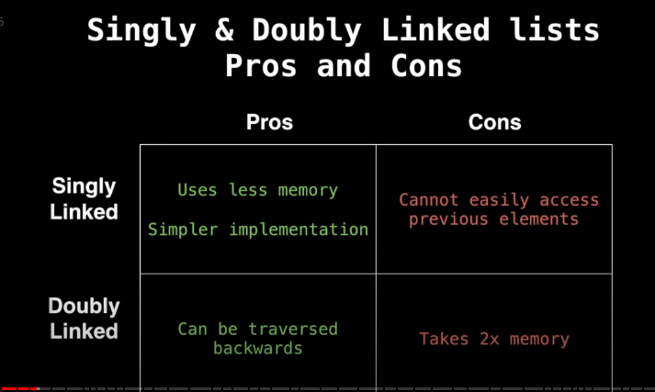
Figure 2:

- Creating a reference uses 8 bytes of memory in a 64-bit machine, and 4 bytes in a 32-bit machine.

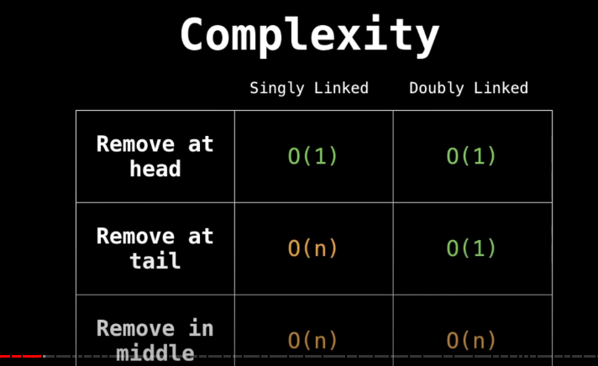
Figure 3:

Difference between dynamic arrays and linked lists:
- In dynamic arrays, the append() and pop() functions have O(1) complexity. But, adding to the front of the list is O(n). This is because each element needs to be shifted to a different index position in the contiguous memory slot.
- In linked lists, append(), pop(), shift() and unshift() have time complexity of O(1). As all the nodes are stored in separate memory locations, elements in the middle don’t need to be altered, as long as the pointers are adjusted correctly.

4. Stacks

- Create a stack of elements following the principle of last-in first-out.

5. Queues

- - Data structure following the principle of first-in first-out.
- - This means that enqueueing elements are added to the back of the stack, which dequeuing elements are removed from the front.
- - Breadth first search (BFS) is an example of a queue.
- - In terms of code, create a singly or a doubly linked list (for eg). Queues implement a FiFo system, so the head needs to be changed to the next node in the linked list every time an element is popped.
- - Can create other attributes for the queue data structure to obtain the length of the queue, ‘peek’ all the elements in the queue, etc.

6. Priority queues

- These are similar to normal queues, but each element has a relative priority associated with it, which can be used to order the elements in the queue based on priority. For Pqs to work, the nodes must contain comparable data. So, they can be ordered from lowest to greatest, for example. Even through PQ is an abstract data type (ADT), ie, it can be implemented in other data structures, its most common application is in the form of heaps.
- What is a heap? It is a tree-based data structure that satisfies the heap property: If A is a parent node to B, then A is ordered with respect to B for all nodes A, B in the heap.
- There are two types of heaps: Min heap and max heap.
- A min heap is where the parent node is the smallest value, and each child node in tree has increasing value, such that B>=A.
- A max heap is where the parent node has the highest value in the heap, and each child node satisfies the condition B<=A.
- Min and max heaps are binary trees (each parent has two child nodes).
- ALL heaps must be trees! Cannot contain a circular path for nodes to be connected, ie, can’t be a graph.
- Use cases for PQ heaps:
- Dijkstra’s shortest path algorithm.
- When you need to dynamically fetch next best or next worst element.
- Best first search algorithms to continuously grab the next most promising node.
- Used by minimum spanning tree algorithms.

Complexity of PQ heaps:

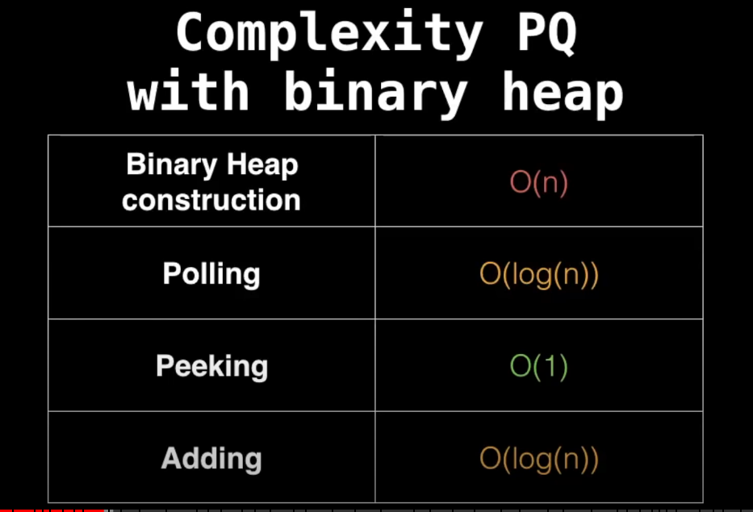

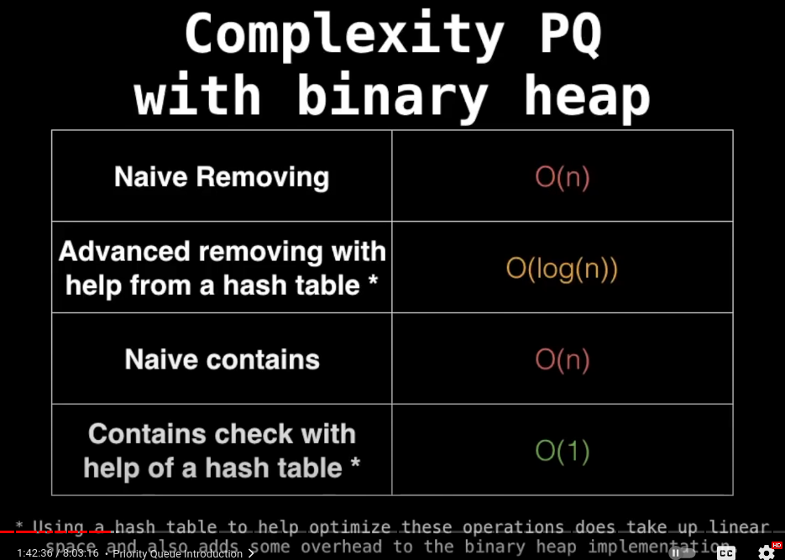

Turning min PQ inro a max pq

For numbers: Negate the numbers that are either in a min heap or max heap. This will reverse the order of the numbers and convert a min heap into a max heap or vice versa. For example: [1,2,3,4,5] is a min heap with 1 as the parent node. Negating the numbers will create [-1,-2,-3,-4,-5]. Now, -5 is the lowest number so the min heap will rearrange to have 5 as the parent node. Then, negate the numbers again, and you have achieved a max heap.
For strings:
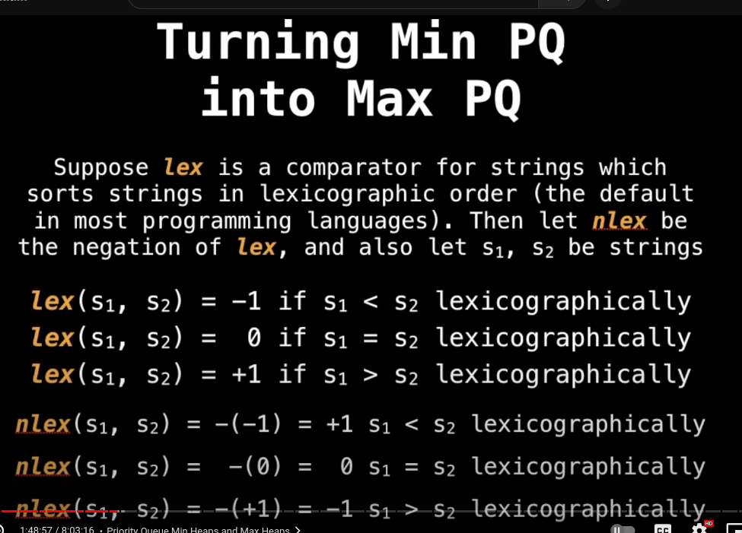
Figure:

Further explanation on what is a binary heap:
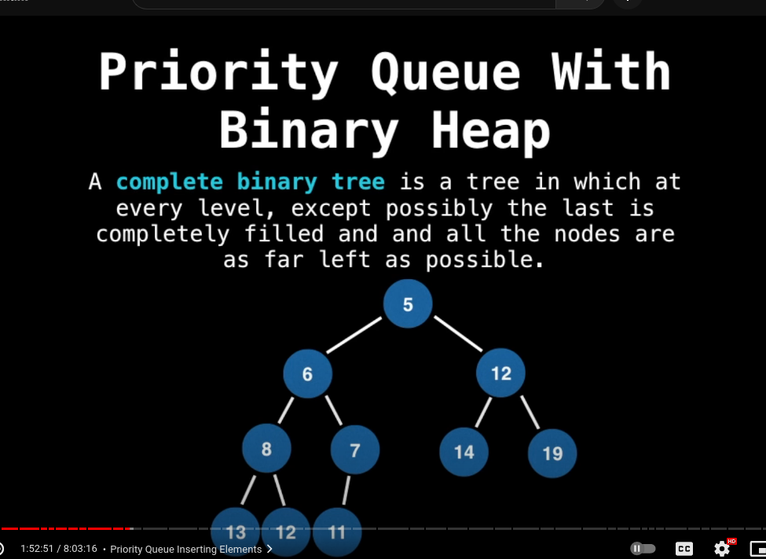
The advantage of always inserting to the left-most node and filling out the levels of a binary tree is that it makes it easy to track where the next insertion point in going to be. Cannot move to the next level in the tree, until the previous level is completely filled with nodes.
This makes is each to represent binary heaps as arrays, where if the parent node index is i , then the child nodes’ indices will be 2i+1 and 2i+2 in the representative array.
Adding elements to a heap: Add the element at the next insertion point and ‘bubble up’. This is the process of comparing the child node to the parent node and if the heap condition is not satisfied, then the parent and child nodes are switched, until the heap condition is met.

