Java Tutorial

Video used for learning:
https://www.youtube.com/watch?v=xk4_1vDrzzo&t=1276s

Chapter 1: Introduction
Topics covered:

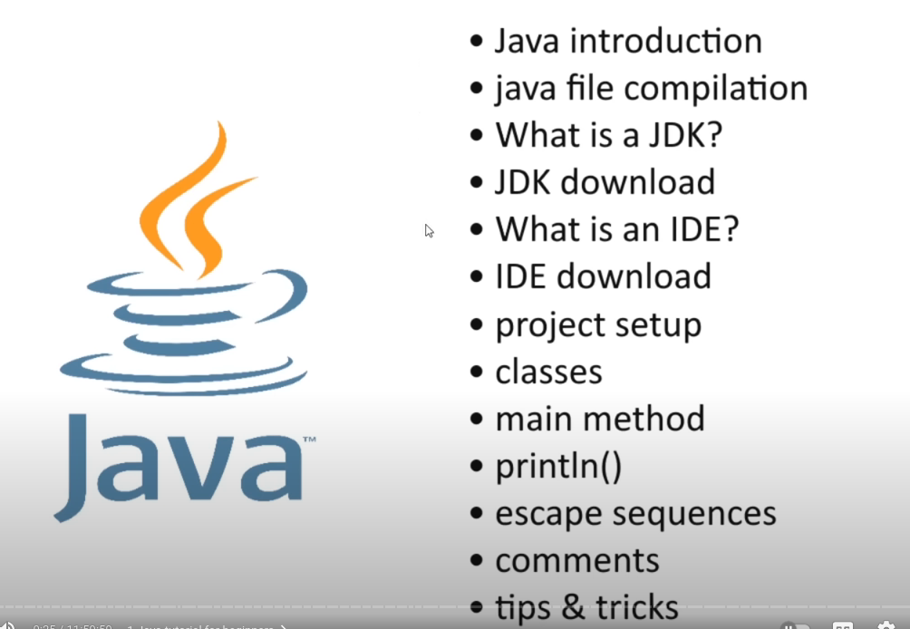
Reasons for learning Java:
1. As of 2024, it is still one of the most popular languages utilised in a variety of industries.
2. Its flexible with a wide range of applications (businesses, web apps, android apps and games).
3. Easy to find a developer job requiring Java.

- Java is a compiled language. But, rather than being complied into machine code, it gets compiled into byte code. The advantage of this is that compiled java code can be run on any machine (mac, windows or linux), as long as the JVM is installed.
- When byte code is compiled, it is saved as a .class file. This can be executed in any JVM.
- Other compiled languages like C and C++ are compiled to machine code and are limited to the kernel architecture for the execution. Eg: C++ code compiled in windows can only be run on another windows machine.
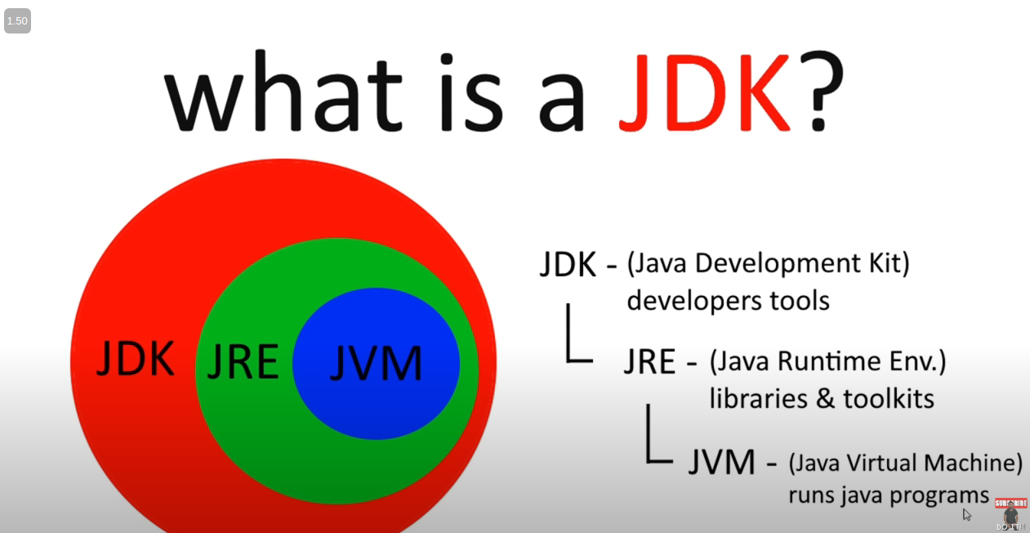
- A java class name needs to match the filename.
- Every java file needs to contain a class, as java is strictly an OOP language.
- The class needs to contain a main function for the file to be executed.
- public static void main(String[] args) {} is a common main function declaration.
- System.out.print(“string”); is how output string to the terminal. This does not end with \n.
- You can either add the \n manually to create a new line, or use the following method instead:
System.out.println(“string”);
- This will automatically create a new line.
- To print quotes and forward or backslashes as strings, need to use escape characters, like in most languages.
- \”, \\, \/, etc.
- “//” is used to create a single line comment that is ignored by the compiler.
- /* */ is used to create multiline comments with the text in between * and *.

Variables in Java

- Variables store values.
- As Java is statically/strongly typed, the datatype being stored in a variable must be declared, unlike JS and Python.
- There are 8 primitive data types and 1 reference datatype in Java:
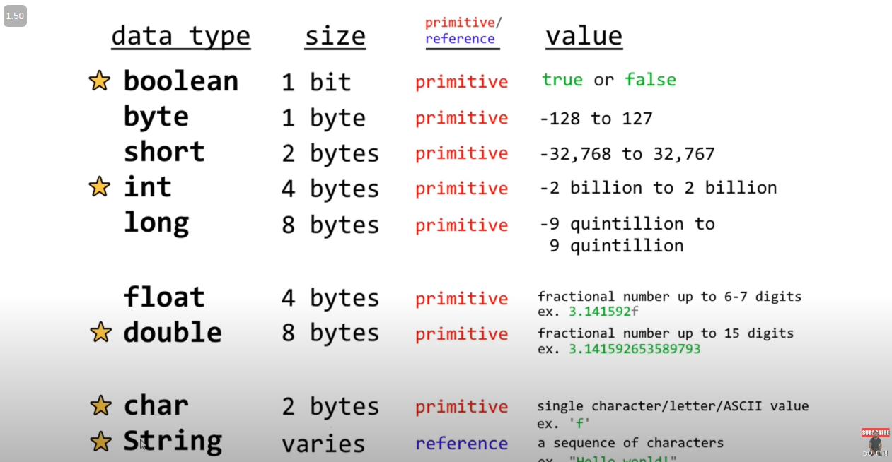
- char datatype is used to store single ASCII letters in single quotes: ‘h’
- String is used to store multiple characters, using double quotes: “hello”

Difference between Primitive and Reference datatypes:

