**Roses**

# **1.Love Rose:**

**The Love Rose, with its captivating beauty and alluring fragrance, has long been a symbol of true love and passion .As an enduring emblem of romance, gifting a Love Rose conveys heartfelt emotions and deep affection .The velvety petals and rich hues of the Love Rose make it a timeless and cherished token of love for special occasions and celebrations .Embrace the enchanting power of the Love Rose to express your deepest feelings and create unforgettable moments filled with love and tenderness .Let the Love Rose be a reminder of the everlasting bond between hearts, making it a cherished and meaningful gift for your beloved.**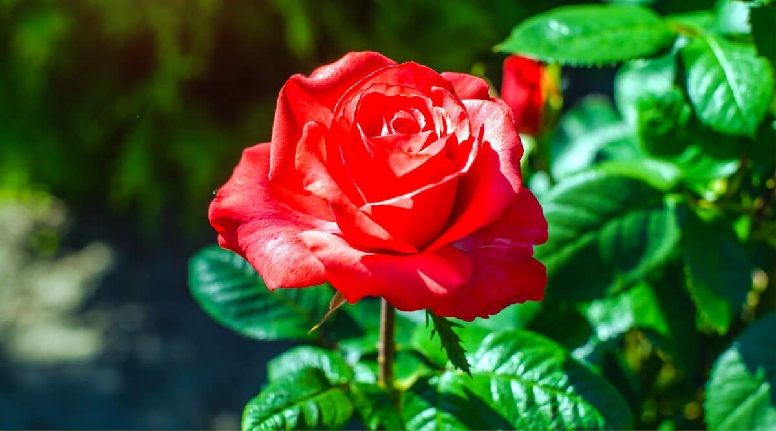

# **2.White Rose:**

**The White Rose, with its pristine beauty and elegant simplicity, represents purity, innocence, and new beginnings . Symbolizing purity of heart and sincerity, the White Rose is often associated with weddings and spiritual ceremonies. With its serene and calming presence, the White Rose brings a sense of peace and harmony to any setting . Gifting a White reverence and admiration, making it a thoughtful gesture for honoring someone special . Embrace the timeless charm of the White Rose to add a touch of grace and purity to your meaningful occasions and heartfelt sentiments.**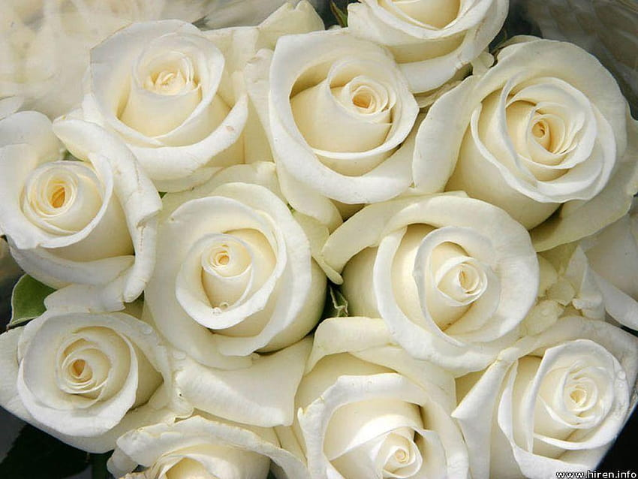

# **3.Pink Rose:**

**The Pink Rose, a delicate and enchanting bloom, exudes grace and admiration. Its soft and gentle hue symbolizes sweetness, gratitude, and affection, making it an ideal gift for expressing admiration and appreciation. The Pink Rose holds a special place in celebrations of love and gratitude, making it a popular choice for Mother's Day, birthdays, and anniversaries. With its captivating beauty and tender connotations, the Pink Rose serves as a heartfelt gesture to convey love, joy, and best wishes to those who hold a special place in our hearts.**

# **4.Blue Rose:**

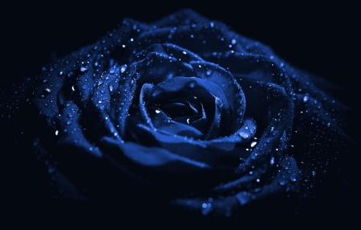**The Blue Rose, a rare and mysterious flower, captivates with its unique and mesmerizing hue. Unlike its natural counterparts, the Blue Rose is a product of human ingenuity, created through careful breeding and genetic modification. As a result, it has come to symbolize the unattainable and the impossible, representing the quest for the extraordinary and the desire for the unreachable. The Blue Rose is often associated with mystery, ambiguity, and the pursuit of the unknown, making it a symbol of hope and enchantment. With its rare beauty and enigmatic allure, the Blue Rose continues to fascinate and inspire, leaving a lasting impression on all who behold its extraordinary splendor.**

# **5.Red Rose:**

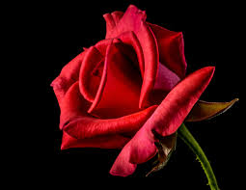**The Red Rose, the quintessential symbol of love and passion, is an iconic and timeless flower that has captured hearts for centuries. Its velvety crimson petals convey deep emotions, making it the ultimate expression of romance and desire. Red roses have been used to signify love and affection in various cultures and traditions, and they continue to be a popular choice for special occasions like Valentine's Day and anniversaries. With its captivating beauty and rich symbolism, the Red Rose serves as a powerful and heartfelt declaration of love, leaving a lasting impression on those who receive it as a token of affection and admiration.**

# **6.Purrple Rose :**

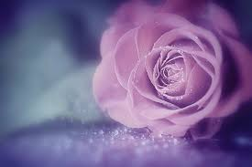**The Purple Rose, a captivating and rare beauty, holds a sense of enchantment and mystique. With its rich and regal hue, the Purple Rose symbolizes admiration, enchantment, and love at first sight. Unlike its more common counterparts, the Purple Rose is a unique and alluring bloom that represents fascination and charm. It is an ideal choice for expressing a sense of wonder and fascination for someone special in your life. As a symbol of individuality and grace, the Purple Rose stands out as a distinctive and meaningful gift, leaving a lasting impression on those who are fortunate enough to receive it.**