**LAB # 1**

**Introduction to GitHub**

**Create account on GitHub.**

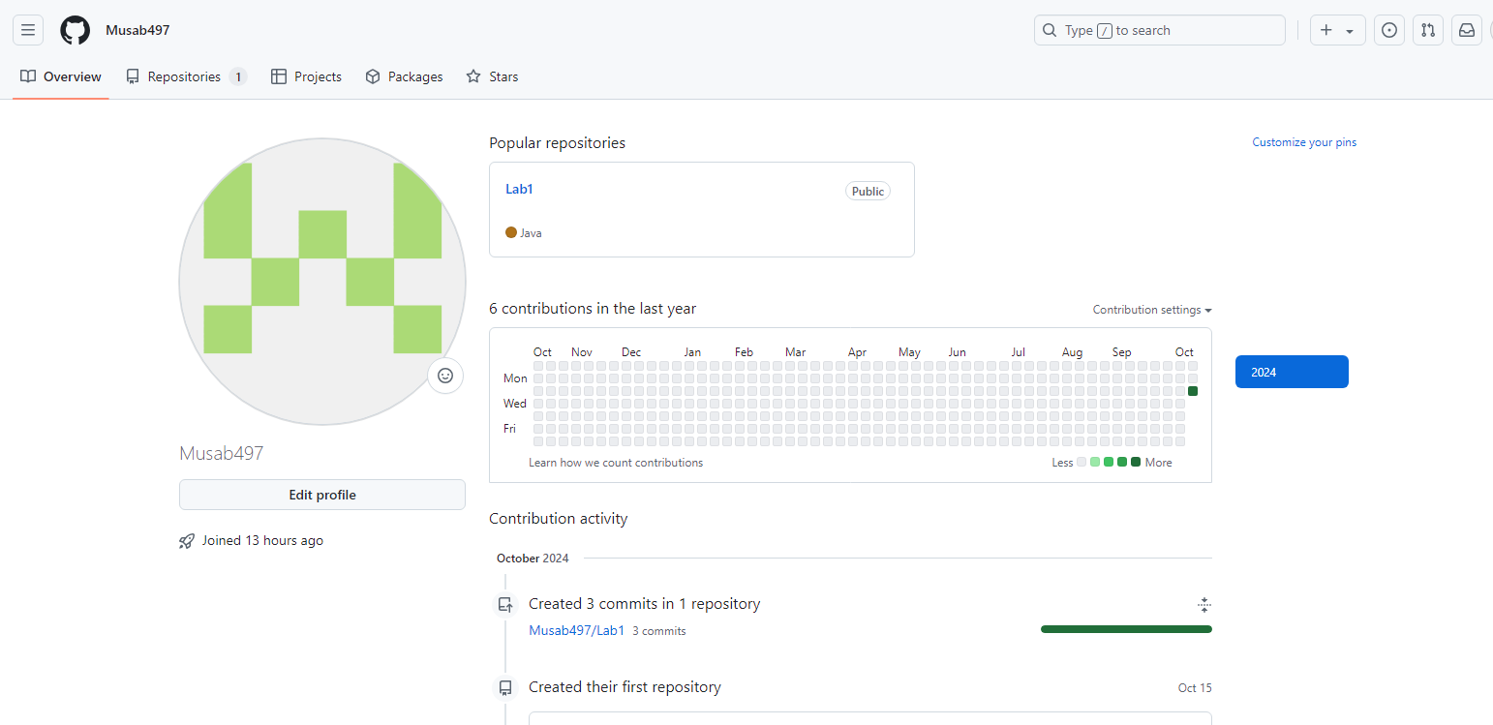

**Upload any of your Java Project files and perform commit, push, pull and merge operations.**



