
CONVERSATION-STATE BASED APPROACH
Assignment on

Assignment Report submitted in partial fulfilment of the requirements for the Course of

DSA0308 – Natural Language Processing
to the award of the degree of
BACHELOR OF Technology
IN
ARTIFICIAL INTELLIGENCE AND Machine Learning
Submitted by
Harissh M(192424014)
Under the Supervision of
Kumaragurubaran T

SIMATS ENGINEERING
Saveetha Institute of Medical and Technical Sciences
Chennai – 602105
SEPTEMBER 2026

STATISTICAL CLASSIFICATION APPROACH
1. Problem Statement and Problem Formulation
Problem Statement
E-commerce customer-service systems must identify what a customer is trying to accomplish from natural-language messages. Customers may describe the same requirement using different vocabulary and grammatical forms. For example, a delivery-related request may contain words such as arrive, arrived, arrival, delivery, or delivered.
A chatbot based purely on exact keyword matching may treat these expressions as unrelated or may assign an incorrect intent when a competing word such as cancel occurs in the conversation.
The proposed system therefore uses a statistical NLP approach based on TF-IDF features and n-grams to classify customer messages. Linguistic processing and contextual correction are then applied to the classifier output so that explicit negation and conversational information can modify an otherwise misleading prediction.
The assignment requires the final classification to use multiple NLP levels rather than keyword frequency alone.
Problem Formulation
Input:
A sequence of customer messages from an e-commerce conversation.
Output:
- Predicted customer intent
- Intent probability/confidence
- Important entities
- Linguistic evidence
- Contextual corrections
- Retrieved information
- Generated response
- Tamil translation
The predefined intent categories include Order Tracking, Order Cancellation, Product Information, Return Request, Refund Request, Payment Problem, Delivery Information, Account Problem, Complaint and General Inquiry.

2. Objective and Expected Outcomes
Objectives
The main objective is to develop a statistical intent-classification system that can recognize customer requirements from different linguistic expressions.
The specific objectives are:
- Preprocess customer conversations.
- Reduce morphological variations through stemming.
- Generate unigram, bigram and trigram features.
- Convert textual input into numerical TF-IDF vectors.
- Train a statistical classifier for intent prediction.
- Use POS and syntactic information as supporting evidence.
- Detect negation explicitly.
- Identify e-commerce entities.
- Resolve context-dependent references.
- Incorporate discourse information.
- Apply contextual correction to the statistical prediction.
- Retrieve information associated with the selected intent.
- Generate a natural-language response.
- Translate the response into Tamil.
The assignment specifically requires unigram, bigram and trigram representations, POS tagging, negation handling, semantic processing, reference resolution and final intent classification.
Expected Outcomes
The system is expected to classify the given conversation as:
Final Intent: Order Tracking / Delivery Information
The expected result is obtained because the statistical model recognizes delivery-related patterns, while contextual correction identifies that cancellation has been explicitly rejected.

3. Requirements, Constraints and Assumptions
Requirements
Functional Requirements
The proposed system should:
- Accept customer conversations.
- Clean and tokenize the text.
- Perform stemming.
- Generate TF-IDF representations.
- Include unigram, bigram and trigram features.
- Perform POS tagging.
- Analyze sentence structure.
- Detect negation.
- Identify entities.
- Resolve references.
- Analyze conversational markers.
- Predict an intent using a trained classifier.
- Apply contextual correction.
- Retrieve appropriate information.
- Generate a response.
- Translate the response into Tamil.
These requirements follow the functional requirements specified in the assignment.
Technical Requirements
Component | Proposed Tool
Programming Language | Python
Text Processing | NLTK
Stemming | PorterStemmer
Vectorization | Scikit-learn TF-IDF
N-grams | Scikit-learn
Classifier | Logistic Regression / Linear SVM
POS Tagging | NLTK
CFG Parsing | NLTK
Semantic Processing | Python/NLP libraries
Retrieval | Python dictionary
Translation | Suitable translation library/API
The assignment permits NLTK, spaCy, Python regular expressions, Scikit-learn and other relevant NLP tools.
Constraints
The classifier cannot operate as a simple keyword-counting system.
The system must:
- use multiple linguistic signals;
- account for negation;
- preserve conversation context;
- resolve references;
- distinguish entities from intents;
- provide intermediate outputs;
- avoid contradictory responses;
- justify the final prediction.
Assumptions
- A labelled training dataset containing e-commerce intents is available.
- Each training example is assigned one primary intent.
- Customer conversations are available in text format.
- The classifier is trained before chatbot execution.
- A predefined intent vocabulary is maintained.
- The system can access a basic information-retrieval store.
- Translation is performed after generating the English response.

4. Application of Relevant Course Knowledge / Concepts
The second approach uses statistical modelling as its central component while incorporating the linguistic concepts from the course.
Unit I – Morphology
Words may appear in different morphological forms.
For example:
Word | Stemmed Form
arrive | arriv
arrived | arriv
arriving | arriv
delivery | deliver
delivered | deliv
cancellation | cancel

Stemming reduces some surface-level variation before vectorization.
Regular expressions can additionally identify order numbers, dates and other structured information.

Unit II – N-Grams and POS
The classifier does not use only individual words.
For the sentence:
“I just want to know when it will arrive.”
the vectorizer can generate:
Unigrams
want
know
arrive
Bigrams
want know
know when
will arrive
Trigrams
just want know
want know when
know when it
N-grams allow the model to learn combinations of words associated with specific intents.
For example:
cancel order
track order
where order
when arrive
payment failed
POS tags provide additional grammatical information that can be used during contextual correction.

Unit III – CFG and Negation
CFG parsing provides syntactic information about the customer message.
A simplified grammar can be:
S → NP VP
VP → V NP
VP → V AdvP
NP → Det N
Negation is particularly important.
For:
“I don't want to cancel it.”
the system identifies:
cancel → cancellation concept
don't want → negation
The statistical classifier may detect cancellation-related features, but the negation module prevents that evidence from being treated as a positive cancellation request.

Unit IV – Semantic Analysis
The system associates words and phrases with semantic concepts.
For example:
“hasn't arrived”
↓
Delivery status problem
↓
Order Tracking
A simplified FOPC representation can be:
Ordered(Customer, Laptop)
NotArrived(Order)
Wants(Customer, DeliveryInformation)
NotWants(Customer, Cancellation)
WSD is applied when words have multiple possible meanings.

Unit V – Discourse and Context
Discourse markers provide information that a bag-of-words representation cannot fully capture.
Marker | Interpretation
but | Contrast
still | Unresolved/continuing condition
just | Restriction or emphasis
it | Reference to earlier entity

The system therefore passes the classifier's prediction through a contextual correction layer.

5. Design / Proposed Solution / Methodology
The major difference in this version is that statistical classification is responsible for the initial intent prediction.
Customer Conversation
↓
Preprocessing
↓
Tokenization + Stemming
↓
Unigram / Bigram / Trigram Generation
↓
TF-IDF Vectorization
↓
Statistical Intent Classifier
↓
Initial Intent + Confidence
↓
Linguistic Analysis
↓
Negation Detection
↓
Entity + Reference Resolution
↓
Discourse Analysis
↓
Contextual Correction
↓
Final Intent
↓
Information Retrieval
↓
Response Generation
↓
Tamil Translation

The assignment's proposed NLP stages are therefore retained, but the classification stage is implemented statistically rather than primarily through manually weighted rules.
TF-IDF Representation
For a term $t$in document $d$:
$$TFIDF\left(t , d\right)=TF\left(t , d\right)×IDF\left(t\right)$$
where:
$$IDF\left(t\right)=\log\left(\frac{N+1}{DF\left(t\right)+1}\right)+1$$
The resulting vector represents how important terms and phrases are within the training corpus.
Classifier
A suitable classifier is Logistic Regression.
The classifier produces scores for all possible intents:
Order Tracking → 0.61
Delivery Information → 0.19
Order Cancellation → 0.13
Complaint → 0.04
Other → 0.03
The exact values above are illustrative; the actual implementation should report its own values.
The initial prediction is then checked against contextual information.

6. Algorithm / Pseudocode
BEGIN

Load labelled intent dataset

Preprocess training text
tokenize
normalize
remove unnecessary symbols
stem words

Create TF-IDF vectorizer
ngram_range = (1,3)

Transform training sentences into TF-IDF vectors

Train statistical classifier

FOR each new conversation:

preprocess conversation

generate TF-IDF representation

classifier_output ← predict probabilities

initial_intent ← highest probability intent

perform POS tagging

perform CFG parsing

detect negation

extract entities

resolve references using previous turns

analyze discourse markers

IF initial_intent = Order Cancellation
AND cancellation is negated:
reduce cancellation confidence
increase relevant alternative intent

IF delivery evidence exists:
increase Order Tracking score

IF arrival/delivery request exists:
increase delivery-related score

final_intent ← highest context-adjusted score

retrieve relevant information

generate response

translate response into Tamil

display all intermediate and final outputs

END
The pseudocode includes the functions, conditions, data processing and decision mechanism required by the assignment.

7. Implementation / Source Code and Environment / Tools Used
Environment
Component | Tool
Language | Python
Development | Jupyter Notebook / VS Code
NLP | NLTK
Machine Learning | Scikit-learn
Vectorization | TfidfVectorizer
Classifier | Logistic Regression
Parser | NLTK CFG
Data Structures | Lists, dictionaries, arrays
Translation | Suitable translation library/API

Main Implementation Modules
load_dataset()
preprocess_text()
stem_text()
build_tfidf()
train_classifier()
predict_intent()
perform_pos_analysis()
detect_negation()
extract_entities()
resolve_reference()
analyze_discourse()
adjust_prediction()
retrieve_information()
generate_response()
translate_response()
Example TF-IDF Configuration
TfidfVectorizer(
ngram_range=(1,3),
min_df=1,
sublinear_tf=True
)
The important part is the use of 1–3 grams, since the assignment explicitly requires unigram, bigram and trigram representations.

8. Test Cases and Expected / Actual Results
Test Case | Customer Input | Expected Intent
TC1 | “Where can I track my order?” | Order Tracking
TC2 | “Please cancel my order.” | Order Cancellation
TC3 | “My package has not arrived.” | Order Tracking
TC4 | “I need to return this item.” | Return Request
TC5 | “The payment was unsuccessful.” | Payment Problem
TC6 | “I don't want to cancel it, I want to know when it will arrive.” | Order Tracking
TC7 | “What features does this laptop have?” | Product Information
Main Conversation Test
Input:
“I ordered a laptop three days ago, but it still hasn't arrived. Can you check where it is?”
Followed by:
“I don't want to cancel it. I just want to know when it will arrive.”
Expected:
Initial classifier prediction:
Delivery-related intent
Contextual analysis:
Cancellation → negated
Final intent:
Order Tracking / Delivery Information
The actual probability values should be obtained from the trained classifier.

9. Execution Screenshots / Outputs
The following screenshots should be captured from the actual implementation.
Screenshot 1 – Preprocessing/tokenization output.
User:
I ordered a laptop three days ago,
but it still hasn't arrived.
Screenshot 2 – N-gram and POS-tagging output screenshot.

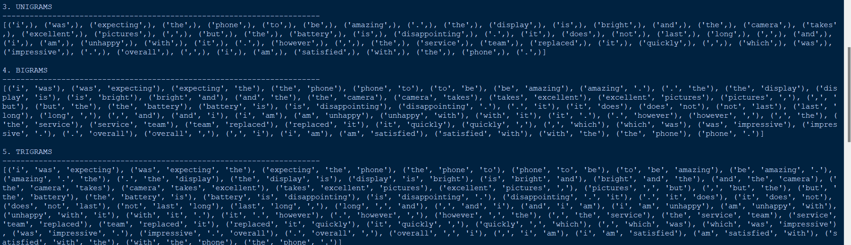
Screenshot 3 – Reference Resolution
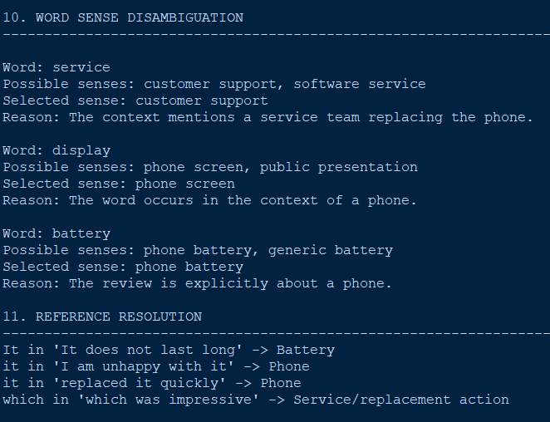
Reference:
"it"

Resolved To:
Existing Order
Screenshot 4 – Negation Analysis
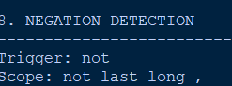
Detected Action:
Cancellation
Negation:
TRUE
Interpretation:
Customer rejects cancellation
Screenshot 5 – Final State
Conversation State
Product : Laptop
Order Status : Existing
Delivery Status : Not Received
Cancellation : Rejected
Current Reference : Order
Requested Information: Arrival Time
Current Intent : Order Tracking
Screenshot 6 – Response
Final Intent:
Order Tracking
Response:
Please provide your order number so I can check
the current delivery status of your laptop.
Tamil Response:
The assignment requires evidence of intermediate NLP representations, final classification and generated chatbot output.
Response:
Please provide your order number so I can check
the current delivery status.

Tamil Response:
[translated response]
The assignment requires evidence including program outputs, screenshots, intermediate representations, final classification and generated responses.

10. Results and Validation
Morphological Analysis
Word | Stem
ordered | order
arrived | arriv
arriving | arriv
delivery | deliver
delivered | deliv
cancelling | cancel
The statistical representation benefits from normalization because multiple surface forms can contribute to related vocabulary patterns.
Intent and Entity Analysis
Component | Result | Evidence
Product | Laptop | “ordered a laptop”
Order | Existing order | “I ordered...”
Time | Three days | “three days ago”
Delivery | Delayed | “hasn't arrived”
Cancellation | Negated | “don't want to cancel”
Reference | “it” → order | Previous message
Final Intent | Order Tracking | Arrival information requested

Classifier Validation
The actual implementation should calculate metrics such as:
- Accuracy
- Precision
- Recall
- F1-score
- Confusion matrix
For example:
Metric | Actual Result
Accuracy | [actual value]
Precision | [actual value]
Recall | [actual value]
F1-score | [actual value]

These values should not be fabricated and must be filled using the student's actual test execution.
The assignment expects the system to validate different expressions, morphological variations, n-grams, negation, ambiguity, references, conversational context and intent classification.

11. Analysis, Comparison, Trade-offs and Justification
The major strength of the statistical approach is its ability to learn patterns from examples.
Consider these expressions:
Where is my order?
When will my package arrive?
My parcel hasn't arrived.
Can you tell me the delivery status?
When will my item be delivered?
A keyword-only system may treat these as different because the vocabulary changes.
A TF-IDF n-gram classifier can learn that terms and phrases occurring across labelled delivery-related examples are associated with the same intent.
Morphological Variation
Words such as:
arrive
arrived
arriving
arrival
delivery
delivered
represent related concepts but are not identical strings.
Preprocessing and statistical representation help the classifier generalize across such variations.
Why N-Grams Matter
The word cancel alone could indicate cancellation.
However:
want cancel
don't want cancel
order cancellation
cancel my order
have different meanings.
Therefore, surrounding terms provide useful classification information.
Why the Classifier Alone Is Not Enough
The statistical model may still incorrectly respond to the strong cancellation signal in:
“I don't want to cancel it.”
This is why the proposed system includes a linguistic correction layer.
Comparison
Method | Strength | Weakness
Keyword matching | Simple and fast | Poor contextual understanding
TF-IDF + classifier | Learns statistical patterns | Can struggle with negation
Rule-based system | Explainable | Requires extensive manual rules
Proposed hybrid statistical approach | Learns patterns + handles linguistic exceptions | More complex to implement
The final approach is justified because it combines data-driven classification with explicit linguistic correction.

12. Broader Considerations / SDG Relevance
The assignment maps the application to SDG 9 – Industry, Innovation and Infrastructure, particularly because automated customer-service systems represent the use of intelligent digital technologies in industry.
Privacy
Customer conversations can contain sensitive information such as order numbers, addresses and payment details. Such information should not be unnecessarily stored or exposed.
Bias
A classifier trained on limited examples may perform poorly on uncommon sentence structures, spelling variations or expressions not represented in the training data.
Incorrect Classification
A wrong prediction could lead to an inappropriate customer-service response. This is especially important for actions such as cancellation or refund processing.
Multilingual Accessibility
Tamil translation can make the chatbot more accessible to customers who prefer Tamil.
Responsible AI
The chatbot should clearly distinguish between retrieving information, recommending an action and actually performing that action.

13. Conclusion, Limitations and Possible Improvements
Conclusion
A statistical NLP approach was designed for e-commerce chatbot intent classification. The system transforms customer conversations into TF-IDF representations containing unigram, bigram and trigram features and uses a statistical classifier to generate an initial intent prediction.
However, classification is not allowed to depend entirely on statistical word patterns. Therefore, the predicted intent is passed through additional linguistic processing involving negation, entities, references and discourse.
For the given conversation, the final prediction is Order Tracking / Delivery Information. Although the classifier may detect cancellation-related vocabulary, the contextual correction layer recognizes that cancellation has been explicitly rejected.
This demonstrates why combining statistical NLP with contextual linguistic analysis provides a more reliable solution than simple keyword matching.
Limitations
- Classification performance depends on training-data quality.
- Rare intents may have insufficient examples.
- TF-IDF does not fully represent deep semantic relationships.
- Negation may still be difficult in complex sentences.
- Reference resolution becomes harder with long conversations.
- Translation quality depends on the external translation system.
Possible Improvements
Future work could include:
- Word embeddings instead of only TF-IDF.
- Transformer-based intent classification.
- Larger and more diverse conversational datasets.
- Advanced coreference resolution.
- Multilingual training data.
- Real-time integration with e-commerce databases.
- Confidence thresholds for transferring difficult cases to human agents.

14. Individual Contribution of Group Members
The following should be replaced with the actual work performed by the group members.
Member | Contribution
Harissh M | Dataset preparation and preprocessing
pradeep kumar S | TF-IDF and n-gram implementation
Lokanath reddy | Classifier development and evaluation
Somashekhar naidu | Negation, reference and contextual correction
G Jaswanth | Response generation, translation and documentation
Yuvaraj R | Testing and validation
The contribution table should reflect actual work rather than assigning tasks retrospectively.

15. References
The report should cite the actual resources used during development. The assignment specifically requires references to relevant textbooks, research papers, NLP libraries, datasets, software/tools, websites and AI-assisted tools where applicable.
Possible reference categories include:
- NLP textbook used for the course.
- NLTK documentation.
- Scikit-learn documentation.
- Python documentation.
- Research papers related to intent classification.
- Dataset documentation.
- Translation library/API documentation.
- Any AI-assisted development tools actually used.

16. One-Page Individual Reflection
Individual Reflection
Module 1: Data Preprocessing and Linguistic Preparation
This assignment gave me an opportunity to understand how natural-language text needs to be prepared before it can be processed by a machine-learning model. Before working on this project, I mainly considered customer messages as simple text that could be directly given to a classifier. During implementation, I learned that preprocessing is an important stage because customer messages can contain different word forms, unnecessary symbols and variations in sentence structure.
My main contribution to the project was the data preprocessing and linguistic preparation module. I worked on cleaning the customer conversations, tokenizing the sentences, normalizing the text and removing unnecessary characters. I also implemented stemming using the Porter Stemmer. This helped me understand how words such as “arrived,” “arriving” and “arrival” can be processed to reduce variations in the vocabulary.
I also gained practical experience with Part-of-Speech tagging. POS information helped me understand that words should not always be considered independently because their grammatical role can provide useful information about the meaning of a sentence. For an NLP chatbot, this type of linguistic information can support the later contextual analysis and intent classification stages.
One of the challenging aspects of this module was deciding how much preprocessing should be performed without removing useful information. I understood that aggressive preprocessing can sometimes remove information that may be important for intent classification. Therefore, the preprocessing stage needs to maintain the meaningful parts of the customer's message while reducing unnecessary variations.
Working on this module also helped me understand the connection between traditional NLP concepts and machine learning. The processed text becomes the input for the n-gram and TF-IDF module, which shows how one NLP stage depends on the output of another stage.
Overall, this assignment improved my understanding of text preprocessing, tokenization, stemming and POS tagging. I learned that preprocessing is not simply cleaning text but is an important foundation for building a reliable NLP system. This project also helped me understand how linguistic preparation contributes to the overall goal of accurately identifying customer intentions.

