3. Develop a flowchart in Figma depicting the operation of a Network Switching Subsystem in a mobile cellular system.
Aim: -
To draw a flowchart in Figma depicting the operation of a Network Switching Subsystem in a mobile cellular system
Procedure: -
1. open Figma
2. Create a new file
3. Click on the resources icon and click on the plugins
4. Search for the Flow Chart
5. Drag and drop the shapes on the screen 6. Now, enter the content on the shapes and connect them through Arrows.
7. Grouping and alignment
8. Review and edit
9. Save and share
Prototype Link: https://www.figma.com/make/Cdv7nln3Tvi7m1zy44fBtj/GSM-NSS-Flowchart-and-Architecture?code-node-id=0-6&p=f&t=xNxYT0pNCebYBSur-0&fullscreen=1

Design: -
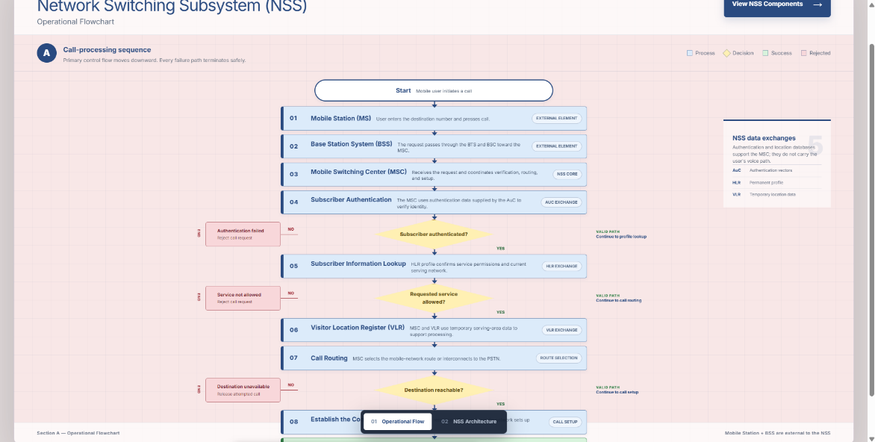

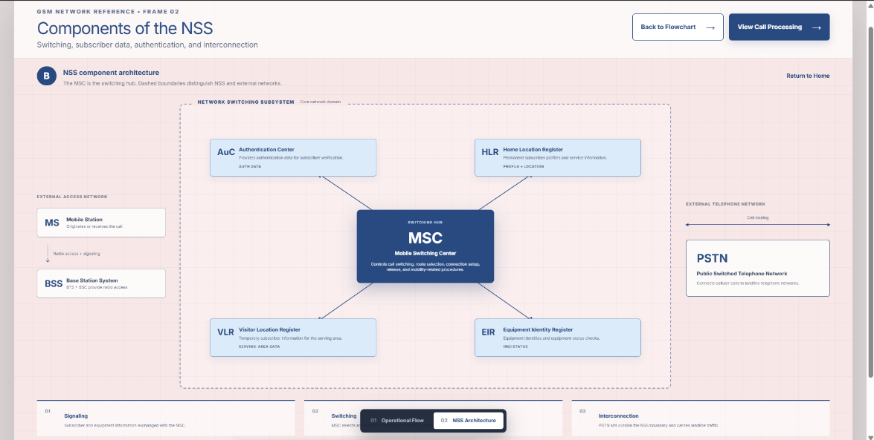

Result: -
Hence the flowchart in Figma depicting the operation of a Network Switching Subsystem in a mobile cellular system has been drawn successfully

