6. Use Figma to simulate a handoff scenario in a mobile network and visualize the process.
Aim: -To simulate a handoff scenario in a mobile network and visualize the process using Figma.
Procedure:
1. Open Figma
2. Create a new file
3. Select the Frames
4. Fill in the content that is required for presentation 5. Design Visual Elements
6. Make it Interactive
7. Add Annotations and Explanations
8. Incorporate Multimedia
9. Storyboard Animation
10. Review and edit the Prototype
11. Save and Share
Prototype Link: https://www.figma.com/make/NE7Ruz4TtU61mrV2FAUAp8/Mobile-Network-Handoff-Simulation?p=f&t=FA90sJf3dogRFJdQ-0

Design:
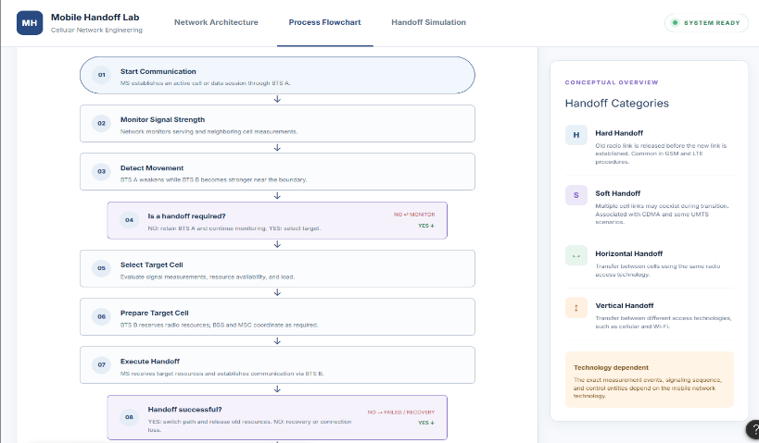
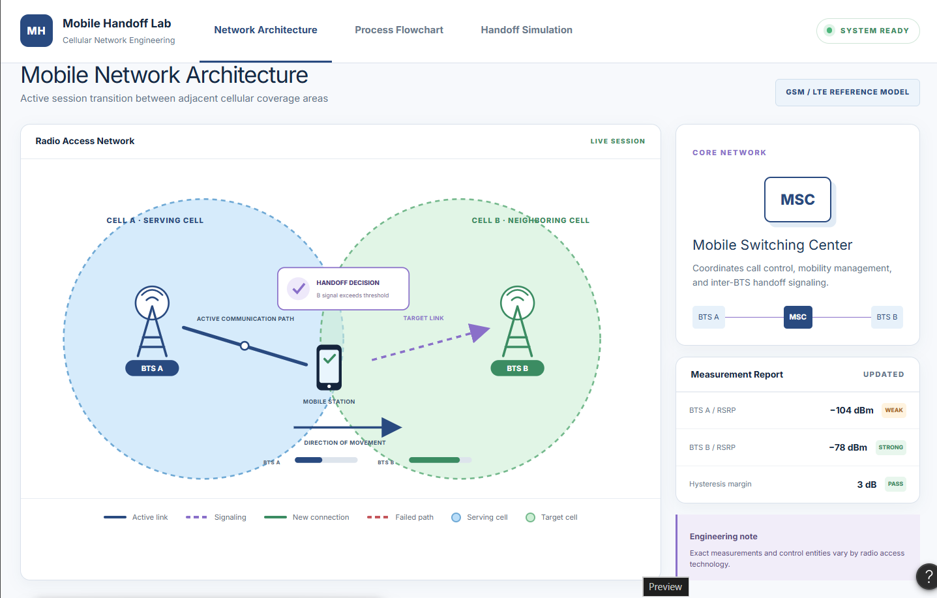

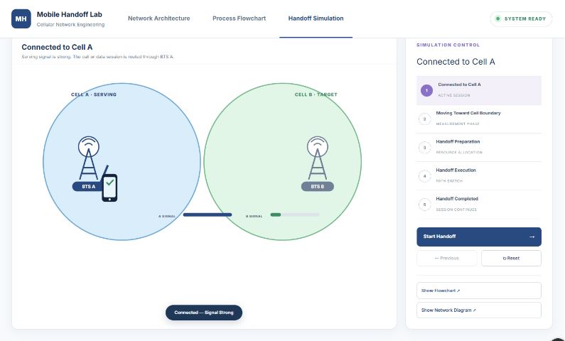
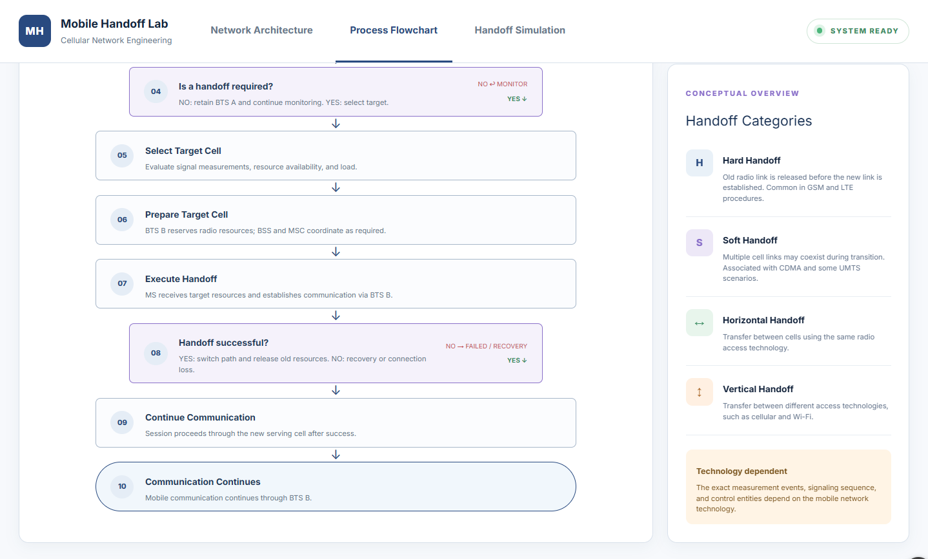

Result:
Hence the simulated a handoff scenario in a mobile network and visualized the process using Figma.

