11.Design a wireframe for a mobile application that incorporates security measures using Figma.
Aim: -
Using Figma design a wireframe for a mobile application (Bank app UI) that incorporates security measures.
Procedure: -
1. open Figma
2. Create a new file
3. Select the Frames
4. Design Visual Elements
5. Make it Interactive
6. Add icons on the Frame
7. Incorporate Multimedia
8. Storyboard Animation
9. Review and edit the Prototype
10. Save and Share
Prototype Link :
https://www.figma.com/make/MBpUeUdk7udEklY1iNUmx9/SecureGuard-Mobile-Security-Wireframe?t=z2kGnA1jeoDWwdDQ-0

Design: -
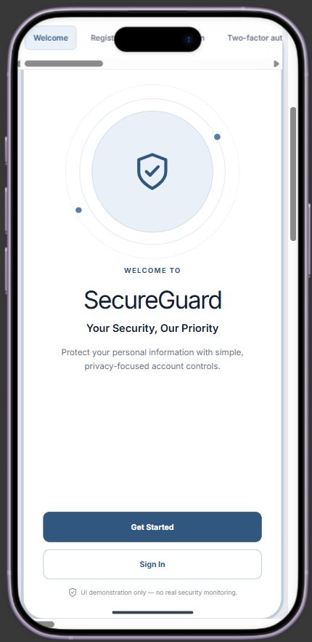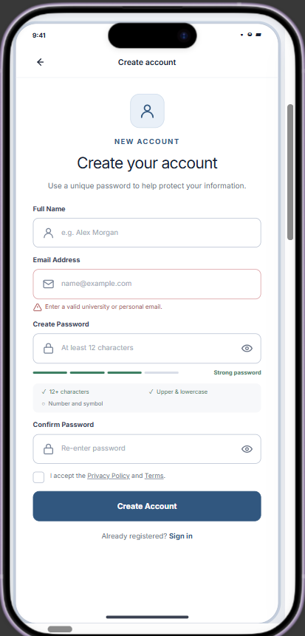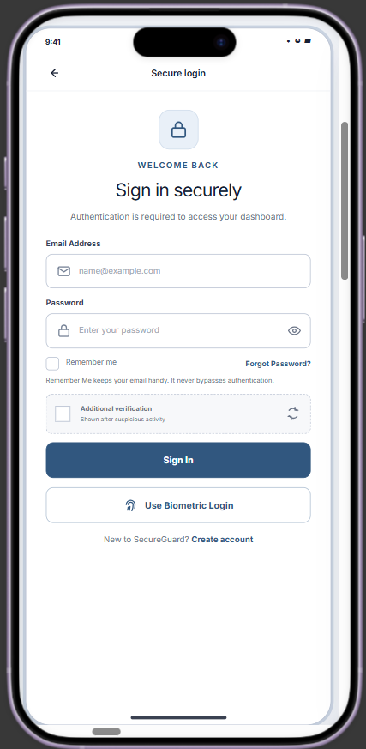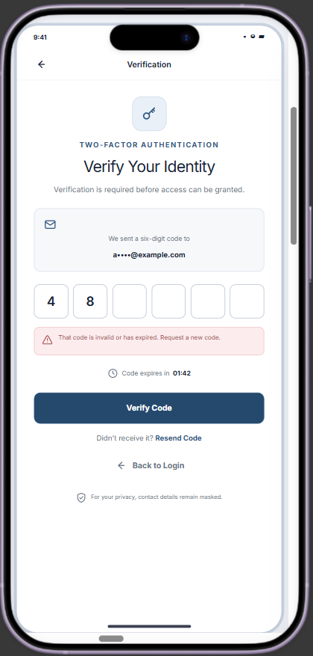
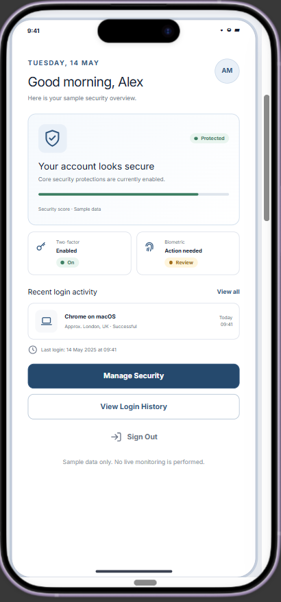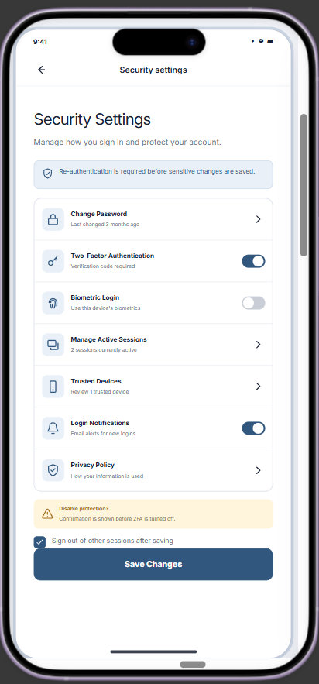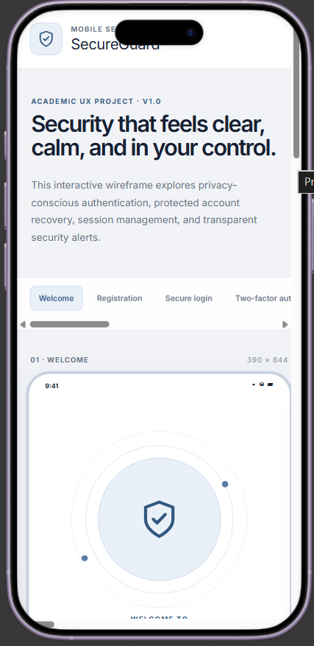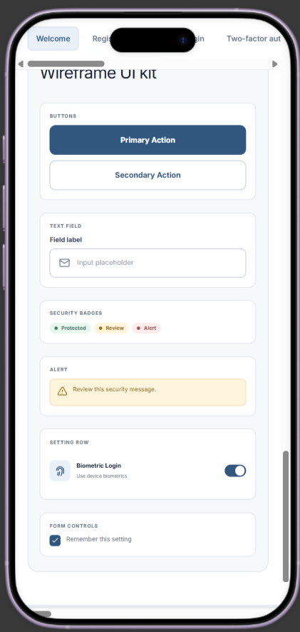
Result: -
A wireframe for a mobile application that incorporates security measures using Figma is created and executed successfully

