14. Develop a flowchart in Figma explaining the operation of General Packet Radio Service (GPRS).
Aim: -
Draw a flowchart in Figma explaining the operation of General Packet Radio Service (GPRS).
Procedure: -
1. open Figma
2. Create a new file
3. Click on the resources icon and click on the plugins
4. Search for the Flow Chart
5. Drag and drop the shapes on the screen 6. Now, enter the content on the shapes and connect them through Arrows.
7. Grouping and alignment
8. Review and edit
9. Save and share
Prototype link : https://www.figma.com/make/gPkaREcU9VcxMspBMrOMbT/GPRS-Network-Operation-Flowcharts?t=DQ5X0qSxNhIx6Gkb-0

Design: -
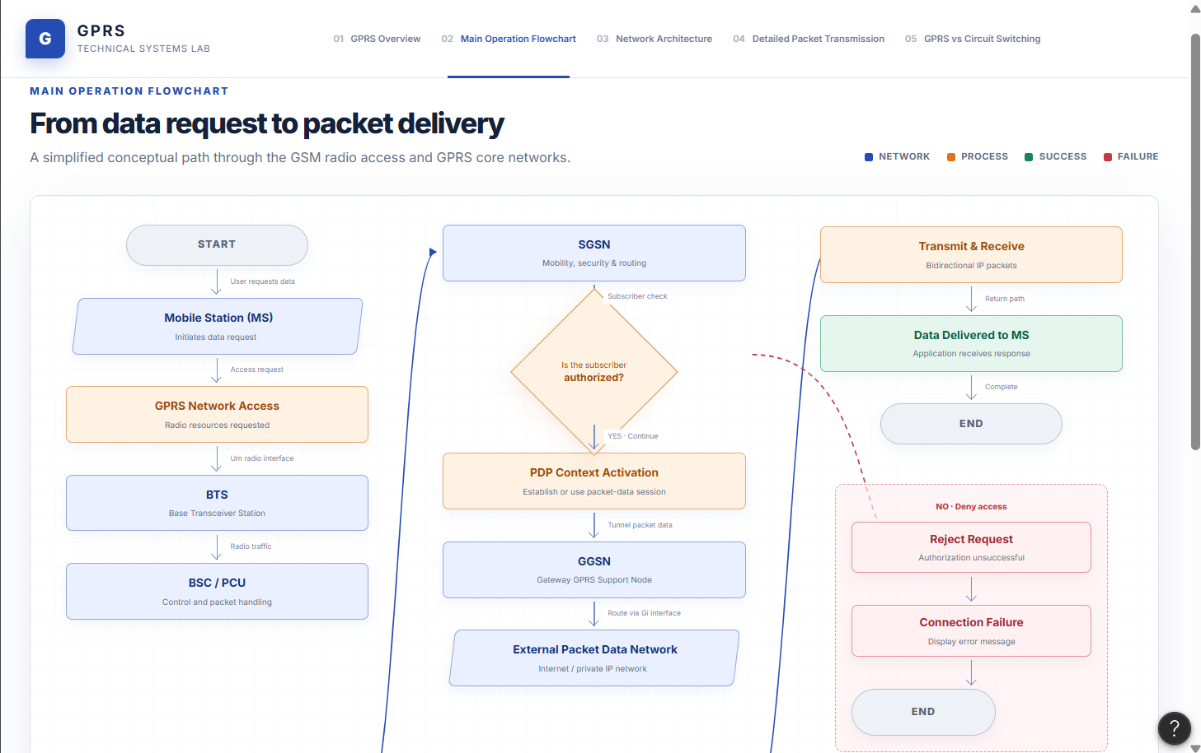
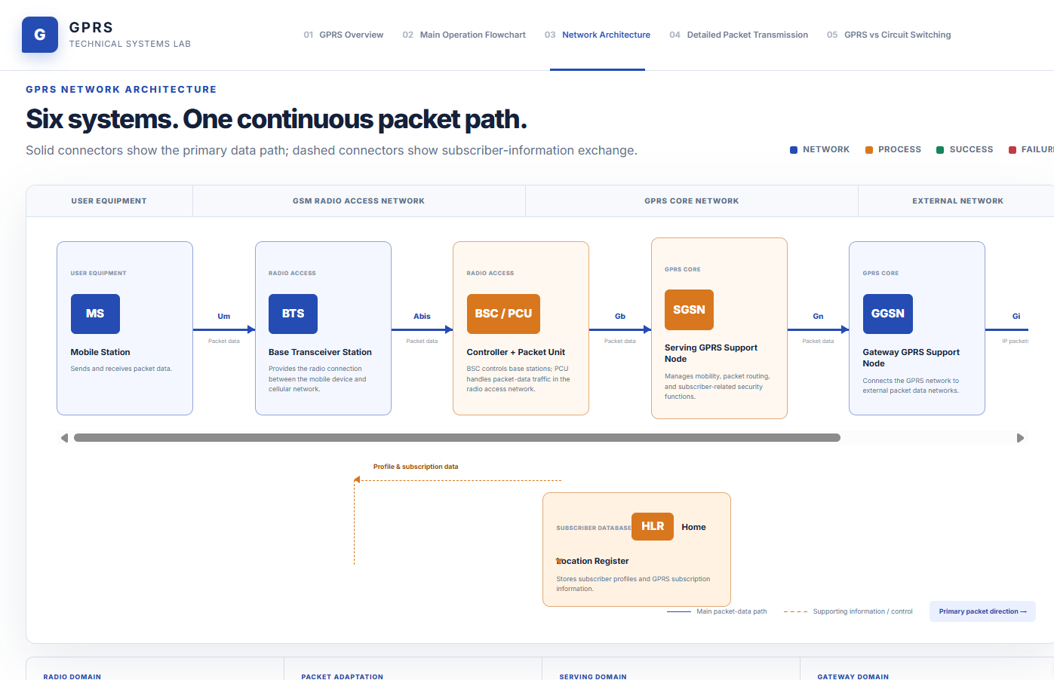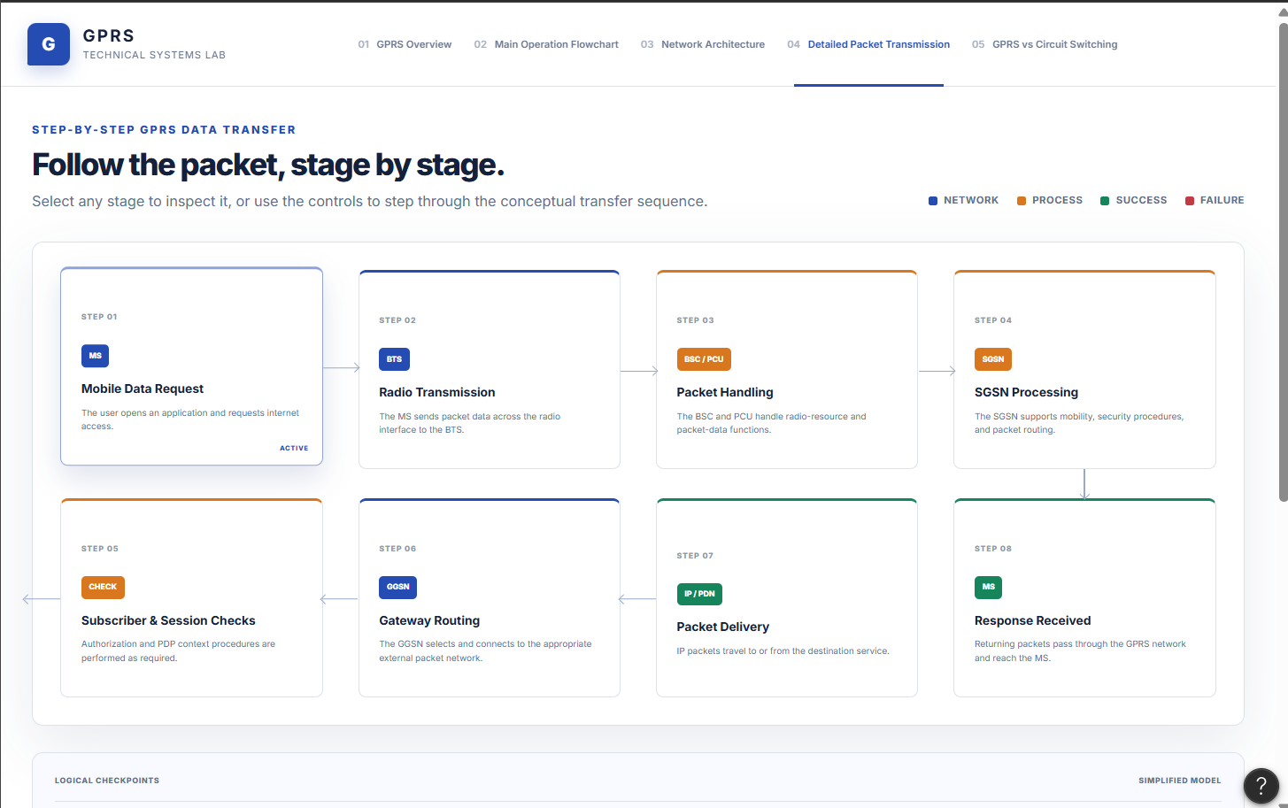
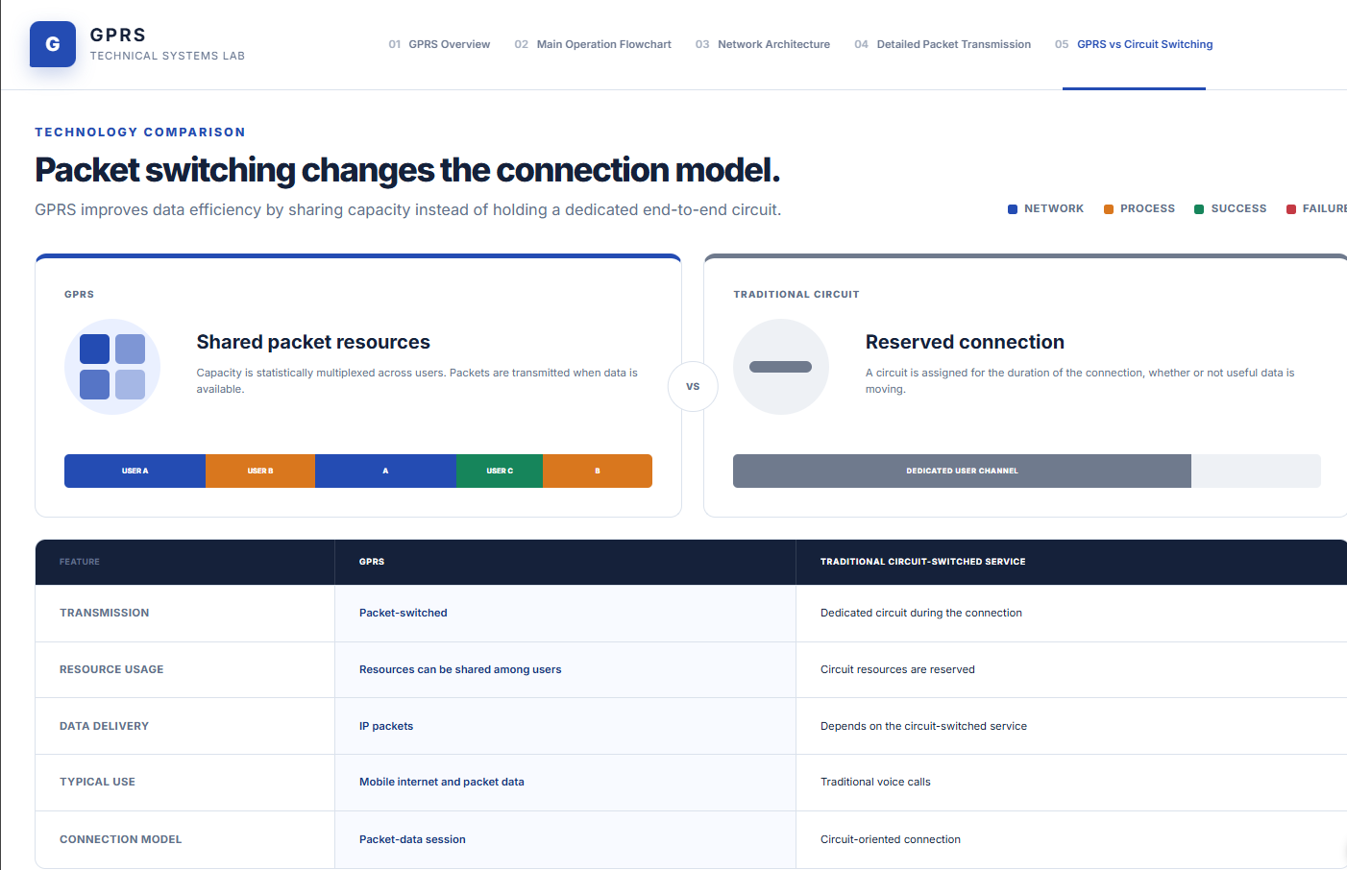
Result: -
Hence the flowchart in Figma explaining the operation of General Packet Radio Service (GPRS) has been drawn successfully.

