15. Develop a wireframe for a mobile application that addresses challenges related to ad hoc wireless networks using Figma.
Aim: -
Create a Wireframe for a mobile application that addresses challenges related to ad hoc wireless networks using Figma.
Procedure: -
1. open Figma
2. Create a new file
3. Select the Frames
4. Design Visual Elements
5. Make it Interactive
6. Add icons on the Frame
7. Incorporate Multimedia
8. Storyboard Animation
9. Review and edit the Prototype
10. Save and Share
Prototype link:
https://www.figma.com/make/XpddTSWxnMOr8WVAAEFYEq/Mesh-Network-Management-App?t=xGdRwhJCMuiFiSd2-0

Design: -

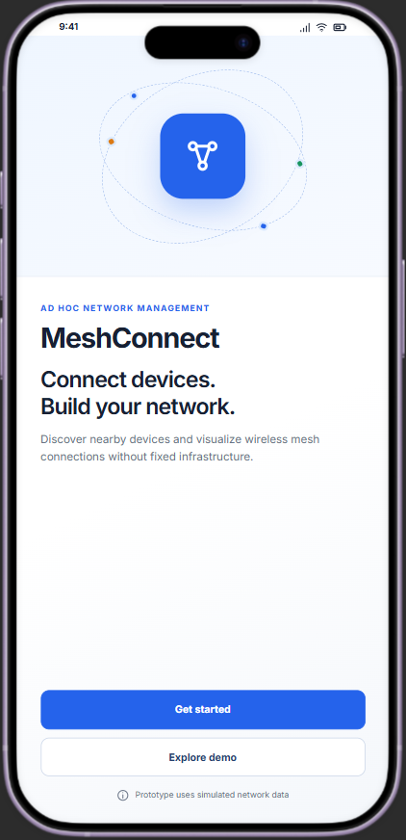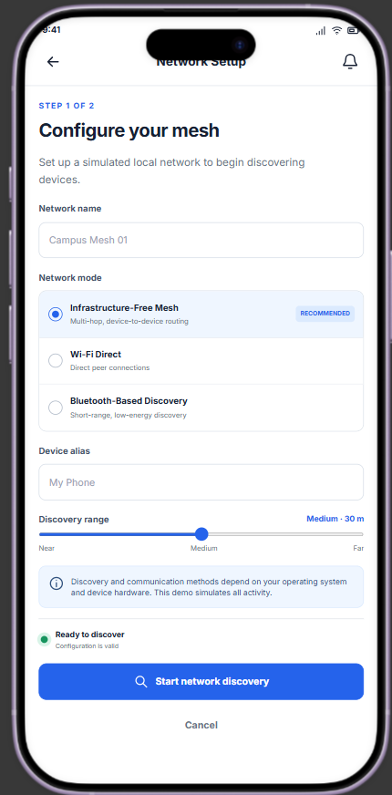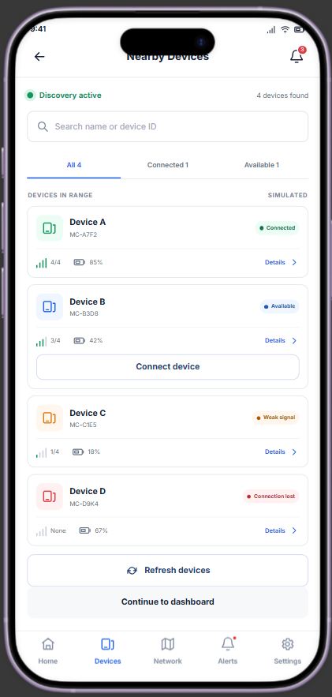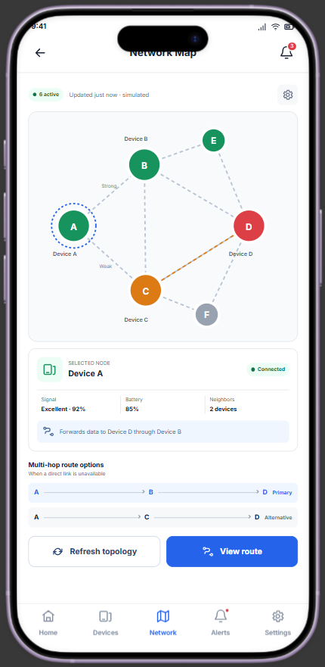

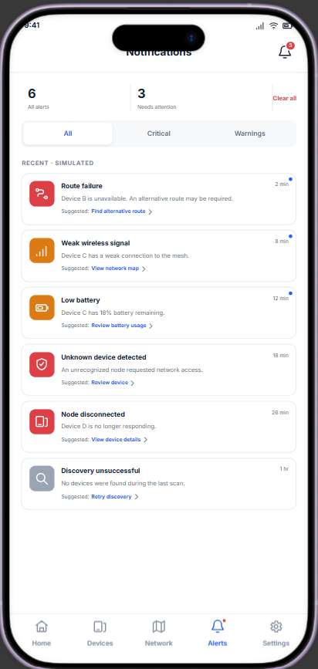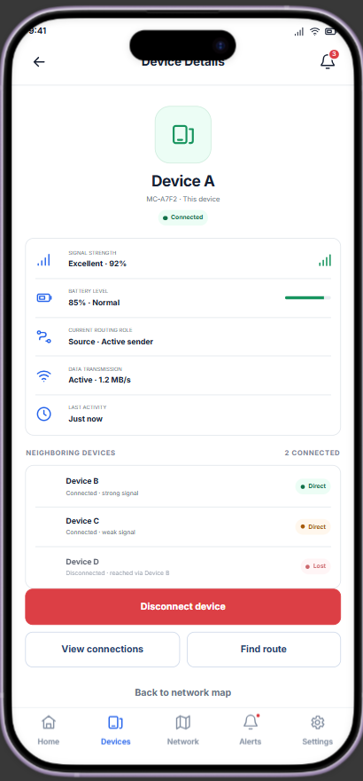
Result: -
Hence a wireframe for a mobile application that addresses challenges related to ad hoc wireless
networks using Figma is created and executed successfully

