7. Develop a dashboard prototype in Figma displaying performance criteria for a cellular system.
Aim: To develop a dashboard prototype in Figma displaying performance criteria for a cellular system.
Procedure:
1. Open Figma
2. Create a new file
3. Select the Frames
4. Fill in the content that is required for presentation 5. Design Visual Elements
6. Make it Interactive
7. Add Annotations and Explanations
8. Incorporate Multimedia
9. Storyboard Animation
10. Review and edit the Prototype
11. Save and Share
Prototype link:
https://www.figma.com/make/iE4WevSayjNUK0tZ7H6iNN/Cellular-Network-Monitoring-Dashboard?t=kP7GFOizHRBHRl7c-0

Design:
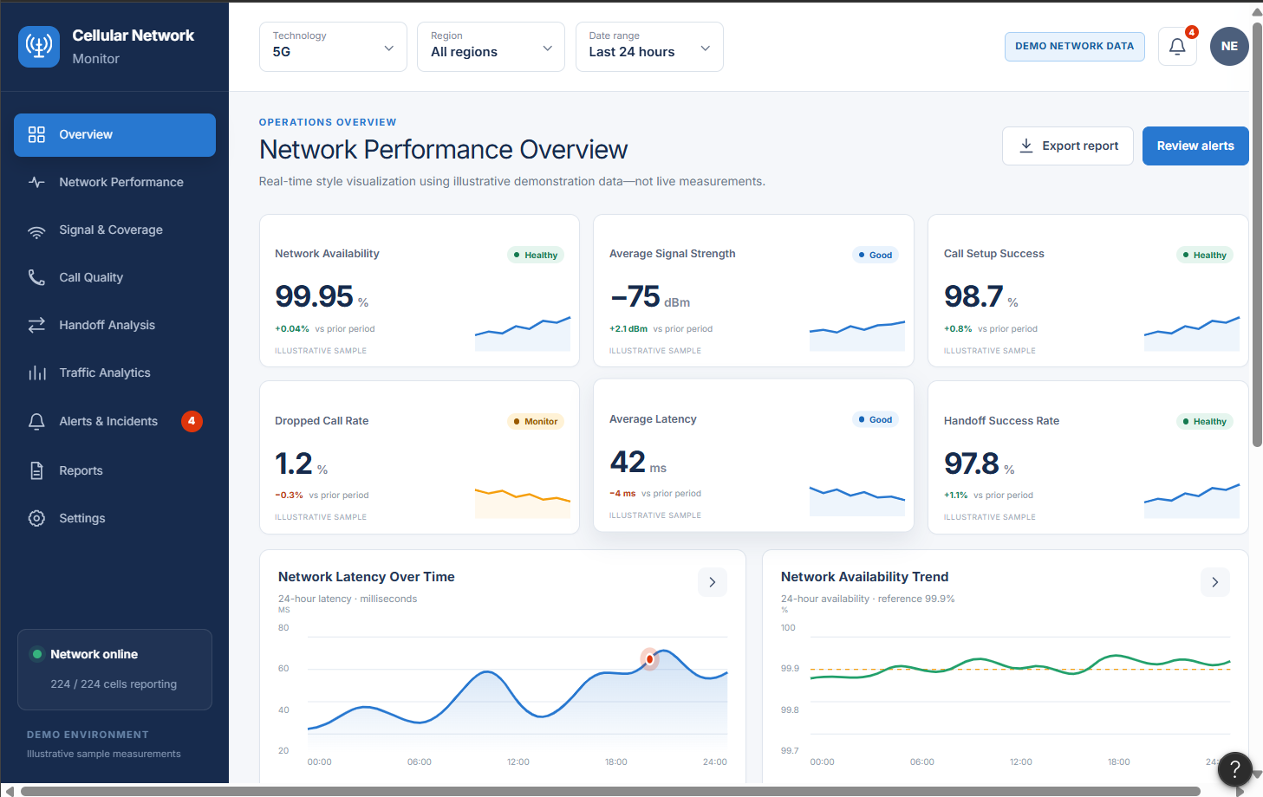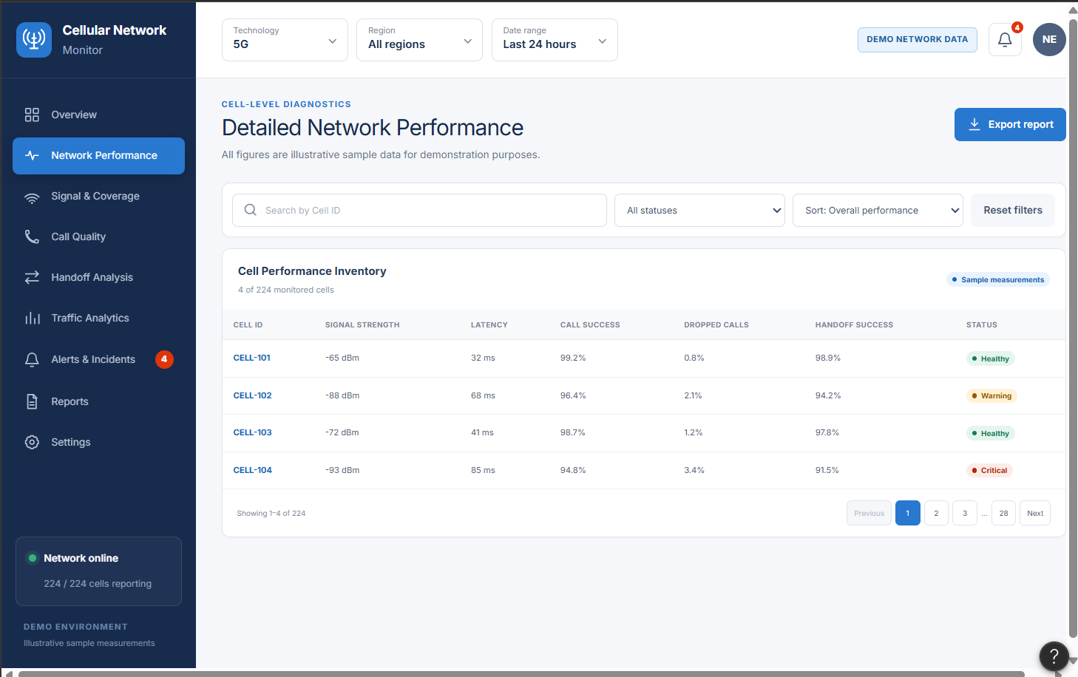
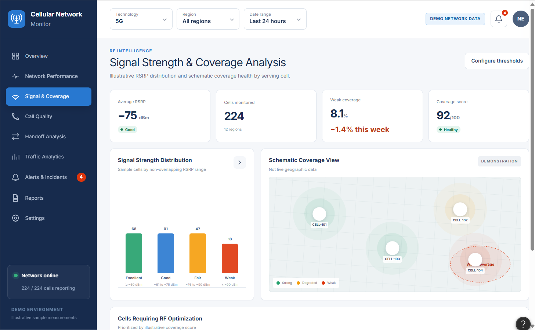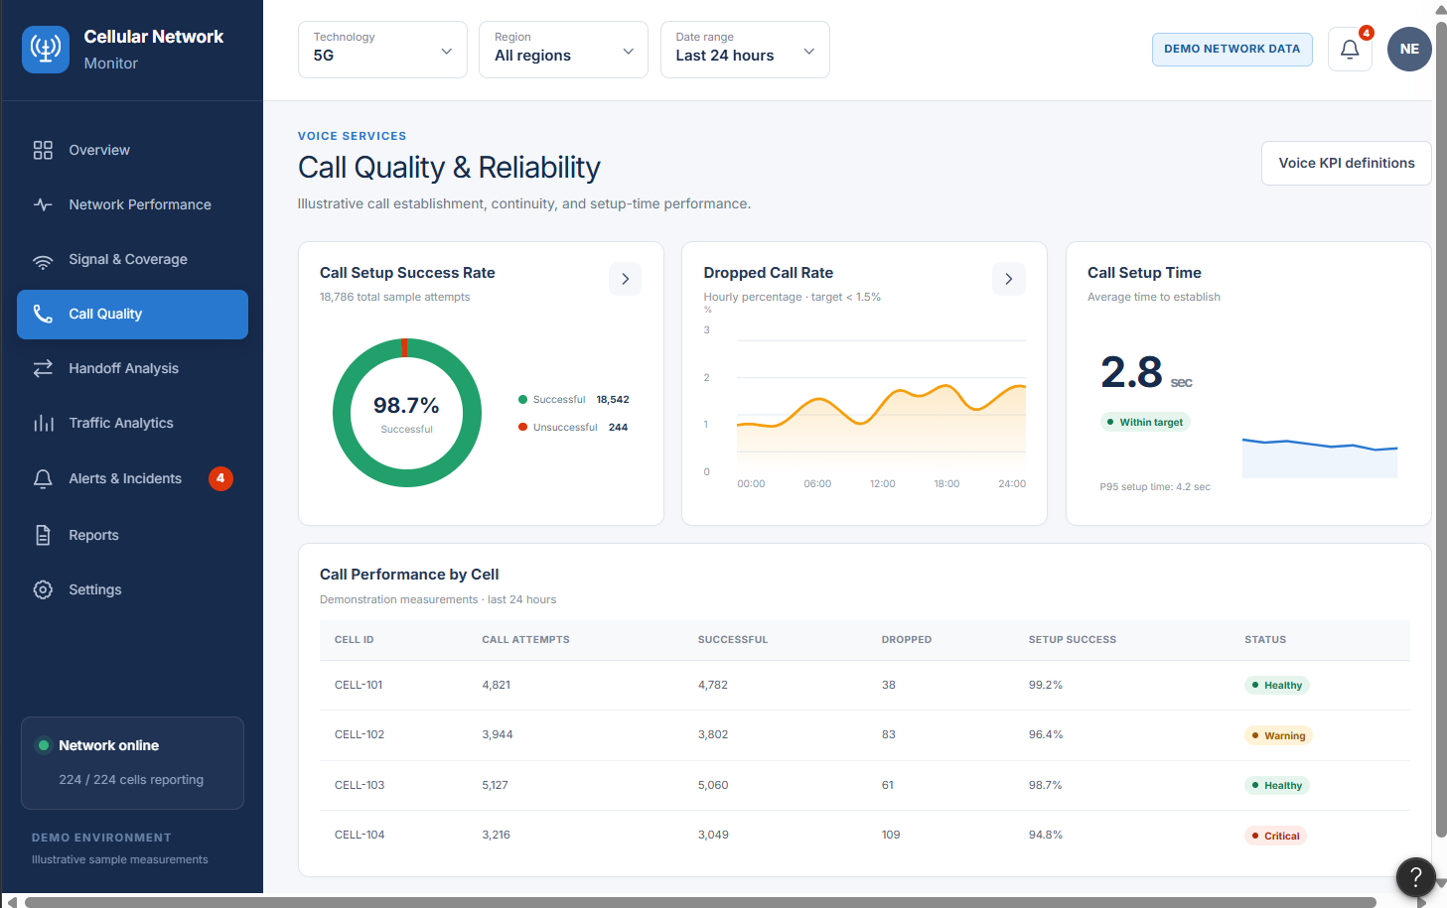
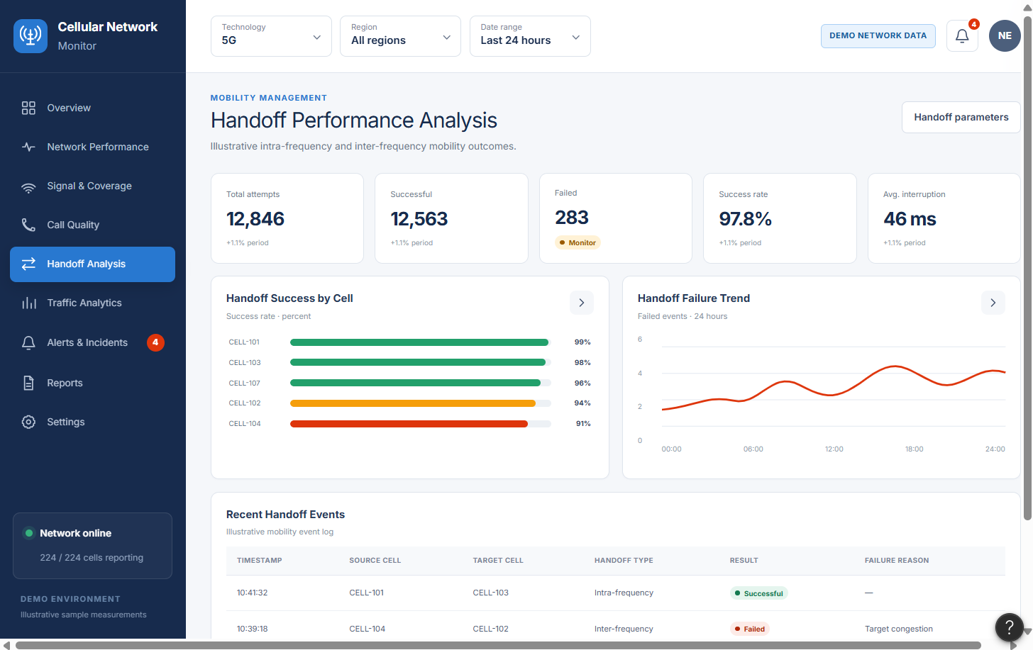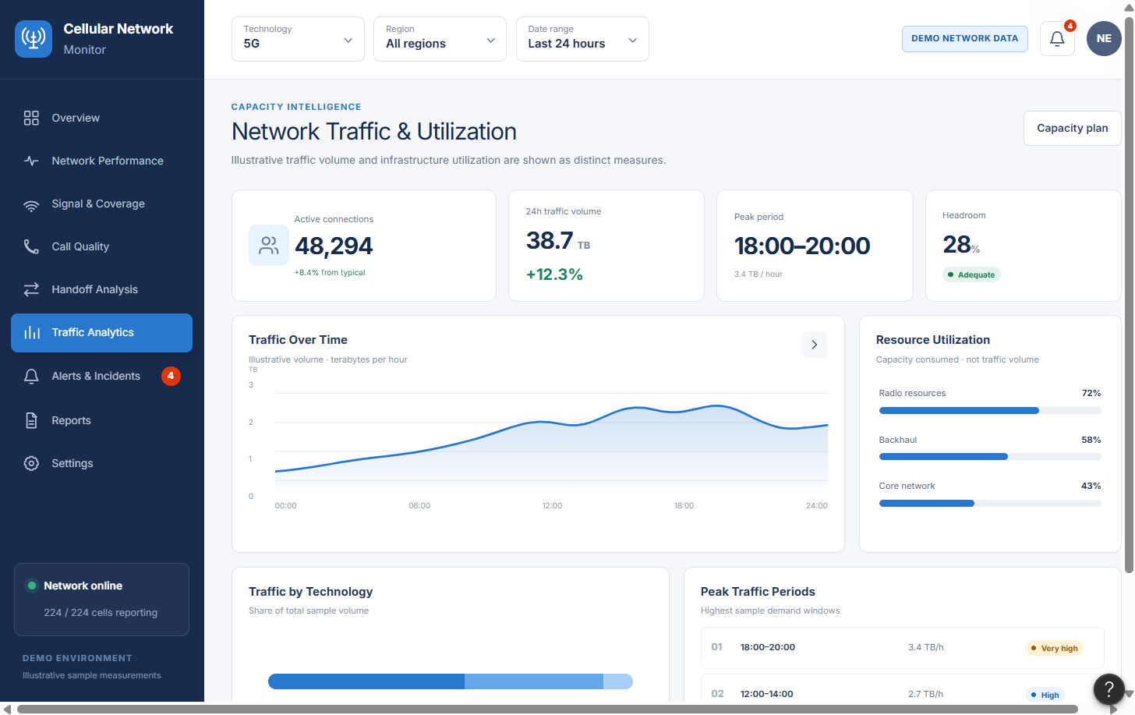
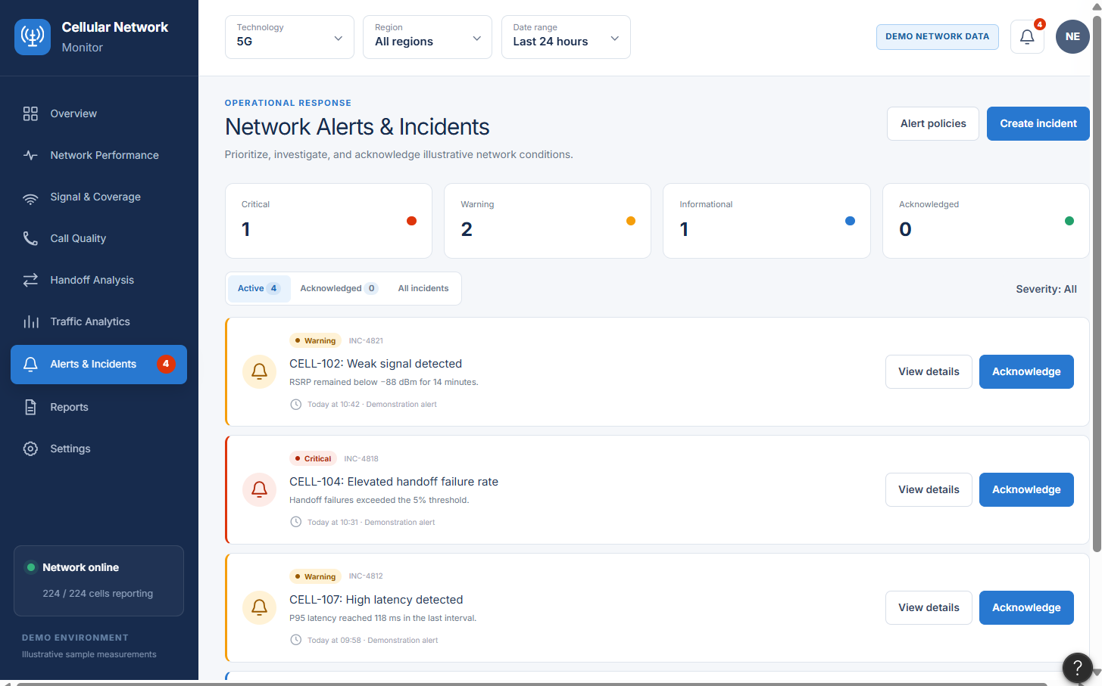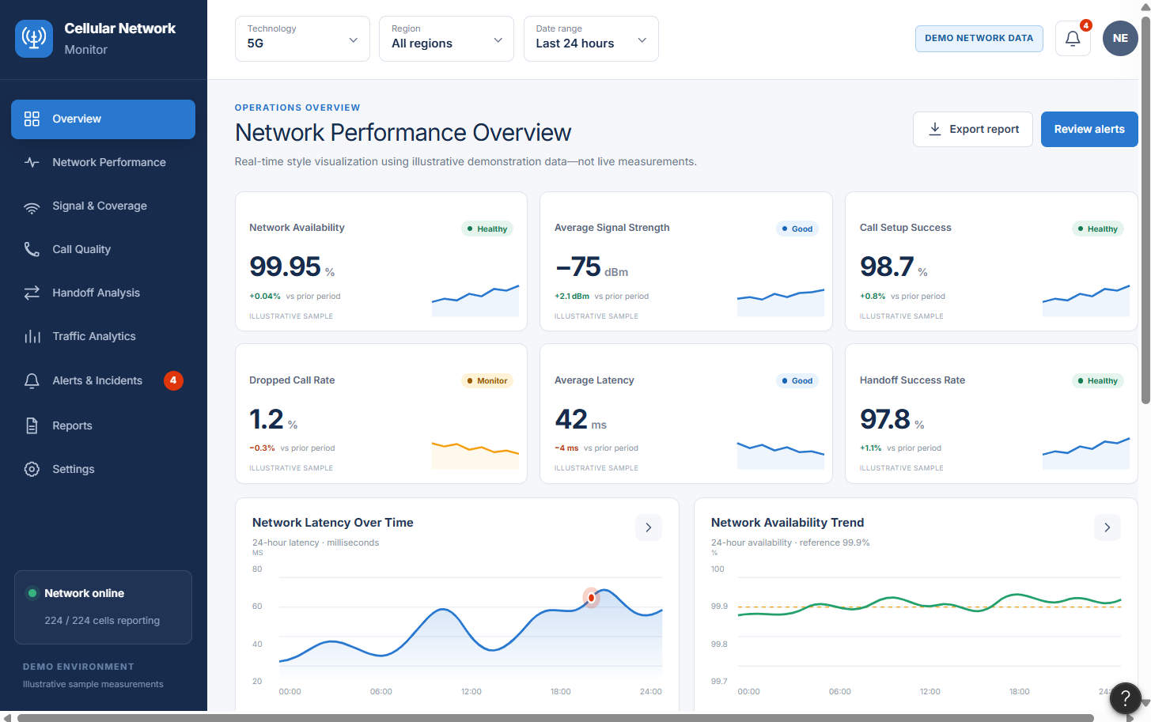

Result:
Hence developed a dashboard prototype in Figma displaying performance criteria for a cellular system.

