Blockchain — Assignment 3
Supply Chain Management DApp
using Polygon and Hardhat

Muhammad Haris
Roll No: 22L-6972
Course: Blockchain

1. Objective
Build a blockchain-based supply chain DApp on the Polygon network that tracks products from Manufacturer → Distributor → Retailer → Customer, with an immutable on-chain audit trail.

2. Tech Stack
- Smart Contract: Solidity 0.8.19
- Framework: Hardhat
- Network: Polygon Amoy Testnet (Chain ID 80002)
- Frontend: React (Vite) + Ethers.js v6
- Wallet: MetaMask

3. Smart Contract — Muhammad_Haris_supplychain.sol
- Roles: None, Manufacturer, Distributor, Retailer, Customer
- Status: Manufactured, InTransit, Delivered
- Core Functions:
  - assignRole(address, Role) — owner only
  - registerProduct(name, description) — Manufacturer only
  - transferOwnership(id, newOwner, status) — current owner only
  - getProduct(id) / getProductHistory(id) — view
Every registration and transfer appends a HistoryEntry on-chain, producing a tamper-proof audit trail.

4. Steps Performed — Compilation to Deployment

4.1 Install & Compile
npm install
npx hardhat compile
Result: Compiled 1 Solidity file successfully.

4.2 Run Tests
npx hardhat test
17/17 tests passing — covering deployment, role assignment, product registration, ownership transfer, and audit-trail edge cases.
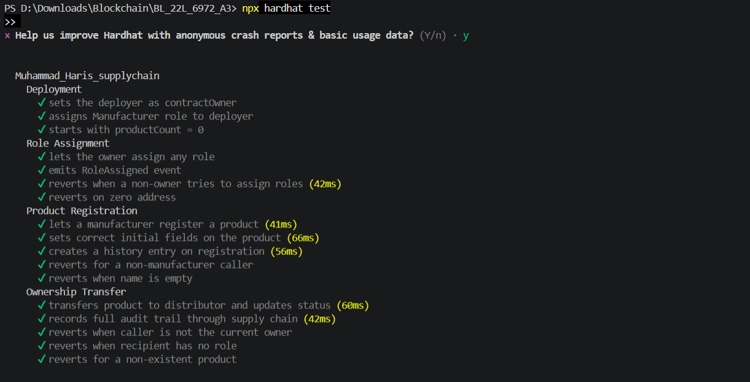
Figure 1. Full test suite passing.

4.3 Configure Environment
Created .env with the deployer private key and the Polygon Amoy public RPC (https://rpc-amoy.polygon.technology). Added Amoy to MetaMask and funded the wallet from https://faucet.polygon.technology.

4.4 Deploy to Polygon Amoy
npx hardhat run scripts/deploy.js --network amoy
Result:
- Contract address: 0xdFE852e192104f8184b43D9F1b72D896bE747D3d
- Tx hash: 0x794e2dc241494c4e138bb3fc6b8647a860f01fd61e0702109164ef78f8992352
- Deployer: 0xD652CAC68231d89a18802A8455dE00A2245278b1
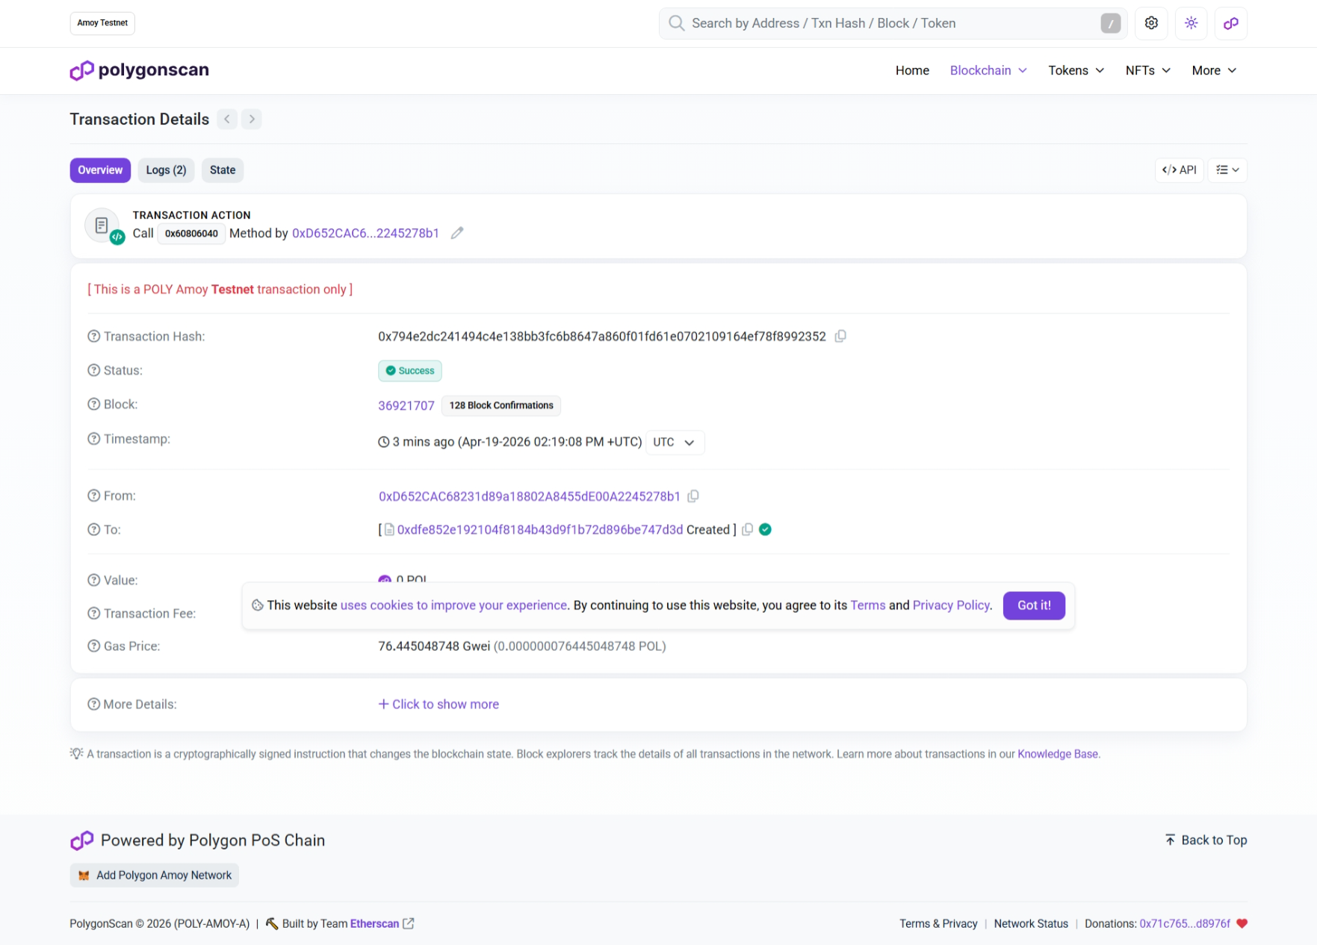
Figure 3. Contract visible on Amoy explorer.

5. Working of the System

5.1 Connection & Roles
User opens http://localhost:5173, connects MetaMask (Amoy network). The app reads the user's role from the contract and exposes only the tabs they are authorized for. The header displays “Muhammad Haris — 22L-6972” on every page. The Manufacturer first assigns Distributor, Retailer, and Customer roles to other wallet addresses.

5.2 Register & Transfer
The Manufacturer registers a product with name + description, which emits ProductRegistered and returns a unique product ID. The product then moves through the chain — each transfer updates currentOwner and status, and appends an audit entry:
- Manufacturer → Distributor (In Transit)
- Distributor → Retailer (In Transit)
- Retailer → Customer (Delivered)

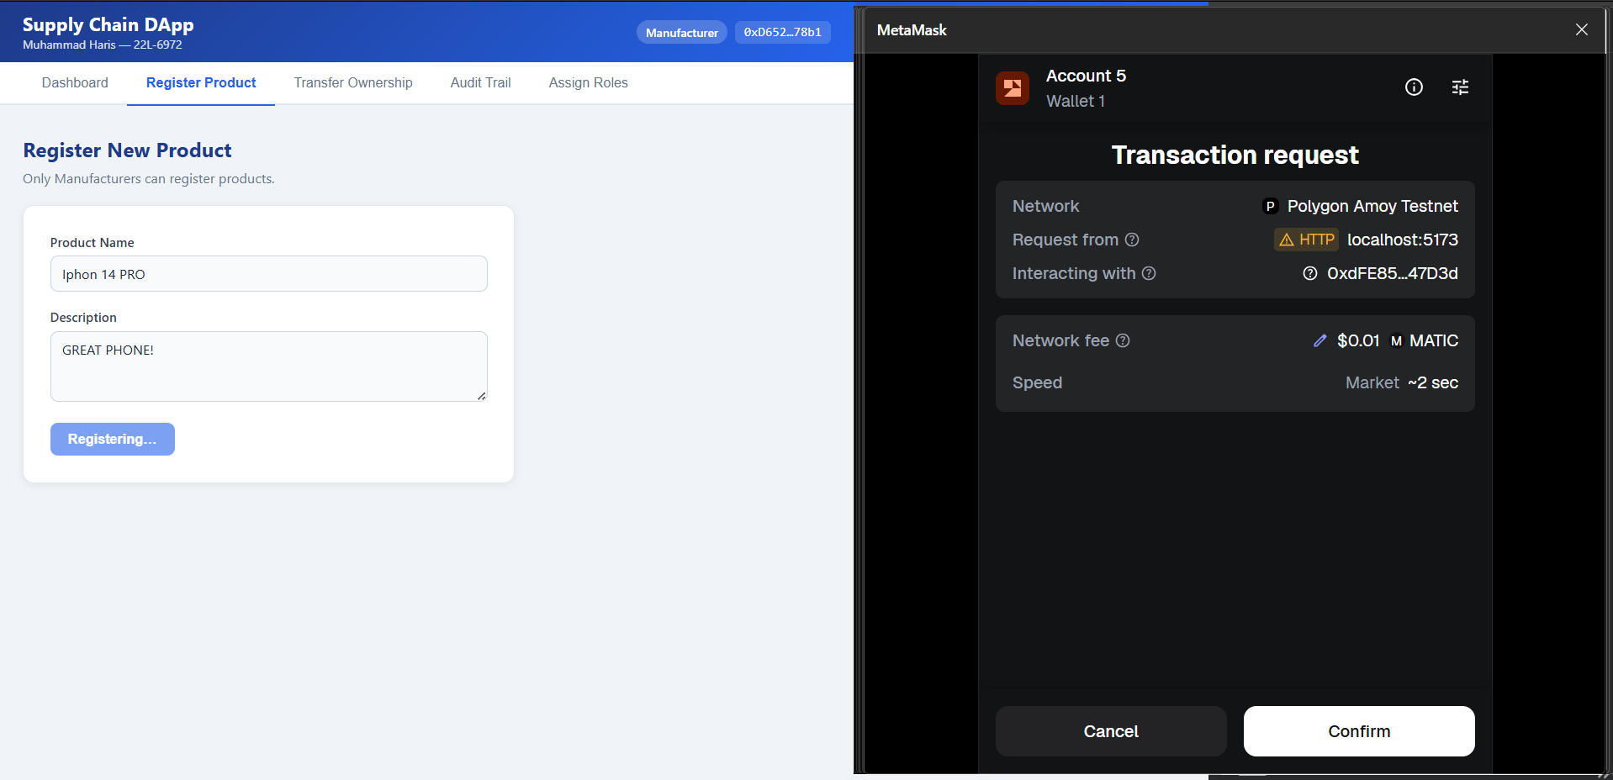

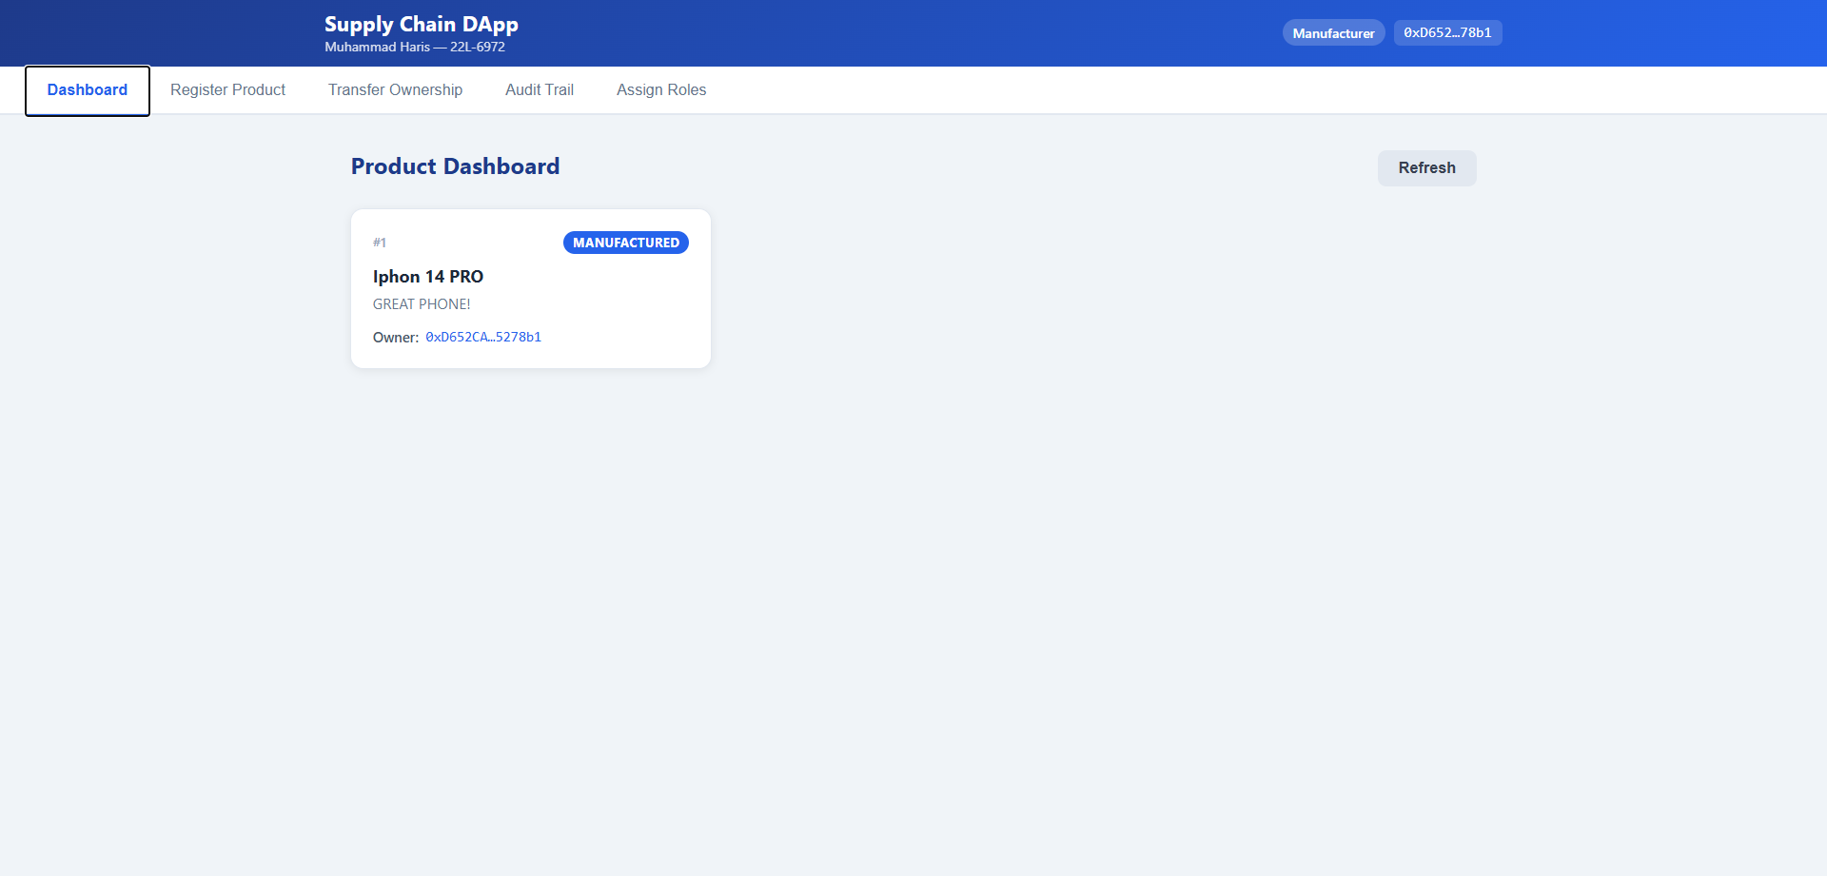
Figure 4. DApp dashboard — product moved through the supply chain.

5.3 Audit Trail
The Audit Trail tab calls getProductHistory(id) and renders the full immutable history as a timeline — confirming all four stages are recorded on-chain.
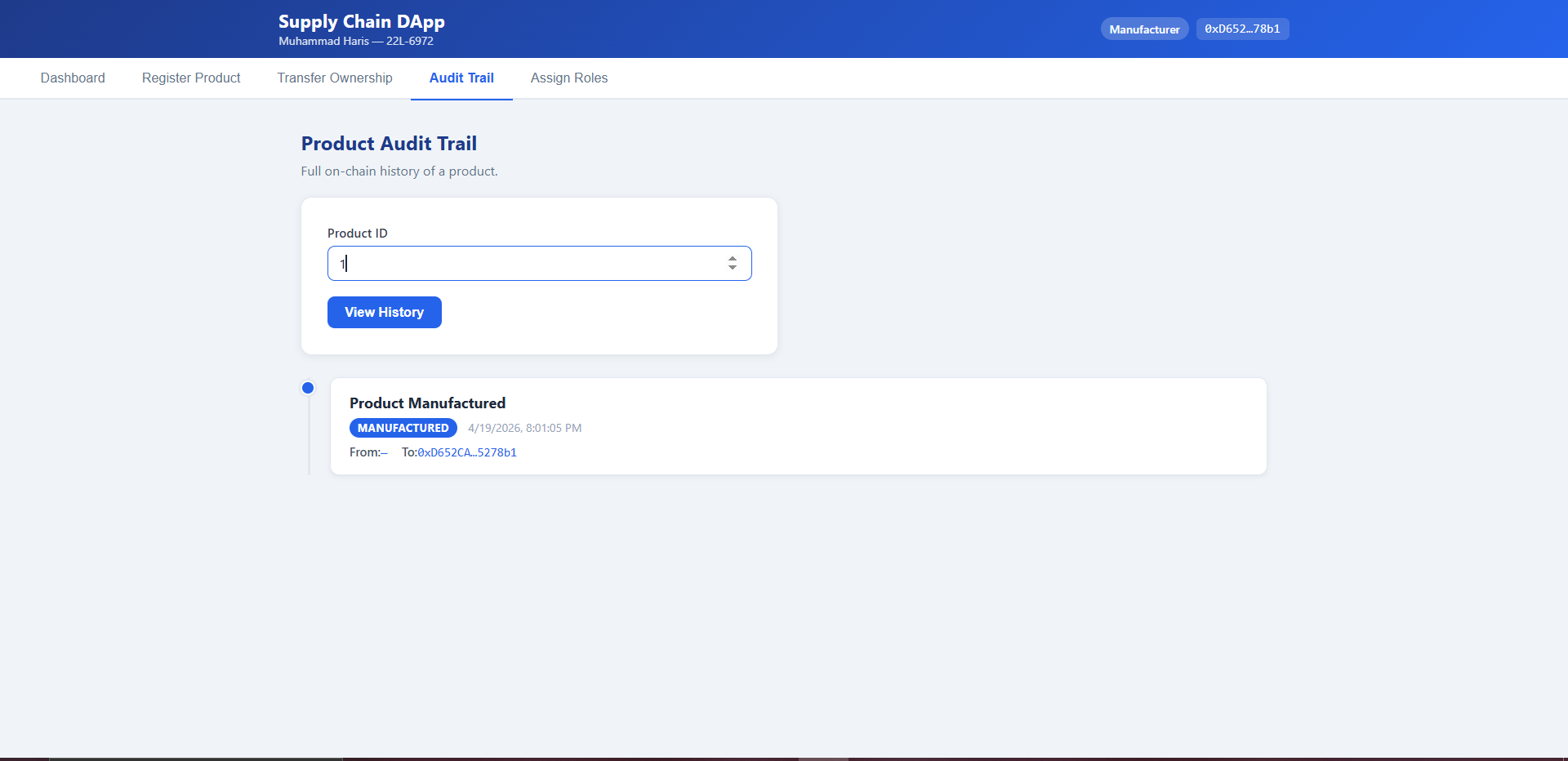
Figure 5. Tamper-proof audit trail for the product.

6. Deliverables Summary
Item | Location / Value
Smart contract source | contracts/Muhammad_Haris_supplychain.sol
Frontend source | frontend/src/ (React + Ethers.js v6)
Contract address | 0xdFE852e192104f8184b43D9F1b72D896bE747D3d
Deployment tx hash | 0x794e2dc241494c4e138bb3fc6b8647a860f01fd61e0702109164ef78f8992352
Network | Polygon Amoy Testnet (chainId 80002)
Explorer link | amoy.polygonscan.com/address/0xdFE852e192104f8184b43D9F1b72D896bE747D3d

7. Conclusion
The DApp delivers a working end-to-end supply chain on Polygon Amoy: role-based access control, unique product IDs, ownership transfers, and a tamper-proof audit trail — all accessible through a React UI that displays my name on every page.

