AI DIET MONITORING APP (“NUTRIVISION AI”)
FYP-I Project Proposal
[Submission date]



[Student Name1, Registration/Roll No]

[Student Name2, Registration/Roll No]

Supervisor: [Name]

This document is submitted to the
Department of Information Technology
in partial fulfillment for the degree
[BSCS]
[Session]

TABLE OF CONTENTS

1. Introduction 1
1.1 Problem Statement 1
1.2 Background/Related work 1
1.3 Scope 1
1.4 Objective 1
2. Proposed TECHNICAL APPROACH 2
2.1 SoftwareRequirements/Tools 2
2.2 Implementation DESIGN 2
3. Deliverables 3
4. Schedule 4
4.1 Timeline 4
5. Design 5
6. GUIDELINES 6

Introduction
Dietary habits play a central role in human health, fitness, and overall well-being. In recent years, the increasing prevalence of obesity, diabetes, and cardiovascular diseases has made diet monitoring more important than ever. At the same time, there has been a growing interest in digital health solutions that empower individuals to track and improve their nutritional intake.
The proposed project is to design and develop an AI-powered Diet Monitoring App, built using the Flutter framework, that simplifies the process of tracking food consumption, provides personalized nutritional feedback, and leverages artificial intelligence to reduce the burden of manual data entry. The app will integrate computer vision for food image recognition, barcode scanning, and nutrition APIs to accurately log meals. In addition, it will feature AI-driven dietary coaching, allowing users to interact conversationally with the system and receive tailored recommendations.
Unlike conventional calorie-tracking applications, this project aims to deliver a cross-platform, intelligent, and user-friendly system that not only monitors dietary intake but also engages users through real-time feedback, gamification, and integration with health ecosystems such as Google Fit and Apple Health.

Problem Statement
Nutrition plays a critical role in maintaining human health and preventing lifestyle-related diseases such as obesity, diabetes, and cardiovascular conditions. However, despite widespread awareness, individuals continue to face major challenges in monitoring and controlling their dietary intake. Studies indicate that most people underestimate calorie intake by 20–30%, primarily because of difficulty in portion estimation and irregular logging practices. The challenge is further compounded by busy lifestyles, limited nutritional literacy, and the inconvenience of existing monitoring systems.
Most available mobile diet monitoring applications require manual entry of food items, where users must search for meals, input portion sizes, and confirm calorie counts. While this method is theoretically accurate, in practice it is time-consuming, tedious, and prone to human error, which discourages consistent usage. For instance, an individual eating a home-cooked meal may find it difficult to identify the exact recipe and portion from an app database. Over time, this logging fatigue leads to incomplete or inconsistent records, reducing the usefulness of the app.
Furthermore, most current solutions provide generic feedback based only on calorie counts. They rarely adapt to user-specific needs such as cultural food preferences, allergies, dietary restrictions, or personalized health goals. This lack of personalization reduces the long-term effectiveness of such tools and often results in abandonment.
Therefore, there is a clear problem: the absence of an intelligent, user-friendly, and automated system for diet monitoring that reduces the reliance on manual input, improves accuracy, and provides personalized, actionable insights. An AI-powered mobile app can address this gap by automating meal recognition, integrating verified nutritional databases, and offering adaptive recommendations that suit individual users’ health goals.

Background/Related work
The rise of mobile health (mHealth) applications over the past decade has led to significant growth in the number of diet and fitness monitoring tools available in app stores. Apps such as MyFitnessPal, Lose It!, Lifesum, and Cronometer are widely used and have millions of active users globally. Their success demonstrates the demand for dietary self-monitoring; however, these tools share common limitations:
- Dependence on manual logging: Users must enter every meal, which is not sustainable in the long term.
- Database limitations: Many apps rely on crowdsourced or inconsistent databases, leading to inaccurate nutrition values.
- Generic recommendations: Advice is usually restricted to calorie counts rather than personalized suggestions based on health goals.
- Engagement issues: Users often discontinue usage after a few weeks due to logging fatigue and lack of meaningful feedback.
Research communities and industry innovators have begun addressing these gaps through artificial intelligence technologies. For example:
- Computer Vision for Food Recognition: Datasets such as Food-101, UEC-Food100, and others have been used to train convolutional neural networks (CNNs) capable of classifying hundreds of food types. Research prototypes like Google’s Im2Calories (2015) demonstrated the possibility of estimating calories from meal images.
- Natural Language Processing (NLP): Large Language Models (LLMs) such as GPT have been increasingly applied in health contexts to provide conversational dietary advice, recipe suggestions, and motivational coaching.
- Integration with Wearables: Many systems now connect with Apple HealthKit, Google Fit, and Fitbit, enabling combined analysis of calorie intake and calorie expenditure.
Despite these advancements, no widely adopted system integrates all three dimensions—computer vision, NLP coaching, and personalized analytics—into one seamless, user-friendly mobile application. Most AI-based food recognition systems remain experimental and are not packaged into accessible apps, while existing commercial apps remain stuck in traditional manual logging models.
This project builds on these developments by proposing an AI-powered diet monitoring app built in Flutter that unifies these technologies. It leverages food image recognition (AI vision models), nutrition databases, and AI coaching (chat-based advice) to provide a truly personalized, intelligent, and engaging dietary monitoring experience.

Scope
The proposed system will be developed as a cross-platform mobile application using Flutter to ensure compatibility with both Android and iOS devices. It will serve as a personal dietary assistant, empowering individuals to monitor their eating habits more accurately and conveniently.
The functional scope of the app includes:
- User Profiling: Collection of age, gender, weight, height, activity level, and health goals (e.g., weight loss, weight maintenance, or muscle gain). Users can also input dietary preferences and restrictions (vegetarian, halal, gluten-free, etc.).
- Meal Logging:
  - Image-Based Logging: Users capture a photo of their meal, and an AI model identifies the food item(s) and estimates calories and macronutrients.
  - Barcode Scanning: Packaged foods can be logged instantly by scanning barcodes to fetch nutrition data from an integrated database.
  - Manual Search: A fallback option that allows users to search a verified food database (e.g., USDA FoodData Central).
- Nutritional Analysis Dashboard: Provides real-time feedback on calories consumed, macros (protein, carbs, fat), and micronutrients compared with user goals.
- AI-Based Recommendations: Suggests healthier alternatives, meal ideas, and portion adjustments based on real-time analysis of user intake.
- Conversational AI Coaching: Allows natural language queries such as “What should I eat for dinner under 500 calories?” and provides context-aware responses.
- Health Ecosystem Integration: Synchronizes with Google Fit and Apple HealthKit to account for calories burned through physical activity.
- Gamification & Motivation: Features streak tracking, achievement badges, and weekly summaries to encourage consistent use.
The non-functional scope includes ensuring data privacy (encrypted storage, secure authentication), offline usability (basic food database and cached results available offline), and scalability (supporting many concurrent users).
The project will not provide clinical or medical-grade nutritional advice. It is designed as a lifestyle support tool and does not replace professional dietitians or physicians.

Objective
The project sets out to achieve the following objectives:
- Automated Food Recognition:
Implement an AI-powered food classification system that uses image recognition to identify food items and estimate nutritional content with minimal manual input.
- Multi-Mode Logging:
Provide users with multiple logging options—photo, barcode scanning, and manual search—to ensure flexibility and accuracy.
- Personalized Nutrition Monitoring:
Create user-specific daily goals based on demographic data and health objectives (e.g., weight loss), and continuously track calories, macronutrients, and micronutrients.
- AI-Powered Recommendations & Coaching:
Integrate a conversational AI assistant capable of delivering meal suggestions, portion adjustments, and motivational tips in natural language.
- Analytics & Visualization:
Provide interactive dashboards displaying daily, weekly, and monthly progress with charts, trends, and summaries that highlight dietary imbalances.
- Integration with Health Platforms:
Sync with wearable and mobile health platforms to create a holistic view of calorie balance (intake vs. expenditure).
- Usability & Engagement:
Design a user-friendly Flutter interface that is fast, intuitive, and engaging, supported by gamification features like streaks and challenges.
- Data Security & Privacy:
Ensure that all user data is securely stored and transmitted, with encryption and clear consent policies in compliance with privacy standards.

Proposed TECHNICAL APPROACH
The development of the proposed AI Diet Monitoring App requires a carefully designed technical approach that ensures functionality, scalability, user-friendliness, and data security. The app will combine cross-platform development (Flutter), AI-based food recognition models, cloud backend services, and integration with health data sources to provide users with a seamless diet monitoring experience.
This section describes the tools, software requirements, system architecture, implementation design, key modules, workflows, and data privacy considerations in detail.

Software Requirements/Tools

Frontend (Mobile Application – Flutter)
The frontend of the system will be developed using Flutter, Google’s UI toolkit for building natively compiled applications for both Android and iOS from a single codebase. Flutter offers a fast development cycle, rich widget libraries, and smooth animations, making it ideal for a consumer-facing health application.
- Programming Language: Dart
- State Management:
  - Provider or Riverpod for simple, reactive state management.
  - Bloc (Business Logic Component) for more complex flows such as meal logging and dashboard updates.
- Networking:
  - dio or http package for API requests (Nutrition API, backend services).
- User Interface and Visualization:
  - fl_chart for plotting daily/weekly calorie and macro graphs.
  - syncfusion_flutter_charts for more advanced visualizations if required.
- Camera & Scanning:
  - camera package for food image capture.
  - mobile_scanner or qr_code_scanner for barcode scanning.
- Local Storage:
  - Shared Preferences for lightweight data like login tokens.
  - Hive for offline caching of nutrition lookups and logs.
- Authentication:
  - firebase_auth for Google, Apple, and email-based login.

Backend Services
Two possible backend strategies are considered depending on complexity and deployment needs:
- Option A (Managed – Firebase):
  - Firestore for real-time cloud database.
  - Firebase Storage for storing meal images (if cloud storage is needed).
  - Firebase Functions for running small serverless logic (e.g., API integration, preprocessing).
  - Firebase Cloud Messaging for push notifications and reminders.
- Option B (Custom – Node.js/Express or Django):
  - A RESTful API exposing endpoints for user profiles, nutrition logs, and AI model results.
  - Database: PostgreSQL (structured relational storage for user profiles, meals, and progress).
  - NoSQL layer: MongoDB for storing unstructured entries like food photos.
  - Cache: Redis to improve query performance for frequently used food items.
  - Deployment on AWS/GCP/Azure, with load balancers and auto-scaling groups for high concurrency.

AI and Machine Learning Tools
- Food Image Recognition:
  - TensorFlow and TensorFlow Lite for training and deploying models.
  - Pre-trained models (e.g., MobileNet, EfficientNet) fine-tuned on food datasets (Food-101, UEC-Food100).
- Conversational AI:
  - OpenAI GPT API or Google Dialogflow for chatbot-style meal recommendations.
  - Custom NLP pipelines for dietary queries (e.g., “Suggest a low-carb dinner under 400 kcal”).
- Nutrition Databases:
  - USDA FoodData Central (free, large dataset).
  - Edamam API or Nutritionix for detailed macronutrient/micronutrient values.

Development Tools
- Version Control: Git with GitHub for collaboration.
- CI/CD: GitHub Actions for automated testing and deployment.
- Project Management: Jira or Trello for task assignment and sprint tracking.
- Testing Tools: Flutter Test (unit/widget tests), Postman for API validation.

Implementation DESIGN
The system will be designed following modular and layered architecture to ensure scalability, maintainability, and ease of integration with external APIs.

High-Level Architecture
- Mobile Client (Flutter App):
  - Captures food photos, barcodes, and manual logs.
  - Displays dashboards, charts, and AI chatbot interface.
  - Handles offline caching of recent logs.
- Backend Services:
  - Manages user authentication, nutrition lookups, and data storage.
  - Provides APIs for user profiles, progress summaries, and AI recommendations.
- AI Layer:
  - On-device TensorFlow Lite model for basic food recognition (fast, offline).
  - Cloud AI services for retraining and advanced classification.
  - NLP chatbot (GPT/Dialogflow) for personalized dietary coaching.
- External Integrations:
  - Nutrition databases (USDA, Edamam, Nutritionix).
  - Health data sources (Google Fit, Apple HealthKit).

System Workflow (End-to-End Example)
- User opens the app and logs in via Firebase authentication.
- User takes a photo of a meal.
- The TFLite model processes the image locally and suggests possible food items.
- The app queries a nutrition API with the identified food to fetch calorie and nutrient values.
- User confirms or adjusts portion size.
- Meal is saved to user’s log in Firestore/Postgres.
- Dashboard recalculates daily calorie balance and macros.
- AI coach provides instant feedback:
  - “Your protein intake is low today, consider adding eggs or lentils for dinner.”
- End-of-day push notification summarises progress:
  - “You consumed 1800 kcal out of 2000. Great job staying within your target!”

Deliverables
The proposed AI Diet Monitoring App will result in several deliverables that demonstrate both the technical implementation and the academic rigor of the project. These deliverables will cover the mobile application itself, supporting AI models, backend services, documentation, and presentation materials.

3.1 Software Deliverables
- Flutter Mobile Application (Android & iOS):
  - Fully functional cross-platform app with features including user onboarding, profile setup, meal logging (via photo recognition, barcode scanning, and manual entry), nutrition dashboards, AI dietary coaching, and notifications.
  - Responsive and intuitive user interface designed for ease of use and accessibility.
- Food Recognition AI Model:
  - A trained TensorFlow/TensorFlow Lite model capable of classifying common food items from images.
  - Integration within the Flutter app for on-device inference, with optional cloud inference for more complex recognition tasks.
  - Model documentation including dataset sources, training methodology, accuracy metrics, and limitations.
- Backend Services and Database:
  - Cloud-hosted backend (Firebase or Node.js/PostgreSQL) providing secure APIs for authentication, user data management, and nutrition lookup.
  - Integration with external nutrition databases (USDA, Nutritionix, or Edamam).
  - Secure data storage with encryption for user logs, profiles, and preferences.
- Conversational AI Module:
  - An integrated AI-powered chatbot for dietary advice and interactive feedback.
  - Support for natural language queries such as “What should I eat for lunch under 500 kcal?” or “Suggest a high-protein dinner.”
  - Documentation of chatbot prompts, logic, and example interactions.

Documentation Deliverables
- System Documentation:
  - High-level architecture diagrams.
  - Detailed module descriptions.
  - API specifications and endpoint documentation.
  - Data flow diagrams for key processes (meal logging, AI recommendations, dashboard updates).
- AI Model Documentation:
  - Dataset description and preprocessing steps.
  - Model architecture and training process.
  - Evaluation metrics (accuracy, precision, recall, F1-score).
  - Limitations and future improvement suggestions.
- User Guide / Manual:
  - Instructions for installing and using the mobile application.
  - Step-by-step guide to logging meals, checking dashboards, and interacting with the AI coach.
  - Troubleshooting common issues.
- Project Report (Final FYP Report):
  - A complete report covering introduction, literature review, technical approach, system design, implementation, results, discussion, limitations, and conclusions.
  - References in required citation style.

Testing and Validation Deliverables
- Test Plan & Test Cases:
  - Unit tests for Flutter components.
  - Integration tests for meal logging workflows.
  - API tests (Postman collections) for backend services.
  - Model validation results (confusion matrices, error analysis).
- Evaluation Results:
  - Quantitative evaluation of food recognition accuracy.
  - Usability testing feedback from a sample group of users.
  - Performance testing for response times and scalability.

Presentation Deliverables
- Project Proposal Presentation (FYP-I):
  - A PowerPoint presentation summarizing the problem, objectives, technical approach, and planned outcomes.
- Final Demonstration (FYP-II):
  - Live demo of the mobile application.
  - Showcase of AI features including photo-based meal recognition and AI dietary coach.
- Poster / Infographic:
  - A visual summary of the project, highlighting key contributions, system architecture, and results.

Expected Outcomes
At the end of the project, the following outcomes are expected:
- A working cross-platform mobile app that simplifies dietary tracking.
- An AI-powered food recognition model integrated into the app.
- A personalized nutrition recommendation system with dashboards and interactive coaching.
- Secure backend infrastructure ensuring scalability and privacy.
- Comprehensive documentation, including technical details, test results, and user manuals.
- Academic contributions in the form of the final report and project presentation.

Schedule
The project will be completed in a series of well-defined phases across 12 weeks. Each phase will focus on key activities such as requirement gathering, design, implementation, AI model integration, testing, and reporting. The schedule ensures systematic progress and timely delivery of milestones.

Timeline
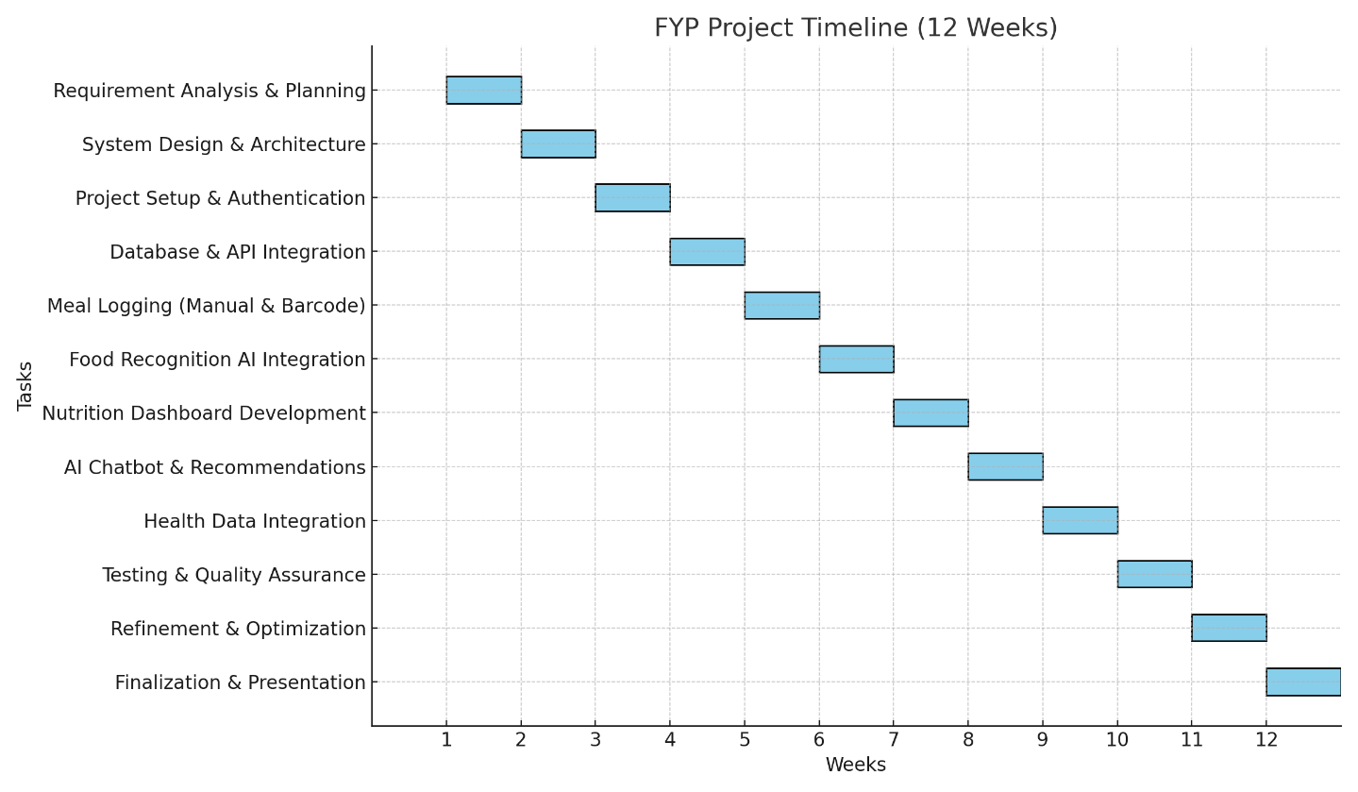

Week 1 – Project Initiation & Requirement Analysis
- Finalize problem statement and project objectives.
- Conduct literature review on existing diet monitoring apps and AI-based food recognition.
- Identify functional and non-functional requirements.
- Prepare use cases and initial user stories.
- Define scope and confirm tools/technologies to be used.
- Deliverable: Requirement Specification Document.

Week 2 – System Design & Planning
- Create high-level system architecture (frontend, backend, AI integration).
- Design data flow diagrams and ER diagrams for database schema.
- Define core modules and their interactions.
- Draft UI/UX wireframes for the mobile app (profile, dashboard, meal logging, chatbot).
- Deliverable: System Design Document & Wireframes.

Week 3 – Project Setup & Authentication Module
- Set up Flutter development environment and project repository.
- Configure Firebase/Node.js backend for authentication.
- Implement user registration, login, and profile setup (age, weight, goals).
- Deliverable: Authentication & Profile Module.

Week 4 – Database & API Integration
- Set up database (Firestore/PostgreSQL).
- Integrate Nutrition API (USDA, Edamam, or Nutritionix).
- Develop API endpoints for user profiles, meal logs, and nutrition lookup.
- Deliverable: Backend & Database Functional Prototype.

Week 5 – Food Logging (Manual Entry & Barcode Scanning)
- Implement manual food search and logging using Nutrition API.
- Add barcode scanning functionality for packaged foods.
- Store logged meals in the database and update daily totals.
- Deliverable: Basic Meal Logging System.

Week 6 – Food Recognition AI (Model Training & Integration)
- Train/fine-tune food classification model using Food-101/UEC datasets.
- Convert trained model to TensorFlow Lite for on-device inference.
- Integrate model into Flutter app for real-time food recognition via camera.
- Deliverable: Food Recognition Prototype.

Week 7 – Nutrition Dashboard & Visualizations
- Implement daily/weekly dashboard showing calories, macros, and progress.
- Add charts and graphs (using fl_chart).
- Provide summary comparisons with user goals.
- Deliverable: Nutrition Analytics Dashboard.

Week 8 – AI Chatbot & Recommendations
- Integrate OpenAI GPT/Dialogflow for dietary coaching.
- Enable natural language queries (e.g., “Suggest dinner under 600 kcal”).
- Implement recommendation engine for healthy swaps and suggestions.
- Deliverable: AI Diet Coach Module.

Week 9 – Health Data Integration
- Integrate Google Fit / Apple Health for calorie expenditure.
- Sync steps, heart rate, and calorie burn data with nutrition logs.
- Deliverable: Health Integration Module.

Week 10 – Testing & Quality Assurance (QA)
- Conduct unit testing of Flutter components.
- Perform integration testing (logging → dashboard → AI coach).
- Validate AI model accuracy with test dataset.
- Conduct usability testing with a small user group.
- Deliverable: Test Report & Validation Results.

Week 11 – Refinement & Optimization
- Fix bugs and optimize app performance (loading times, caching).
- Refine UI/UX based on feedback.
- Improve chatbot prompts and meal recommendations.
- Prepare documentation drafts (user manual, technical doc).
- Deliverable: Refined Prototype & Draft Documentation.

Week 12 – Finalization & Presentation
- Finalize all documentation (system docs, user guide, final report).
- Prepare final presentation slides and poster.
- Conduct end-to-end demo of the mobile app.
- Deliverable: Final Report, Presentation, and App Demonstration.

Design
The design of the proposed AI Diet Monitoring App follows a modular architecture. Each module is responsible for a specific function while interacting with others to provide a seamless user experience. This modular approach ensures scalability, maintainability, and flexibility for future enhancements.

System Modules

Authentication & User Profile Module
- Handles user registration, login, and authentication (via Firebase/Google/Apple/email).
- Stores demographic and biometric information such as age, weight, height, gender, and activity level.
- Allows users to set dietary preferences and health goals (e.g., weight loss, maintenance, or muscle gain).

Food Logging Module
- Photo Logging: Users capture food images. The app uses an AI model (TensorFlow Lite) to identify the meal and estimate calories/macros.
- Barcode Logging: Users scan packaged food items to retrieve nutrition values from a verified database.
- Manual Entry: Users can search and log meals directly from the integrated nutrition database.

Nutrition Database & API Module
- Connects with external databases such as USDA FoodData Central, Edamam, or Nutritionix.
- Ensures that all nutrition values (calories, macros, and micronutrients) are accurate and verified.
- Provides backend services for food lookups and data storage.

AI Diet Coach Module
- Conversational chatbot powered by GPT/Dialogflow.
- Provides personalized recommendations and answers to user queries (e.g., “What should I eat for dinner under 600 kcal?”).
- Delivers motivational feedback, portion control tips, and healthy meal swaps.

Nutrition Analytics & Dashboard Module
- Displays daily, weekly, and monthly summaries of calorie intake and macronutrient distribution.
- Provides charts, graphs, and visual cues to highlight trends and imbalances.
- Tracks progress against user goals.

Health Integration Module
- Syncs with Google Fit and Apple Health to import data on calories burned, steps, and physical activity.
- Calculates net calorie balance (intake vs. expenditure).

Notifications & Gamification Module
- Sends reminders for meal logging, hydration, or activity.
- Tracks streaks and achievements to encourage consistent usage.
- Provides weekly progress summaries.

Settings & Privacy Module
- Allows users to control preferences, notifications, and privacy options.
- Provides data export and deletion functionality.
- Ensures compliance with data security standards (TLS, AES encryption).

fLOW diaram
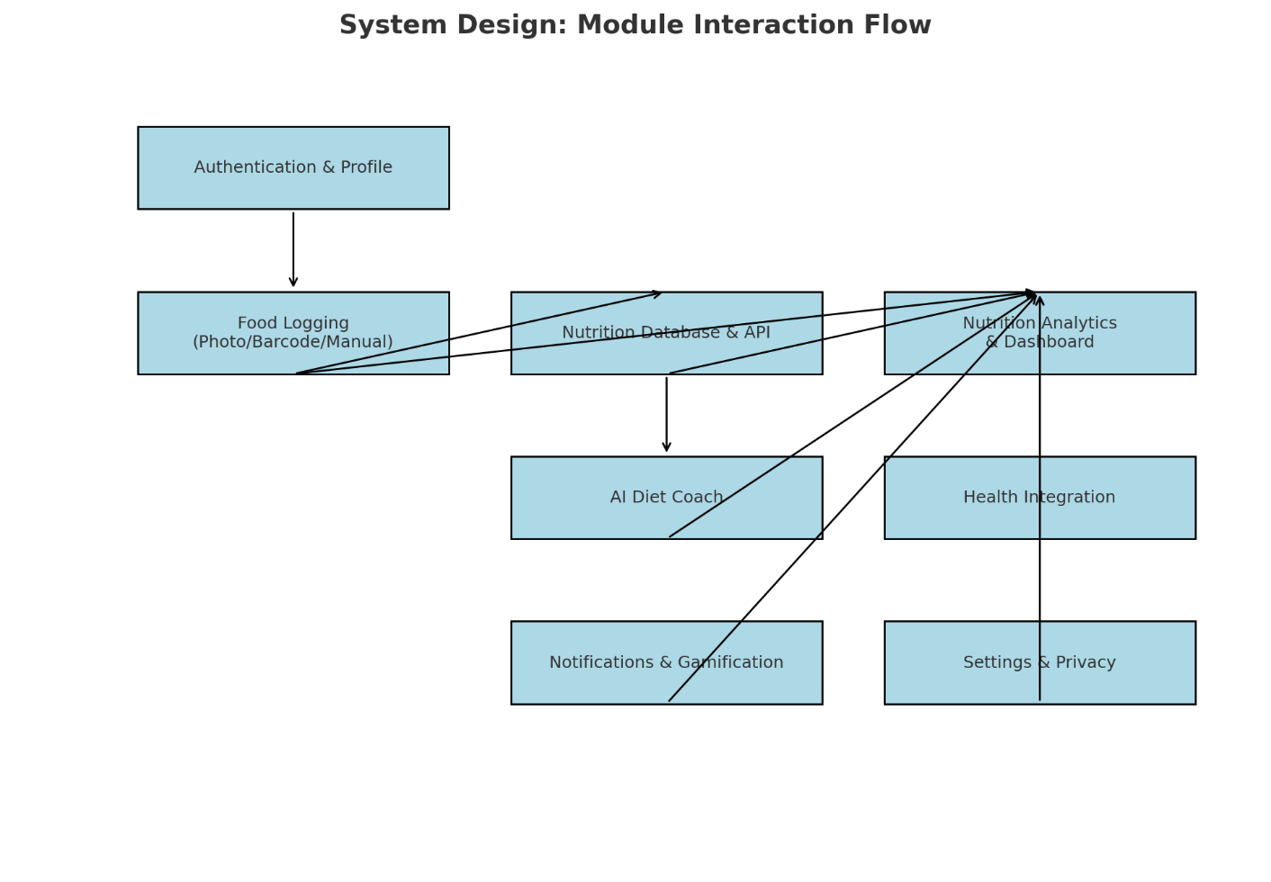

INSTRUCTION:
Some key points while writing proposal.
1. Heading 1 (17 PT / Bold / UPPER CASE)
2. Heading 2 (15 PT/ Bold/ Title Case)
3. Heading 3 (13 PT /Bold / Title Case)
4. Paragraph (12 PT Normal, Justify)
5. Line Spacing 1.5
6. Before Paragraph Spacing (0 PT)
7. After Paragraph Spacing (12 PT)
8. Same Bullets Style in Different area
9. Figure Caption [Below Picture]
10. Table Caption [Before Table]
11. Same Font Style in whole Document
12. Consider This Document as sample for writing proposal/ project.

