microbetag: simplifying microbial network
interpretation through annotation, enrichment tests and metabolic complementarity analysis
Haris Zafeiropoulos¹, Ermis Ioannis Michail Delopoulos¹, Andi Erega², Annelies Geirnaert², John Morris³, Karoline Faust^{1*}

¹ Department of Microbiology, Immunology and Transplantation, Rega Institute for Medical Research, KU Leuven, Herestraat, Leuven, 3000, Belgium.
² Institute of Food, Nutrition and Health, ETH Zurich, Street, Zurich, 8092, Switzerland.
³ Resource for Biocomputing, Visualization, and Informatics, University of California San Francisco, 16th Street, San Francisco, 94143, California, USA.

*Corresponding author(s). E-mail(s): karoline.faust@kuleuven.be;
Contributing authors: haris.zafeiropoulos@kuleuven.be ;
ermisioannis.michaildelopoulos@student.kuleuven.be; andi.erega@hest.ethz.ch; annelies.geirnaert@hest.ethz.ch ; scooter@cgl.ucsf.edu ;

Abstract

Background:
The inference of microbial association networks from metagenomic data is a popular hypothesis-generating method, yet its use is hampered by low accuracy and tool dependency “Reverse ecology” uses genomic and metabolic modeling to predict ecological traits for less well-known microorganisms and their interactions within microbial communities. microbetag combines reverse ecology approaches with phenotypic trait mapping to ease the interpretation of microbial association networks.
Results:
microbetagDB consists of 34,608 high-quality Genome Taxonomy DataBase genomes, along with their corresponding KEGG annotations and genome-scale metabolic reconstructions. Seed sets (externally acquired compounds) were retrieved from the latter, supporting the prediction of over 1 billion potential pairwise metabolic interactions. Relying on KEGG MODULE definitions, 342,000 unique pathway complements were identified based on pairwise overlaps between the annotated genomes. In addition, 33 phenotypic traits (e.g., pH optima, oxygen tolerance etc.) were predicted for the annotated genomes and incorporated in microbetagDB. microbetag maps node taxonomies to their closest genome in microbetagDB and annotates them with phenotypic traits and functional potential previously derived from the literature. Edges are then annotated with pathway complements and seed complementarities that may represent cross-feeding relationships.

In a validation case, microbetag successfully identified known metabolic interactions between Variovorax and neighboring species, enabling the latter to produce thiamine. Using a 16S rRNA data set of infant microbiota supplemented with iron and a set of prebiotics, the potential of microbetag as a hypothesis generation tool was showcased suggesting potential mechanisms for butyrate producers increase.
Accessible as a CytoscapeApp, microbetag offers a user-friendly interface called microbetag GUI (MGG) that simplifies the construction of a fully annotated co-occurrence network from an abundance table, providing a quick and intuitive way to explore hypotheses about microbial interactions. A microbetagDB free version of our approach enables its usage directly to custom sets of reference genomes; this way microbetag can be used to extract complementarities from user’s Metagenome Assembled Genomes (MAGs). All microbetag-annotated networks can be visualized and investigated using MGG.

Conclusions:
microbetag, together with its database and GUI, simplify the interpretation of microbial association networks by systematically integrating prior knowledge about the taxa involved.

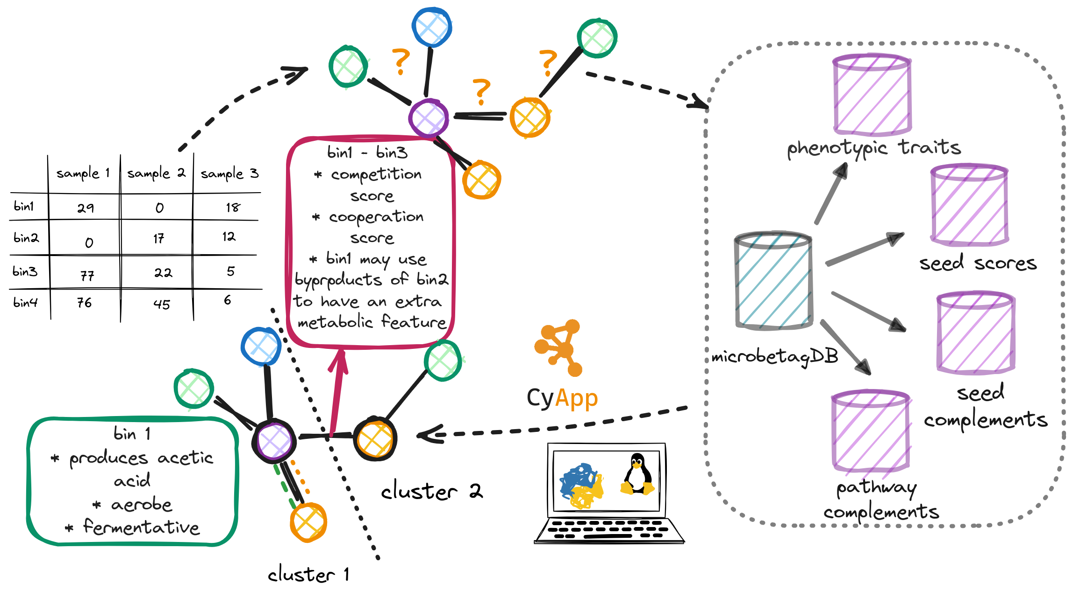
Figure abstract.
Keywords: microbial associations, enrichment analysis, data integration, pathway complementarity, seed set

Background
Microbial interactions play a fundamental role in the stability and resilience of ecosystems and their processes; from soils, aquatic environments and biogeochemical cycles [1] to host-associated environments and the human health [2, 3]. Most microbial species live only in communities [4] and most natural microbial communities consist of hundreds or even thousands of species [5]. Each species exhibits a unique repertoire of reactions and adapts to various niches, each with specific nutrient and environmental requirements.
Depending on the net fitness effects that result for the taxa involved, interactions range from cooperation, competition, parasitism, commensalism and amensalism [3]. Metabolic interactions can be established through a range of contact-independent and contact-dependent mechanisms leading to both positive and negative interactions. These interactions can involve either one-way (unidirectional) or two-way (bidirectional) exchanges of metabolites. Depending on the biosynthetic cost borne by the interacting partners, two types of metabolite exchanges occur: byproduct cross-feeding, where metabolites result from a selfish act of the producer, and cooperative cross-feeding, where one partner actively invests resources to produce metabolites benefiting the interaction partner [7].
High-throughput sequencing (HTS) has provided insight into the diversity and composition of microbial communities [8]. Uncultivated species can now be detected, and their features can be inferred from their genomic information [9]. Moreover, the composition of thousands of microbiome samples is now accessible allowing for the inference of patterns across sets of samples. A widely used approach to extract such patterns is the creation of microbial co-occurrence (aka association) networks based on metagenomic read data (amplicon and/or shotgun) [10]. Several approaches are available for co-occurrence network inference based on a range of statistical concepts such as: correlation (e.g., CoNet [11], SparCC [12]) and conditional dependency identification (e.g., SpiecEasi [13], FlashWeave [14]). Nevertheless, microbial co-occurrence networks continue to encounter various challenges [15, 16]. Each inference approach comes with its own assumptions and parameterization, leading to variations in network structure. The choice of the association measure, the data preprocessing techniques applied and the handling of sparsity and zero inflation, and considerations for indirect causal relationships all influence the resulting network. As a consequence, the result of network construction is tool-dependent [17, 18]. Moreover, microbial network inference inherits the challenges of metagenomic data and analysis (e.g., sampling scale, compositionality, tuning of parameters linked to sequencing data processing) and the returned network is often a ”hairball” of densely interconnected taxa. Thus, additional analysis is necessary to generate testable hypotheses [15].
The assessment of interactions predicted by microbial co-occurrence networks has underscored their low accuracy for this task [19-21]. Data integration has been suggested to address this challenge [15]. In addition, clusters in microbial association networks have been demonstrated to mirror key drivers of community composition [22] and several algorithms and implementations are available to identify them [23]. However, data integration approaches in microbial co-occurrence networks are so far limited. Here, we present microbetag, a microbial co-occurrence network annotator that exploits several channels of information to enhance or reduce the confidence into the associations suggested by the network and generate hypotheses for further investigation both at the taxon pair and the community level.
microbetag serves as a comprehensive platform that provides information on taxa along with their potential metabolic interactions from multiple channels (see “Implementation”). The key concept here is the reverse ecology approach [24]. Reverse ecology leverages genomics to explore community ecology with no a priori assumptions about the taxa involved. The reverse ecology framework enables the prediction of ecological traits for less-understood microorganisms, their interactions with others, and the overall ecology of microbial communities [25].
Metabolic networks are comprehensive representations, in a mathematical form, of biochemical reactions occurring within an organism's cells or a biological system [26–28]. Over the last decade, (semi-) automated approaches support such reconstructions in a time-efficient way [carveme, modelseed etc.]. A metabolic network’s “seed set” is the set of compounds that, based on the network topology, cannot be produced by the organism and need to be acquired exogenously [29] (Fig. 2). Such seeds might be independent, i.e. they cannot be produced by any other biochemical reaction in the metabolic network, or they can be interdependent forming groups of seed compounds. Seeds are a useful proxy for the essential nutrients of an organism [30, 31]. Based on the seed concept, several graph theory-based metrics (indices) have been described to predict species interactions directly from their metabolic networks’ topologies [32–34].
Metabolic complementarity among species reflects the potential for cooperation through cross-feeding. In contrast, metabolic competition refers to the metabolic overlap between two species leading to exploitative competition, e.g. for nutrient resources. Seed and non-seed compound sets can be used to compute complementarity and overlap indices. The examination of such indices can reveal metabolic interactions leading to patterns observed in co-occurrence network.
However, such indices consider a species genomic repertoire as a bag of genes and thus, they cannot resolve how exactly a species could benefit another [35-37]. To explore whether a species may benefit from a partner, it is helpful to move from the network to the pathway level and check whether their pathways complement each other. We present here a naive approach exporting all possible complements between a pair of species based on their KEGG ORTHOLOGY (KOs) annotations and the KEGG MODULES database [38].
microbetag annotates a user’s co-occurrence network by integrating phenotypic traits of the taxa present in the network (nodes) and by mapping potential metabolic interactions onto their associations (edges). microbetag includes a Graphical User Interface (GUI) implemented as a Cytoscape (Shannon, et al. 2003) App (Saito, et. al. 2013) providing a user-friendly environment to investigate annotations in a straightforward way. All annotations present in microbetagDB are also available through an Application Programming Interface (API). microbetag’s source code is distributed under a GNU GPL v3 license and available on GitHub. Documentation and further support on how to use microbetag is available at the documentation website. To the best of our knowledge there is no software with which microbetag could be compared directly. To validate our annotations, we used a recently published network with partially known interactions between some pairs of species found to be associated [39]. To demonstrate microbetag’s potential, we present the main features of its interface, and we discuss a real-world use-case.

Implementation

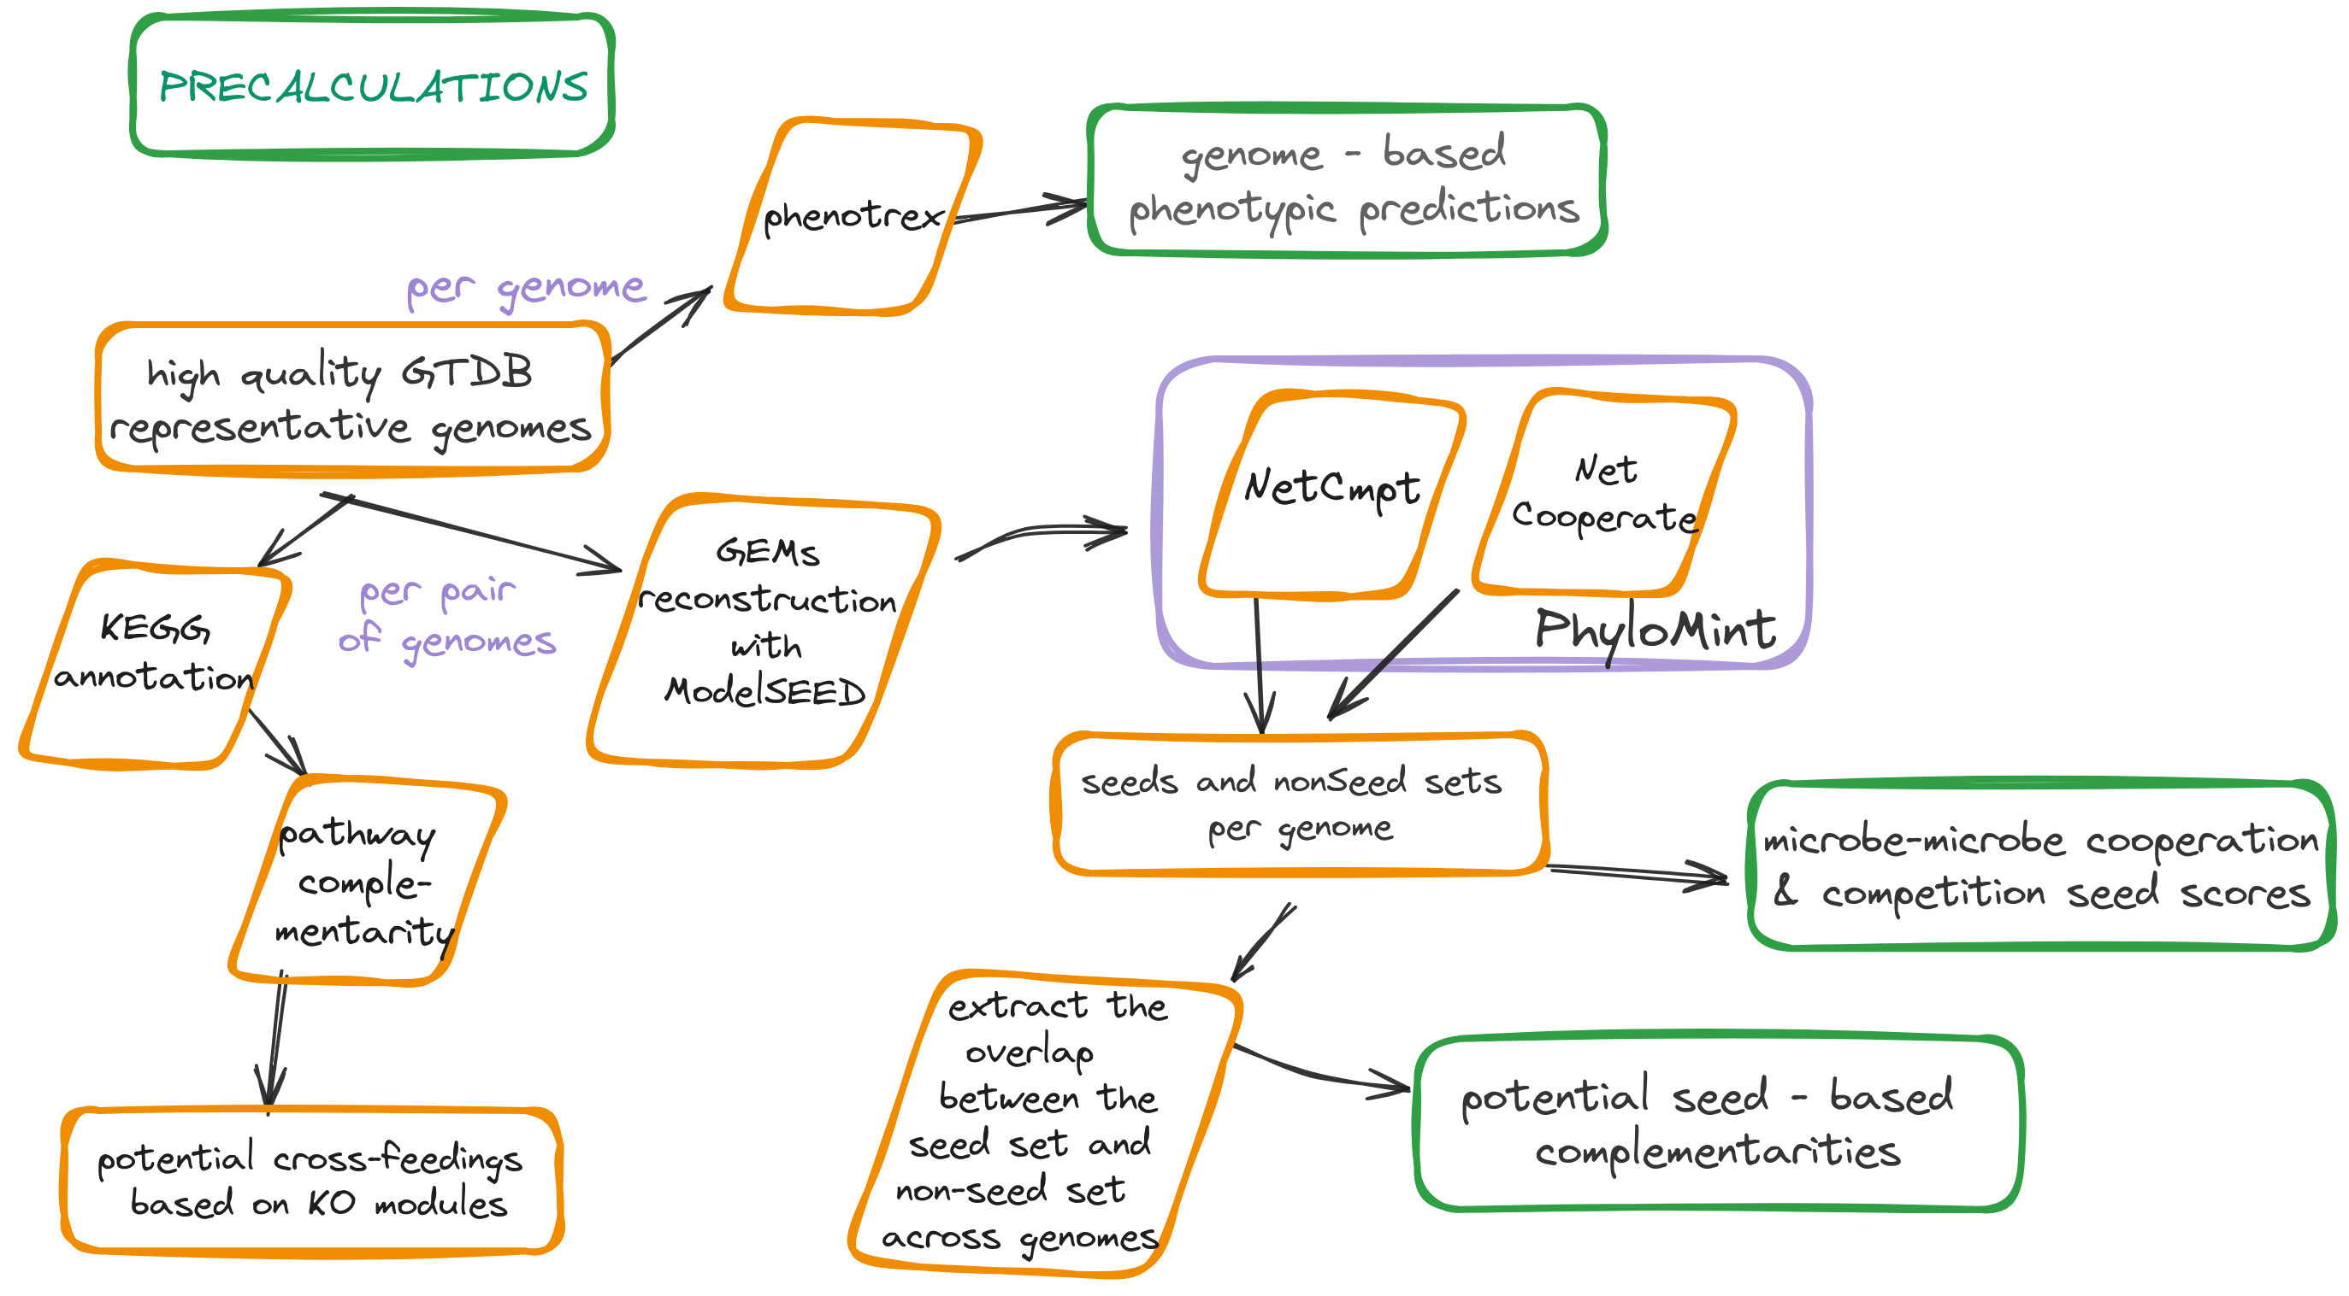
Fig. 1: Diagram of the microbetag precalculations. GTDB v207 representative genomes were filtered and for those of high-quality, 33 phenotypic traits were predicted using phenotrex. To this end, models were re-trained to sync with version 5.0 of EggNOG.

Genomes included
Using the Genome Taxonomy Database (GTDB) v207 metadata files, we retrieved the NCBI genome accessions of the high-quality representative genomes, i.e., completeness ≥ 95% and contamination ≤ 5%. A set of 26,778 genomes was obtained, representing 22,009 unique NCBI Taxonomy Ids. Using these accession numbers, we were able to download their corresponding .faa files when available leading to a set of 16,900 amino acid sequence files. The latter were annotated (see “Genome-based node annotation”) and used to obtain potential pathway complementarities between pairs of genomes (see “Pathway Complementarity”). Last, when available, their corresponding annotations in the PATRIC database [40] were retrieved to reconstruct metabolic networks (see “Seed scores and complements”).

Taxonomy schemes
microbetag maps the taxonomy of each entry in the abundance table to their corresponding NCBI Taxonomy Id and, if available, their closest GTDB representative genome(s), since several GTDB representative genomes may map to the same NCBI Taxonomy Id. Two well established taxonomy schemes are supported: the GTDB [41] that is being broadly used for bins and/or MAGs (Metagenome Assembled Genomes) taxonomic classification and the Silva database [42] that is widely used in amplicon studies. Both taxonomy schemes link their taxonomies to NCBI Taxonomy Ids [43]. In case neither of those two taxonomies was used, and the abundance table contains less than 1,000 taxa, microbetag maps the user-provided taxonomies to the NCBI Taxonomy. To this end, microbetag makes use of the fuzzywuzzy library that implements the Levenshtein Distance Metric to get the closest NCBI taxon name and thus its corresponding NCBI Taxonomy Id; a high similarity score is used (90) to avoid false positives. In the rare case a taxon gets the same score with more than one NCBI taxonomies, microbetag will choose one random. Also, using the nodes dump file of NCBI Taxonomy, microbetag may retrieve the child taxa of a taxon in user’s data, along with their corresponding NCBI Taxonomy Ids, if requested by the user. If the user provides their abundance table with taxonomies already mapped to the GTDB taxonomy, microbetag will quickly report the best possible annotations.

Network inference
When a co-occurrence network is not provided by the user, microbetag relies on FlashWeave [14] to build one on the fly. Yet, microbetag supports the annotation of networks built from any algorithm/software, in any format Cytoscape can load.

Microbetag preprocessing
To aid the user to map their sequences to the GTDB taxonomy, DADA2-formatted 16S rRNA gene sequences for both bacteria and archaea [44] were used to train the IDTAXA classifier of the DECIPHER package [45] and are available through the microbetag preprocess Docker image. Likewise, when the abundance table consists of more than 1,000 taxa, providing a network as an input is mandatory. Again, to help the user, the microbetag preprocess Docker image supports the inference of a network using FlashWeave.
For a computationally efficient way to annotate large networks, a Docker image is provided, so the user runs a taxonomy assignment using the IDTAXA algorithm [45] of the DECIPHER R package [46]. A co-occurrence network is also built using FlashWeave [14], as microbetag also does.

Literature-based node annotation
Using a set of Tara Ocean samples [47] FAPROTAX [48] estimates the functional potential of the bacterial and archaeal communities, by classifying each taxonomic unit into functional group(s) based on the current literature, descriptions of cultured representatives and/or manuals of systematic microbiology. In this manually curated approach, a taxon is associated with a function only if all the cultured species within the taxon have been shown to exhibit that function. In its current version, FAPROTAX includes more than 80 functions based on 7600 functional annotations and covers more than 4600 taxa. Contrary to gene-content-based approaches, e.g., PICRUSt2 [49], FAPROTAX estimates metabolic phenotypes based on experimental evidence. microbetag invokes the accompanying script of FAPROTAX and converts the taxonomic microbial community profile of the samples included in the user’s abundance table or of the taxa present in the provided network, into putative functional profiles. Then, it parses FAPROTAX’s sub-tables to annotate each taxonomic unit present in the user’s data with all the functions for which they had a hit. FAPROTAX annotations are not part of the microbetagDB but are computed on the fly.

Genome-based node annotation
phenDB [50] is a publicly available resource that supports the analysis of bacterial (meta)genomes to identify 47 distinct functional traits, e.g. whether a species is producing butanol or has a halophilic lifestyle. It relies on support vector machines (SVM) trained with manually curated datasets based on gene presence/absence patterns for trait prediction. More specifically, the model for a particular trait is trained using a collection of EggNOG annotated genomes where the knowledge of whether that trait is present or absent among its members is available. These models (classifiers) are used to predict presence/absence of their corresponding traits in non-studied species.
For microbetagDB, classifiers were re-trained using the genomes provided by phenDB for each trait to sync with the latest version of EggNOG [51] and the phenotrex [50] software tool. Genomes were downloaded from NCBI using the Batch Entrez program. Then, genotype files were produced for all the high quality GTDB representative genomes. Each model was then used against all the GTDB genotype files to annotate each with the presence or the absence of the trait. A list of all the phenotypic traits available for the genomes present in microbetagDB is available on microbetag ’s documentation site. The updated models are also available.

Pathway complementarity
To infer potential pathway complementarities, we rely on the modules in the KEGG MODULES database [38]. A KEGG module is defined as a functional unit within the KEGG framework that represents a set of enzymes and reactions involved in a specific biological process or pathway [52]. Such a unit consists of several steps, each of which may have more than one molecular way to occur (Fig. 2). A module’s definition is a logical expression and consists of KEGG ORTHOLOGY terms (KOs) that may be coupled with one another as: a) connected steps of the pathway b) parts of a molecular complex, c) alternatives of the same step, and d. optional entities of a complex. Both (a) and (b) cases should be considered as the AND logical operator, while (c) would be the OR (Fig. 2). Given a module’s definition, we will consider as an alternative any subset of the KO terms mentioned in the definition, that has exactly one way to perform each step, provided that all the steps of the module are covered. We define a genome as having a complete module, only if all the KOs of at least one alternative are present in it. In Supplementary Information we show an example of a module along with its alternatives.
Within this framework, kofamscan [53] was used to annotate with KOs the 16,900 high quality GTDB representative genomes for which a .faa was available [54]. The KOs of each genome were then mapped to their corresponding KEGG modules; a KO may map to more than one module (1 : n).
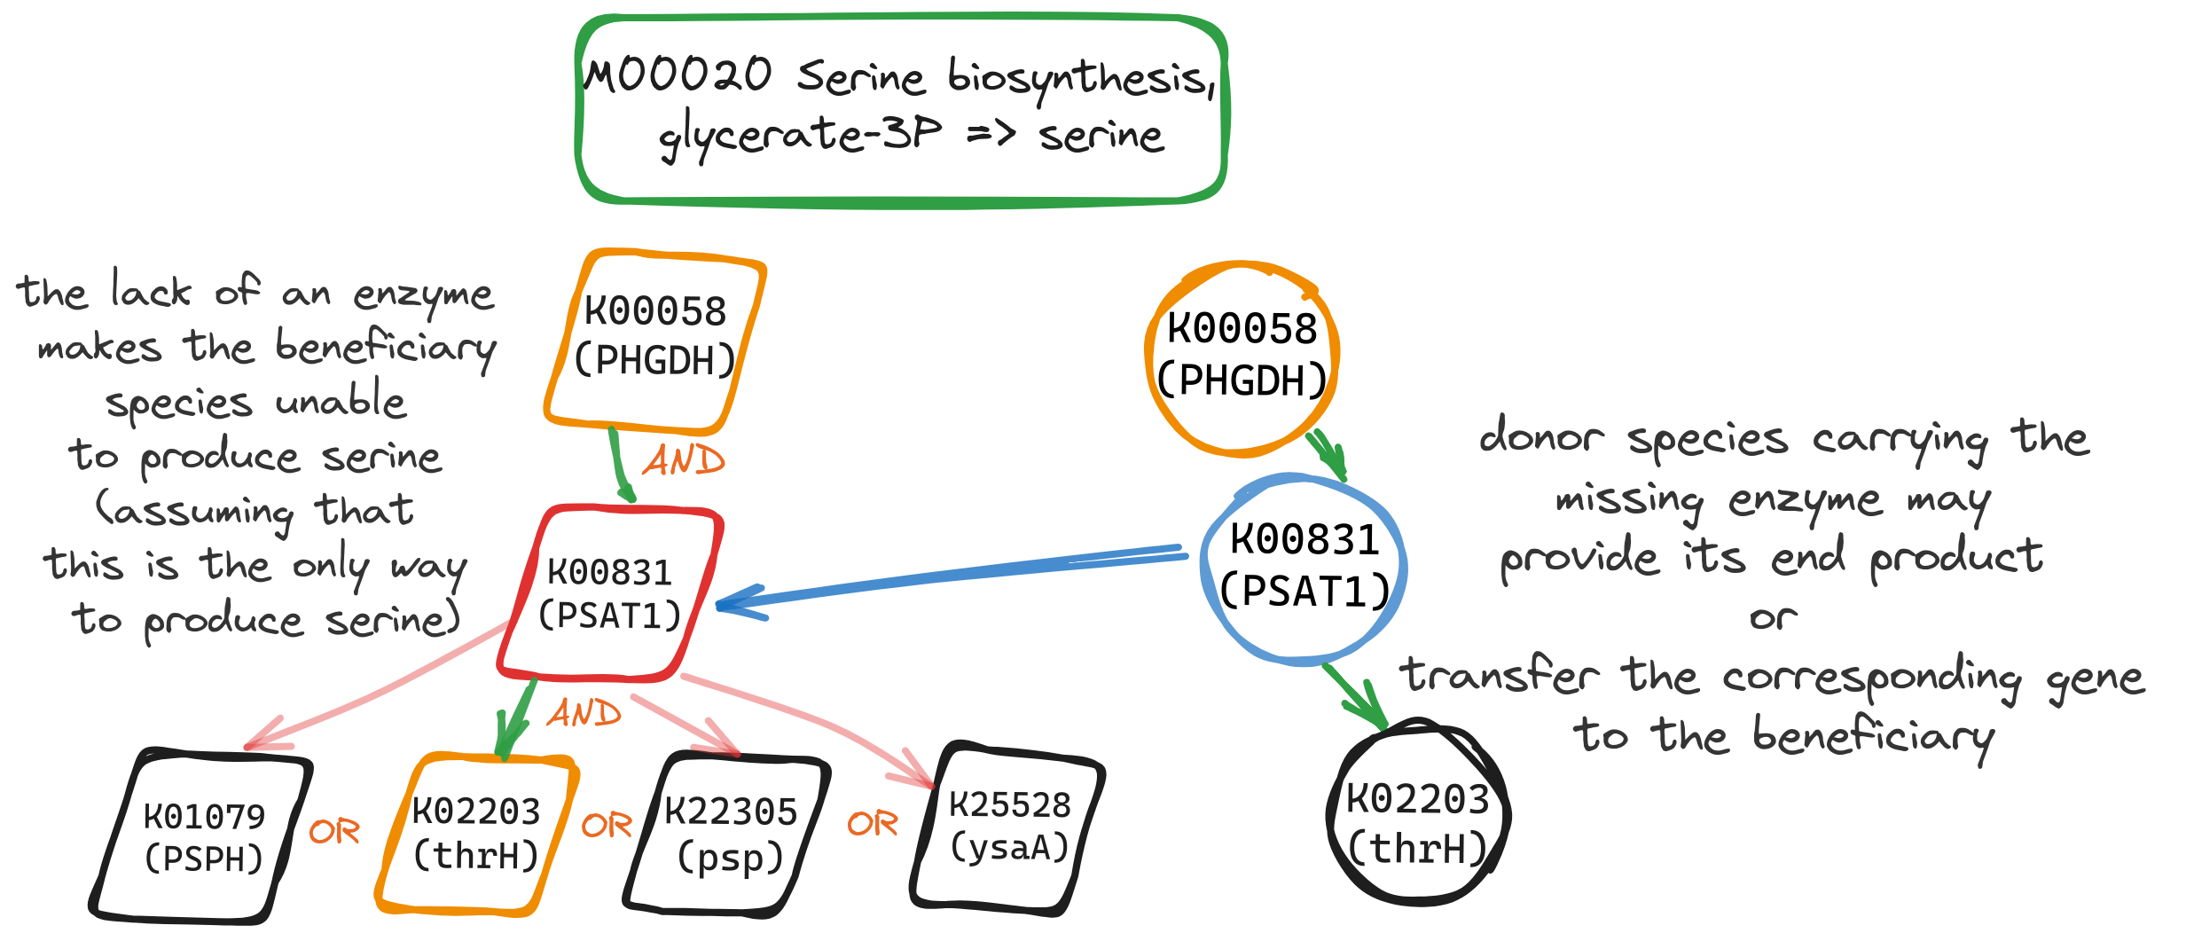
Fig. 2: Pathway complementarity approach. The high-quality GTDB genomes were annotated with KEGG ORTHOLOGY (KO) terms. The several ways of completing a KEGG module were enumerated and all the possible ways a donor species could “fill” a beneficiary’s incomplete module were calculated. In this case, there are 4 unique ways to complete the serine biosynthesis module; in all of them K00831 is required. However, it is missing from the beneficiary species that supports two out of the three steps of the module’s definition. The enzyme linked to KOO831 in the donor species completes the glycerate-3P to serine biosynthesis pathway in the beneficiary. Such complementarities may represent interactions in case the beneficiary depends on the end product to grow, has no alternative pathways to synthesize it and intermediary metabolites can be shared.
All module definitions were retrieved using the KEGG API and parsed to enumerate their alternatives. Each pair of the KEGG annotated genomes was then investigated for potential pathway complementarities, i.e., whether a genome lacking a number of KOs (genome_{A}) to have a complete module (module_{x}) could benefit from another species' genome(s) (genome_{B}). In that case, genome_{B} does not necessarily have a complete alternative of module_{x}; as long as it has the missing KOs that genome_{A} needs to complete an alternative of it, genome_{B} potentially complements genome_{A} with respect to module_{x}. In total, 341,568 unique complementarities were identified.
Thanks to the graphical user interface (GUI) of the KEGG pathway map viewer [55, 56], each complementarity can be visualised as part of the closest KEGG metabolic map. In this case, the KOs contributed by the donor are shown in blue-green whereas those coming from the beneficiary genome are coloured in red.
microbetag annotates the edges of a co-occurrence network by identifying pairs where both taxa map to an annotated genome present in microbetagDB. Since co-occurrence networks are usually undirected, both nodes of a suggested association are considered as potential donors and beneficiary species. When more than one GTDB representative genome map to the same NCBI Taxonomy Id all the possible genome combinations are considered. Finally, two edges are added for such taxon pairs in the annotated network: one considering species_{A} as the potential beneficiary and species_{B} as the potential donor species, and one vice-versa.

Seed scores and complements using genome scale metabolic reconstructions
The Metabolic Complementarity Index (MI_{Complementarity}) measures the degree to which two microbial species can mutually assist each other by complementing each other’s biosynthetic capabilities. As described in [57], it is defined as the proportion of seed compounds of a species that can be synthesized by the metabolic network of another but are not included in the seed set of the latter. MI_{Complementarity} offers an upper bound assessment of the potential for cross-feeding interactions between two species. Further, the Metabolic Competition Index (MI_{Competition}) represents the similarity in two species’ nutritional profiles. This index establishes an upper limit on the level of competition that one species may face from another. Those indices have been described and implemented in the NetCooperate [28] and NetCompt [29] tools, respectively. We will be referring to those two indices as ”seed scores”. Recently, the PhyloMint tool [57] was released supporting the calculation of the seed scores of metabolic networks in SBML format.

In the microbetag framework, seed scores were computed using metabolic networks derived from the high-quality GTDB representative genomes and the PhyloMint tool. Metabolic networks were reconstructed using the Model SEED pipeline [58] through its Python interface ModelSEEDpy. The latter requires RAST annotated genomes [59]; if available through the PATRIC database [40], annotations were retrieved. For the rest of the genomes, RAST annotation was performed through RASTtk [60].

In contrast to seeds, non-seeds are metabolites that the metabolic network can produce on its own. The seed and non-seed sets of each genome were used to compute their overlap among all the pairwise combinations of those genomes. More specifically, seed and non-seed compounds of each metabolic network were mapped to their corresponding KO terms (as substrates or products of their reactions) and those related to a KEGG MODULE were considered further. Focusing on the KEGG MODULE-related KO terms as terms of interest, the overlap of seed set_{speciesA} with the non seed set_{speciesB} was retrieved (Fig. 3). Such seed complementarities were calculated for all metabolic network pairs and are now available through microbetagDB. Edges of the co-occurrence network where both taxa have been mapped to at least one GTDB genome are further annotated by listing all the KEGG maps for which there is at least one seed compound of the potentially beneficiary species.

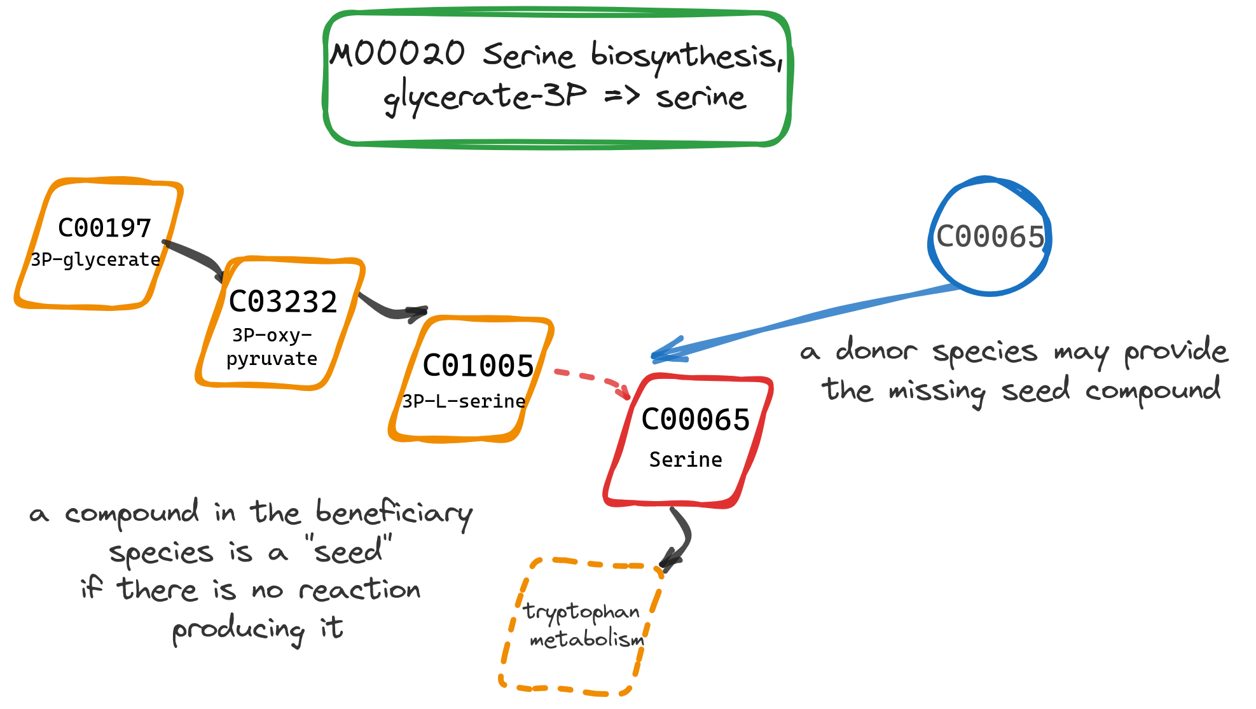
Fig. 3 Seed complementarity. Using the total metabolic model of a species, we can export compounds that are required for their growth but cannot be produced by the species reaction set (“seeds”). Such compounds are imported to the species from their environment and could be available to them thanks to cross-feeding. In this case, serine is required but based on species_{A} metabolic model there is no way to produce it on its own. Thus, a potential donor species_{B} may provide it.

Network clustering
manta is a heuristic network clustering algorithm that clusters nodes within weighted networks effectively, leveraging the presence of negative edges and discerning between weak and strong cluster assignments. microbetag invokes manta [23] to cluster the microbial network. In case manta is performed, the annotated network inherits the layout that manta returns. However, as mentioned below, the microbetag GUI (MGG) can work with clusters resulting from any network clustering algorithm if it meets the expected output format.

The microbetag workflow
As shown in Fig. 4, the microbetag workflow expects an abundance table representing either amplicon or shotgun data. If a co-occurrence network is already available, the user may provide it too as input. The microbetag workflow will first map the taxa present in the abundance table to their corresponding GTDB representative genomes if that is possible, i.e., in case the taxonomy provided does reach the species or the strain level (see “Taxonomy schemes”). If a network is not provided, microbetag will build one using FlashWeave [14]. Then the abundance table will be used for a literature-based annotation using FAPROTAX [48]. This is the only annotation step that is microbetagDB independent within the web-service workflow. The nodes of the network will be further annotated with phenotypic traits based on the model predictions [50]. Edges linking taxa assigned to the species or strain level will be annotated with pathway and seed complementarities and seed scores. Last, network clustering will be performed with manta, assigning each node to a cluster. The annotated network is then returned in a .cx format. The user may skip any of these annotation steps if not needed for their analysis.

Groups of phenotypic traits
Biologically meaningful groups were described to group phenotypic traits returned from FAPROTAX and phenDB-like annotation steps. The main groups supported are related to a) the lifestyle of a species, for example being halophilic or thermophilic etc., b) the bio-geochemical processes that are linked to the metabolic potential of a species, for example Nitrite-oxidizing bacteria (NOB) bacteria and c) important metabolites a species is predicted to produce, e.g. butanol. The aim of these groups is to facilitate filtering of the taxa present. Enrichment analysis for traits in such groups (e.g., based on the clusters identified by an algorithm like manta) can be performed through the Cytoscape app.

Software architecture
microbetag is a Docker-based application. We deployed the microbetag application using Docker containers [61] (v24.0.2) managed by Docker Compose (see Supplementary Fig. 1). Docker Compose is a tool for defining and running multi-container Docker applications using a YAML file to configure the services required for the application. Containers of three Docker images are being used simultaneously: a) a MySQL database including the microbetagDB b) a nginx [62] web server and c) the application itself, including the API and the microbetag workflow. Gunicorn (20.1.0) was used to build an application server which communicates with the web server using the Web Server Gateway Interface (WSGI) protocol and handles incoming HTTP requests. microbetag is implemented as an Flask application (v2.3.2); Flask is a micro web framework for developing Python web applications and RESTful APIs. The API has a route for performing the microbetag workflow, either through any Python console or the Cytoscape MGG app, but also several other routes that enable quick and easy access to the microbetagDB content, i.e. the genomes present, their phenotypic traits predicted based on genome annotations, pathway and seed complementarities among specific genomes or NCBI Taxonomy Ids and their corresponding seed scores if available. A thorough description of the microbetag API is available at the ReadTheDocs web site. The source code of the microbetag web service is available on GitHub (see “Code availability”).
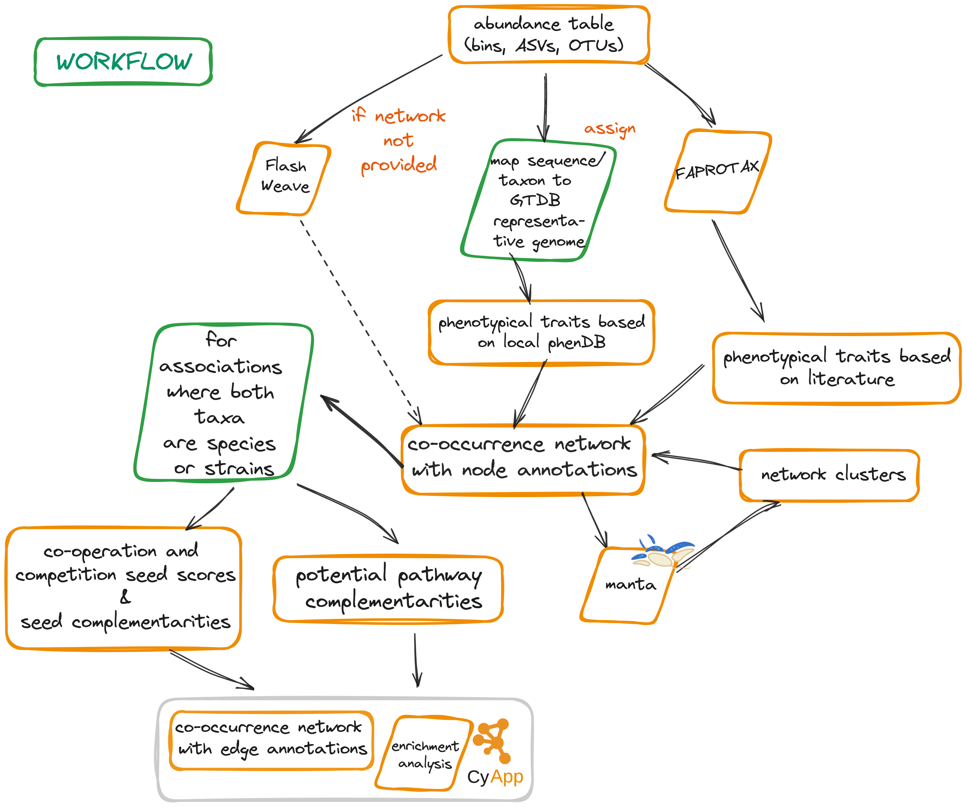
Fig. 4 Diagram of microbetag’s on-the-fly workflow. microbetag expects either an abundance table only as input and infers a co-occurrence network using FlashWeave or an abundance table along with an already inferred co-occurrence network. After mapping taxa to GTDB reference genomes, for those possible, phenotypic attributes are assigned to the nodes. Literature-based annotations of the nodes are also added using FAPROTAX. On the edge level, microbetag assigns the precalculated potential complements based on the pathway and the seed complementarity approaches. microbetag supports optional network clustering with manta. The annotated network can then be parsed into Cytoscape using the MGG app.

The MGG Cytoscape App
We developed a Cytoscape app to enable a straightforward, user-friendly way to perform the microbetag workflow and visualise microbetag-annotated networks. The microbetag Cytoscape app (called MGG) was built based on the source code of the scVizNet [63]. A visual style was developed to better distinguish annotated nodes and edges. Nodes are colored based on the level of the taxonomic assignment with those being annotated highlighted in green. Similarly, edges are green when they carry a positive weight and dark pink when negative. Black edges denote pathway and/or seed complementarities. The latter were not accounted for in the edge weights since edges represent an undirected relationship while complementarity/overlap scores assume a direction, i.e. the complementarity score of species A versus B is not necessarily the same as that of B versus A. MGG allows the user to import their data, retrieve an annotated network and investigate the annotations through a series of CyPanels both for node and edge annotations. Fig. 5 shows an example of the CyPanels. In the node panel (Fig. 5A), the node name, taxonomy, NCBI Taxonomy Id and GTDB genome to which the sequence was mapped can be viewed. Depending on the user’s settings and the available annotations for a node, genome- or literature-based predictions may be present. Further, the trait groups mentioned in “Groups of phenotypic traits” are on top of this panel allowing for the selection of the nodes carrying either one among several attributes (OR logical relationship) or all of them (AND). Accordingly, in the edge panel (Fig. 5B), the beneficiary taxon is specified along with their corresponding GTDB representative sequence identifier. Pathway and seed complementarities are shown each in a table. Potential metabolic interactions are shown in a sub-table entitled with the genome pair under consideration, as several GTDB genomes may have been assigned to a node. In case of pathway complementarities, these tables consist of six columns: a) the KEGG MODULE id of the module to be completed, b) its description, c) a more general metabolic category to which the module belongs, d) the complement itself as a list of KEGG terms, e) the alternative that now represents a complete module in the beneficiary and f) a URL that points to a coloured KEGG map highlighting the complement. If clicked, the user’s default browser pops up showing a coloured KEGG map as shown in an example in Fig. 5C. Last, MGG allows to test for enrichment or depletion of the phenotypic traits assigned to the nodes in each of the network clusters. Clusters may have been returned from manta [23] while performing the microbetag workflow or users may assign them on their own or using any other network clustering algorithm. For thorough instructions on how to use MGG and microbetag the reader may visit the ReadTheDocs web site.
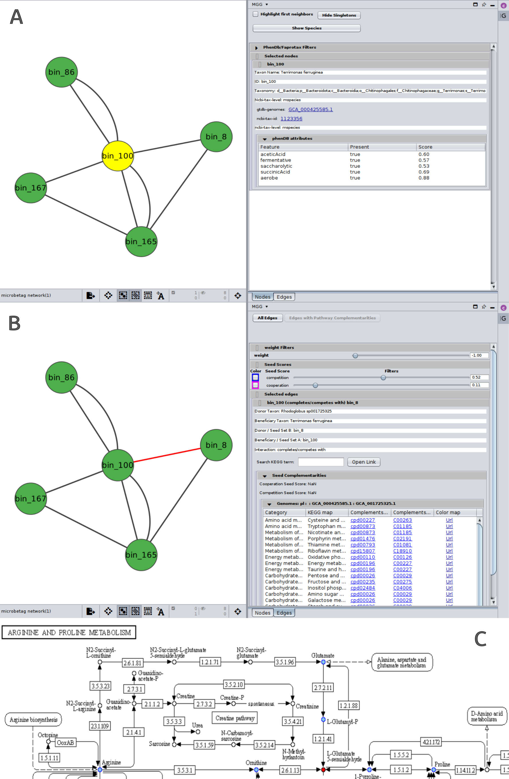
Fig. 5 CyPanels of the MGG Cytoscape app. A. Nodes panel displays the annotations of each taxon (node) mapped to one or more GTDB genomes. In this example, genome-based predicted phenotypic traits are shown along with their prediction score. B. Edges panel displays the list of potential metabolic complementarities between two nodes, specifying which is the potential donor and the potential beneficiary taxon, thus giving a direction to the corresponding edge in the graph. There are two cases of complementarities in microbetag. The first are seed complementarities, which are computed based on the species’ reconstructed metabolic networks (case shown above). Seed complementarities are first exported based on ModelSEED complements (column three) and mapped to KEGG COMPOUNDS (column four). The provided URL points to a colored KEGG map that highlights seeds complementing a beneficiary’s metabolic network. The second is pathway complementarities. These are directly computed from the KEGG annotated genomes and do not involve ModelSEED ids since the metabolic network construction step is not necessary in this case. In brief, seed complementarities represent essential compounds that the beneficiary cannot produce, and pathway complementarities represent enzymes that fill gaps in a beneficiary's pathway. C. Part of a colored KEGG map returned based on the seed complementarities. Compounds that belong to the beneficiary taxon are colored in cyan while the potential complementing seeds from the donor are highlighted in red.

microbetag with custom genomes
To enable the microbetag approach with custom/local genomes, instead of mapping user’s taxa to the GTDB representative ones, a MicrobetagDB-free version is also available. In this case, the user has to pull a Docker image of microbetag that supports all the annotation steps using a set of genomes by the user. microbetag will first perform either all or some of the steps described in Fig. 1 depending on user’s settings. In case a user has already annotated for example their genomes with KEGG, or they already have reconstructed their corresponding metabolic models, the relative precalculation steps may be omitted. Then, the microbetag workflow (Fig. 2) will be performed to return an annotated network. The computing resources for such a task can be quite extensive. Yet, once completed the annotated network will be saved as .cx file and can be visualized on Cytoscape using the MGG app. A tutorial for running microbetag using custom genomes can be found in the Documentation webpage.

Results and discussion

Annotating microbial co-occurrence networks with microbetag
The microbetag software ecosystem consists of five main modules: a) microbetagDB including microbetag precalculations, b) the microbetag workflow to annotate the co-occurrence network, c) a web server hosting both the microbetagDB and the microbetag application, d) a Cytoscape app called MGG that enables users to easily invoke the workflow and investigate the annotated network, and e) a stand-alone preprocessing workflow provided as a Docker image for data sets with more than 1,000 sequence identifiers (OTUs/ASVs/bins etc.).

Currently, microbetagDB includes more than 34,000 genomes (Table 1) along with their corresponding annotations. Most of these genomes represent bacterial taxa (364 taxa are Archaea). The presence/absence of more than 30 phenotypic traits have been predicted for those genomes. About 1.4 billion potential metabolic interactions leading to pathway or seed complementarities have been precomputed as well. There is one order of magnitude more seed complements than those corresponding to pathway complementarities as for all metabolic networks present in microbetagDB all pairwise complements were calculated (33,755²) and stored, even if empty. In the case of pathway complementarities, a genome pair is present in the database and thus counted only if a potential complementarity was found. Yet, in the first case, the number of genomes with no potential seed complements ranges from zero to a few dozen. All annotations can be accessed directly from microbetagDB through the API. Seed complements can be interpreted as compounds that are essential for the beneficiary since, by definition, they cannot be produced by its metabolic network, and which can be potentially cross fed from the donor to the beneficiary. However, this comes with its own challenges (see “Potential and limitations”).

Running the microbetag workflow is straightforward and only takes an abundance table with taxonomic assignments as minimal input. When the taxonomy scheme being used is not one among the GTDB, Silva or the GTDB-oriented taxonomy for 16S rRNA amplicon data (see “microbetag preprocess”), the most time-consuming step of the workflow is the one mapping the user’s taxonomy to a NCBI Taxonomy Id and from that to GTDB representative genomes. Network inference can be a computationally intensive step too, particularly as the number of taxa in the abundance table increases. To enable annotation of large data sets, a stand-alone preprocess workflow is provided with microbetag. The user can either assign their amplicon data to the GTDB-oriented taxonomy and/or reconstruct a network locally. Once a network is available and the taxonomy used is among the standard ones for microbetag, the computational time required for annotation ranges from several seconds to a few minutes based on user’s settings. An annotated network in cx2 format is returned, which can be viewed in Cytoscape. A tutorial, frequently asked questions and hints to address the idiosyncrasies of various data sets are available on the ReadTheDocs web site while a Gitter community allows users to exchange experience and ask for more specific help. In the following two sections, we present a validation and use case, highlighting our approach's potential.

Table 1: Summary of the data in microbetagDB
Description | Entries
GTDB representative genomes | 34,608
Phen-model-oriented metabolic functions | 32
FAPROTAX functions | 92
Unique pathway complements | 341,568
Pairwise pathway complementarities | 184,184,548
Metabolic networks | 33,755
Seed complements | 1,139,400,025
Seed scores | 1,105,250,048

Validation of microbetag on a network with known interactions
To validate microbetag we used the correlation network of Hessler et al. [39] describing mine tailing-derived laboratory microbial consortia. In this study, Variovorax, a thiamine producer, and its co-occurrence with a series of thiamine auxotrophs are discussed. The study was selected as a validation case as the authors tested the network’s predictions by performing co-culture experiments measuring the thiamine production. Sequence bins corresponding to network nodes and the original network were obtained from the authors. Using GTDB-tk [64], bins were annotated to GTDB taxonomies; those retrieved were added to the original network, which was then annotated with microbetag. Supplementary Fig. 2 highlights bin_55 that corresponds to Variovorax as well as its first neighbors. The annotated network is available on microbetag’s GitHub repository. GTDB-tk returned GCA 001899795.1 as the one closer to bin 55 assigning it to Variovorax sp001899795. microbetag then suggested that this specific genome corresponds to an aerobe [65] that can grow autotrophically [66] and utilizes D-glucose, while producing ethanol and lactic acid [67]. Last, the Type VI secretion system was suggested to be available on its genome [68].
Hessler et al. argue that Variovorax is an important thiamine source and can supply neighboring species that cannot produce it (auxotrophs). Indeed, microbetag was able to suggest several thiamine-related potential seed complements among the potential metabolic interactions between Variovorax and its neighbors (Table 2). Potential interactions were also found in some cases between the neighbors themselves (Supplementary Table 1). The authors also argue that isolates of that Variovorax strain required the addition of pantothenic acid to grow. However, based on the KEGG annotation of the genome that bin_55 was mapped to, it contains both KEGG MODULES related to pantothenate biosynthesis, M00119 (valine/L-aspartate ⇒ pantothenate) and M00913 (2-oxoisovalerate/spermine ⇒ pantothenate). However, other genomes are not capable of either one or any of those reactions (Supplementary Table 2). This example highlights a challenge of the microbetag approach (see “Potential and limitations”). The complementarities between the nodes would have been different if bin_55 was classified as another Variovorax genome, with incomplete modules. For example, if GCF_001577265.1 was picked and its complementarities with the neighboring taxa were retrieved, it would have revealed that all its neighboring species can provide it with pantothenate (C00864) as suggested by their seed complementarities (Supplementary Table 1).

Table 2: Thiamine biosynthesis related seed complements between Variovorax and its first neighbors in the network of Hessler et al. [39]

Interpreting a real-world network with microbetag
In their study, Cabrera et. al (2024) [REF] showed that iron supplementation combined with either inulin or a mixture of short-chain galacto-oligo oligosaccharides and long-chain fructo-oligosaccharides (scGOS/lcFOS) leads to higher abundance of bifidobacteria, increased production of acetate, propionate, and butyrate, and a significant shift in microbial composition compared to non-supplemented microbiota. In this way, enteropathogens that may increase during iron supplementation, a common approach to prevent anemia, could be reduced.
To analyze these data further, we first ran the microbetag preparation step to map the ASVs in the 16S rRNA sequencing data of this study to GTDB-based taxonomic assignments. Then we inferred the network with FlashWeave (wrapped by microbetag) and annotated it using microbetag. Fig. 6A shows the microbetag-annotated co-occurrence network of donor 3 microbiota, an eight-month-old female infant, whose fecal microbiota was used to inoculate the continuous in vitro gut model experiment. After a stabilization period of 7 to 13 days, iron and scGOS/lcFOS were continuously supplied for 6 to 9 days, and this treatment set-up was repeated twice. microbetag predicted several taxa to be butyrate producers. Interestingly, most of the associations involving butyrate producers are negative, reflecting that their abundance changed in opposite direction from the associated ASVs and likely not responsible for the observed increased butyrate production during scGOS/lcFOS supplementation. For example, in the scGOS/lcFOS case, the abundance of Clostridium perfringens (ASV0068, predicted butyrate producer) decreased while the abundance of an unclassified Bifidobacterium (ASV0003) increased. At the same time, a single butyrate producer (Flavonifractor plautii; ASV0012) had several positive associations, including with ASV0003. microbetag reports that F. plautii and its neighbor species Eggerthella lenta (ASV0107) have several potential pathway and seed complementarities (Fig. 6B), in particular for Coenzyme A biosynthesis, which is involved in the bacterial butyrate production pathway (REF). More specifically, F. plautii requires alanine and pantothenate to be exogenously acquired, while E. lenta is capable of producing both of them. Thus, the analysis with microbetag results in a first testable hypothesis: the observed increase in butyrate production and Flavonifractor relative abundance in infant gut microbial communities upon scFOS/lcFOS treatment in vitro (see Figures 5B and 7 in Cabrera et. al (2024)) may be, at least to some extent, due to cross-feeding partners directly boosted by the treatment that complement metabolic pathways involved in butyrate production. Relevant files for the use case can be found at microbetag’s main GitHub repository.
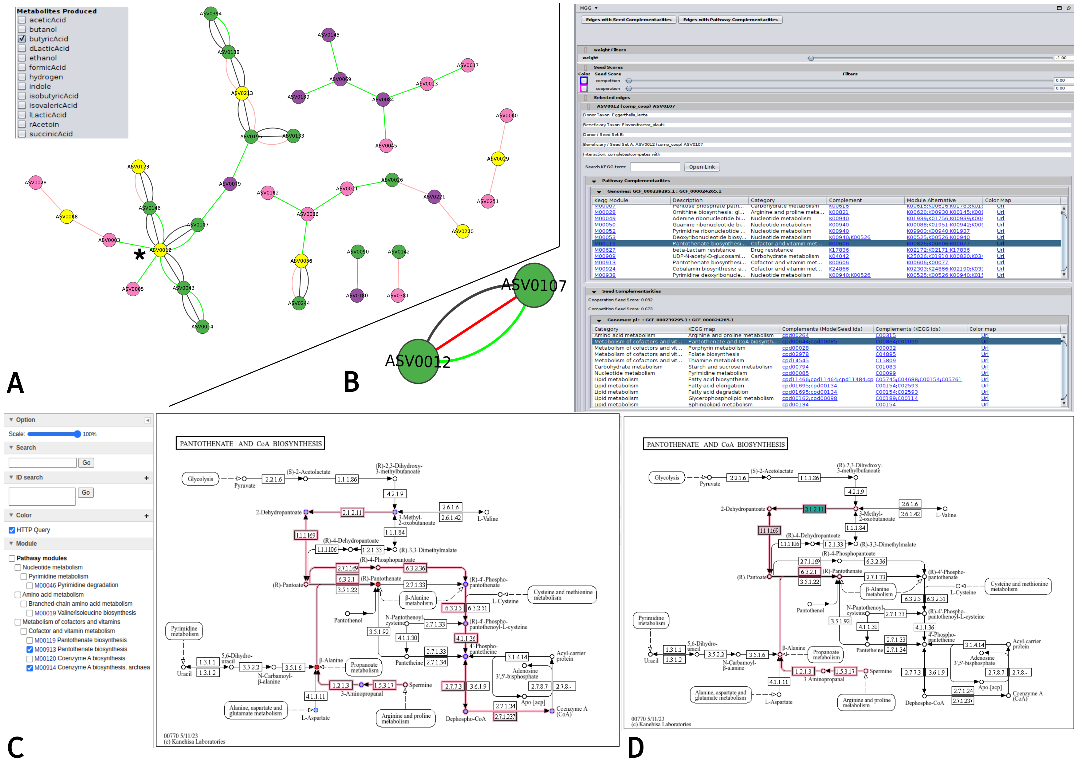
Fig. 6 microbetag-oriented analysis using a real-world dataset (Cabrera et. al (2024). A. The microbetag-annotated co-occurrence network as viewed in Cytoscape with the MGG visual style. Taxa predicted to be butyrate producers are highlighted in yellow. The asterisk (*) points to Flavonifractor plautii B. microbetag edge annotations considering F. plautii (ASV00012) as the potential beneficiary and Eggerthella lenta (ASV0107) as a potential donor. In this case, both pathway and seed complementarities are available and pantothenate (vitamin B5) biosynthesis, and thus NAD biosynthesis, related complements are present C. Coloured Pantothenate and CoA biosynthesis KEGG map returned by microbetag highlighting potential seed complementarities provided by E. lenta; with red β-Alanine and (R)-pantothenate the two seeds of F. plautii that E. lenta may provide D. The same KEGG map suggesting a missing enzyme (2.1.2.11) of F. plautii for producing pantoate could be acquired by E. lenta. In this case, pantothenate F. plautii would be able to produce pantothenate from pantoate (pathway complementarity).

Potential and limitations
The previous paragraph shows the potential of microbetag in the interpretation of co-occurrence networks and how it can be used to generate new hypotheses derived from those. However, microbetag benefits the microbiome community in several other ways. The microbetagDB provides a vast number of annotations; 31 predicted traits for more than 30,000 genomes, their metabolic networks along with their corresponding seed sets, potential metabolic complementarities and cooperation/competition scores. Such a resource may support a range of studies; from a more theoretical perspective regarding the distribution of the complements among taxonomic groups or how often a complement potentially appears, to applications such as eco-evolutionary studies and the investigation of interactions.
Yet, there are several challenges involved in our approach. First, microbetag inherits all the biases and drawbacks of both the data and the software it is based on. Functional annotation comes with its own limitations. Some domains boast richer annotations and more comprehensive descriptions compared to others, thus exhibiting a wealth of detail and employing more precise terminology, particularly for widely recognized processes (e.g., glycolysis vs secondary metabolites biosynthesis).
In the validation case, the bin representing the Variovorax strain was mapped to a genome that is supposed to contain the pantothenate KEGG modules. Thus, the fact that it requires to receive pantothenate from its environment to grow, as the authors mention, would not have been predicted in the microbetag framework. Beyond the sequencing and annotation challenges, we also need to consider the fact that a pathway may not be fully represented in a KEGG module or that an organism may have alternative pathways for its product(s). In addition, various factors can prevent the actual production of an enzyme even if its genetic information is present in a species’ genome.
Pathway complementarity can only be as accurate as the KEGG MODULE database and as precise as the software annotating genomes with KO terms. It is well known that automated metabolic network construction comes with a number of challenges and different software for this task have their own limitations [69]. Using ModelSEED with a complete medium may limit potential metabolic interactions but, on the other hand, the retrieved ones will be of higher confidence. In addition, pathway complementarity per se does not guarantee that intra-cellular metabolites are indeed exchanged. Microbetag does not check whether metabolites can be excreted or consumed. If the donor lacks a transporter and the metabolite cannot cross the cell wall, sharing could still occur through lysis, but even then, it is unknown whether the recipient can take up metabolite(s) released in this manner. This is the main reason why pathway and network complementarities are predictions of potential cross-feeding relationships and do not necessarily reflect actual interactions.
In addition, pairwise relationships do not capture higher-order ecological interactions, in which species depend on (or are influenced by) multiple other species [3]. However, since microbetag is decoupled from network inference, it could annotate a network with hyperedges (i.e. edges connecting more than two taxa) produced by a future tool capable of inferring higher-order interactions.
Last, the limited number of Archaea in microbetagDB is also the result of a software limitation. As shown in [70] (see Figure 6b), the original version of CheckM [71] that is still being used by GTDB returns lower completeness scores for genomes that correspond to phyla known for having smaller genomes in general, e.g. Patescibacteria representative genomes on GTDB have an average completeness of ∼65%. Thus, only a few representatives from these taxonomic groups passed our filters leading to an important under-representation of Archaea.

Future work
In the near future, we plan to develop two main features: a) the integration of transcriptomics data provided by the user, which would enhance or lower the probability for a potential metabolic interaction to occur based on whether the KO terms involved are present or not, and b) the integration of spatial data; it is well-known that the distance between cells determines whether an interaction occurs [72]. For this, we intend to support data with spatial dimensions.

Conclusions
Co-occurrence networks are widely used in microbiome studies to explore associations [4]. However, their inference and their interpretation come with several challenges [15]. Metabolic exchanges among microbial taxa are considered ubiquitous [73] in a large number of environments. In our study, we exploit reverse-ecology approaches and publicly available genomic data and software to predict phenotypic traits and construct metabolic networks to annotate co-occurrence networks derived from amplicon or shotgun data. Our annotation was in-line with the study of Hessler et al. [39] predicting thiamine-related metabolic interactions among Variovorax and its closest neighbors, suggesting several ways to achieve them. Using the Cabrera et. al dataset, we showcased the potential of microbetag as a hypothesis generation tool suggesting mechanisms for the increase of butyrate producers in infant microbiota supplemented with iron and GOSFOS. microbetag is a first one-stop-shop platform highlighting the potential of data integration combined with enrichment analysis and network clustering algorithms for the interpretation of microbial co-occurrence networks. Both microbetagDB and microbetag will benefit microbiome studies, as a resource and as a hypothesis generation tool.

Supplementary information.

List of supplementary figures and tables in Supplementary Information:
Supplementary Fig. 1: microbetag software ecosystem architecture.
Supplementary Fig. 2: Variovorax (node 55) and its closest neighbors. Variovorax annotations are shown in the node CyPanel.
Supplementary Table 1: Variovorax genomes present on microbetagDB and their corresponding complete/incomplete presence of the pantothenate - related KEGG modules
Supplementary Table 2: Computing times per step of the microbetag workflow using four different data sets.

Declarations
Availability of data and materials
- Raw sequences for the use case:
- Raw data for the validations case:
Funding
This work was initiated thanks to an EMBO Scientific Exchange Grant to HZ. It was then supported by the 3D’omics Horizon project (101000309). We would also like to thank the National Resource for Network Biology (NRNB) and the Google Summer of Code 2023 for the support of E.I.M.D.
Conflict of interest/Competing interests
The authors declare that they have no other competing interests.
Authors’ contributions
Conceptualization: K.F. Methodology: K.F. and H.Z. Software: H.Z., E.I.M.D. and J.M. Validation: H.Z. and K.F. Formal analysis: H.Z. and K.F. Investigation: H.Z. Resources: K.F., A.E. and A.G. Data Curation: H.Z. Writing - Original Draft: H.Z. and K.F. Writing - Review & Editing: all Visualization: H.Z. Supervision: K.F., H.Z. and S.M. Project administration: K.F. Funding acquisition: K.F., H.Z.
Acknowledgments
We would like to thank Dr. Christina Pavloudi for the insight on how to organise the trait groups. We would also like to thank Dr. Hessler and Prof. Jillian F. Banfield for sharing both the bins and the network of their study [39].
Ethics approval
Not applicable
Consent to participate Not applicable.
Code availability:
- microbetagDB related scripts: https://github.com/hariszaf/microbetag
- microbetag application: https://github.com/msysbio/microbetagApp
- MGG CytoscapeApp: https://github.com/ermismd/MGG/
- Validation and use case: https://github.com/hariszaf/microbetag/tree/ms/docs
- Documentation web-site: https://hariszaf.github.io/microbetag/

References
- Yuan, M.M., Guo, X., Wu, L., Zhang, Y., Xiao, N., Ning, D., Shi, Z., Zhou, X., Wu, L., Yang, Y., et al.: Climate warming enhances microbial network complexity and stability. Nature Climate Change 11(4), 343–348 (2021)
- Raes, J., Bork, P.: Molecular eco-systems biology: towards an understanding of community function. Nature Reviews Microbiology 6(9), 693–699 (2008)
- Faust, K., Raes, J.: Microbial interactions: from networks to models. Nature Reviews Microbiology 10(8), 538–550 (2012)
- R¨ottjers, L., Faust, K.: From hairballs to hypotheses–biological insights from microbial networks. FEMS microbiology reviews 42(6), 761–780 (2018)
- B´alint, M., Bahram, M., Eren, A.M., Faust, K., Fuhrman, J.A., Lindahl, B., O’Hara, R.B., Opik, M., Sogin, M.L., Unterseher, M.,¨ et al.: Millions of reads, thousands of taxa: microbial community structure and associations analyzed via marker genes. FEMS microbiology reviews 40(5), 686–700 (2016)
- Robinson, C.J., Bohannan, B.J., Young, V.B.: From structure to function: the ecology of host-associated microbial communities. Microbiology and Molecular Biology Reviews 74(3), 453–476 (2010)
- D’Souza, G., Shitut, S., Preussger, D., Yousif, G., Waschina, S., Kost, C.: Ecology and evolution of metabolic cross-feeding interactions in bacteria. Natural Product Reports 35(5), 455–488 (2018)
- Finn, R., Balech, B., Burgin, J., Chua, P., Corre, E., Cox, C., Donati, C., Santos,
V., Fosso, B., Hancock, J., Heil, K., Ishaque, N., Kale, V., Kunath, B., M´edigue, C., Pafilis, E., Pesole, G., Richardson, L., Santamaria, M., Van Den Bossche, T., Vizca´ıno, J., Zafeiropoulos, H., Willassen, N., Pelletier, E., Batut, B.: Establishing the elixir microbiome community [version 1; peer review: awaiting peer review]. F1000Research 13(50) (2024) https://doi.org/10.12688/f1000research.144515.1
- Hug, L.A., Baker, B.J., Anantharaman, K., Brown, C.T., Probst, A.J., Castelle, C.J., Butterfield, C.N., Hernsdorf, A.W., Amano, Y., Ise, K., et al.: A new view of the tree of life. Nature microbiology 1(5), 1–6 (2016)
- Matchado, M.S., Lauber, M., Reitmeier, S., Kacprowski, T., Baumbach, J., Haller, D., List, M.: Network analysis methods for studying microbial communities: A mini review. Computational and structural biotechnology journal 19, 2687–2698 (2021)
- Faust, K., Sathirapongsasuti, J.F., Izard, J., Segata, N., Gevers, D., Raes, J., Huttenhower, C.: Microbial co-occurrence relationships in the human microbiome. PLoS computational biology 8(7), 1002606 (2012)
- Friedman, J., Alm, E.J.: Inferring correlation networks from genomic survey data. PLoS computational biology 8(9), 1002687 (2012)
- Kurtz, Z.D., Mu¨ller, C.L., Miraldi, E.R., Littman, D.R., Blaser, M.J., Bonneau, R.A.: Sparse and compositionally robust inference of microbial ecological networks. PLoS computational biology 11(5), 1004226 (2015)
- Tackmann, J., Rodrigues, J.F.M., Mering, C.: Rapid inference of direct interactions in large-scale ecological networks from heterogeneous microbial sequencing data. Cell systems 9(3), 286–296 (2019)
- Faust, K.: Open challenges for microbial network construction and analysis. The ISME Journal 15(11), 3111–3118 (2021)
- Cao, H.-T., Gibson, T.E., Bashan, A., Liu, Y.-Y.: Inferring human microbial dynamics from temporal metagenomics data: Pitfalls and lessons. BioEssays 39(2), 1600188 (2017)
- Kishore, D., Birzu, G., Hu, Z., DeLisi, C., Korolev, K.S., Segr`e, D.: Inferring microbial co-occurrence networks from amplicon data: a systematic evaluation. Msystems, 00961–22 (2023)
- Weiss, S., Van Treuren, W., Lozupone, C., Faust, K., Friedman, J., Deng, Y., Xia, L.C., Xu, Z.Z., Ursell, L., Alm, E.J., et al.: Correlation detection strategies in microbial data sets vary widely in sensitivity and precision. The ISME journal 10(7), 1669–1681 (2016)
- Berry, D., Widder, S.: Deciphering microbial interactions and detecting keystone species with co-occurrence networks. Frontiers in microbiology 5, 219 (2014)
- Guo, B., Zhang, L., Sun, H., Gao, M., Yu, N., Zhang, Q., Mou, A., Liu, Y.: Microbial co-occurrence network topological properties link with reactor parameters and reveal importance of low-abundance genera. npj Biofilms and Microbiomes 8(1), 3 (2022)
- Ma, B., Wang, Y., Ye, S., Liu, S., Stirling, E., Gilbert, J.A., Faust, K., Knight, R., Jansson, J.K., Cardona, C., et al.: Earth microbial co-occurrence network reveals interconnection pattern across microbiomes. Microbiome 8, 1–12 (2020)
- Guidi, L., Chaffron, S., Bittner, L., Eveillard, D., Larhlimi, A., Roux, S., Darzi, Y., Audic, S., Berline, L., Brum, J.R., et al.: Plankton networks driving carbon export in the oligotrophic ocean. Nature 532(7600), 465–470 (2016)
- R¨ottjers, L., Faust, K.: Manta: A clustering algorithm for weighted ecological networks. Msystems 5(1), 10–1128 (2020)
- Levy, R., Borenstein, E.: Reverse ecology: from systems to environments and back. In: Evolutionary Systems Biology, pp. 329–345. Springer, ??? (2012)
- Levy, R., Borenstein, E.: Metagenomic systems biology and metabolic modeling of the human microbiome: From species composition to community assembly rules. Gut Microbes 5(2), 265–270 (2014)
- Thiele, I., Palsson, B.Ø.: A protocol for generating a high-quality genome-scale metabolic reconstruction. Nature protocols 5(1), 93–121 (2010)
- Durot, M., Bourguignon, P.-Y., Schachter, V.: Genome-scale models of bacterial metabolism: reconstruction and applications. FEMS microbiology reviews 33(1), 164–190 (2008)
- Cerk, K., Ugalde-Salas, P., Nedjad, C.G., Lecomte, M., Muller, C., Sherman, D.J., Hildebrand, F., Labarthe, S., Frioux, C.: Community-scale models of microbiomes: Articulating metabolic modelling and metagenome sequencing. Microbial Biotechnology n/a(n/a), 14396 https://doi.org/10.1111/1751-7915.14396 https://ami-journals.onlinelibrary.wiley.com/doi/pdf/10.1111/1751-7915.14396. e14396 MICROBIO-2023-392.R1
- Borenstein, E., Kupiec, M., Feldman, M.W., Ruppin, E.: Large-scale reconstruction and phylogenetic analysis of metabolic environments. Proceedings of the National Academy of Sciences 105(38), 14482–14487 (2008)
- Parter, M., Kashtan, N., Alon, U.: Environmental variability and modularity of bacterial metabolic networks. BMC evolutionary biology 7, 1–8 (2007)
- Levy, R., Carr, R., Kreimer, A., Freilich, S., Borenstein, E.: Netcooperate: a network-based tool for inferring host-microbe and microbe-microbe cooperation. BMC bioinformatics 16(1), 1–6 (2015)
- Kreimer, A., Doron-Faigenboim, A., Borenstein, E., Freilich, S.: Netcmpt: a network-based tool for calculating the metabolic competition between bacterial species. Bioinformatics 28(16), 2195–2197 (2012)
- Zelezniak, A., Andrejev, S., Ponomarova, O., Mende, D.R., Bork, P., Patil, K.R.: Metabolic dependencies drive species co-occurrence in diverse microbial communities. Proceedings of the National Academy of Sciences 112(20), 6449–6454 (2015)
- Belcour, A., Frioux, C., Aite, M., Bretaudeau, A., Hildebrand, F., Siegel, A.: Metage2metabo, microbiota-scale metabolic complementarity for the identification of key species. Elife 9, 61968 (2020)
- Little, A.E., Robinson, C.J., Peterson, S.B., Raffa, K.F., Handelsman, J.: Rules of engagement: interspecies interactions that regulate microbial communities. Annu. Rev. Microbiol. 62, 375–401 (2008)
- Zientz, E., Dandekar, T., Gross, R.: Metabolic interdependence of obligate intracellular bacteria and their insect hosts. Microbiology and Molecular Biology Reviews 68(4), 745–770 (2004)
- Kallus, Y., Miller, J.H., Libby, E.: Paradoxes in leaky microbial trade. Nature communications 8(1), 1361 (2017)
- Muto, A., Kotera, M., Tokimatsu, T., Nakagawa, Z., Goto, S., Kanehisa, M.: Modular architecture of metabolic pathways revealed by conserved sequences of reactions. Journal of Chemical Information and Modeling 53(3), 613–622 (2013) https://doi.org/10.1021/ci3005379 https://doi.org/10.1021/ci3005379. PMID: 23384306
- Hessler, T., Huddy, R.J., Sachdeva, R., Lei, S., Harrison, S.T., Diamond, S., Banfield, J.F.: Vitamin interdependencies predicted by metagenomics-informed network analyses and validated in microbial community microcosms. Nature Communications 14(1), 4768 (2023)
- Wattam, A.R., Davis, J.J., Assaf, R., Boisvert, S., Brettin, T., Bun, C., Conrad, N., Dietrich, E.M., Disz, T., Gabbard, J.L., et al.: Improvements to patric, the all-bacterial bioinformatics database and analysis resource center. Nucleic acids research 45(D1), 535–542 (2017)
- Parks, D.H., Chuvochina, M., Rinke, C., Mussig, A.J., Chaumeil, P.-A., Hugenholtz, P.: Gtdb: an ongoing census of bacterial and archaeal diversity through a phylogenetically consistent, rank normalized and complete genome-based taxonomy. Nucleic acids research 50(D1), 785–794 (2022)
- Quast, C., Pruesse, E., Yilmaz, P., Gerken, J., Schweer, T., Yarza, P., Peplies, J., Gl¨ockner, F.O.: The silva ribosomal rna gene database project: improved data processing and web-based tools. Nucleic acids research 41(D1), 590–596 (2012)
- Schoch, C.L., Ciufo, S., Domrachev, M., Hotton, C.L., Kannan, S., Khovanskaya, R., Leipe, D., Mcveigh, R., O’Neill, K., Robbertse, B., et al.: Ncbi taxonomy: a comprehensive update on curation, resources and tools. Database 2020, 062 (2020)
- Alishum, A.: DADA2 Formatted 16S rRNA Gene Sequences for Both Bacteria & Archaea. https://doi.org/10.5281/zenodo.6655692 . https://doi.org/10.5281/ zenodo.6655692
- Murali, A., Bhargava, A., Wright, E.S.: Idtaxa: a novel approach for accurate taxonomic classification of microbiome sequences. Microbiome 6(1), 1–14 (2018)
- Wright, E.S.: Using decipher v2. 0 to analyze big biological sequence data in r. R Journal 8(1) (2016)
- Sunagawa, S., Coelho, L.P., Chaffron, S., Kultima, J.R., Labadie, K., Salazar, G., Djahanschiri, B., Zeller, G., Mende, D.R., Alberti, A., et al.: Structure and function of the global ocean microbiome. Science 348(6237), 1261359 (2015)
- Louca, S., Parfrey, L.W., Doebeli, M.: Decoupling function and taxonomy in the global ocean microbiome. Science 353(6305), 1272–1277 (2016)
- Douglas, G.M., Maffei, V.J., Zaneveld, J.R., Yurgel, S.N., Brown, J.R., Taylor, C.M., Huttenhower, C., Langille, M.G.: Picrust2 for prediction of metagenome functions. Nature biotechnology 38(6), 685–688 (2020)
- Feldbauer, R., Schulz, F., Horn, M., Rattei, T.: Prediction of microbial phenotypes based on comparative genomics. BMC bioinformatics 16(14), 1–8 (2015)
- Huerta-Cepas, J., Szklarczyk, D., Heller, D., Hern´andez-Plaza, A., Forslund, S.K., Cook, H., Mende, D.R., Letunic, I., Rattei, T., Jensen, L.J., et al.: eggnog 5.0: a hierarchical, functionally and phylogenetically annotated orthology resource based on 5090 organisms and 2502 viruses. Nucleic acids research 47(D1), 309–314 (2019)
- Muto, A., Kotera, M., Tokimatsu, T., Nakagawa, Z., Goto, S., Kanehisa, M.: Modular architecture of metabolic pathways revealed by conserved sequences of reactions. Journal of chemical information and modeling 53(3), 613–622 (2013)
- Aramaki, T., Blanc-Mathieu, R., Endo, H., Ohkubo, K., Kanehisa, M., Goto, S., Ogata, H.: Kofamkoala: Kegg ortholog assignment based on profile hmm and adaptive score threshold. Bioinformatics 36(7), 2251–2252 (2020)
- Kanehisa, M., Goto, S., Sato, Y., Furumichi, M., Tanabe, M.: Kegg for integration and interpretation of large-scale molecular data sets. Nucleic acids research 40(D1), 109–114 (2012)
- Kanehisa, M., Sato, Y.: Kegg mapper for inferring cellular functions from protein sequences. Protein Science 29(1), 28–35 (2020)
- Kanehisa, M., Sato, Y., Kawashima, M.: Kegg mapping tools for uncovering hidden features in biological data. Protein Science 31(1), 47–53 (2022)
- Lam, T.J., Stamboulian, M., Han, W., Ye, Y.: Model-based and phylogenetically adjusted quantification of metabolic interaction between microbial species. PLoS computational biology 16(10), 1007951 (2020)
- Henry, C.S., DeJongh, M., Best, A.A., Frybarger, P.M., Linsay, B., Stevens, R.L.: High-throughput generation, optimization and analysis of genome-scale metabolic models. Nature biotechnology 28(9), 977–982 (2010)
- Overbeek, R., Olson, R., Pusch, G.D., Olsen, G.J., Davis, J.J., Disz, T., Edwards,
R.A., Gerdes, S., Parrello, B., Shukla, M., et al.: The seed and the rapid annotation of microbial genomes using subsystems technology (rast). Nucleic acids research 42(D1), 206–214 (2014)
- Brettin, T., Davis, J.J., Disz, T., Edwards, R.A., Gerdes, S., Olsen, G.J., Olson, R., Overbeek, R., Parrello, B., Pusch, G.D., et al.: Rasttk: a modular and extensible implementation of the rast algorithm for building custom annotation pipelines and annotating batches of genomes. Scientific reports 5(1), 1–6 (2015)
- Merkel, D., et al.: Docker: lightweight linux containers for consistent development and deployment. Linux j 239(2), 2 (2014)
- Reese, W.: Nginx: The high-performance web server and reverse proxy. Linux J. 2008(173) (2008)
- Choudhary, K., Meng, E.C., Diaz-Mejia, J.J., Bader, G.D., Pico, A.R., Morris, J.H.: scnetviz: from single cells to networks using cytoscape. F1000Research 10 (2021)
- Chaumeil, P.-A., Mussig, A.J., Hugenholtz, P., Parks, D.H.: GTDB-Tk: a toolkit to classify genomes with the Genome Taxonomy Database. Oxford University Press (2020)
- Carbajal-Rodr´ıguez, I., St¨oveken, N., Satola, B., Wu¨bbeler, J.H., Steinbu¨chel, A.: Aerobic degradation of mercaptosuccinate by the gramnegative bacterium ¡i¿variovorax paradoxus¡/i¿ strain b4. Journal of Bacteriology 193(2), 527–539 (2011) https://doi.org/10.1128/jb.00793-10 https://journals.asm.org/doi/pdf/10.1128/jb.00793-10
- Han, J.-I., Choi, H.-K., Lee, S.-W., Orwin, P.M., Kim, J., LaRoe, S.L., Kim, T.g., O’Neil, J., Leadbetter, J.R., Lee, S.Y., Hur, C.-G., Spain, J.C., Ovchinnikova, G., Goodwin, L., Han, C.: Complete genome sequence of the metabolically versatile plant growth-promoting endophyte ¡i¿variovorax paradoxus¡/i¿ s110. Journal of Bacteriology 193(5), 1183–1190 (2011) https://doi.org/10.1128/jb.00925-10 https://journals.asm.org/doi/pdf/10.1128/jb.00925-10
- Sun, J., Matsumoto, K., Nduko, J.M., Ooi, T., Taguchi, S.: Enzymatic characterization of a depolymerase from the isolated bacterium variovorax sp. c34 that degrades poly(enriched lactate-co-3-hydroxybutyrate). Polymer Degradation and Stability 110, 44–49 (2014) https://doi.org/10.1016/j.polymdegradstab.2014.08. 013
- Astafyeva, Y., Gurschke, M., Qi, M., Bergmann, L., Indenbirken, D., Grahl, I., Katzowitsch, E., Reumann, S., Hanelt, D., Alawi, M., Streit, W.R., Krohn, I.: Microalgae and bacteria interaction—evidence for division of diligence in the alga microbiota. Microbiology Spectrum 10(4), 00633–22 (2022) https://doi.org/10.1128/spectrum.00633-22 https://journals.asm.org/doi/pdf/10.1128/spectrum.00633-22
- Mendoza, S.N., Olivier, B.G., Molenaar, D., Teusink, B.: A systematic assessment of current genome-scale metabolic reconstruction tools. Genome biology 20(1), 1–20 (2019)
- Chklovski, A., Parks, D.H., Woodcroft, B.J., Tyson, G.W.: Checkm2: a rapid, scalable and accurate tool for assessing microbial genome quality using machine learning. Nature Methods 20(8), 1203–1212 (2023)
- Parks, D.H., Imelfort, M., Skennerton, C.T., Hugenholtz, P., Tyson, G.W.: Checkm: assessing the quality of microbial genomes recovered from isolates, single cells, and metagenomes. Genome research 25(7), 1043–1055 (2015)
- Dal Co, A., Vliet, S., Kiviet, D.J., Schlegel, S., Ackermann, M.: Short-range interactions govern the dynamics and functions of microbial communities. Nature ecology & evolution 4(3), 366–375 (2020)
- Kost, C., Patil, K.R., Friedman, J., Garcia, S.L., Ralser, M.: Metabolic exchanges are ubiquitous in natural microbial communities. Nature Microbiology, 1–9 (2023)

