Supplementary Information

Background on pathway and seed complementarity
For a genome to have a KEGG module complete means it provides at least one complete alternative. Alternatives are considered as the unique combinations of KOs that connect an input compound to an output compound of the module
For example, the definition of the D-Galacturonate degradation in Bacteria (M00631) is:
K01812 K00041 (K01685,K16849+K16850) K00874 (K01625,K17463)
Once breaking down, it leads to 4 alternative sets of KOs (pathways):

K01812 K00041 K01685 K00874 K01625 K01812 K00041 K16849+K16850 K00874 K01625 K01812 K00041 K01685 K00874 K17463 K01812 K00041 K16849+K16850 K00874 K17463
In alternatives two and four, the K16849+K16850 is a complex, meaning both KO terms are required for the step to be available.
In case of seed complementarity, in microbetag we focus on the effect that a metabolic exchange between two taxa might have if the seed of the beneficiary taxon is linked to a KEGG MODULE. Therefore, the KOs that were found linked to modules were mapped to ModelSEED ids. The initial seed and non-seed sets that were exported as sets of ModelSEED ids were then mapped to KOs too. When the non-seed set of a genome (donor) provided a seed related to a KEGG module to another genome (beneficiary), this is considered a potential metabolic interaction.

Supplementary Table 1: Bin sequence files were mapped against GTDB using GTDB-tk. Chloroflexi refers to the GTDB taxonomy of: 54-19 sp001898225

Potential thiamine-related complements among Variovorax neighbors
Beneficiary | Donor | potential complement
Terrimonas ferruginea | Tahibacter sp001725155 | C01081
Terrimonas ferruginea | Rhodoglobus sp001725325 | C01081
Nitrosospira sp001899235 | Bosea sp001898115 | C04327;C01279
Chloroflexi | Bosea sp001898115 | C15809
Chloroflexi | Xanthobacteraceae | C15809
Chloroflexi | Nitrosospira sp001899235 | C15809

Supplementary Table 1: Variovorax genomes present in microbetagDB and their corresponding complete/incomplete presence of the pantothenate related KEGG modules. The genome that bin_55 was mapped to is shown in bold.

Genome | md:M00119 | md:M00913
GCA_004210915.1 | incomplete | complete
GCA_902506565.1 | incomplete | incomplete
GCF_000184745.1 | complete | complete
GCF_000282635.1 | complete | complete
GCF_000463015.1 | complete | complete
GCF_000834655.1 | complete | complete
GCF_001424835.1 | complete | complete
GCF_001425205.1 | complete | complete
GCF_001426505.1 | complete | complete
GCF _001577265.1 | incomplete | incomplete
GCF _002157355.1 | complete | complete
GCF_002754375.1 | complete | complete
GCF_003019815.1 | incomplete | complete
GCA_001899795.1 | complete | complete
GCF_003852515.1 | complete | complete
GCF_003951285.1 | complete | complete
GCF _003952165.1 | complete | complete
GCF_003952185.1 | complete | complete
GCF_003984625.1 | complete | complete
GCF_003984645.1 | complete | complete
GCF_006438845.1 | complete | complete
GCF_007828835.1 | complete | complete
GCF_009498455.1 | complete | complete
GCF_009755665.1 | complete | complete
GCF_010499245.1 | complete | complete
GCF_013376045.1 | complete | complete
GCF_014170375.1 | complete | complete
GCF_014302995.1 | complete | complete
GCF_014303735.1 | incomplete | incomplete
GCF_901827175.1 | complete | complete
GCF_ 901827205.1 | complete | complete

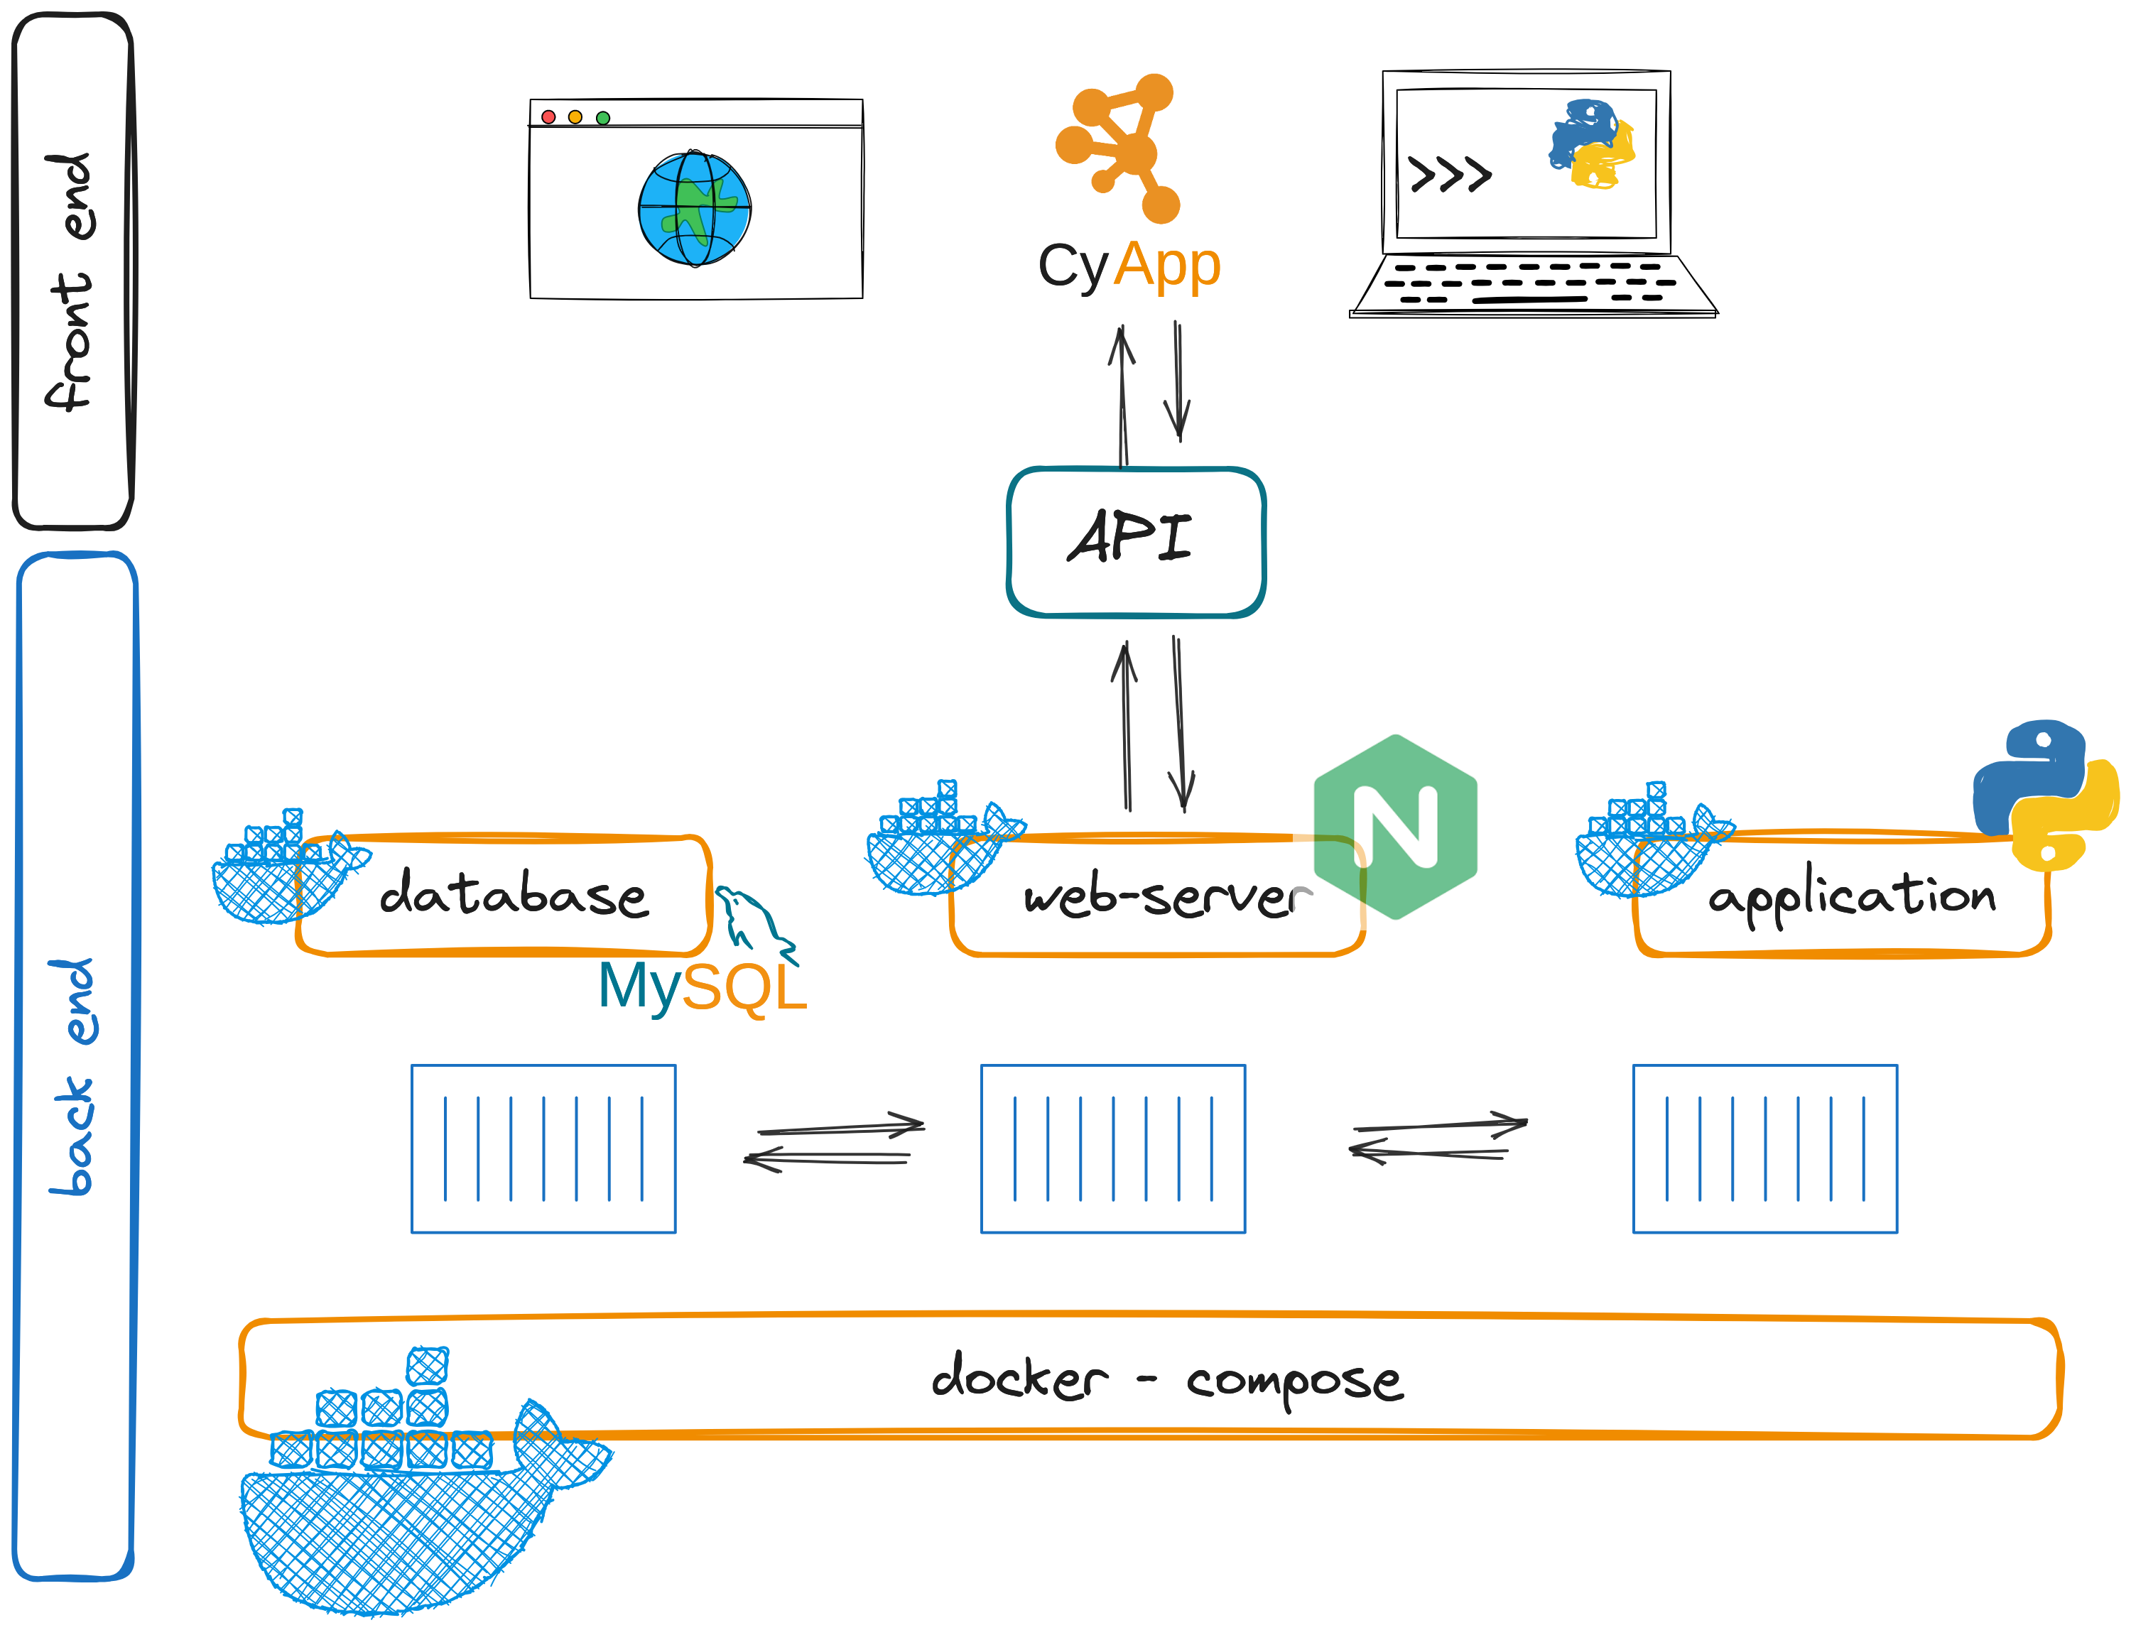
Supplementary Fig. 1: microbetag software ecosystem. Three Docker containers are combined: a nginx web server connected to a MySQL database and the microbetag workflow. An API, as part of the last container, enables communication between the client (front) and the server side (back end). The content of the microbetagDB and the microbetag workflow are accessible through a web-browser, a terminal and a CytoscapeApp (MGG).

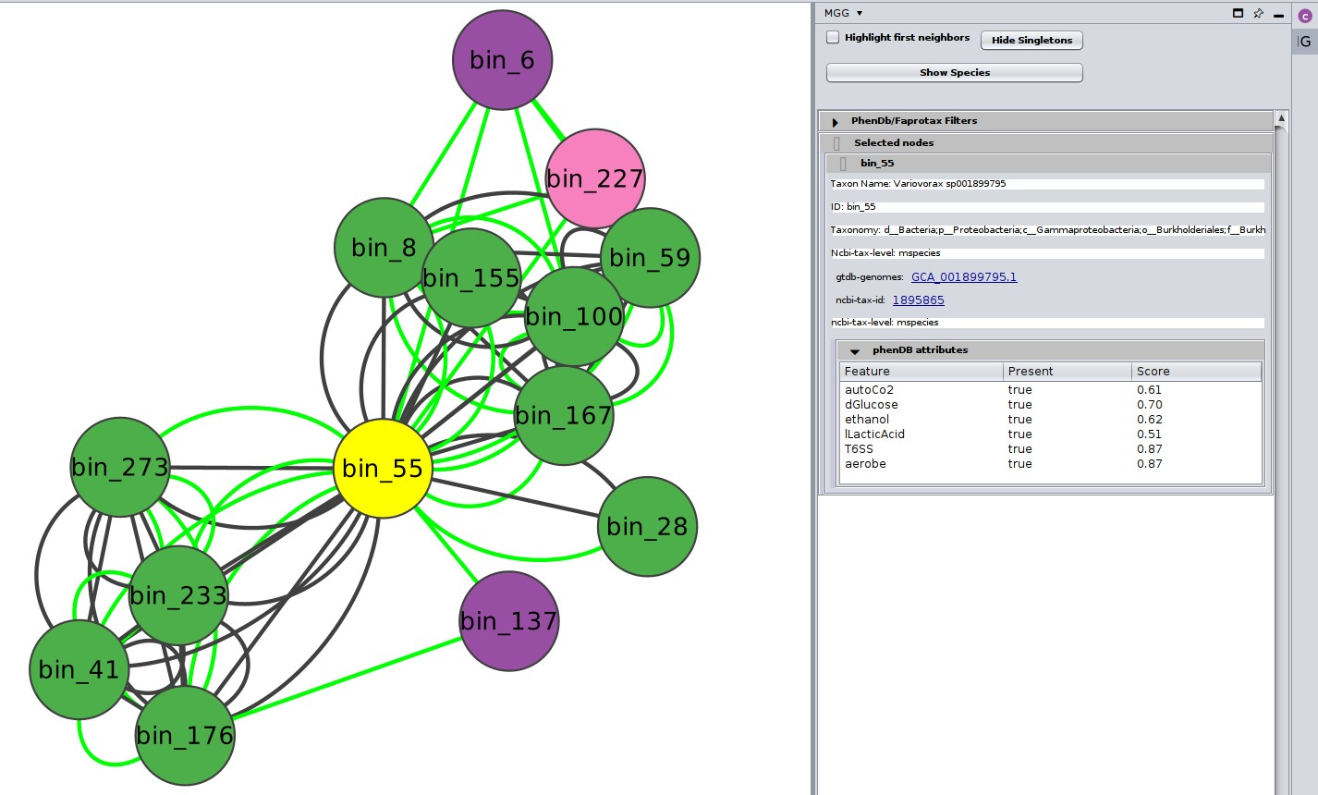
Supplementary Fig. 2: Variovorax node (bin_55) and its neighbors annotated by microbetag. Only three of them were not mapped to a GTDB representative genome (pink and purple nodes denoting genus and family taxonomic levels accordingly). Green edges represent the positive association weights. The black edges represent pairwise seed complementarities and scores.

