**Harita Shroff**

**CMPE#210**

**03/28/2018**

**Prof. Younghee Park**

# 

# **Homework #3**

**Q1.** [50 points] Please implement a simple application by using REST API. For example, you can implement an application to get the current bandwidth information for a particular device. Please explain your application and attach your code together.

**Answer**: Below application collects the statistics for switch in a given topology. Here the floodlight controller is used for this application. Statistics collection is an important part of network triaging and performance analysis. Ingress and egress packet rates help understand the network flow in the topology. This application has following steps.

1. Enable statistics collection: By default, statistics collection is disabled in floodlight controllers, this application enables the statistics collection first.
2. Collect Statistics for switches: Here in this example, there is only 1 switch in the network and statistics for port 1 of the switch is pre-programmed in the code. Because controller takes couple of cycles to collect data, sleep for 150 seconds have been added to the application.

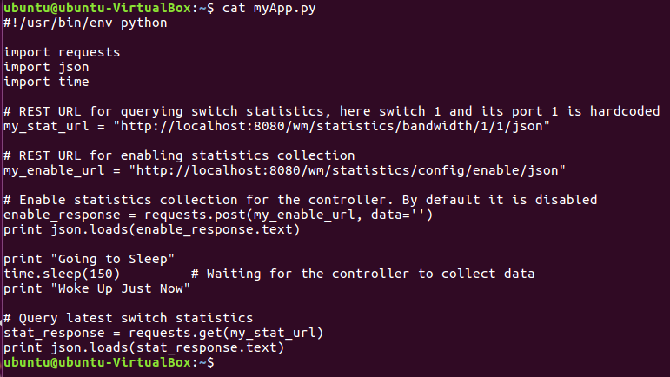

In the below image, we can see that all rx and tx port counters are 0 and no statistics have been captured by the controller. After using mininet’s “pingall” functionality for creating traffic in the topology, we see the increment in the counters at later point of time.

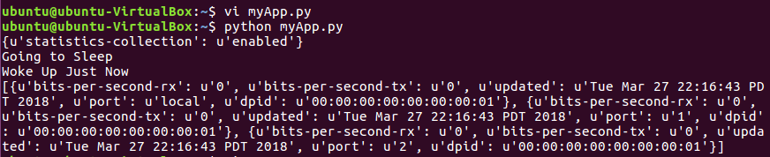

Counters can be seen increasing in the below image. Pingall has been executed multiple times to generate some traffic which can be captured by this application.

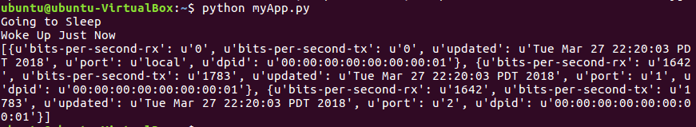

**Q2.** [50 points] Please the Click Exercise 1 as attached.

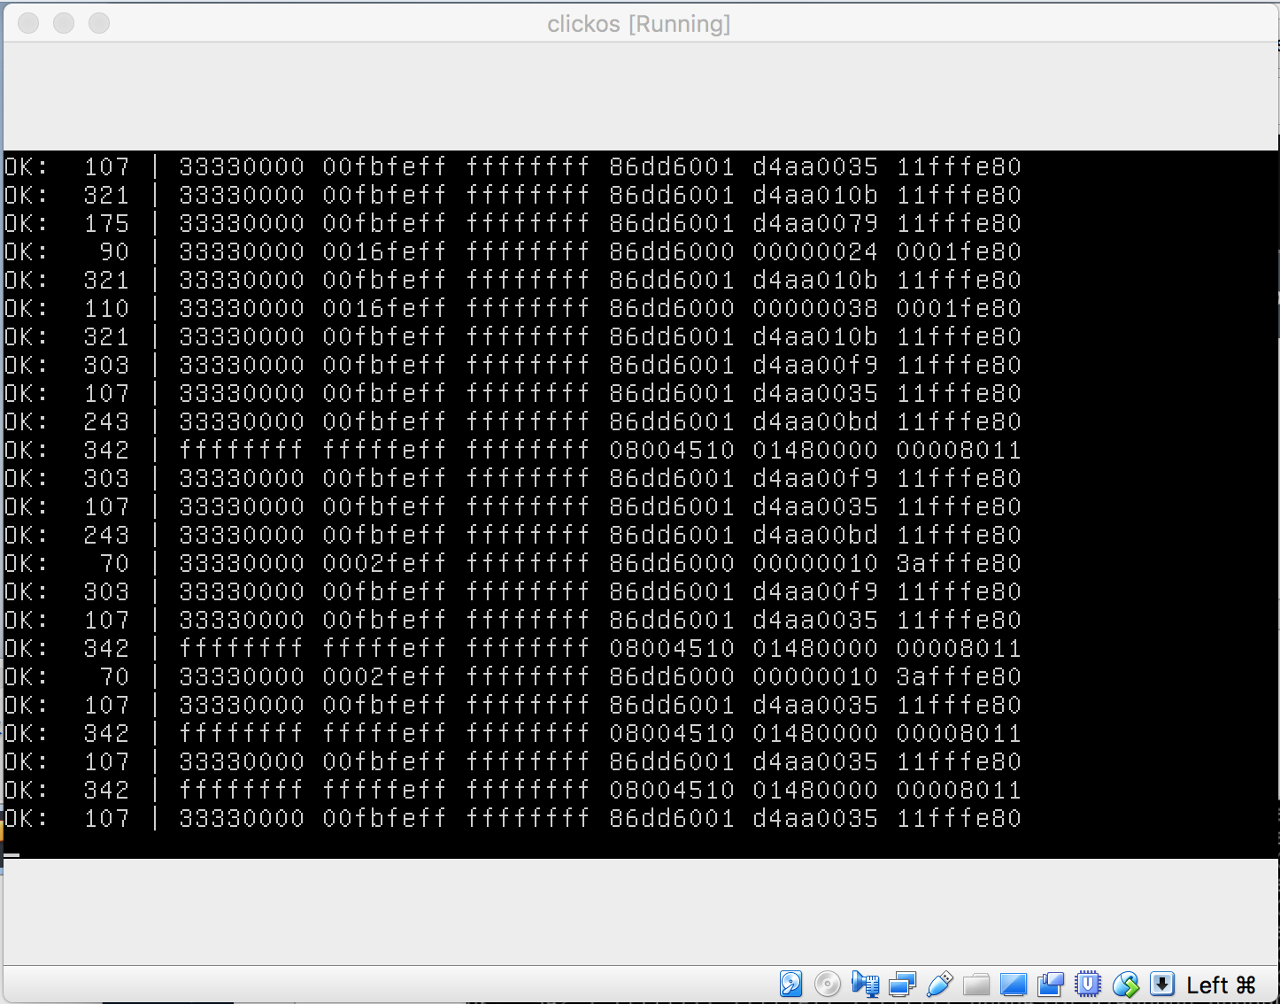

**Q3.** [50 points]Please the Click Exercise 2 as attached.

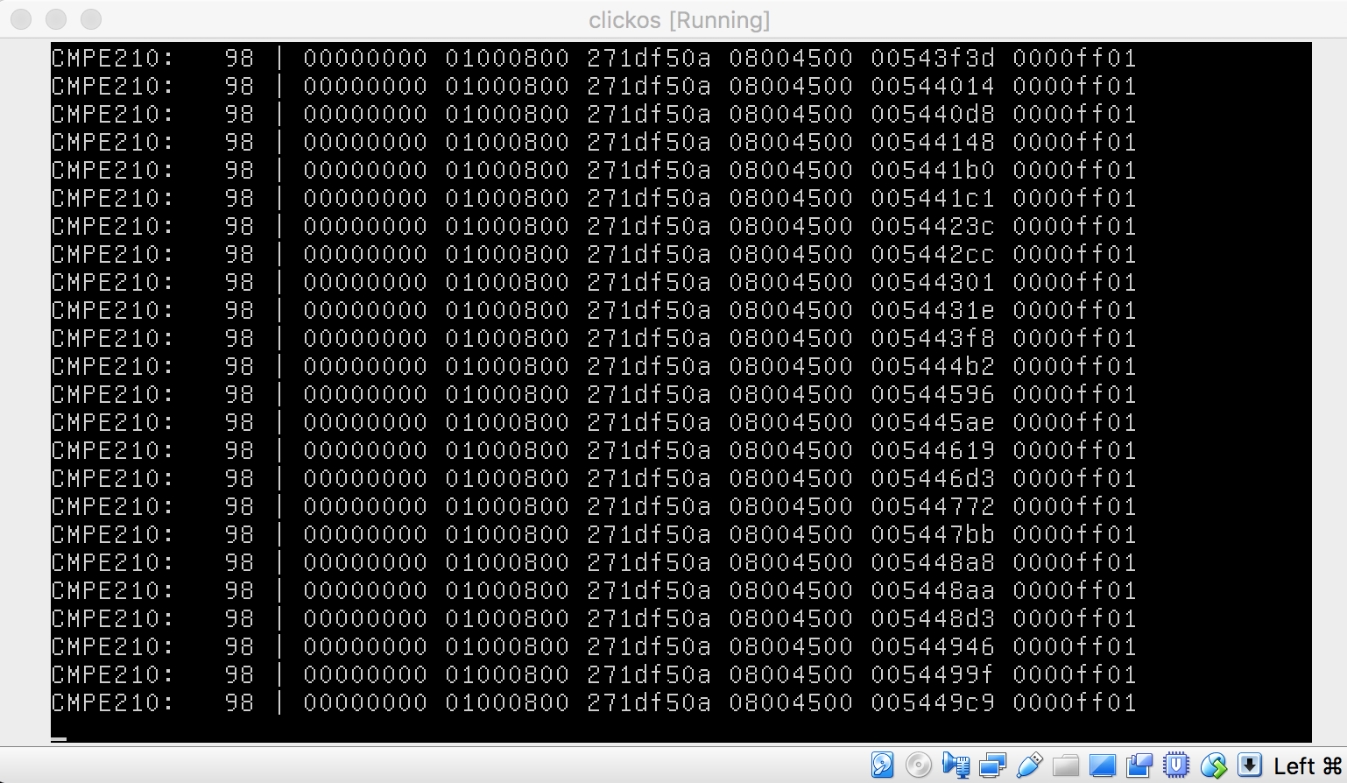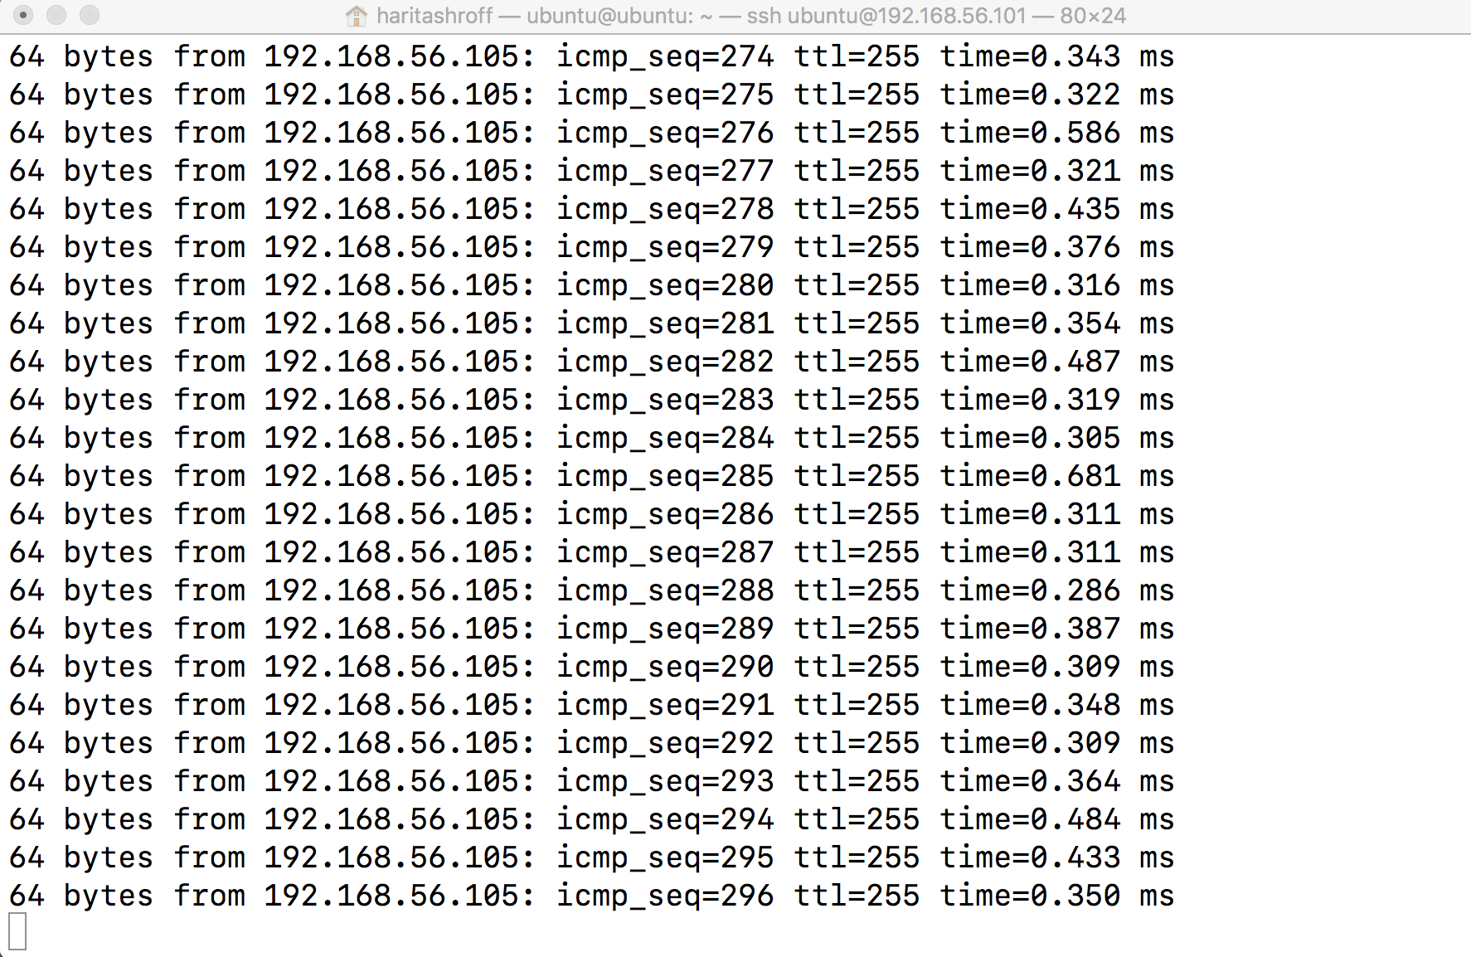

Q4. [50 points] Please the Click Exercise 3(TCP Syn Flood Attack Detection) as attached.

