SSIS Architecture:-

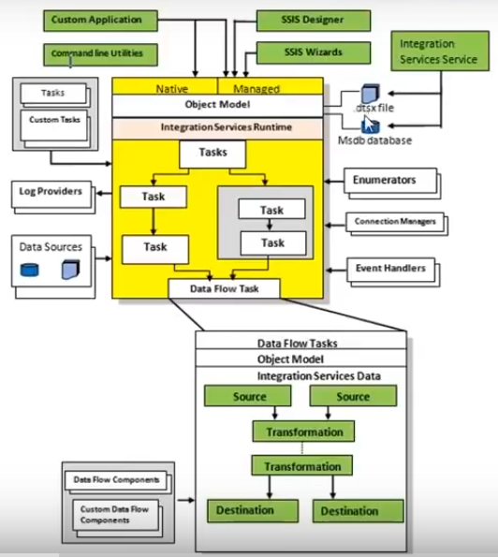

**SSIS Designer:-**

SSIS Designer is a graphical tool that you can use to create and Maintain Integration Services package. SSIS Designer is available in Business Intelligence Development Studio as part of an Integration Services project. **It Contains: -** Control Flow, Data Flow, Parameters, Event Handlers, Package Explorer and Execution Results

**Runtime Engine:-**

The Integration Services runtime saves the layout of packages, runs Packages and provides support for logging, breakpoints, configurations, connections, and transactions.

**Tasks and other executables:-**

The Integration Services run-time executables are the packages, containers, tasks, and event handlers that Integration Services includes. Run-time executables also include custom tasks that you develop.

**1. Integration Service Tasks:-**

* **Data Flow Task: -** The task that runs data ﬂow to extract data, apply Column level transformations and ﬁnally load.
* **Data Preparation Tasks: -** These tasks do the processes like copy ﬁles and directories; download ﬁles and data; run Web methods; apply operations to XML documents; and proﬁle data for cleansing.
* **Work ﬂow task:** - The tasks that communicate with other processes to run packages, run programs or batch ﬁles, send and receive messages between packages, send e-mail messages, read Windows Management Instrumentation (WMI) data, and watch for WMI events.
* **SQL Server Tasks: -** The tasks that access, copy, insert, delete and modify SQL Server objects and data.
* **Scripting Tasks: -** The tasks that extend package functionality by using scripts.

**2. Integration Services Containers:-**

* **For-each Loop Container: -**Runs a control flow repeatedly by using an enumerator.
* **For Loop container: -** Runs a control flow repeatedly by testing a condition.
* **Sequence Container: -** Groups tasks and containers into control flows that are subsets of the package control flow.

**3. Integration Services Event Handlers:-**

* Clean up temporary data storage when a package or task finishes running.
* Retrieve system information to assess resource availability before a package runs.
* Refresh data in a table when a lookup in a reference table fails.
* Send an e-mail message when an error or a warning occurs or when a task fails.

**Data Flow engine (also known as the pipeline) and Data Flow components:-**

* The Data Flow task encapsulates the data flow engine.
* The data Flow engine provides the in-memory buffers that move data from source to destination, and calls the sources that extract data from files and relational databases.
* The data flow engine also manages the transformations that modify data, and the destinations that load data or make data available to other processes.
* Integration Services data flow components are the sources, transformations, and destinations that integration services includes

**SQL Server Import and Export Wizard:-**

The SQL Server Import and Export Wizard is capable of copying data to and from any data source for which managed .NET Framework data provider or a native OLE DB provider is available. This wizard also offers the easiest method to create an Integration Services Package that can copy data from a source to a destination.

**API or Object Model:-**

The Integration Services object model includes managed application programming interfaces (API) for creating custom components for use in packages, or custom applications that create, load, run, and managed packages. It helps the developer to write custom applications or custom tasks or transformations by using any common language runtime (CLR) compliant language.

**Integration Services Service:-**

The Integration Services service lets you use SQL Server Management Studio that helps to monitor running Integration Services packages and to manage the storage of packages.