# Tableau: -

Tableau is a Business Intelligence tool for visually analyzing the data. Users can create and distribute an interactive and shareable dashboard, which depict the trends, variations, and density of the data in the form of graphs and charts. Tableau can connect to files, relational and Big Data sources to acquire and process data. The software allows data blending and real-time collaboration, which makes it very unique. It is used by businesses, academic researchers, and many government organizations for visual data analysis.

As a leading data visualization tool, Tableau has many desirable and unique features. Its powerful data discovery and exploration application allows you to answer important questions in seconds. You can use Tableau's drag and drop interface to visualize any data, explore different views, and even combine multiple databases easily. It does not require any complex scripting. Anyone who understands the business problems can address it with a visualization of the relevant data. After analysis, sharing with others is as easy as publishing to Tableau Server.

# Tableau Features

Tableau provides solutions for all kinds of industries, departments, and data environments. Following are some unique features which enable Tableau to handle diverse scenarios.

1. Speed of Analysis − as it does not require high level of programming expertise, any user with access to data can start using it to derive value from the data.
2. Self-Reliant − Tableau does not need a complex software setup. The desktop version which is used by most users is easily installed and contains all the features needed to start and complete data analysis.
3. Visual Discovery − the user explores and analyzes the data by using visual tools like colors, trend lines, charts, and graphs. There is very little script to be written as nearly everything is done by drag and drop.
4. Blend Diverse Data Sets − Tableau allows you to blend different relational, semi structured and raw data sources in real time, without expensive up-front integration costs. The users don’t need to know the details of how data is stored.
5. Architecture Agnostic − Tableau works in all kinds of devices where data flows. Hence, the user need not worry about specific hardware or software requirements to use Tableau.
6. Real-Time Collaboration − Tableau can filter, sort, and discuss data on the fly and embed a live dashboard in portals like SharePoint site or Salesforce. You can save your view of data and allow colleagues to subscribe to your interactive dashboards so they see the very latest data just by refreshing their web browser.
7. Centralized Data − Tableau server provides a centralized location to manage all of the organization’s published data sources. You can delete, change permissions, add tags, and manage schedules in one convenient location. It’s easy to schedule extract refreshes and manage them in the data server. Administrators can centrally define a schedule for extracts on the server for both incremental and full refreshes.

# Installation and Environment setup of Tableau:-

Go through the link for installation and Environment setup of tableau

<https://www.tutorialspoint.com/tableau/tableau_environment_setup.htm>

# Tableau Get-Started: -

There are three basic steps involved in creating any Tableau data analysis report.

* **Connect to a data source −** It involves locating the data and using an appropriate type of connection to read the data.
* **Choose dimensions and measures −** this involves selecting the required columns from the source data for analysis.
* **Apply visualization technique −** this involves applying required visualization methods, such as a specific chart or graph type to the data being analyzed.

### **Dimensions and Measures: -**

**Dimensions** are the descriptive data while **measures** are numeric data. When put together, they help visualize the performance of the dimensional data with respect to the data which are measures.

For Sample report go through the following link

<https://www.tutorialspoint.com/tableau/tableau_get_started.htm>

# Menu Commands: -

Various sections of the menu are shown in the following diagram.

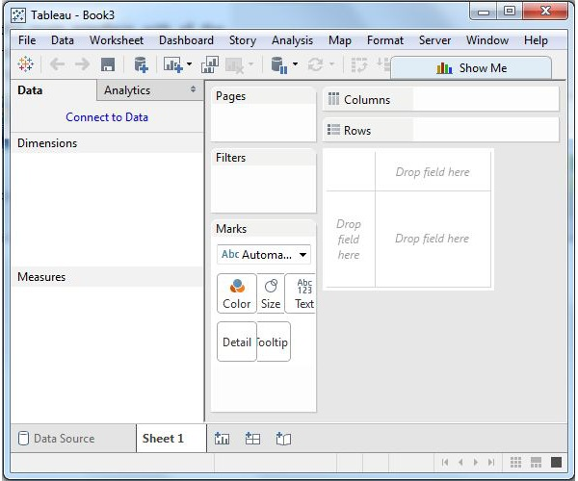

## File Menu

This menu is used to create a new Tableau workbook and open existing workbooks from both the local system and Tableau server. The important features in this menu are −

* **Workbook Locale** sets the language to be used in the report.
* **Paste Sheets** pastes a sheet into the current workbook, which is copied from another workbook.
* **Export Packaged Workbook** option is used to create a packaged workbook, which will be shared with other users.

## 1 File Menu

## Data Menu

This menu is used to create new data source to fetch the data for analysis and visualization. It also allows you to replace or upgrade the existing data source.

The important features in this menu are as follows −

* **New Data Source** allows to view all the types of connections available and choose from it.
* **Refresh All Extracts** refreshes the data from the source.
* **Edit Relationships** option defines the fields in more than one data source for linking.

## 2 Data Menu

## Worksheet Menu

This menu is used to create a new worksheet along with various display features such as showing the title and captions, etc.

The important features in this menu are as follows −

* **Show Summary** allows to view the summary of the data used in the worksheet such as, count, etc.
* Tooltip shows the tooltip when hovering above various data fields.
* **Run Update** option updates the worksheet data or filters used.

## 3 Worksheet Menu

## Dashboard Menu

This menu is used to create a new dashboard along with various display features, such as showing the title and exporting the image, etc.

The important features in this menu are as follows −

* **Format** sets the layout in terms of colors and sections of the dashboard.
* **Actions** link the dashboard sheets to external URLs or other sheets.
* **Export Image** option exports an image of the Dashboard.

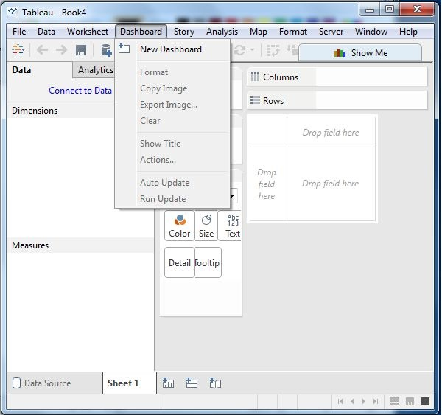

## Story Menu

This menu is used to create a new story which has many sheets or dashboards with related data.

The important features in this menu are as follows −

* **Format** sets the layout in terms of colors and sections of the story.
* **Run Update** updates the story with the latest data from the source.
* **Export Image** option exports an image of the story.

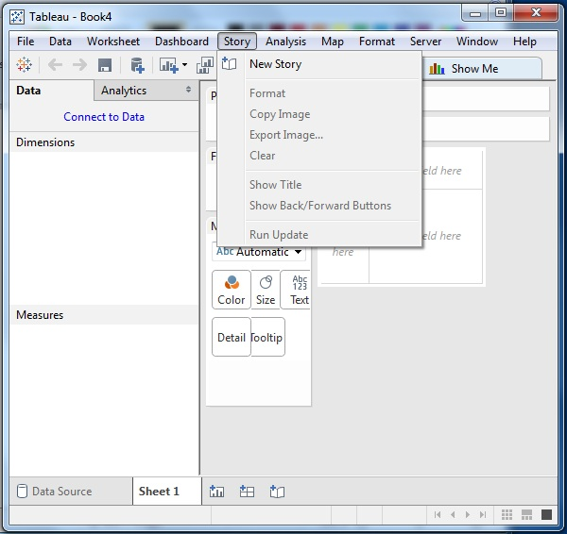

## Analysis Menu

This menu is used for analyzing the data present in the sheet. Tableau provides many outof-the-box features, such as calculating the percentage and performing a forecast, etc.

The important features in this menu are as follows −

* **Forecast** shows a forecast based on available data.
* **Trend Lines** shows the trend line for a series of data.
* **Create Calculated Field** option creates additional fields based on certain calculation on the existing fields.

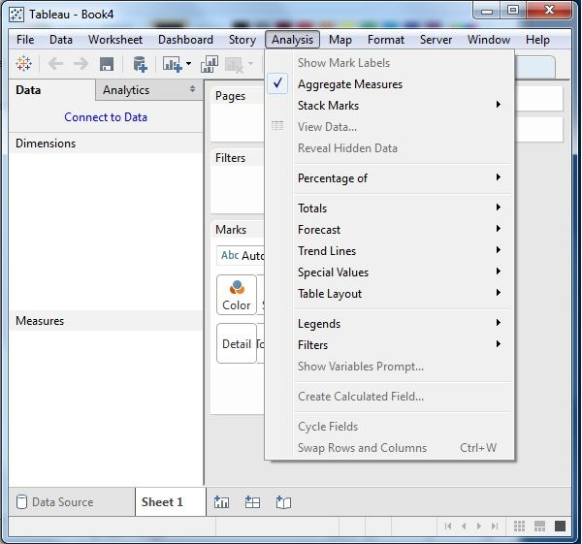

## Map Menu

This menu is used for building map views in Tableau. You can assign geographic roles to fields in your data.

The important features in this menu are as follows −

* **Map Layers** hides and shows map layers, such as street names, country borders, and adds data layers.
* **Geocoding** creates new geographic roles and assigns them to the geographic fields in your data.

## 7 Map Menu

## Format Menu

This menu is used for applying the various formatting options to enhance the look and feel of the dashboards created. It provides features such as borders, colors, alignment of text, etc.

The important features in this menu are as follows −

* **Borders** applies borders to the fields displayed in the report.
* **Title & Caption** assigns a title and caption to the reports.
* **Cell Size** customizes the size of the cells displaying the data.
* **Workbook Theme** applies a theme to the entire workbook.

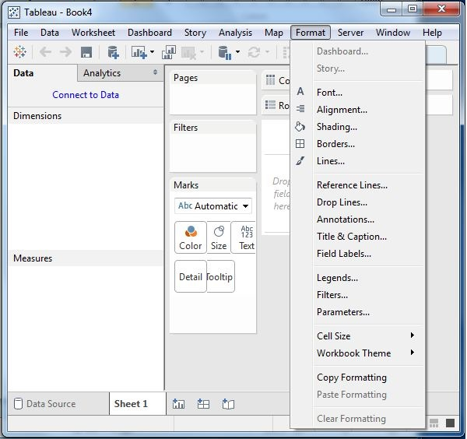

## Server Menu

Server Menu is used to login to the Tableau server if you have access, and publish your results to be used by others. It is also used to access the workbooks published by others.

The important features in this menu are as follows −

* **Publish Workbook** publishes the workbook in the server to be used by others.
* **Publish Data Source** publishes the source data used in the workbook.
* **Create User Filters** creates filters on the worksheet to be applied by various users while accessing the report.

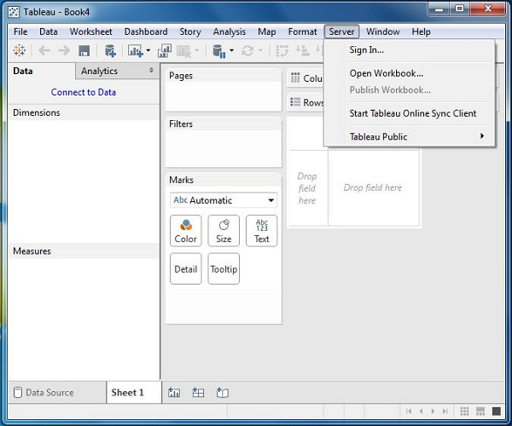

# Tableau Dataflow

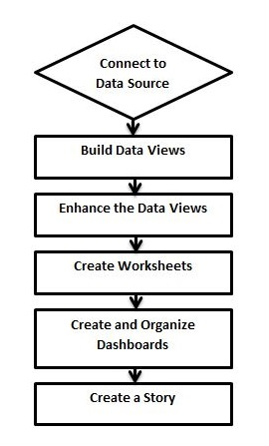

## Connect to Data Source

Tableau connects to all popular data sources. It has inbuilt connectors which take care of establishing the connection, once the connection parameters are supplied. Be it simple text files, relational sources, SQL sources or cloud data bases, Tableau connects to nearly every data source.

## Build Data Views

After connecting to a data source, you get all the column and data available in the Tableau environment. You classify them as dimensions and measures, and create any hierarchy required. Using these you build views, which are traditionally known as Reports. Tableau provides easy drag and drop feature to build views.

## Enhance the Views

The views created above needs to be enhanced further by the use of filters, aggregations, labeling of axes, formatting of colors and borders, etc.

## Create Worksheets

Create different worksheets to create different views on the same or different data.

## Create and Organize Dashboards

Dashboards contain multiple worksheets which are linked. Hence, the action in any of the worksheet can change the result in the dashboard accordingly.