DATA processing ORDER
1) DATA files in sequence order (DATA2026123.XML fully processes before DATA2026124.XML etc) ; then
2) CTNG files in sequence order (CTNG2026123.XML fully processes before CTNG2026124.XML etc) ; then
3) CTNG delete files in date order (GCI06052026.DEL before GCI07202026.DEL) ; then
4) DATA delete files in date order (DRCI04082026.DEL before DRCI07202026.DEL).

DATA Flow:
Step1: Upload the CTNG file at the specified S3 location.
s3://clvt-ref-master-prod/prod/drrRetroBaseLine/DATA2026072.xml
Step2: Below is the POSTMAN url to process the DATA file.
https://ref-master-common.prod.singularity.clarivate.com/reference-master/drr/processDATA
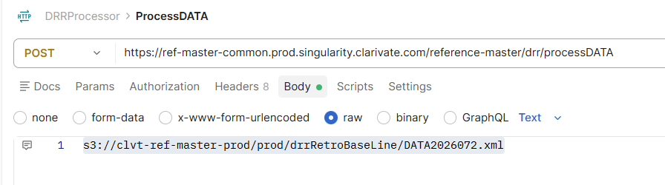
Step3: Here it posts the DataMessage to the specified QUEUE below.
ref-master-data-drr-request-prod.fifo
Sample Data Message:
[{
"dataRecord": { "dataSetId": "DATA2026172036638542" },
"key": “prod/drrRetroBaseLine/toBeProcessed/data/SeptemberFiles/DATA2026172.XML",
"bucket": "clvt-ref-master-prod",
"fileName": "DATA2026172.XML",
"chubPguid": "urn:asset:26:eac89bbb-e0d6-4272-bfc5-5a2ca1c352a3"
}]
Step4: Message gets processed and IMS notification is sent to the SQS queues mentioned below:
1.ref-master-drr-ims-notification-prod.fifo
2.ref-master-drr-imsdbx-notification-prod.fifo

Step5: Finally, file is moved to the https://clvt-ref-master-uat.s3.us-west-2.amazonaws.com/prod/outbound/DRCI/DATA2026075.xml

CTNG Flow:
Step1: Upload the CTNG file at the specified S3 location.
s3://clvt-ref-master-prod/prod/drrRetroBaseLine/CTNG2025190.xml
Step2: Below is the POSTMAN url to process the CTNG file.
https://ref-master-common.prod.singularity.clarivate.com/reference-master/drr/reProcessCTNG
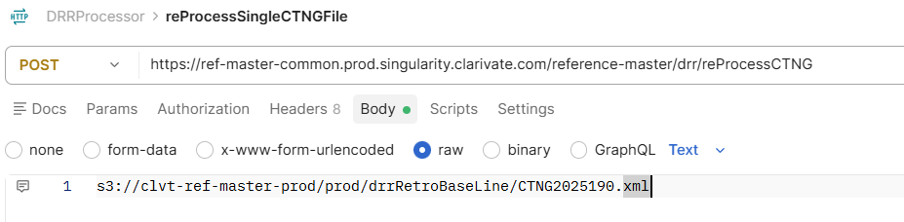
Step3: Initially CTNG Message is framed and posted in the SQS Queue.
ref-master-ctng-drr-request-prod.fifo
Step4: After further processing of the data, it frames the CTNG Message part2 and posts it to the following SQS Queue.
ref-master-ctng-drr-part2-request-prod-fifo
Sample Message:
Step5: Once data gets processed, system saves the information to the DB as well as to the CHUB.
For example: In image below shown for the file: CTNG2012173.XML, ItemId: CTNG2012173001420232 , dataset_Id: DATA2012173001816423, It updates the WOS- JSON file
WOS:000026368410004.json at specified aws location: clvt-chub-prod/prod/published/references.
Step6: During the flow it updates the CTNG tracker table which gives you the CTNG ItemId, DataSetId, CTNG Filename, resolved_UT.
Here it stores the following information to the CTNG tracker table. (CTNG-ID, DATASET_ID, FILE_NAME, RESOLVED_UT).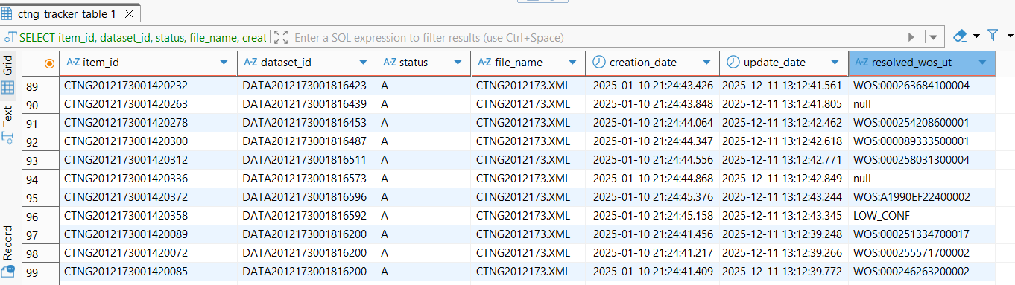
Step7: Finally, system sends the IMS notification to the following IMS Queues:
IMS notification message : {"uid":null,"dataSetId":"DATA2026172036638562","type":"DATA","source":"s3://clvt-chub-prod/artifact/references/DATA2026172.XML","itemId":null}
1.ref-master-drr-ims-notification-prod.fifo
2.ref-master-drr-imsdbx-notification-prod.fifo

Copies the file: CTNG2012173.XML to the outbound location: s3://clvt-ref-master-prod/ /outbound/CTNG/ CTNG2012173.XML

After processing of the file, inform the IMS team Manager for further processing of the file and so that content reaches the product.

DELETE CTNG /DATA File
Step1: Upload the GCI file at the specified S3 location. (Folder – DEL), folder name can be changed as per the convenient.
s3://clvt-ref-master-uat/uat/drrRetroBaseLine/DEL/GCI06052026.DEL
Step2: Below is the POSTMAN url to delete the GCI.DEL file.
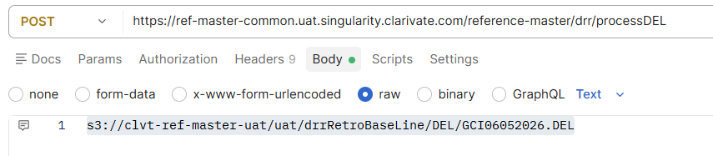

Step3: Once the file gets deleted, file is moved to the arn:aws:s3:::clvt-ref-master-prod/prod/outbound/DEL/GCI06052026.DEL

