CTNF flow diagram:
Process Flow
- Receive CTNG XML Feed.
- Parse all Citing Items.
- For each Citing Item:
  - Read ItemID, CitationString, and CitedDatarecordID.
  - Use the CRS System to identify the corresponding WOS UT.
  - If no WOS UT is found:
    - Log an error.
    - Send NULL notification to IMS.
  - If WOS UT is found:
    - Check whether the WOS UT exists in the database.
    - If not found in DB:
      - Log an error.
      - Send NULL notification to IMS.
    - If found in DB:
      - Check whether a DataSetId (Fact60) already exists.
      - If DataSetId exists:
        - Do not process further.
      - If DataSetId does not exist:
        - Add the CTNG CitedDatarecordID as Fact60.
        - Save/update the record in DB.
        - Update the JSON payload in CHUB.
- After all items are processed, send completion notification (if applicable) and end processing.

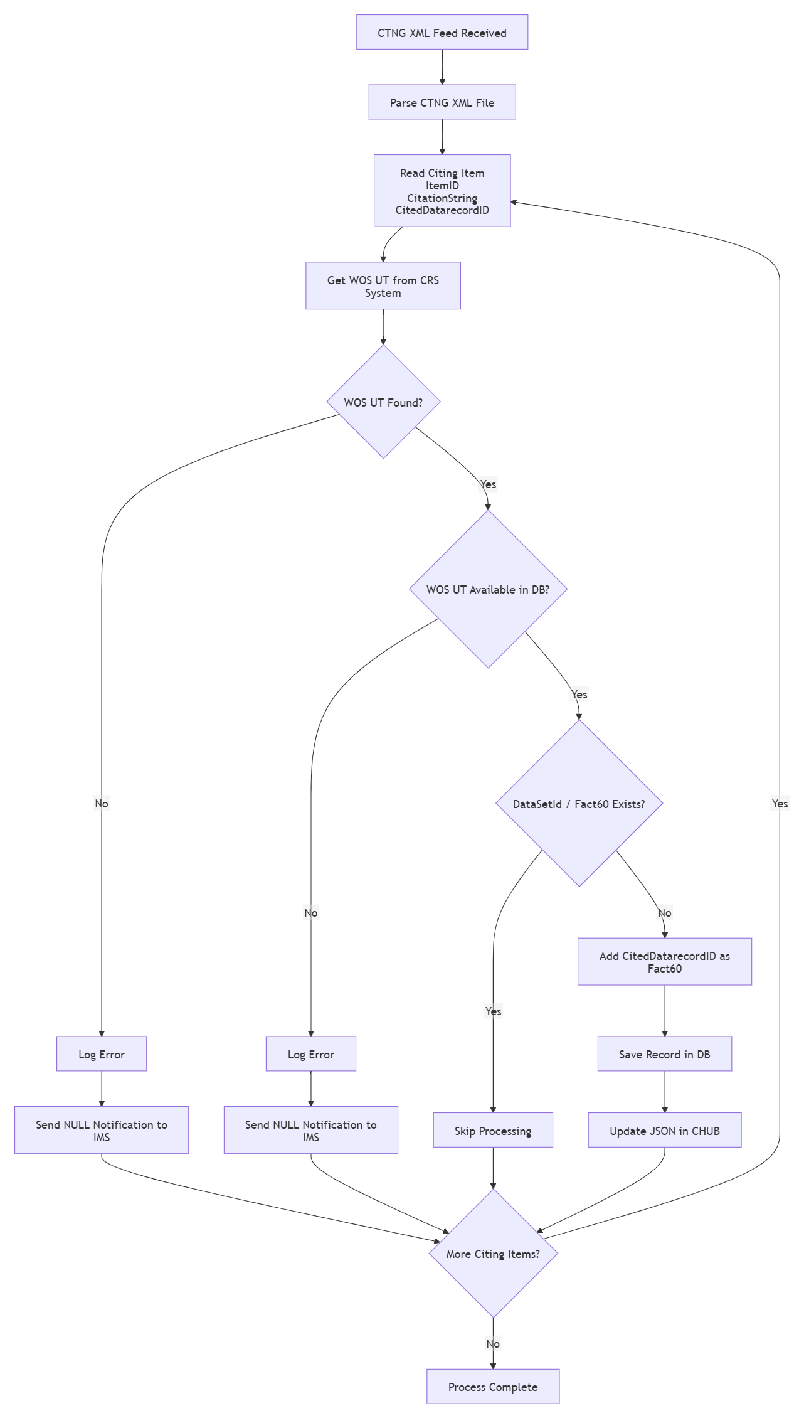
DATA File Processing (e.g., DRCI04082026.XML)
- The input file contains one or more citation records along with associated DataSet IDs.
- The file is parsed to extract citation attributes such as DataSet ID, DOI, Article Title, Authors, Year, Volume, and Citation Blurb.
- The extracted citation information is submitted to CRS to identify a matching WOS UT.
- If a WOS UT is found, additional metadata is retrieved from CRS.
- If a WOS UT is not found, Citadel is used to populate FCR elements, followed by the Transformation Service to generate the required transformed fields.
- The transformed citation data is then processed through ORS to obtain the ClusterKey and any available WOS UT information.
- The record content is updated with the enriched metadata, including ClusterKey, WOS UT, and other cited source fields.
- The enriched record is saved to the Reference Master Database.
- The processed record is then published to CHUB.
- Finally, a notification is sent to IMS to make the processed data available for downstream Product systems.

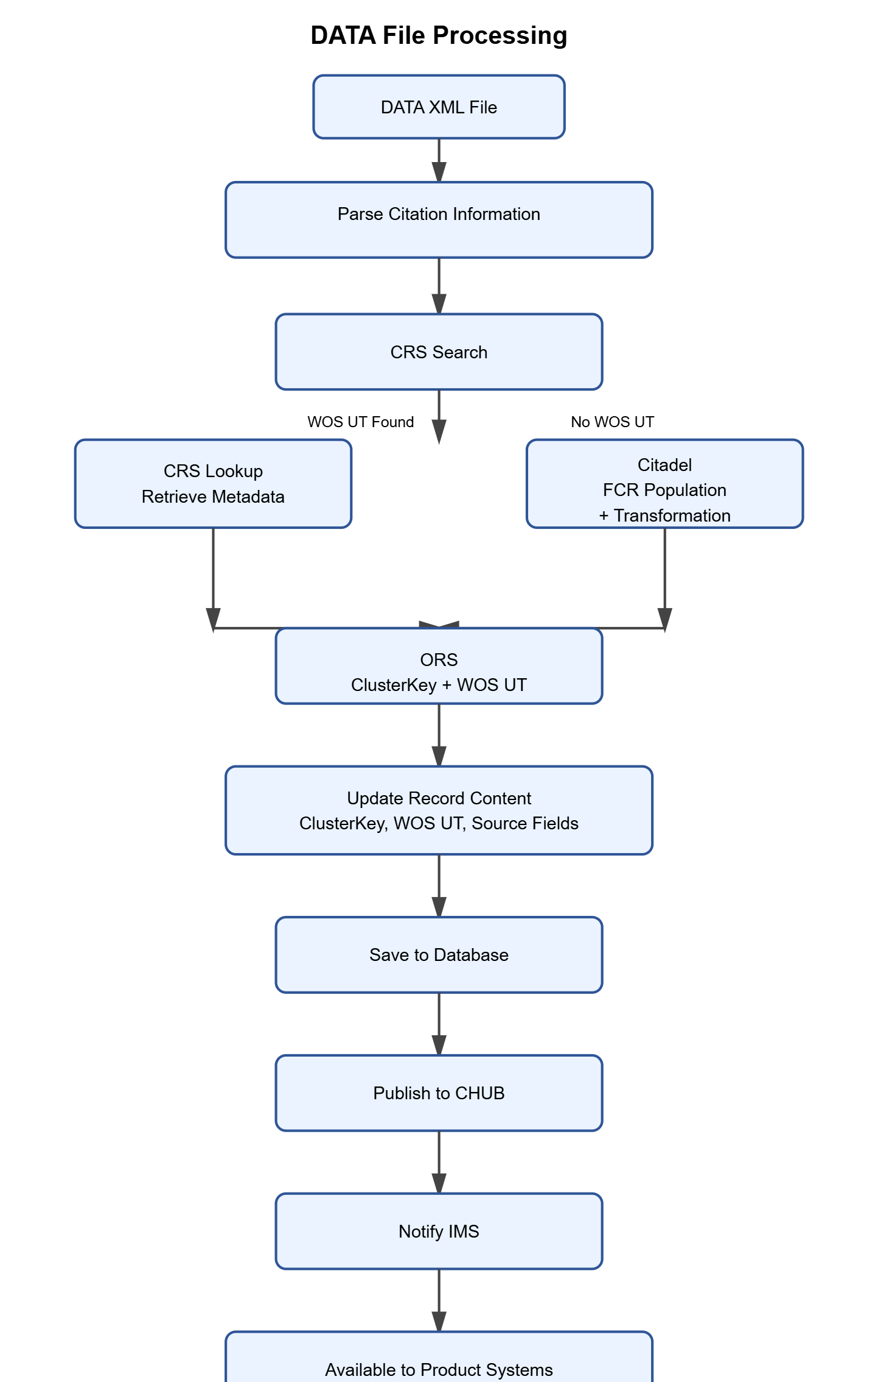

CTNG Delete File Processing (GCI05072026.DEL)
- The delete file contains a collection of CTNG IDs.
- The system retrieves all records corresponding to the CTNG IDs provided in the file.
- The identified records are then removed from both the Reference Master (RM) database and ORS.
- Once the cleanup is completed, a delete notification is published to CHUB.
- IMS is subsequently notified so that the corresponding CTNG information can be removed from IMS and the downstream Product systems.

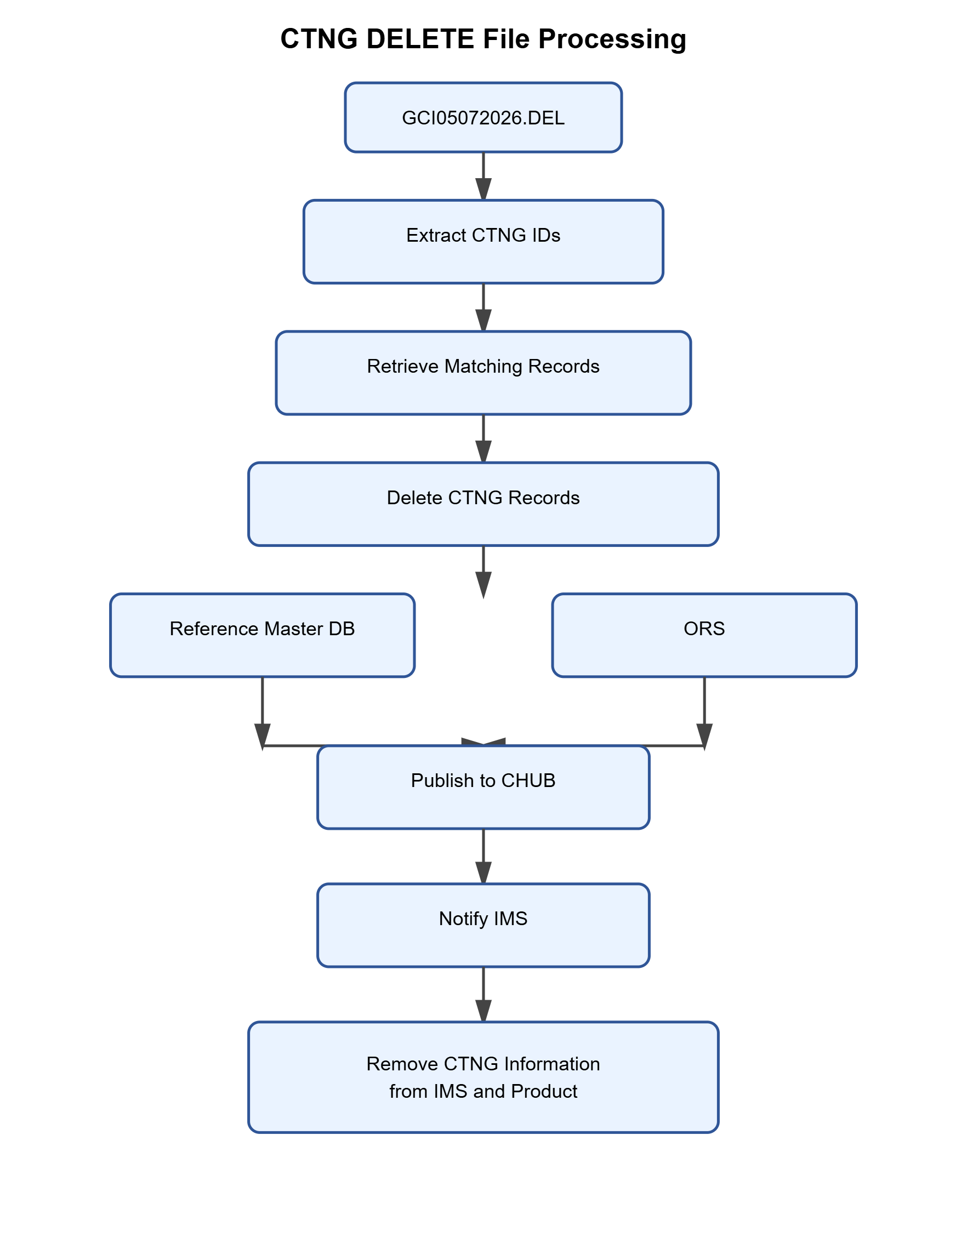

DATA DELETE File Processing (DRCI04082026.DEL)
The delete file contains a collection of DataSet IDs.
The system identifies and expires all records associated with the DataSet IDs provided in the file.
The corresponding data is expired across all applicable systems, including ORS.
Upon successful expiration, a notification is published to CHUB.
IMS is then informed to ensure that the associated DataSet information is removed from IMS and all downstream Product systems.
- 

