

BENV0006: MSc EPEE Dissertation

How can machine learning predict green bond syndicates

by

August 30, 2024

Paper submitted in part fulfilment of the

Degree of Master of Science in Economics and Policy of Energy and the Environment

Institute for Sustainable Resoures/Energy Institute University College London

Word count:

Acknowledgment

I would first like to thank Dr. Alexander Kartun-Giles for the support and detailed supervision throughout this process. I have learned a lot in an exceedingly complex and important topic area. Further, I am appreciative to the faculty and cohort of the EPEE course. They are both some of the most brilliant people I have met and are to thank for making the past year as memorable as it has been. Lastly, I am grateful to my family and Lina, without whom this journey would not have been possible.

Abstract

In light of the financial markets' growing emphasis on climate-focused initiatives, highlighted by numerous studies, this analysis centers on green bonds as the pivotal element of green investments. This paper adopts a quantitative methodology and an analytical framework, reflecting its practical nature. Utilizing historical data, it examines various global regions. To analyze the differing regulatory environments for green bonds, machine learning techniques are employed. Initially, data from Bloomberg is used to scrutinize the development, both current and historical, of each green bond.

Introduction

Financial markets and climate change

Despite the landmark of the Paris Agreement, carbon emissions are still on the rise, underscoring our ongoing reliance on fossil fuels. This troubling trend projects a 3-degree increase in global temperatures by 2100, threatening to exceed the Paris targets within this decade and signaling a new and daunting climate era. The planet is grappling with a surge in natural disasters – from rampant wildfires and unbreathable air to relentless heatwaves – and the urgency of addressing the climate crisis became increasingly evident. These calamities serve as stark reminders of the severe repercussions of neglecting climate change, revealing the irreverence towards it has dire consequences that are impossible to ignore. In response to these escalating exogenous and endogenous crises, financial markets, though complex, are increasingly pivoting towards sustainable development.

Large-scale investments are acknowledged by both the United Nations and OECD as essential to achieving the necessary emission reductions (United Nations, n.d.). In a 2018 report, the OECD estimated that $6.9 trillion per year will be required until 2030 to meet climate objectives (OECD et al., 2018). Consequently, the importance of green funding cannot be overstated. Financial markets are responsible for allocating capital that drive broad economic development and sustainability; they are also increasingly channeling investments towards low-carbon interventions that directly mitigate harmful emissions. In the pursuit of developing projects with an environmental sustainability focus, such as wind farms, developers frequently consider the mobilization of capital through financial markets. One such market is the ‘green bond’ market, a type of fixed-income instrument that is similar to a conventional bond, except that it is specifically designed to raise funds for projects with environmental benefits. Green bonds have evolved significantly since their inception in 2007, expanding from basic vanilla corporate bonds to more complex forms like project bonds, asset-backed bonds, and covered bonds. However, it wasn't until 2013, after the first ‘corporate’ green bond was issued, that the market started to grow significantly. Despite this momentum, the market grapples with significant challenges, including insufficient investor protections, unbinding and variable reporting standards, and pervasive risks of greenwashing. Moreover, given the heterogeneous nature of investment preferences, interest rates, market conditions, and GDP, behavior in these markets appears arbitrary, resembling the dynamics of a complex system.Additionally, complexities surrounding issuer compliance and the lack of enforceable legal mechanisms further complicate the landscape.

How and why bank syndicates occur

Financial institutions, typically banks, are responsible for orchestrating the issuance of green bonds where they often work together and form syndicates to distribute and hedge investment risks, and undertake the underwriting process of green bonds. No single bank typically shoulders the risk of a billion-dollar loan alone. Syndicates allow for the distribution of risk across multiple financial institutions. If the investment falters, the loss is not borne by one bank alone, mitigating the "all eggs in one basket" problem.

The underwriting process is crucial, as it involves substantial due diligence, risk assessment, and the structuring of financial products, whilst also marketing developers’ risk-assessed debts. Nevertheless, it is important to mention that when underwriters coordinate both underwriting and debt sales, they are referred to as ‘book runners’. They manage the overall process, bringing in other banks as needed to handle specific tasks like payment processing and insurance. Consequently, a collaborative and specialized nature of modern underwriting practices exists, where smaller banks generally rely on the more experienced underwriters from larger banks in order to cut costs and specialize in debt financing.

Developers often prefer to issue bonds through an underwriter rather than seeking a loan from a single bank, since ‘interest rate that companies pay bond investors is usually less than the interest rate available from banks’. In this process, developers approach a bank to act as an underwriter for their bond issuance. Within ESG-related mutual funds – investment vehicles that pool money from multiple investors to purchase a diversified portfolio of stocks, bonds, or other securities– firms like Vanguard manage a substantial portion of green debt, mirroring their investment strategies in the fossil fuel sector. Syndications between these banks are frequently utilized for such bonds because of their niche and narrow market, often with extended maturities. The syndicate members, acting as intermediaries, commit to purchasing the entire bond issuance and then sells these bonds to a diverse group of investors —allowing developers to access a broader pool of capital and distribute the investment risk among multiple investors—, including individuals and institutional investors such as pension funds. These transactions are pre-arranged, ensuring the bond's immediate resale post-issuance, which facilitates the rapid mobilization of capital towards the developer. Although the banks momentarily hold the bond, their role as underwriters means they assume a degree of liability. Should the project fail to generate the expected returns, these banks are positioned to absorb some of the financial losses.

These investors purchase the bonds, essentially providing a loan to the developers with a commitment to receive the principal amount back along with periodic interest payments, referred to as a coupon, at a predetermined rate. The underwriting process offers a near-assurance of principal repayment, shifting the focus for investors from the security of their principal to the amount of interest they will earn. This interest, or more commonly known as ‘yield’ —which is calculated as the coupon divided by the bond's price— can fluctuate but is generally seen as more attractive compared to returns from more conservative investments, such as savings accounts. The favorable bond yield underscores the appeal of such investments in the context of sustainable finance.

The examination of green bond syndicates holds paramount importance for companies aiming to invest, and is critical given the interconnected financial dynamics and systemic risks present in today's market. The results of such an analysis can illuminate portfolio overlaps, the impacts of external shocks, the likelihood of banks forming syndicates, the identification of key influential players, and the broader systemic risks associated with these financial networks. Gaining insights into these relationships and the potential for financial contagion within green funds provides essential market data in the field of climate finance.

Furthermore, a deeper understanding of these networks can inform investment strategies and risk management practices. Companies can leverage this knowledge to develop more resilient investment portfolios that are better equipped to withstand financial turbulence. Additionally, this research can contribute to the formulation of policies aimed at enhancing the stability and sustainability of the green bond market. By identifying the most influential players and understanding their roles within these syndicates, policymakers and regulators can design interventions to mitigate systemic risks and promote long-term investment in sustainable projects.

Moreover, the study of green bond syndicates can reveal critical information about the behavior of investors under varying market conditions, shedding light on the factors that influence their decision-making processes. This information is invaluable for both investors and issuers of green bonds, as it enables them to better align their objectives and strategies, thereby fostering a more stable and efficient market. Ultimately, this research not only advances the field of climate finance but also supports the broader goal of achieving sustainable development by facilitating the flow of capital towards environmentally beneficial projects.

Quantum Economics and Complex Networks

Quantum economics emerges as an interdisciplinary field, akin to quantum physics, which marries the methodologies of physics with the complexities of economic systems. This innovative approach treats economies as models similar to physical systems, such as gases or magnets, consisting of numerous individual agents whose interactions lead to complex, emergent phenomena. The inception of this field dates back to the 1990s and has gained significant attention, particularly following the unpredicted financial crash of 2008. Such economic crises are reminiscent of phase transitions in physical or engineering systems, like energy networks, which are characterized by a high degree of objectivity.

However, unlike the deterministic nature of physical laws, economic behavior is rooted in mechanisms that are more assumption-based and less absolute. While economic models can predict the effects of policy changes, such as the impact of interest rate fluctuations on currency value, the exact outcomes often remain uncertain. This uncertainty in economic predictions is paralleled in physics, where even with thorough models, certain behaviors of systems, like those involving black holes, can be unpredictable. Despite the complexities and uncertainties inherent in both disciplines, the predictive power remains a shared feature. Physics provides us with tools to make informed predictions even when complete understanding of systems is not within reach, much like in economics, where despite many unknowns, certain outcomes can be anticipated.

The practical applications of this cross-disciplinary approach are extensive. For instance, the skills of physicists in data analysis and probabilistic modelling are invaluable in economic contexts. These models are instrumental in analysing the potential impacts of economic decisions and policy changes, including how a particular interest rate decision by a bank could potentially trigger wider economic effects or even a systemic collapse. This fusion of physics and economics opens up new avenues for understanding and potentially solving complex problems in financial networks, such as those encountered in green bond syndicates. It suggests that breakthroughs in one field could provide valuable insights into the other, further highlighting the interconnectedness of these seemingly disparate fields of study.

Understanding the composition and role of bondholders, including their syndication dynamics, is crucial for comprehending the distribution network and support framework of green bonds. Using similarity-based models, LP is an instrumental method in forecasting potential future connections between agents, thereby enhancing the understanding of evolving network dynamics. Link prediction involves forecasting potential future connections between pairs of nodes within a network by analyzing historical data, the network's structural characteristics, and the attributes of its nodes. Real-world networks, such as social or economic systems, often do not adhere to random distribution models. Instead, they are better explained by models like the Barabási–Albert distribution, which demonstrates how networks expand through a mechanism called ‘preferential attachment’, a core element in this study. In these models, new nodes tend to connect to existing nodes that already have many connections, leading to a situation where some nodes become significantly more connected than others. For example, consider a town where new residents are more likely to choose the most popular bank. As more people join this bank, its popularity grows even further, reinforcing its position as the preferred choice. This process of preferential attachment results in an organic growth pattern where popular nodes—or banks, in this analogy—attract more connections over time. Understanding these principles helps elucidate the mechanics of network growth and connectivity, shedding light on the underlying patterns that drive the development of complex systems.

Following this direction, this paper makes a significant contribution to the literature on network formation by examining 'green bond' networks. In the financial sector, these collaboration networks form intricate patterns of interbank connections. The network structure can be depicted with nodes representing entities such as the transaction originator (bank) and the counterparty buyer (fund manager), and edges representing the transactional links between them. This dynamic syndicated investment chain evolves over time, such as the addiction of new links/nodes, which underscores the interconnectedness of various financial market participants and highlights the reliance of large-scale development projects on the global financial system. The complexity of how investments in green bonds and loans create an intricate system has yet to be clearly defined by the research community, thus prompting this study. By leveraging the understanding of previous network configurations, the study aims to illuminate the key drivers of link formation through data-driven preferential attachment. It also seeks to determine the attachment probabilities for each node to all other nodes in the network, whether they are incumbent nodes already part of the existing network or newcomer nodes likely to join the network in the future.
  - The use of Machine Learning in prediction syndicates

Syndicates can vary in size, and while each bank contributes a portion of the total loan, the formation of syndicates is so complex that it can be effectively modelled using random models. Stemming from the complexity and seemingly random nature of their formation, using machine learning to predict these syndicate behaviours is justified. Machine learning can analyse vast amounts of data to find trends and make predictions about the syndicates, providing valuable information for banks, investors, and economists. By gathering comprehensive datasets that include the banks investors, a machine learning model can be trained to identify patterns and characteristics unique to each collaboration.

A crucial aspect of this research is to unearth the attributes that increase the likelihood of banks forming syndicates. Geographic proximity, for example, may significantly influence the propensity for banks to collaborate. However, the complexity of financial networks suggests that multiple factors, including balance sheet health or specific financial indicators, could play a role in syndication dynamics. The challenge lies in pinpointing these factors and understanding how they interplay to encourage syndicate formation. To address this, regression models, particularly Gradient Boosting Regression, have proven to be effective. Consequently, regression analysis allows for the modelling of relationships between dependent and independent variables, making it an ideal approach for predicting continuous outcomes such as the likelihood or extent of syndicate formation. Gradient Boosting Regression, in particular, stands out due to its ability to handle complex datasets and capture intricate patterns within the data. This technique builds an ensemble of weak learners, typically decision trees, which sequentially correct the errors of their predecessors, resulting in a robust predictive model.

Gradient Boosting is favored for several reasons. Firstly, it excels in handling various types of data and can incorporate numerous features, both numerical and categorical, without extensive pre-processing. Secondly, it effectively manages the overfitting problem through techniques such as shrinkage and subsampling. Thirdly, its flexibility in choosing loss functions allows for fine-tuning to specific needs, enhancing its applicability across different domains. In this research, similarity-based methods, such as preferential attachment, Jaccard coefficient, common neighbors, Adamic- Adar and resource allocation capture essential aspects of network connectivity and similarity, offering a foundational understanding of relational dynamics among banks. However, to achieve a comprehensive model, additional features such as node centrality measures, historical performance data, bond characteristics, holder demographics, temporal features, and market conditions will be integrated. By leveraging the Gradient Boosting Regression model, this study aims to intricately model these complex interactions, providing a nuanced prediction of syndicate formation among banks and thereby contributing significantly to the field of financial network analysis.

This paper unfolds as follows: Section 2 embarks on a detailed exploration of the existing literature and theoretical underpinnings, which culminates in the articulation of the research question. Section 3 elaborates on the research design, specifying the methodological framework, methods employed, and the analytical strategies adopted. Section 4 presents a rigorous analysis and discussion of the results, highlighting significant findings and their implications. Finally, Section 5 synthesizes the conclusions drawn from the study, summarizing key insights and proposing directions for future research endeavors.

Literature Review
This section proceeds as follows. First, it elaborates on the literature of green bonds and its actors. Second, it looks at the green market's role in decarbonization, delving into the types of green bonds. Third, the economics and policies of green bonds will be assessed. Finally……
This review brings together the academic, policy, and popular literature to frame this paper's research topic.

What is a Green Bond?
As introduced previously, green bonds are financial instruments used to secure funding in debt capital markets, aiming to undertake eco-proactive investments related to renewable energy, energy efficiency, and similar projects (Russo et al., 2021). The capital raised through these bonds is exclusively used for financing or re-financing environmentally sustainable projects and/or assets. A recent real-life example of such projects is E. ON’s €1.5 billion green bond that is used to fund sustainable projects driving the further decarbonization of energy systems.
To classify a project as 'green,' the International Capital Market Association (ICMA) has delineated criteria guided by four voluntary principles, collectively known as the Green Bond Principles (GBP). These principles encompass the use of proceeds disclosure, procedures for project evaluation and selection, management of proceeds, and ongoing reporting. A degree of information asymmetry may exist between the issuer and the investor when the issuer provides the voluntary information, therefore second-party opinions (SPO) are established. To enhance transparency, adhering to the Task Force on Climate-Related Financial Disclosures (TCFD) guidelines is recommended, which aims to facilitate the provision of consistent and reliable information on climate-related risks and opportunities, aiding stakeholders in making informed decisions (TCFD, 2021). This framework encompasses governance, strategy, risk management, and metrics and targets, promoting a comprehensive and comparable approach to climate-related financial reporting.
However, the absence of a universally accepted legal and commercial definition of a green bond means that the GBPs, while a valuable framework, remain voluntary. Without binding contractual obligations, there is no guarantee that bonds marketed as green will maintain their green status throughout their lifetime. This lack of strict covenants can lead to misuse of proceeds and inadequate reporting, leaving bondholders with limited recourse in cases of non-compliance. Further discussion on the challenges will be delineated in the following sections.

Green Bond Market Development
Since its inception in 2007, the green bond market has experienced exponential growth. A notable acceleration in this expansion has been observed following the introduction of the Green Bond Principles in 2014. According to IFC and Amundi (2024), the issuance of green bonds in emerging markets increased from 1 billion in 2013 to $939 billion in 2023, and 34% increase in 2023 compared to the previous year, with China still the largest issuer of green bonds within emerging markets, with a total issuance of $89.1 billion, reflecting an 18% year-over-year growth. This expansion has been significantly influenced by global green initiatives like the Paris Agreement, the Green Climate Fund and others, flourishing aspiration from major investors such as asset managers, insurers, and pension funds to acquire them.
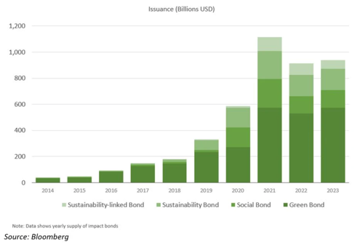
Figure 2: Annual Green Bond Issuance

In addition to green bonds, several other types of sustainability-oriented bonds cater to specific industry contexts, including sustainability-linked bonds, transition bonds, and brown bonds. These financial instruments play crucial roles in promoting environmental sustainability across various sectors.
Sustainability-linked bonds (SLBs) and transition bonds serve as financial tools predominantly utilized by entities in 'brown' industries, which are sectors not readily associated with distinct 'green' initiatives where bond proceeds can be allocated. These instruments provide issuers with the latitude to apply the funds for broad corporate uses​​. The distinctive feature of SLBs is the nature of their coupon rates: these rates are conditional on the achievement of specific Environmental, Social, and Governance (ESG) objectives, where they decrease if targets are met and increase otherwise. Failure to meet these predefined targets may result in financial repercussions for the issuer.
Transition bonds support high-emission sectors like energy and transportation in reducing carbon emissions through incremental steps, aligning with frameworks like the ICMA's Climate Transition Finance Handbook. Some examples of sectors include energy, mining, heavy industry and transportation. Last but not least, social bonds, on the other hand, finance projects that deliver positive social outcomes, such as affordable housing, education, and healthcare, addressing social challenges and promoting societal well-being.
The use of proceeds is a cornerstone of the Green Bond Principles, serving as a critical mechanism to ensure that funds raised through green bonds are exclusively directed towards projects that yield tangible environmental benefits. As illustrated in the first pie chart, the percentage use of proceeds reveals a broad spectrum of participation. Utilities lead the issuance, followed by the energy sector, materials, and communications. This wide-ranging involvement from various industries underscores the pervasive recognition of green bonds as an essential tool for financing environmentally sustainable projects across diverse economic sectors. Moreover, the second pie chart depicts the percentage distribution of bond types within the green bond market, highlighting the contributions from corporates, financial institutions, government agencies, and supranational. This distribution reflects the extensive adoption and support for green bonds across different bond categories, further demonstrating their integral role in advancing sustainable development.

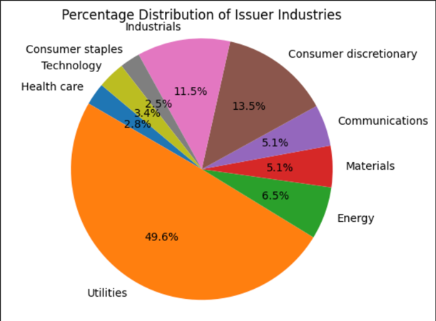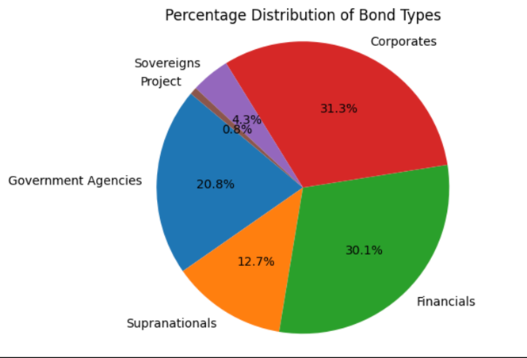
In conclusion, the diverse landscape of sustainable bonds reflects the multifaceted approach needed to address global environmental challenges. By understanding and leveraging these different instruments, investors and policymakers can more effectively drive the transition towards a sustainable and low-carbon economy.

2.1.2 Challenges of Green Bonds
The concept of green bonds has been critiqued for several inherent flaws. Firstly, the fungibility of money means that even if funds raised through green bond issuance are directed towards sustainable investments, other available ‘brown’ funds could still be allocated to environmentally detrimental activities, thereby negating the net positive impact. Moreover, the notion of 'greenwashing,' wherein bonds are marketed as 'green' but do not achieve substantial environmental benefits, has become a significant topic of debate. Green bonds are undeniably susceptible to this issue due to the absence of stringent binding regulations for ex-post commitment reporting. The payment structure of green bonds, which is independent of any ESG outcomes, further complicates the verification of the direct impact of these investments. While numerous studies, including those by Fatica & Panzica (2021), demonstrate that green bonds can contribute to pollution reduction, they also acknowledge the potential for endogeneity problems, which might bias estimates of the impact of green bonds on carbon emissions.
The commitment of financial institutions to indicators such as the Science Based Targets initiative (SBTi) is paramount to monitor and assess their dedication to reducing carbon emissions. A firm is classified as "committed" if at least one of its current or previous lenders commits to the SBTi. Alternative proxies for this commitment include conditioning on the subset of lead arrangers and considering the intensive margin, which refers to the percentage of committed banks and lead arrangers.
In an investment point of view, the credit risk associated with green bonds is fully embodied in the issuer's balance sheet, meaning that these bonds do not mitigate credit risk any more effectively than traditional bonds (BDO, 2024; Sustvest, 2023). Additionally, the green designation of a bond does not confer any special privileges or seniority in the event of bankruptcy, thus offering no added security to investors compared to conventional debt instruments (ICMA, 2022; Government of Canada, 2022). Furthermore, there may be no risk mitigation benefits involved in the issuance of green bonds, raising questions about their effectiveness in promoting sustainability (Baker McKenzie, 2019). It remains uncertain whether green bonds offer any special financial returns for investors, thereby questioning their attractiveness as investment vehicles purely on financial grounds. These points collectively suggest that the practical benefits of green bonds in driving environmental sustainability may be limited, necessitating a more critical examination of their role in green finance.
Underwriting becomes inherently more complex and riskier in the absence of deep, elastic, and liquid secondary trading markets. Green bonds often lack the volume and standardization, disincentivizing a 'dealer of last resort,' an entity that traditionally stabilizes markets by purchasing more liquid and broadly traded assets/markets during periods of stress prefer. Markets such as the tax equity market for renewable energy projects, investment-grade debt for energy projects, and mezzanine financing are particularly vulnerable to this lack of a safety net. These markets are characterized by significant liquidity risk, which is the difficulty of selling assets quickly without affecting their price, in addition to the inherent risks of investing in nascent and unproven technologies. Conversely, a dealer of last resort is typically present in markets that are highly liquid, standardized, and of systemic importance to the financial system, including government bonds, major corporate bonds, and critical short-term funding markets like buy-backs.
Given that we are in the early stages of banking sector decarbonization, it remains uncertain whether these commitments have led to substantial effects or what the magnitude of these effects might be. The proactive involvement of banks in initiatives like the SBTi highlights their potential role in driving the transition to a sustainable, low-carbon economy, provided these commitments translate into concrete actions rather than remaining superficial pledges.

Financial Bodies
After outlining the background, necessity, and technical characteristics of green bonds, we now turn to the relevant literature on how these bonds are created. This section first reviews the academic literature and then examines the literature related to the role of banks and machine learning predictions of syndicates, within the contemporary global context.

2.2.1 The roles of banks
In recent years, the question of whether banks actively decarbonize their portfolios has gained significant attention in the context of climate change and finance. Empirical evidence reveals diverse responses from banks to both physical and transition risks associated with climate change. For instance, Nguyen, Ongena, Qi, and Sila (2022) highlight that banks tend to adjust their mortgage terms in response to heightened physical risks. Furthermore, Delis, de Greif, Iosidi, and Ongena (2021) demonstrate that banks often raise the cost of commercial loans to the fossil fuel industry when faced with stronger legislative risks. The evidence related to transition risks reveals that banks' lending practices are influenced by significant policy changes. For example, Regazza et al. (2021) show that banks tightened credit following the Paris Agreement, reflecting increased regulatory scrutiny and commitment to environmental standards. Conversely, these institutions loosened credit in the wake of the Trump election, which was associated with a deregulatory agenda.
A crucial aspect of this discussion is whether bank decarbonization efforts lead to real adjustments in the companies they lend to. Studies suggest that these efforts do indeed have significant effects on corporate real and financial decisions, including greenhouse gas (GHG) emissions. Kacperczyk and Peydro (2022) provide evidence that decarbonization by banks can influence corporate behavior and decision-making processes. Moreover, research by Degryse et al. (2021) indicates that green firms benefit more from green banks, highlighting the symbiotic relationship between financial institutions and environmentally responsible companies.
Banks' commitments to carbon net neutrality are often driven by stakeholder pressure, which can vary based on institutional ownership, client loyalty, and board size. These pressures can be uneven across different geographical locations and bank sizes. Most bank commitments focus on Scope 1 (direct) emissions and involve both absolute and intensity measures of emissions. While many banks have yet to set specific targets, the trend is moving towards more precise goals.
In contemporary financial landscapes, public banks are emerging as pivotal actors in the pursuit of sustainability and equitable development. The stringent regulatory frameworks governing modern banks, coupled with the evolving missions of public banking institutions, underscore an increasing emphasis on sustainability. Ensuring that public banks operate under democratic governance is essential for safeguarding the public interest and advancing sustainable development. This governance framework is imperative for fostering green and equitable transitions that benefit both people and the planet.
The propensity of financial investors to exploit public banks for private gain necessitates a reconceptualization of the role and function of these institutions. A dynamic and nuanced perspective on public banking is crucial for unlocking their potential to serve the public good effectively. The burgeoning green financial market, characterized by instruments such as green bonds, social bonds, and sustainability-linked bonds, offers innovative mechanisms to curtail the exploitation of public banks. These instruments facilitate a shift from the traditional emphasis on shareholder value—epitomized by Freeman's paradigm—to a broader focus on societal benefits. By leveraging these financial innovations, public banks can significantly contribute to sustainable and equitable development, realigning their operations to prioritize the public interest.
The syndication of banks, working collaboratively, plays a crucial role in achieving sustainability and equitable development goals through the aforementioned innovative financial instruments. In this collaborative landscape, the role of lead managers is pivotal. Lead managers, while operating on a smaller scale, directly connect issuers with investors, enabling capital seekers to distribute bonds more efficiently (Tamplin, 2023). This connection is essential for maximizing the impact and reach of these financial instruments.
In this context, two principal entities emerge: underwriters and asset managers (DeChesare, 2018). Underwriters form syndicates composed of multiple financial institutions to underwrite and distribute bonds, ensuring a wider market reach and diversified financial support (Boreyko et al., 2023). These syndicates are vital for mitigating risks and enhancing the credibility of bond issuances. The collective capacity of such syndicates to underwrite associated risks reflects their interest, confidence, and risk appetite, varying in size based on these factors (Segal, 2019b).
Similarly, asset managers participate in 'co-investing,' acting as a syndicate to pool resources, thereby increasing the financial muscle available for sustainable projects. This collaborative approach is crucial for underwriting and distributing bonds, especially in volatile market conditions. The formation of underwriter syndicates and the distribution of bondholders are influenced by complex factors, including market conditions, the issuer's creditworthiness, and the specifics of the project being financed (Segal, 2019b). By pooling resources and expertise, these syndicates enhance the marketability of sustainable financial instruments and ensures that the capital raised is effectively and collectively channelled towards projects that promote sustainability and equitable development.

  - Academic Literature
Over the past ten years, there has been a significant expansion in scholarly research on green energy equity markets. Numerous papers discuss the role of financial markets in decarbonizing various emitting industries.
Kartun-Giles and Ameli (2023) provide a foundational paper that highlights how network approaches analyze the intricate dynamics of low-carbon finance markets, and utilizes network approaches to explore the intricate dynamics and non-linear behaviors of investor interactions and capital flows. Moreover, Zhang's (2023) study on syndicated loan pricing focuses on the efficiency benefits arising from robust lender-borrower relationships. These benefits are demonstrated by less frequent pricing adjustments and shorter syndication times, which also help reduce loan underpricing.
Boreyko et al (2023) analysed the role of underwriters in the green bond market, finding that companies with past relationships with major green bond underwriters tend to increase emissions after issuance, while those without such relationships significantly reduce emissions, suggesting that green bonds primarily serve as a genuine commitment device for some companies and a greenwashing opportunity for others. Gyura (2020) investigates whether green bonds genuinely contribute to environmental sustainability, highlighting the rapid growth of the green bond market and the concept of additionality, which examines whether these bonds generate additional capital for green investments, and explores the differential impacts of green bond issuers in developed versus emerging markets.
Further, Martin Hillebrand et al (2021) studied on investor demand in syndicated bond issuances from 2014 to 2020, focusing on order book dynamics, key determinants of demand, and price relations, provides valuable insights into the mechanisms of bond syndication that can be applied to understand and enhance the efficacy of green bond syndicates in the financial market. Kacperczyk and Peydro (2022) investigated the commitments of banks to the Science Based Targets initiative (SBTi) to reduce carbon emissions. They identify 22 banks that have made such commitments, with these banks participating in at least one loan for approximately 60% of the sample, thereby representing a significant portion of the lending market. The baseline sample in their study includes banks that are active in the syndicated loan market and have borrowers with available carbon emissions data. The findings indicate that these banks predominantly made their SBTi commitments during mid-2015 and mid-2016, highlighting a clear timeline of increased engagement with carbon reduction targets. This study underscores the growing role of financial institutions in the global effort to mitigate climate change through strategic lending practices.
(paraphrase) Furthermore, empirical research on greenium—whether green bonds are issued at a premium compared to conventional bonds—provides essential context. Larcker and Watts (2020) found no significant greenium when comparing green and non-green bonds issued by the same issuer on the same day. Conversely, Baker et al. (2018) demonstrated that green bonds tend to be issued at a premium with lower yields. Zerbib (2019) identified that while pro-environmental preferences minimally impact green bond prices, factors like rating and issuer type are crucial, with an average yield premium of 2 basis points. Kapraun and Scheins (2019) showed that only specific green bonds, such as those from governments and large corporations, trade at a premium, particularly when certified or listed on dedicated green bond segments with stringent requirements.
Additionally, there is evidence of a positive relationship between the issuance of corporate green bonds and a firm's financial performance. Tang and Zhang (2020) used a sample of 1,510 green bonds issued worldwide from June 2007 to July 2017 and found that issuers' stock prices increase significantly around the announcement of green bond issuance. Institutional ownership, especially from domestic institutions, also increases post-issuance. Similarly, Wang et al. (2020) analyzed 159 corporate green bonds issued in China from January 2016 to June 2019 and observed positive stock market returns. Flammer (2021) provided compelling empirical evidence, showing that green bond issuance positively impacts a company’s stock price, return on assets, and long-term investor ownership, with stronger effects for first-time issuers and third-party certified bonds.
In conclusion, these contributions are part of a broader academic discourse in finance that explores the market components necessary for a decarbonized financial market, as discussed in the preceding section.

Research Question
This paper addresses a significant research gap at the intersection of climate finance and advanced machine learning methodologies. Despite the recognized potential of machine learning in this field (Mackenzie, 2015), there remains a noticeable deficiency in comprehensive studies that leverage these sophisticated methods to analyze climate finance datasets, predict financial trends in climate-related initiatives, or assess the impact of sustainable investment tools such as green bonds. Current research on these topics is fragmented and fails to form a cohesive body of knowledge. This highlights an urgent need for more integrated and extensive research that utilizes the capabilities of machine learning to thoroughly investigate various aspects of climate finance. Consequently, this study formulates the following hypotheses and research questions to bridge this gap.
1. To what extent can predictive models accurately anticipate the formation of green bond syndicates in future scenarios?
2. What underlying patterns can be identified that shed light on the collaborative frameworks among financial institutions in the underwriting of green debt securities?
3. How proficient are machine learning algorithms in accurately predicting these syndicate formations and deciphering the complex interbank collaboration dynamics?
4. What role do regulatory frameworks play in shaping the formation and success of green bond syndicates?

This paper intends to make several pivotal contributions. Initially, it addresses the pressing need for accelerated decarbonization in light of the escalating urgency to mitigate climate change. This heightened urgency presents both a duty and an opportunity for the financial sector to intensify its efforts towards sustainable practices. Additionally, by integrating Artificial Intelligence and machine learning with climate finance, this study aims to expand and enrich the current literature, identifying both barriers and opportunities within eco-financial markets. Furthermore, this research aspires to be an invaluable resource for a broad audience, including policymakers, financial institutions, industry leaders, and others vested in climate finance. The forthcoming section details the research design employed in this paper.

Research Design
This section employs the 'research onion' model by Saunders et al (2019), as illustrated in figure 4, to delineate the paper's research design. Initially, the research philosophy and approach are addressed. Subsequently, the methodology is elaborated upon, culminating in a detailed account of the data and analytical techniques to be employed. This paves the way for the subsequent results and discussion section.
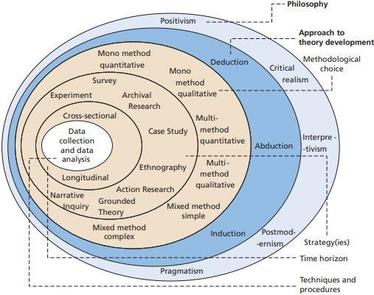

Figure 4: The ’research onion’ from Mark Saunders, Philip Lewis and Adrian Thornhill (2018), illustrating the core components of research design.

Philosophy and Approach

This paper embraces a pragmatic philosophical approach. According to the research onion framework, pragmatism is particularly suited for this dissertation due to its key characteristics. These include an acknowledgment of the complexity and contingency of real-world financial phenomena, an emphasis on context-specific solutions, and the versatility to employ various methods. While the broader literature on the financial and economic aspects of green finance often follows a traditional positivist philosophy, the relevant policy literature adopts a more pragmatic stance, given their nature to be objective and subjective. Pragmatism's inherent flexibility—its ability to synthesize diverse literatures, methods, and approaches—makes it exceptionally well-suited for exploring how machine learning can predict green bond syndications. This approach allows for the integration of quantitative data analysis with qualitative insights, facilitating a comprehensive understanding of the dynamics involved in green bond syndications. In this study, the primary problem addressed is the lack of knowledge regarding the syndication of green bonds, which hampers decision-makers and policymakers in assessing the genuineness and likelihood of successful green bond issuances. By predicting green bond syndications, this research also aims to tackle issues related to market transparency, the effectiveness of green finance initiatives, and the identification of potential greenwashing activities.

In this research, an abductive approach to theory development is employed. This method is particularly apt for our study, which navigates between general principles and specific instances, aligning well with a pragmatic philosophy. Unlike purely deductive or inductive approaches, abduction is neither solely focused on testing pre-existing hypotheses nor exclusively on constructing novel theories from scratch. Instead, it thrives on the interplay between theory and empirical data. As highlighted by recent scholars, abduction is especially effective in fields where comprehensive literature exists in certain areas (such as financial market dynamics), but is sparse in others (like the application of machine learning to predict green bond syndications). This approach enables the research to both utilize existing theoretical frameworks and contribute new insights, addressing the gaps and extending the body of knowledge in climate finance.

Methodology
The methodological framework for this study is meticulously crafted to align with the context and nature of the research topic. Adopting a complex mixed-methods approach that integrates both quantitative and qualitative techniques, this methodology is grounded in a pragmatic philosophy (Saunders, Lewis, & Thornhill, 2019). This approach is particularly pertinent, as many academic papers reviewed in the literature demonstrate the efficacy of combining qualitative and quantitative methods, especially in the domains of energy and climate, where qualitative analysis can provide depth and context that enriches quantitative findings.
For this study, a case study strategy will be employed, focusing on specific instances of green bond syndicates. This approach facilitates detailed insights and a nuanced understanding of the dynamics within these syndicates. Additionally, given the evolving nature of green finance, a longitudinal time horizon is adopted, enabling the research to capture trends and shifts over an extended period. Data collection will involve a mix of archival research to gather historical data, ensuring a comprehensive analysis that leverages both established theoretical frameworks and novel empirical data to advance the field of climate finance.

The research design is predominantly quantitative and longitudinal, involving sophisticated data collection and analytical techniques. Initially, data on green bond issuances will be compiled using Python, which will facilitate the construction of an adjacency matrix illustrating the number of syndications each holder engages in. This matrix will elucidate the network structure of syndicate members and highlight key players within the green bond market. Consequently, to analyse this data, a Gradient Boosting model will be utilised. This machine learning technique is selected for its capacity to manage complex data structures and its robustness in pattern recognition and accurate prediction. The Gradient Boosting model is particularly well-suited for link prediction tasks, as demonstrated in numerous studies, making it ideal for forecasting the likelihood of various institutions participating in future syndications based on historical data and relevant features. This methodological approach not only ensures a rigorous analysis but also enhances the predictive power and practical relevance of the findings, contributing significantly to the understanding and development of sustainable finance practices.

Analysis
This section outlines the methodology, conceptual framework, analytical techniques, and data sources utilized in this dissertation. The initial phase of the analysis incorporates quantitative and longitudinal elements, leveraging the Bloomberg API to extract data from the bondsUniv database, which encompasses the entire universe of bonds. For this study, the filter is applied to isolate green bonds and loans, setting the green bonds and loans indicator to true.

    - Sequence 1: Conceptual Framework

Link prediction in green bond trading networks is particularly complex due to the nature of financial transactions. Unlike social networks, which are often represented as undirected graphs with single edges between vertices-pairs, bond trading networks feature multiple directed edges between nodes. Each edge corresponds to a unique transaction between entities, such as banks and fund managers. In this study, we extracted information about green bonds and their holders, specifically focusing on the number of syndications each holder has with another bank, without considering additional transaction features like bond type, rating, or trade volume.

A complex network can be represented by $G=(V,E)$ where $V$is a set of nodes (such as banks and fund managers) and $E$ is a set of edges representing transactions. Time is represented by $T$, split into mmm equal intervals, giving a set $T=\{T1,T2,…,Ti,Tm\}$. The network $G$ can be described by snapshots $G=\{GT1,GT2,…,GTi,GTm\}$, where $GTi$ represents the network during the $Ti$ time period. Each snapshot $GTi$ is represented by $GTi=(VTi,ETi)$, with $VTi$being the set of nodes and $ETi$ the set of edges during $Ti.$

For example, consider a hypothetical green bond trading network observed over three distinct time periods, denoted as $T1$ and $T2$. In the initial snapshot at $T1$, the network comprises three primary nodes: Vanguard, BlackRock, and Credit Suisse Group AG. During this period, the edges between these nodes represent syndicated transactions, specifically, Vanguard is linked to both BlackRock and Credit Suisse Group AG, indicating active syndications with these entities. Thus, the nodes $VT_{1}$​ at time $T1$ include Vanguard, BlackRock, and Credit Suisse Group AG, while the edges $ET_{1}$​ reflect the transactions as $(Vanguard, BlackRock)$, $(Vanguard, Credit Suisse Group AG)$.

By the second snapshot at $T2$, the network expands to include Morgan Stanley, reflecting the evolving nature of the trading environment. In this period, the nodes $VT_{2}$​ encompass Vanguard, BlackRock, Credit Suisse Group AG, and Morgan Stanley. The transactional links $ET_{2}$​ change accordingly, showing continued transactions between Vanguard and BlackRock, and a new transaction between Morgan Stanley and Credit Suisse Group AG. Therefore, the edges for this period are$(Vanguard, BlackRock)$, $(Morgan Stanley, Credit Suisse Group AG)$. This expansion signifies Morgan Stanley’s entry into the network, forming a significant transactional relationship with Credit Suisse Group AG, while Vanguard maintains its existing link with BlackRock. These snapshots collectively demonstrate the dynamic nature of green bond trading networks, characterized by the entry of new participants and the formation of new transactional links over time.

Given this complexity, traditional link prediction methods, which typically address simpler, undirected networks, are less effective. Therefore, we employed a Gradient Boosting method to enhance link prediction techniques, aiming to accurately forecast future connections within the evolving green bond network. To achieve high prediction accuracy in the formation of links for newcomers (actors not previously part of the network), we focus on the specific attributes of nodes and links. While this study does not consider all potential features of each transaction, such as bond type or trade volume, the number of syndications is a crucial factor. This approach helps in predicting the link formation between nodes based on historical transaction data.

    - Sequence 2: Prediction

Consider a pair of entities, for example Vanguard and BlackRock, observed at time $t$, that we indicate as ${(Vanguard,BlackRock)}_{t}$. We associate a target syndicated transaction variable $P{(Vanguard,BlackRock)}_{t}$ which indicates whether a syndicated transaction occurs (1 for yes, 0 for no). Our goal is to develop a prediction model that uses past features ${features}_{{(Vanguard,BlackRock)}_{t}}$ related to the pair ${(Vanguard,BlackRock)}_{t}$ to forecast these transactions.

This involves constructing a predictive function $f(.)$ to forecast co-syndication events accurately:
$$\{{features}_{{(Vanguard,BlackRock)\}}_{t}}→f(.)→P_{{(Vanguard,BlackRock)\}}_{t}}$$

In our methodology, we apply similarity-based techniques such as preferential attachment, Jaccard coefficient, resource allocation, and Adamic-Adar index to determine the likelihood of link formation. These metrics provide insights into the potential connections between nodes. The data is organized in an edge list format, where each feature corresponds to a column and each pair of nodes to a row.

To accurately predict syndication links within the green bond trading network, we utilized an adjacency matrix to represent the connections between entities. This matrix captures the transactional relationships among various banks and fund managers, with each entry in the matrix indicating the presence or absence of a syndication between two entities. The accompanying figure, created by the author using existing data and Python, illustrates a subgraph with 10 nodes. It demonstrates how varying connection probabilities can result in either a sparse or a densely connected network, thereby highlighting the pivotal role of probabilistic parameters in shaping network connectivity. The construction of networks frequently relies on probabilistic models where nodes (entities) and edges (connections between them) represent the network structure. The probability of forming these connections is determined by specific parameters, which, when adjusted, can significantly alter the overall structure of the network.
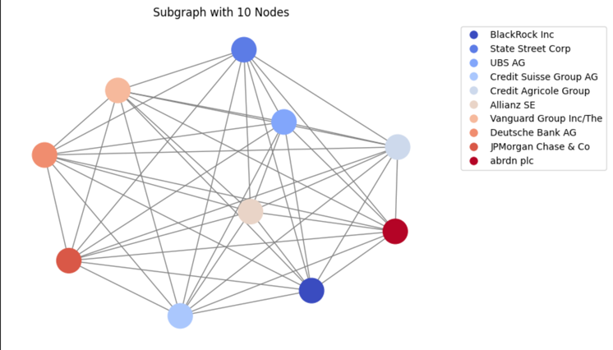

The adjacency matrix forms the basis for calculating various network similarity measures critical to predicting future links within the green bond trading network. We employed several established methods to assess the likelihood of future transactions between entities. These methods include:

1. Common Neighbours: Stemming from the small world phenomena, this measure counts the number of mutual connections between two nodes, providing an indication of the likelihood of forming a new link.
2. Jaccard Coefficient: This metric evaluates the similarity between two nodes by comparing the ratio of their common neighbours to their total unique neighbours.
3. Adamic-Adar Index: This index refines the common neighbour’s approach by assigning higher weights to less-connected neighbours, thereby emphasizing rarer common links.
4. Preferential Attachment: This measure operates on the principle that nodes with higher degrees (i.e., more connections) are more likely to form new links, reflecting the "rich-get-richer" phenomenon.
5. Resource Allocation Index: This metric assigns higher scores to pairs of nodes that share connections with low-degree nodes, thus allocating resources or link potential based on the neighbour’s connectivity.

To efficiently compute these similarity measures for a vast number of potential node pairs, we implemented a parallel processing approach using Ray, a distributed execution framework. This approach involved several key steps:

1. Adjacency Matrix Construction: Initially, we constructed the adjacency matrix representing the network's current state, capturing all existing transactions between nodes.
2. Similarity Calculation: For each pair of nodes, we calculated the similarity scores using the aforementioned methods. This involved identifying common neighbors, computing the Jaccard coefficient, Adamic-Adar index, preferential attachment score, and resource allocation index for each node pair.
3. Parallel Processing with Ray: Given the extensive number of possible node pairs, we utilized Ray to distribute the computational workload across multiple processors. This process entailed splitting the node pairs into chunks and processing each chunk in parallel to compute the similarity measures efficiently.
4. Data Aggregation: After calculating the similarity scores, we aggregated the results into a comprehensive dataset. This dataset included the similarity scores for each node pair, which were then utilized to predict the likelihood of future syndications.

By applying these advanced techniques, we developed a robust model capable of predicting future connections within the green bond trading network. The resulting predictions provided valuable insights into the network's evolving structure and significantly contributed to the broader understanding of sustainable finance practices.
This rigorous, data-driven methodology, rooted in network theory and augmented by cutting-edge computational techniques, ensures the accuracy and reliability of our link predictions. Consequently, it enables stakeholders to make informed decisions, thereby fostering the growth and development of green bond markets.

    - Sequence 2: Prediction-Quantitative Analysis of Green Bond Syndication
The quantitative analysis began with the systematic collection and preparation of bond data. A critical component of our research involves collecting comprehensive data on various types of bonds, including specific information about their underwriters and identifying whether they qualify as "green bonds." Incorporating the practical steps for acquiring this data involves a detailed approach to utilizing Bloomberg's fixed income database effectively using its Python API. The process starts by accessing Bloomberg Terminal, where we will use specific queries to filter for bonds that are designated as "green" by looking for entries where the "Green bond indicator" is set to "Yes." This search will span the period from the first green bond in 2008 to the last update green bond in the middle of 2023, aligning with our research timeframe.
Data preparation encompasses extensive quality checks, including validation of the "Green bond indicator," scrutiny of syndicate roles, and enrichment with contextual information such as market conditions and issuer financial health. The dataset will encompass several key aspects: the category of the bond (whether it is corporate, municipal, or supranational),offering a broad view of the market; the nature of the debt (distinguishing between loans and bonds),for nuanced analysis; types of identifiers used, the ID number, details about the issuer including subsidiary and parent company information, the issuer's sub-industry, countries associated with the risk and domicile of the issuer, and details regarding the bond's assurance, management of proceeds, project selection, and reporting mechanisms to assess participation, strategies, transparency, governance, and impact of green bonds. Additionally, we will note whether the bond was tapped or original, the date of issue, the currency in which the bond was issued, and the total amount issued in U.S. dollars (USD bn). The categorization phase further refines the dataset by segregating bonds according to their underwriters and identifying features, ensuring a thorough representation of the market dynamics and the specificities of green bond issuances. The features and roles of these holders and underwriters are critical; no other data will suffice for the depth of analysis we aim to achieve.
Bondholder data, stored in CSV files, underwent rigorous cleaning and preparation. Custom functions were designed to read and parse these files, addressing common formatting issues to ensure accuracy. The cleaned data was then merged, linking bonds to their respective holders, thus creating a comprehensive dataset for analysis.
Generating the Adjacency Matrix
To analyze the network structure of bondholders and their syndication activities, an adjacency matrix was constructed. This matrix represents collaborative relationships between bondholders, with each cell indicating the number of syndications involving pairs of bondholders. The analysis covered a total of 2,495 bonds, 3,126 unique holders, and six distinct bond types. The adjacency matrix serves as a crucial tool for visualizing and quantifying collaboration within the green bond market.
Network Analysis and Visualization
An in-depth network analysis was performed using the adjacency matrix to understand the interconnectedness of bondholders. Visualization techniques were employed to create graphical representations of the bondholder network, highlighting key players and their syndication relationships.
In this network, nodes represent fund managers/holders, and edges indicate links between managers if they have co-invested in at least one bond. This graphical representation provided a clear summary of the complex interactions within the green bond market.
The network analysis also identified the top collaborators within the bondholder network. By summing the connections in the adjacency matrix, the analysis highlighted the most influential entities in the market, with Vanguard Group Inc. and BlackRock Inc. emerging as the top two holders, each with 1,214 collaborations.
Predictive Modeling Using Gradient Boosting
A Gradient Boosting model was employed to predict future syndication participation. The adjacency matrix was transformed into a feature set that captured collaborative patterns among bondholders. A target variable was defined to reflect high levels of syndication participation.
The dataset was split into training and testing subsets to train the Gradient Boosting model. The model's performance was evaluated using accuracy metrics to ensure reliability. Once validated, the model was applied to the entire dataset to predict future participation trends, providing stakeholders with actionable insights.

Results and Analysis
Extracting Network Features
Network features such as the Jaccard coefficient, preferential attachment, and Adamic-Adar index were successfully extracted from the bondholder network. These features are critical for understanding the similarities and interaction patterns among bondholders.
Key points of feature extraction:
- Feature Extraction: Implemented calculations for network similarity measures, including the Jaccard coefficient, preferential attachment, and Adamic-Adar index.
- Performance Bottleneck: Initial runs were efficient for the first 100 bondholders but slowed significantly with larger datasets, requiring approximately 20 minutes for 3,000 holders.
- Current Status: Practical for smaller datasets but necessitates optimization for larger datasets.
Future efforts will focus on optimizing the code for better performance with larger datasets, enhancing the scalability and speed of feature extraction.
Output and Interpretation
The analysis produced a detailed adjacency matrix showing the number of collaborations between bondholders. This matrix revealed patterns and identified key players within the network. Notably, Vanguard Group Inc. and BlackRock Inc. were found to have the highest number of collaborations, each with 1,214.
Network visualization offered a clear depiction of the bondholder network, highlighting the most connected entities and their relationships. This aids in understanding the structure and dynamics of the green bond syndicate network.
The Gradient Boosting model demonstrated high accuracy in predicting future syndication participation. The model's predictions provide valuable insights, helping market participants identify potential collaboration opportunities and anticipate market trends.
Conclusion
This quantitative analysis utilized a structured approach to data collection, preparation, network analysis, and predictive modeling. By integrating these methodologies, the research offers a robust framework for understanding and forecasting bondholder collaborations in the green bond market. The findings contribute significant knowledge to the field of climate finance, identifying key players and interaction patterns within green bond syndicates.
Future research will focus on optimizing the feature extraction process for larger datasets and exploring additional predictive models to enhance the accuracy and applicability of the findings.

    - Sequence 2: Qualitative Comparative Policy Analysis: Power Sector Decarbonization
The second sequence, being qualitative and contemporary, represents the core of the analysis. Under the umbrella of qualitative comparative policy analysis (Pruditsch, 2017), framework analysis, a technique of document and content analysis, is used to analyze California and Texas’ policy environments.

Framework analysis was developed by Spencer et al. (2003) to assist the UK government with evidence-based policy. The method is a qualitative evaluative method that is particularly useful in applied policy as it allows for systematic analysis, using matrices and themes of a policy area. Framework analysis has been used in energy policy by Bessa and Gouveia (2022) and Chen (2011). This paper is guided by the five stages of framework analysis described by Hackett and Strickland (2019) – familiarization, identifying themes, indexing, summarizing, and interpretation.

Familiarization is simply gathering and understanding data. This paper uses multiple sources of data to analyze California and Texas’ policy environments. First, 21 government initiatives will be used to analyze policy that has been enacted or proposed. But given no case has a complete suite of decarbonization policies, additional material will be used in discussion. The core data used in the policy analysis comes from governmental actors in California and Texas, respectively, including, state legislatures, governors, energy commissions, utility commissions, and independent system operators. Then in discussion, policy reports, literature, and popular media from non-governmental groups (like that in the literature review) is used to supplement the analysis.

Identifying themes requires sorting through the data, either deducting or applying a framework through which to analyse the data. Here, a framework comprised of the core technological features of the ‘electricity grid of the future’, detailed in section 2.1, is used to analyse policy environments. While there are many policies, political approaches, and specific technology mixes that can accommodate decarbonization – as is evidenced by the two distinctly different cases chosen here – due to characteristics of a VRE-based power system, there are technological

components that will be fundamental to power decarbonization. Visualised in figure 3 the components that make up the framework are the following: Variable renewable energy, firm low- carbon resources, transmission, and demand-side resources. This technological focus has been detailed elsewhere by Bhutada (2023) and Sepulveda et al. (2018), with these components being outlined in policy reports including, Donohoo-Vallett, Ryan and Wiser (2023), Domeshek et al. (2022), Chakroun et al. (2021), and Harris et al. (2021). The ‘electricity grid of the future’ framework is illustrated below in figure 5.
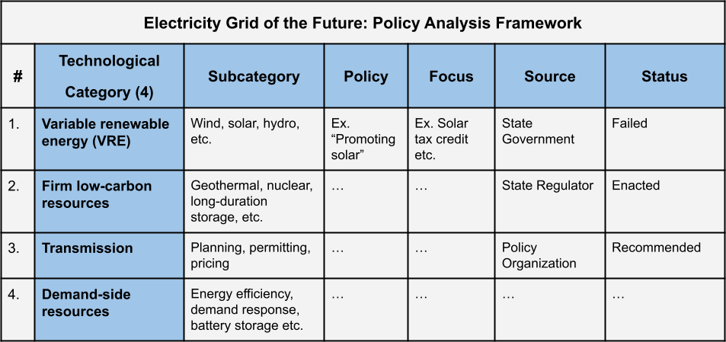
Figure 5: Policy Analysis Framework to evaluate state power sector policy.

The third step, Indexing, is applying the analysis framework to the data (policies) of each case study (California and Texas). In doing so the policy environment regarding power decarbonization is made clear in each state and allow for further discussion.

The last steps, summarizing and interpretation, involve pulling together and stylizing the results and then discussing the meaning and implications of them regarding the research question. The following section – results and discussion – covers these steps, presenting the outcomes of the analysis and then addressing their implications for future challenges and opportunities.

Results and Discussion
This section outlines the results of the analysis and the discussion thereof. Following from the analysis previously described, the results are here presented in order. First, ‘Sequence 1’ which is historical and quantitative, will be addressed. This analysis describes the evolution of California and Texas’ electricity systems; covering electricity generation and carbon intensity over time, analysis of policy interventions, and then current short-term power dynamics. This analysis leads into ‘Sequence 2’, which is contemporary and qualitative. Using a case study approach and framework analysis – applying the ‘electricity grid of the future’ framework – this section details the policy environments towards power sector decarbonization in California and Texas, respectively. In conclusion, this section discusses future implications and outlines key findings.

Historical Development of California and Texas’ Electricity Systems
As is described in the introduction, both California and Texas stand apart in their renewable energy generation and resources (Penney, 2021; EIA, 2023a, b). These patterns are shown in this analysis, with each state having distinct characteristics in its electricity generation mixes – especially regarding renewable energy. First, California’s electricity generation by source from 2001 to 2022 is seen below.
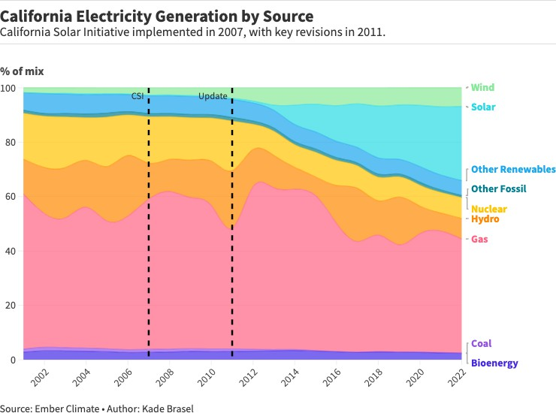
Figure 6: Illustration of California’s Electricity Generation over time, with key polices denoted.

In California’s power mix, the fossil fuel share, constituting just 43% of generation, is notably small. Further, the near absence of coal – different than many other states – is responsible for its low carbon intensity. While gas currently accounts for 42% of the power – the most significant challenge to decarbonization – it has decreased from its peak of 60% in 2013. However, low- carbon nuclear has also decreased over time, with its 8% share in 2022 being less than half of its

peak. But renewables growth is staggering, with solar energy's growing from under 1% in 2012 to 27% in 2022. Taken together, the combination of minimal coal and growth of solar, displacing gas, positions California as a leader in clean electricity, especially noteworthy given its size. Concurrent with the development of solar, two policy interventions are seen, the California Solar Initiative (CSI) in 2007 and a related update in 2011. These policy interventions are analyzed in coming sections.

Texas also has an interesting evolution in its electricity system. And while different in magnitude and technology than California, its contrast is illustrative. Figure 7 shows this evolution of Texas’ electricity generation from 2001 to 2022.
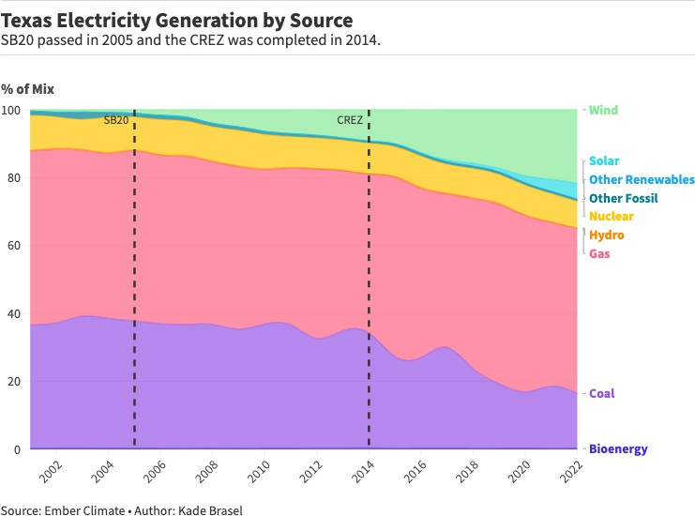
Figure 7: Illustration of Texas’ Electricity Generation over time, with key polices denoted.

Texas’ generation is 65% fossil fuel-based, a far greater share than California’s. More acutely, coal accounts for 16% of generation despite declining historically. However, low-carbon resources play an increasingly significant role. Nuclear has remained steady, supplying 10% over time. But renewables have seen a sharp increase. Inverted from California’s solar, Texas is known for its impressive growth in wind, which has grown from 0% in 2001 to 22% in 2022, producing more than a quarter of all wind power in the U.S. (EIA, 2023b). This growth in wind coincides with the two key policy interventions, SB20 and the subsequent ‘Competitive Renewable Energy Zones’ (CREZ). The effect of these policies is analyzed in the coming sections. Lastly, solar energy which accounts for only 5% of generation in 2022, Is beginning to show a pattern like wind. However, the primary concern for decarbonization is the consequent carbon emissions from these electricity systems. To compare carbon emissions from electricity between states, Figure 8 shows the carbon emissions from electricity per kilowatt hour over the same period.
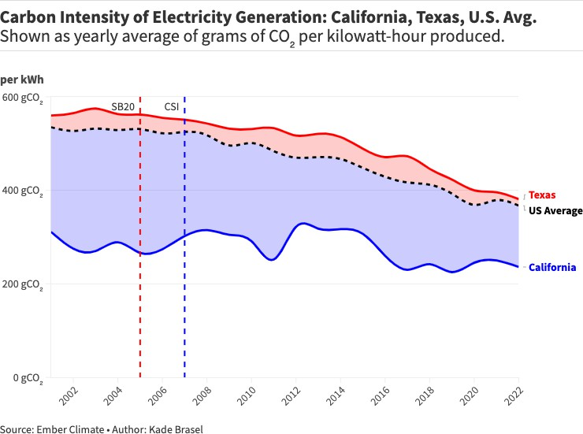
Figure 8: Comparison of California and Texas’ electricity carbon intensity.

California remains well below the U.S. average and Texas in carbon intensity, decreasing by 22% since 2007 with the CSI. This is in large part due to the absence of coal and gradual displacement of gas with renewables. However, the spikes in carbon intensity coincide with decreases in nuclear energy – decreasing from 18% to 9% of generation between 2011 and 2012 – which was compensated for with gas. Conversely, Texas – even with a 32% reduction since 2005 and SB20 – continues to have much more carbon-intensive electricity than California. With Texas electricity being comprised of 54% more fossil-based generation than California this is not surprising, but the difference is disproportionate. In 2022, Texas power was 61% more carbon-intensive than its west coast counterpart. This effect then is twofold; fossil fuel generation is the primary source of emissions, but gas generation is only 15% higher as a share in Texas. Meaning coal – playing a third of the role of gas in Texas – is responsible for most of the difference in emissions between the states. Lastly, while carbon intensity relates to the generating technology in each state, absolute emissions matter. In this regard, Texas – in addition to its more carbon-intensive electricity – regularly has an electricity load of 80 Gigawatts, twice California's (Kanter, 2022).

  - Policy Impact: Time-series Analysis in R
The policies in the previous section relate to the most evident renewable energies; solar in California and wind in Texas. But to further interrogate the impact of the policies on technologies, this section presents time-series analysis, done in R.

In California, the California Solar Initiative was created in 2007. To spur growth in solar, a key provision was the New Solar Homes Partnership (NSHP) program, which gave financial incentives to builders, developers, and homeowners to install solar on new homes (Dodson, 2022). Accordingly, 2007 was presumed to be a break in solar's trend. However, immediately after 2007 the trend was no more significant than before the policy. The model instead found a break a few years later in 2011, which in addition to being a few years removed from the CSI, coincided with other significant changes. The figure below illustrates this analysis.

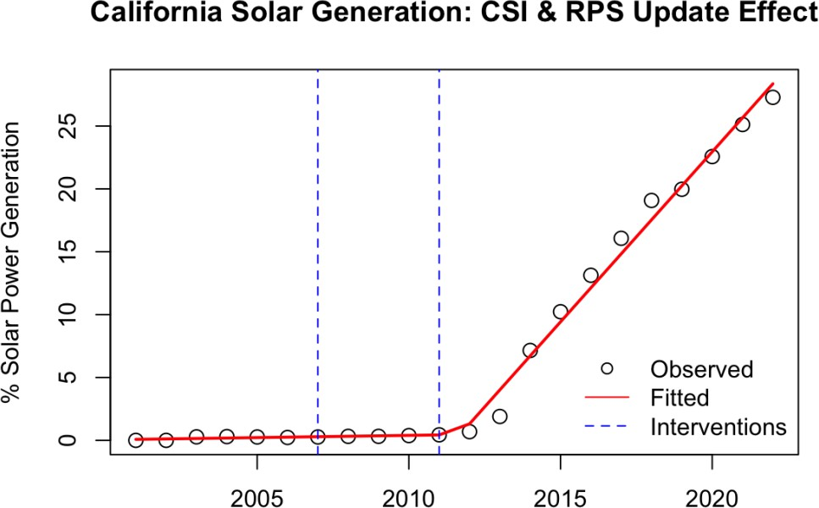
Figure 9: Segmented linear regression model in R, showing the effect of Californian solar policy.

Figure 9 shows the non-immediate effect in 2007 and the strikingly clear impact in 2011. First, the linear regression had an adjusted R-squared of 0.993, meaning that the model (seen in red) fit the data well. From the beginning of the time series through 2007, the coefficient, or growth of solar was 0.035 with a t-stat of 0.447, meaning solar growth was effectively non-existent and there was no initial effect from the CSI intervention. However, it is common for any policy to take time to have an effect. This case is no different, as in 2011 there is a dramatic increase in solar generation. The coefficient post-2011 is 2.67, meaning as a share of generation, solar grew 2.6% annually after this intervention; with a t-stat of 23.934, it is overwhelmingly likely that the intervention in 2011 in addition to the 2007 CSI, impacted this. In 2011, California adopted a renewable portfolio standard requiring that one-third of the state’s power come from clean sources by 2020. In the same year, solar on existing buildings and parking lots were made exempt from standard environmental review (Office of Governor Edmund G. Brown Jr., 2012). This target was easily met, with clean resources accounting for 55% of generation in 2020. California also became the first state with more than 1GW of distributed solar power in 2011 and a record

amount of utility scale solar deployed that year (SEIA, 2012). These findings show that more than a coincidence, California’s success in solar energy is due to early and ambitious policy interventions.

Again, Texas stands out in wind generation, producing more than a quarter of all wind in the U.S. (EIA, 2023b). The growth of wind is evident in Figure 7 and coincides with major policy changes. Below, Figure 10 shows the growth of wind generation in Texas with two key policies denoted.

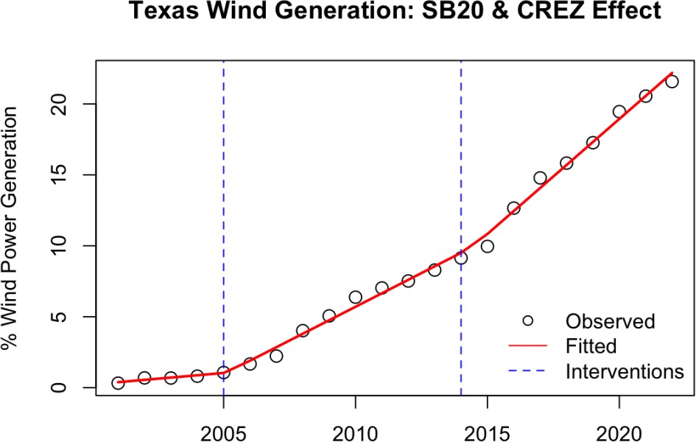
Figure 10: Segmented linear regression model in R, showing the effect of Texas’ wind policy.

In the Texas model, 2005 – the year of SB20 – was presumed to be the year of a significant break in the trend. The model found an additional break in 2014 that aligns with another significant event. To begin, the linear model fits the data well, with an R-squared of 0.996. And while there was a pre-intervention coefficient of 0.162 with a t-stat of 1.113, the growth rate of wind before the policies was small. Of the first intervention, in 2005 the Texas legislature established the CREZ

(Competitive Renewable Energy Zones) Initiative. The effort that aimed to build 3,600 miles (about the width of the United States) high-voltage transmission to unlock 18GW of the abundant Texas wind power (ACEG, 2017; Jankovska and Cohn, 2020). The CREZ Initiative was completed in 2014 – the second intervention – and the project unlocked 23GW of wind in Texas, which currently has more than 40GW of installed capacity (DOE, 2015; Jankovska and Cohn, 2020). The coefficient of the creation of CREZ after 2005 was 0.788, illustrating a .78% absolute increase in wind’s share of generation year after year. With a t-stat of 5, the policy can be taken to have had a significant effect. Similarly, in 2014 upon completion of the CREZ, there was coefficient of 0.671 with a t-stat of 7.25, which represents an additional yearly increase in wind growth. Taken together compared to the .16% growth rate before the CREZ, after its creation and completion wind grew 1.45% annually as an absolute share of generation.

In both cases, growth of renewables is due to ambitious policy. California promoted solar with a suite of policies, while Texas built the infrastructure needed to unlock its wind resources. With the historical development of these power systems outlined we now turn to the present. But before analyzing contemporary policy environments, we must understand each power system in the short-term; as VRE-based power systems have dynamics which implicate the technology and policy needed for full decarbonization.

Inter- and Intraday Electricity Load(s)
This section outlines the short-term dynamics of the power system in California and Texas. Covering the load of three recent summer days in each state's electricity grid – CAISO and ERCOT, respectively – the magnitude and technological attributes of each system will be clarified. This will lead to the next, contemporary, and qualitative, analysis of the policy environments.

Again, decarbonizing electricity primarily with VRE will require firm low-carbon resources (Sepulveda et al., 2018). The following analysis can be understood in the same way, with variable (renewable) and firm (currently mostly fossil-based) resources. However, the operation of these resources is best understood as base-, intermediate-, and peak load (Ueckerdt and Kempener,

2015). Addressing the variability in renewables, which are necessarily intermediate load, peak and base load operate to satisfy what is known as ‘net-load’ the difference in total load and VRE generation. Figure 11 below, captures the case of California.
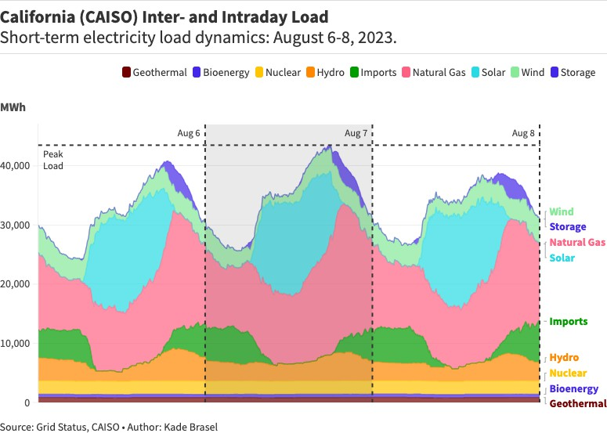
Figure 11: Illustration of California’s electricity load in CAISO.

In California, the system dynamics are heavily influenced by solar energy, which peaks during midday coinciding with the lowest net-load. Gas addresses intermediate and peak load, especially in the evenings and nighttime. Notably, storage plays a role in covering some of the peak load, effectively shifting solar power into the evening hours. Imports, driven by economic and resource adequacy reasons, contribute significantly to intermediate load. The base load is supported by a combination of hydro, nuclear, bioenergy, and geothermal. Observing the current dynamics, renewables present potential for further growth, especially as storage can enhance their value with dipping net-loads at midday. While the growth of clean resources for base and intermediate

load is essential, gas, which currently addresses much of the latter, remains the most significant challenge to further decarbonization. Next, Figure 12 illustrates the ERCOT electricity grid in Texas, which is comparatively simple, with obvious room for improvement.
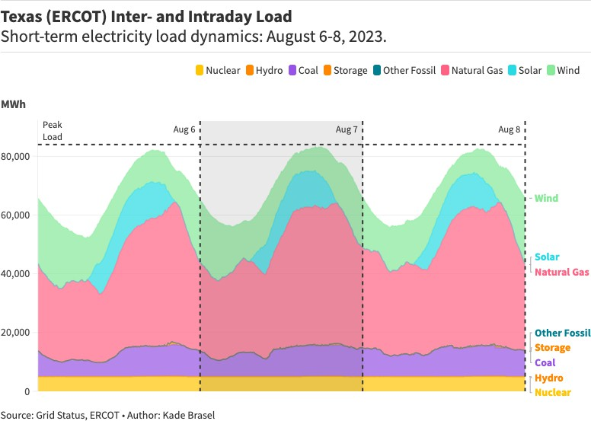
Figure 12: Illustration of Texas’ electricity load in ERCOT.

In Texas, the generation composition is simpler with wind being the predominant renewable, accompanied by a modest contribution from solar. Consequently, net-load reaches its lowest in the early morning, coinciding with peak wind generation. The base load is primarily maintained by nuclear and coal, while gas assumes a role like its function in California, serving as the principal resource for both peak and intermediate load. Given the limited solar presence and almost non- existent storage, there is a considerable potential for expansion in both VRE and storage. And

additionally, immediate challenges for decarbonization lie in transitioning from coal and addressing gas dominance.

Contemporary Policy Environments
The following sections describe the contemporary policy environments regarding power sector decarbonization in California and Texas, respectively. Then a comparison and discussion of the implications for decarbonization will be addressed before summarizing key findings, leading to the conclusion of the paper.

The first case, California, unsurprisingly has a policy environment both robust and explicit in its climate and decarbonization focus (Roedner Sutter, 2022). Below, Table 1, using the ‘electricity grid of the future’ framework, details California’s contemporary policy environment towards power decarbonization.
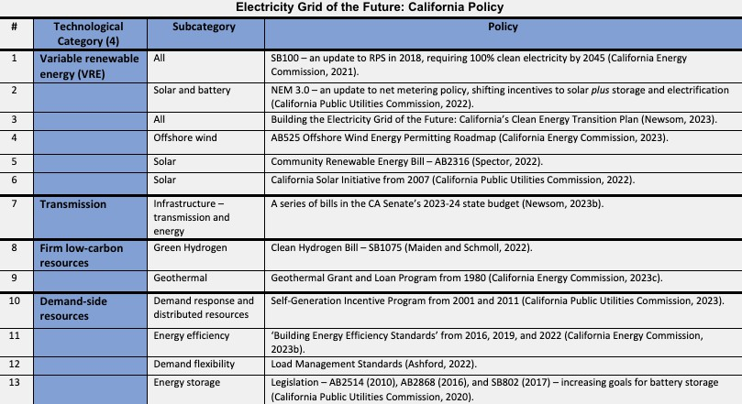
Table 1: California’s policy environment visualized through ‘electricity grid of the future’
framework.

As is seen above, California has a wide range of recent policies. The abundance of VRE policies, including the goal of 100% clean electricity by 2045 and the accompanying policy plan from Governor Newsom stands out. While this goal falls short of President Biden’s 2035 goal, it puts California in a minority group of states with similar goals. Lastly, the few policies regarding transmission and firm low-carbon resources are of note. A further detailed table can be found in Appendix 1.

On the other hand, Texas, in its distinctly different political environment, has a similarly contrasting policy environment to California. Table 2 outlines the contemporary policy environment toward decarbonizing power in Texas.
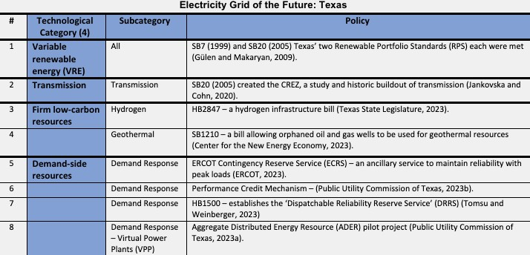
Table 2: Texas’ policy environment visualized through the ’electricity grid of the future’
framework.

Texas has a less robust policy environment and no clear ambition toward decarbonization. More than not having decarbonization goals, Texas faces many political obstacles which stand in stark contrast to its opportunities (Webber, 2023). The most notable policies, the RPS and CREZ, which were successful, are historical. The policy area with most attention currently is demand-side resources, which excluding the most recent virtual power plant project, are in response to

problems of reliability in Texas (Lewin, 2023). A further detailed table can be found in Appendix 2.

Opportunities and Obstacles: Implications for Future Decarbonization
Sequence 1 showed the development and current arrangement of the electricity systems in California and Texas. Even though each state has made progress in introducing renewable energy and decarbonizing its grid––due to historical policy successes; achieving a decarbonized grid is not as simple and requires specific technological components. In this regard, targeted policies will be needed to create an ‘electricity grid of the future,’ Figure 12 contrasts these policies in California and Texas.
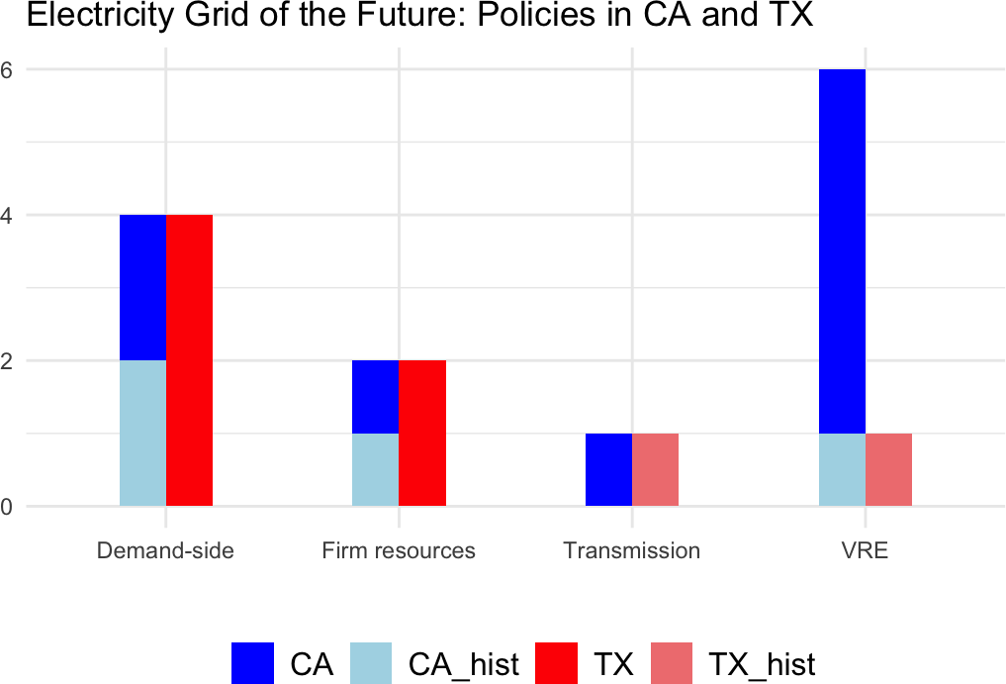
Figure 13: A side-by-side comparison of policies in California (blue) and Texas (red) illustrating the differences in the cases.

The figure illustrates the distinct policy approaches between the states. California has a suite of policies with a focus on VREs and a subsequent plan for further action by Newsom (2023a).

Conversely, Texas has no similar ambition, and their most successful policies are historical. This difference is key to understanding the obstacles and opportunities in each case, as the explicit goal of decarbonization is not unanimous amongst states. This divergence has been detailed by Clune et al. (2020) who describes states as either policy driven, or cost driven, with California being the former and Texas of the latter group. Unsurprisingly, in their modelling Clune et al. (2020) found policy driven markets to be more successful in decarbonizing compared to cost driven markets; with CAISO reducing emissions by 100% by 2050, and ERCOT stagnating completely. But neither of these outcomes are necessary. As our analysis showed Texas – with the boon in wind energy following the CREZ Initiative – has had success in decreasing emissions historically; and California has more work to do in key policy areas.

However, the obstacles and opportunities for power decarbonization are different in type and magnitude in each state. Captured in Figure 6 and 11, gas continues to play a key role in California’s grid. Displacing this gas generation requires an increase in renewables and transmission, and firm resources. Regarding renewables, California has plans to build 25GW of offshore wind by 2045 which will bolster grid reliability and decarbonization (California Energy Commission, 2023a). Furthermore, while some critique the update to California's net metering policy, known as NEM 3.0, for potentially slowing solar growth, the new policy should help by incentivizing solar plus storage. This addresses the state's deepening 'duck curve,' enhancing solar's value to the grid (Zeitlin, 2023). With respect to transmission, even though policy appears lacking, according to Zimmerman, Gramlich and Hayes (2023), California does well in transmission planning and processes. This is exemplified by recurrent transmission plans from CAISO (2023) and recent legislation to expedite the building of infrastructure, including transmission (Newsom, 2023b). Nonetheless, as Jackson et al. (2021) outline, firm low-carbon resources are key to California’s 100% clean electricity goals. This is already a pressing issue, as the state has recently extended the life of gas plants to ensure grid reliability (Roth, 2023). So, whether it is geothermal or gas with carbon capture, the challenge of firm low-carbon resources remains an obstacle in California (Bartosz and Thomsen, 2020; Glenwright, 2020).

Texas, however, has no clear policy ambition and much further to go in decarbonizing its electricity grid. Fossil fuel resources still supply 65% of Texas’ electricity, with coal still accounting for 16% of generation. Luckily, in addition to obvious decarbonization and health benefits, closing coal power plants is increasingly economical in most cases (although Texas has tight grid conditions recently) (Engel, Teplin and Dyson, 2021; Gimon, Myers and O’boyle, 2021). Beyond coal, Texas faces similar obstacles to California in displacing gas, growing renewables, building transmission, unlocking firm resources, and reducing peak loads. And even without policies – due to unmatched economic growth and renewable resources (Penney, 2021; Bureau of Economic Analysis, 2023) – Texas has 10.38GW of renewables and batteries planned for installment in 2023, 15% more than California in second place (Kennedy, 2023). It is not only renewables that are thriving in the Texas market; an advanced nuclear project, the first net-zero gas plant, and Fervo Energy, an advanced geothermal startup, are all being developed in Texas (Anchondo, 2022; Temple, 2023; The Dow Chemical Company, 2023). However, Texas has no transmission policy and compares poorly to other regions (Zimmerman, Gramlich and Hayes, 2023). But Texas knows how to build transmission and has historically been a leader in this regard (ACEG, 2017). Further, where policy ambition lacks, many reports have charted the way forward. First, Gee et al. (2022) detailed a comprehensive net-zero plan for Texas in their “Don't Mess with Texas” report. Regarding transmission, energy efficiency, demand response, and geothermal, an abundance of policy resources are available. For instance, Rhodes (2023) outlines the future transmission needs of the Texas electricity grid; Nadel, Amann, and Chen (2023) detail ten programs to advance energy efficiency and demand response in the state; and Beard et al. (2023) explore opportunities for geothermal energy in Texas.

Summary of Key Findings
In summary, this analysis of the development and policy of California and Texas’ electricity grids has illuminated similarities and differences, and opportunities and obstacles for both states. California continues to have one of the least carbon-intensive electricity systems in the country. Given California’s historical leadership in climate policy, this success towards decarbonization is not surprising. As a Democratic state, California’s ambitious approach – using standards and

regulation with an emphasis on climate – echoes findings in the literature (Bang, 2021; Marshall and Burgess, 2022). However, gas is persistent in California’s electricity mix, and as load grows and deadlines approach, the need for firm low-carbon resources becomes more pressing. Luckily, California has a robust policy environment alongside its decarbonization goals (Borenstein and Kellogg, 2022). As far as innovative firm low-carbon technologies and demand-side resources continue to develop, and California remains diligent, they are on their way to 100% clean electricity. On the other hand, Texas has further to go in its decarbonization. Having historically taken an ‘all-of-the-above', focusing on economic growth and energy more than climate––Texas lacks any explicit effort towards decarbonization, and fossil fuels continue to dominate its electricity grid (Bang, 2021; Marshall and Burgess, 2022). So, even though Texas produces more renewable power than any other state, it continues to have disproportionally carbon-intensive electricity. Nonetheless, Texas has had success historically in decarbonizing, exemplified by the boon in wind energy following the CREZ Initiative. And if Texas’ politics and policy ambition can realign, and take advantage of its wealth of natural resources and booming economy––Texas has many opportunities to lead in decarbonization (Wallace-Wells, 2023a).

In conclusion, the contrast between California and Texas illuminates a key takeaway for building the ‘electricity grid of the future’. Successful policy will require both a market-led and policy-led component. First, proven technologies, namely variable renewable energies (VREs) and batteries, require a supportive approach. This includes marginal incentives, appropriate regulation and deregulation, and investment in necessary infrastructure – transmission – to enable their continued growth. On the other hand, decarbonization is exceedingly challenging and necessitates intentional policy. More specifically, development of advanced firm resources, implementation of demand-side resources, and displacing of fossil fuels, will require generous economic incentives, standards, and regulation, respectively. (Grubb, Hourcade, and Neuhoff, 2013; Green and Denniss, 2018; Borenstein and Kellogg, 2022).

Conclusion
This dissertation focuses on power sector decarbonization within the United States. While climate change becomes dire, effort towards energy transition are developing in kind. This is especially true in the U.S., who despite being responsible for the largest share of historical carbon emissions, is also the wealthiest country in the world and has revived its climate ambition with unprecedented policy. In this effort of decarbonization, ‘electrify everything,’ has emerged as the path forward. Comprised of two parts, power decarbonization and electrification, the former is considered the linchpin in the energy transition. Supercharged with federal legislation and ambition, states now play the leading role in implementation and further decarbonization. As such, this paper focuses on two distinct, but exceptionally important states––California and Texas. This paper addresses a gap at the nexus of literature on the technology, economics, and applied policy of power sector decarbonization.

Adopting a pragmatic philosophy and an abductive approach, this study employs case studies and utilizes a sequential mixed-methods design for a comprehensive analysis. The first sequence involves descriptive statistics and time-series analysis, focusing on generation mix and emission trends using Ember Climate data. This data is then subjected to segmented linear regression in R to evaluate key policy impacts. Additionally, short-term system dynamics are examined using Grid Status data. The second sequence employs qualitative framework analysis to scrutinize current policies aimed at decarbonizing the power sector in California and Texas. The 'electricity grid of the future' framework, derived from existing literature and comprising four key technological components, guides the analysis of governmental policy documents.

It is found that California and Texas are quite different in their electricity system composition and policy towards decarbonization. California has historically had a clean power system, being especially successful in solar energy. But a reliable electricity grid requires firm resources and so gas remains in the state's generation mix. Nonetheless, consistent with its history, California leads with ambitious policy. And given the development of firm low-carbon resources and continued effort, California is on track for its goals. Conversely, the Texas electricity grid is

dominated by fossil fuels. But Texas has also had success in wind energy – due to its CREZ initiative – and continues to lead in absolute renewable energy. However, Texas lacks explicit effort towards decarbonization and so falls behind despite its abundant natural resources and economic conditions. And so, in combination, building the ‘electricity grid of the future’ will require both an enabling market environment and targeted and intentional policy. However, even the most ambitious states fall short of the 2035 target––a prerequisite to economy-wide decarbonization. This proves the need for more work at state and federal levels to meet clean power and net-zero targets.

This paper’s contribution is novel in applying the ‘electricity grid of the future’ framework to policy in California and Texas; substantial in addressing an important and dynamic topic area; and rigorous in using mixed methods for a more complete analysis. But especially in this topic area, further research is needed. Specifically, using a case-study approach, modelling studies could clarify in more detail what policies and technologies each state will require for its decarbonization. Further, a political economic framework and qualitative methods including interviews could be utilized to study differing politics and other crucial, non-state actors.

Appendix 3: Ethics form
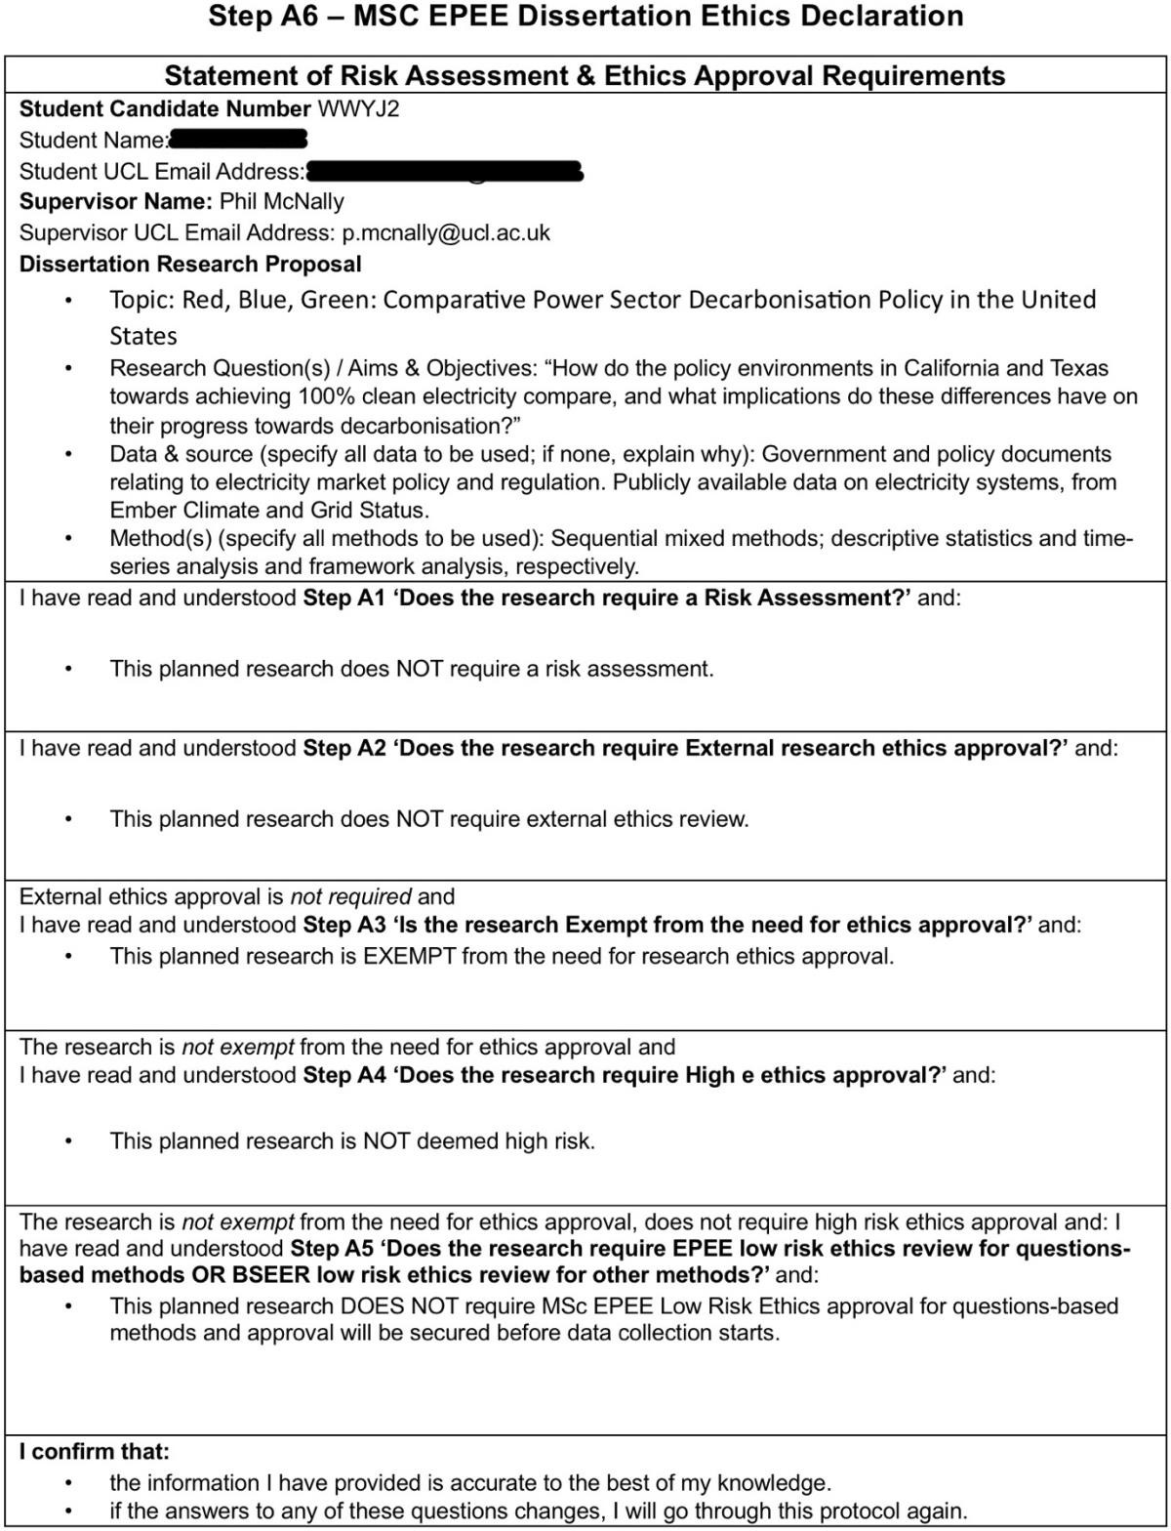

https://essd.copernicus.org/articles/16/2625/2024/
https://www.theguardian.com/environment/2023/may/17/global-heating-climate-crisis-record-temperatures-wmo-research
https://www.unep.org/resources/report/spreading-wildfire-rising-threat-extraordinary-landscape-fires?gad_source=1&gclid=CjwKCAjwvIWzBhAlEiwAHHWgvf6eFlwrnr0DrruG-beJLqv8PzDh5Fj9QXyiFrroMurVyTSYf7422BoCykgQAvD_BwE
https://www.eea.europa.eu/publications/europes-air-quality-status-2024
https://www.wwf.org.uk/what-we-do/climate-change-and-energy?pc=ASF001002&ds_rl=1263542&gad_source=1
United Nations, U. (n.d.). The Paris Agreement. United Nations CLimate Change. Retrieved May 6, 2021, from https://unfccc.int/process-and-meetings/the-paris-agreement/the-parisagreement
OECD, The World Bank, & UN Environment. (2018). Financing Climate Futures Financing Climate Futures : Rethinking Infrastructure.
https://www.weforum.org/agenda/2023/11/what-are-green-bonds-climate-change/
https://www.weforum.org/agenda/2023/11/what-are-green-bonds-climate-change/#:~:text=The%20first%20green%20bond%20was,market%20to%20finance%20green%20projects.
https://www.proquest.com/docview/2304753875?sourcetype=Trade%20Journals
Climate Bonds Initiative. (2020). Explaining Green Bonds. Climatebonds.Net. https://www.climatebonds.net/market/explaining-green-bonds
https://academic.oup.com/cje/article-abstract/29/6/873/1685588
https://www.publicenterprise.org/blog/overreading-into-underwriting-combined
https://www.publicenterprise.org/blog/overreading-into-underwriting-combined
https://www.publicenterprise.org/blog/overreading-into-underwriting-combined
https://www.investopedia.com/articles/investing/062813/why-companies-issue-bonds.asp
https://linkinghub.elsevier.com/retrieve/pii/S2210422422000636
https://www.esm.europa.eu/system/files/document/2022-03/ESM_WP_50%20(03-22).pdf
https://www.nirwanuniversity.ac.in/uploads/pdf/ram-lal-bagaria.pdf
https://pubs.aip.org/aapt/ajp/article-abstract/78/4/325/1057469/Econophysics-and-economics-Sister-disciplines?redirectedFrom=fulltext
https://philsci-archive.pitt.edu/3851/1/EconoCompFinal.pdf
https://www.sciencedirect.com/science/article/abs/pii/S0378437113003014
https://link.springer.com/chapter/10.1007/978-3-031-38708-1_6
Liben-Nowell, D. and Kleinberg, J., 2007. The link-prediction problem for social networks. journal of the Association for Information Science and Technology (2007). Google Scholar Google Scholar Digital Library Digital Library.
https://link.springer.com/article/10.1007/s13278-022-00999-1
https://ieeexplore.ieee.org/abstract/document/9010471
https://barabasi.com/f/623.pdf
https://www.liebertpub.com/doi/abs/10.1089/106652703322539024
https://finance.wharton.upenn.edu/department/Seminar/2005Spring/MicroSpring05/sufi2-micro020305.pdf
https://rio.tamiu.edu/cgi/viewcontent.cgi?article=1129&context=etds
https://www.nber.org/system/files/working_papers/w27701/w27701.pdf
https://www.fdic.gov/analysis/cfr/bank-research-conference/annual-18th/8-gao.pdf
https://link.springer.com/chapter/10.1007/978-3-030-66891-4_4
https://deepai.org/machine-learning-glossary-and-terms/gradient-boosting
https://deepai.org/machine-learning-glossary-and-terms/gradient-boosting
https://link.springer.com/article/10.1007/s13278-022-00999-1
Russo, A., Mariani, M., & Caragnano, A. (2021). Exploring the determinants of green bond issuance: Going beyond the long-lasting debate on performance consequences. Business Strategy and the Environment, 30(1), 38–59.
https://www.eon.com/en/about-us/media/press-release/2024/eon-successfully-issues-green-bonds-in-the-first-days-of-2024.html
https://www.icmagroup.org/assets/documents/Sustainable-finance/2022-updates/Green-Bond-Principles-June-2022-060623.pdf
https://www.icmagroup.org/assets/documents/Sustainable-finance/2022-updates/Green-Bond-Principles-June-2022-060623.pdf
https://www.sustainalytics.com/corporate-solutions/sustainable-finance-and-lending/second-party-opinions
https://www.bakermckenzie.com/-/media/files/insight/publications/2019/09/iflr--green-bonds-%28002%29.pdf
https://www.bakermckenzie.com/-/media/files/insight/publications/2019/09/iflr--green-bonds-%28002%29.pdf
https://www.eib.org/en/press/all/2022-308-15-years-of-eib-green-bonds-leading-sustainable-investment-from-niche-to-mainstream
https://www.climatebonds.net/market/data/
https://www.icmagroup.org/sustainable-finance/the-principles-guidelines-and-handbooks/green-bond-principles-gbp/#:~:text=The%20Green%20Bond%20Principles%20(GBP,credentials%20alongside%20an%20investment%20opportunity.
https://int.media.amundi.com/news/emerging-market-green-bonds-report-2023-green-bonds-issuance-in-emerging-markets-increased-34-in-2023-444f-b6afb.html
https://www.weforum.org/agenda/2023/11/what-are-green-bonds-climate-change/#:~:text=Global%20green%20initiatives%20such%20as,keen%20to%20scoop%20them%20up.
https://books.google.co.uk/books/about/Climate_Finance.html?id=fJTWzwEACAAJ&redir_esc=y
​(World Economic Forum)
https://books.google.co.uk/books/about/Climate_Finance.html?id=fJTWzwEACAAJ&redir_esc=y
(Herbert Smith Freehills)​
(PIMCO)​​ (Herbert Smith Freehills).
https://books.google.co.uk/books/about/Climate_Finance.html?id=fJTWzwEACAAJ&redir_esc=y
https://www.icmagroup.org/sustainable-finance/the-principles-guidelines-and-handbooks/social-bond-principles-sbp/
https://afajof.org/management/viewp.php?n=59584
https://www.bakermckenzie.com/-/media/files/insight/publications/2019/09/iflr--green-bonds-%28002%29.pdf
https://www.bakermckenzie.com/-/media/files/insight/publications/2019/09/iflr--green-bonds-%28002%29.pdf
Fatica, S., & Panzica, R. (2021). Green bonds as a tool against climate change?. Business Strategy and the Environment, 30(5), 2688-2701.
https://www.bdo.co.uk/en-gb/insights/industries/real-estate/green-bonds-in-real-estate
https://blog.sustvest.com/green-bonds-vs-traditional-bonds/
https://www.icmagroup.org/sustainable-finance/the-principles-guidelines-and-handbooks/green-bond-principles-gbp/
https://www.canada.ca/en/department-finance/programs/financial-sector-policy/securities/debt-program/canadas-green-bond-framework.html
https://www.bakermckenzie.com/en/-/media/files/insight/publications/2019/05/green-bonds--an-overview--may-2019.pdf
https://www.publicenterprise.org/blog/overreading-into-underwriting-combined
https://www.publicenterprise.org/blog/overreading-into-underwriting-combined
https://www.investopedia.com/terms/l/lenderoflastresort.asp
https://academic.oup.com/rof/article-abstract/26/6/1509/6542327
https://papers.ssrn.com/sol3/papers.cfm?abstract_id=3125017
https://papers.ssrn.com/sol3/papers.cfm?abstract_id=3915486
https://www.weforum.org/agenda/2023/03/this-is-why-and-how-banks-are-regulated/
https://www.unep.org/news-and-stories/story/why-financial-institutions-are-banking-sustainability#:~:text=%E2%80%9CThe%20activities%20of%20a%20financial,and%20also%20in%20the%20environment.%E2%80%9D&text=Becoming%20more%20environmentally%20sustainable%20requires,their%20business%20models%2C%20says%20Usher.
https://www.nytimes.com/1970/09/13/archives/a-friedman-doctrine-the-social-responsibility-of-business-is-to.html
Tamplin, T. (2023). How Does Issuing Bonds Work? | Process, Pros and Cons. [online] Finance Strategists. Available at: https://www.financestrategists.com/wealth-management/bonds/how-does- issuing-bonds-work/.
DeChesare, B. (2018). Debt Capital Markets (DCM) Explained: Definitive Guide. [online] MERGERS & INQUISITIONS. Available at: https://mergersandinquisitions.com/debt-capital-markets/.
Boreyko, N., Barbalau, A., Bhattacharyya, S., Hagemann, A., Malenko, A., Malenko, N., Purnanandam, A., Rajan, U. and Yimfor, E. (2023). Role of underwriters in the green bond market *. [online] Available at: https://afajof.org/management/viewp.php?n=64148
Segal, T. (2019b). Syndicated Loan. [online] Investopedia. Available at: https://www.investopedia.com/terms/s/syndicatedloan.asp.
https://www.sciencedirect.com/science/article/pii/S0360544222032625
https://pea.lib.pte.hu/bitstream/handle/pea/23690/gyura-gabor-tezis-eng-2020.pdf?sequence=3&isAllowed=y
https://papers.ssrn.com/sol3/papers.cfm?abstract_id=3915486
https://books.google.co.uk/books/about/Climate_Finance.html?id=fJTWzwEACAAJ&redir_esc=y
https://www.sciencedirect.com/science/article/abs/pii/S0165410120300148
Baker M, Bergstresser D, Serafeim G, Wurgler J (2019) Financing the response to climate change: the pricing and ownership of U.S. green bonds. NBER working paper
https://www.mdpi.com/1911-8074/14/12/589#:~:text=Zerbib%20(2019)%20detected%20a%20small,the%20pro%2Denvironmental%20investor's%20preferences.
https://www.researchgate.net/publication/332203008_In-Credibly_Green_Which_Bonds_Trade_at_a_Green_Bond_Premium
https://www.mdpi.com/1911-8074/14/12/589
https://www.researchgate.net/publication/339423277_The_market_reaction_to_green_bond_issuance_Evidence_from_China
https://www.columbia.edu/~cf2870/PDFs/Corporate-Green-Bonds_Flammer_JFE2021.pdf
https://www.researchgate.net/publication/330760964_Research_Methods_for_Business_Students_Chapter_4_Understanding_research_philosophy_and_approaches_to_theory_development
https://www.researchgate.net/publication/330760964_Research_Methods_for_Business_Students_Chapter_4_Understanding_research_philosophy_and_approaches_to_theory_development
https://www.ncbi.nlm.nih.gov/pmc/articles/PMC6511546/
https://proceedings.mlr.press/v119/duan20a/duan20a.pdf
https://www.nature.com/articles/s41598-022-26531-1
https://www.jstor.org/stable/2699986
https://ieeexplore.ieee.org/abstract/document/9010471
(https://ieeexplore.ieee.org/abstract/document/9010471)
https://ar5iv.labs.arxiv.org/html/2101.11191
https://www.nature.com/articles/30918
https://onlinelibrary.wiley.com/doi/10.1002/asi.21664

