|  |  |
| --- | --- |
| **EXP.NO:1(a)** | **BASIC C PROGRAMMING-PRACTICE** |
|  |

**QUESTION:**

Given two numbers, write a C program to swap the given numbers.

**For example:**

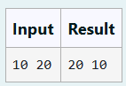

**PROGRAM:**

#include<stdio.h>

int main()

{

int a, b, t;

scanf("%d %d", &a, &b);

t=a;

a=b;

b=t;

printf("%d %d", a, b);

return 0;

}

**OUTPUT:**

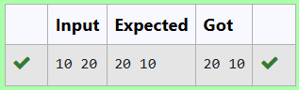

|  |  |
| --- | --- |
| **EXP.NO:1(b)** | **BASIC C PROGRAMMING-PRACTICE** |
|  |

**QUESTION:**

Write a C program to find the eligibility of admission for a professional course based on the following criteria:

Marks in Maths >= 65

Marks in Physics >= 55

Marks in Chemistry >= 50

Or

Total in all three subjects >= 180

**Sample Test Cases**

**Test Case 1**

**Input**

70   60   80

**Output**

The candidate is eligible

**PROGRAM:**

#include<stdio.h>

int main()

{

int m,p,c;

scanf("%d %d %d",&m,&p,&c);

int t=m+p+c;

if(m>=65 && p>=55 && c>=50){

printf("The candidate is eligible");

}

else if(t>=180){

printf("The candidate is eligible");

}

else{

printf("The candidate is not eligible");

}  
}

**OUTPUT:**

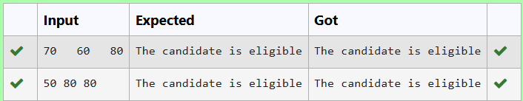

|  |  |
| --- | --- |
| **EXP.NO:1(c)** | **BASIC C PROGRAMMING-PRACTICE** |
|  |

**QUESTION:**

Malini goes to BestSave hyper market to buy grocery items. BestSave hyper market provides 10% discount on the bill amount B when ever the bill amount B is more than Rs.2000.  
The bill amount B is passed as the input to the program. The program must print the final amount A payable by Malini.

Input Format:

The first line denotes the value of B.

Output Format:

The first line contains the value of the final payable amount A.

Example Input/Output 1:

Input:

1900

Output:

1900

Example Input/Output 2:

Input:

3000

Output:  
2700

**PROGRAM:**

#include<stdio.h>

int main(){

int c, t;

scanf("%d",&c);

if(c>2000){

t=c-(c*0.1);

}

else{

t=c;

}

printf("%d",t);

}

**OUTPUT:**

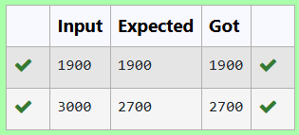

|  |  |
| --- | --- |
| **EXP.NO:1(d)** | **BASIC C PROGRAMMING-PRACTICE** |
|  |

**QUESTION:**

Baba is very kind to beggars and every day Baba donates half of the amount he has when ever a beggar requests him. The money M left in Baba's hand is passed as the input and the number of beggars B who received the alms are passed as the input. The program must print the money Baba had in the beginning of the day.

**Input Format:**

The first line denotes the value of M.  
The second line denotes the value of B.

**Output Format:**

The first line denotes the value of money with Baba in the beginning of the day.

**Example Input/Output:**

Input:

100  
2

Output:

400

**PROGRAM:**

#include<stdio.h>

int main(){

int m, b;

scanf("%d", &m);

scanf("%d", &b);

int t=m*b;

printf("%d", t*2);

}

**OUTPUT:**

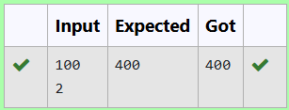

|  |  |
| --- | --- |
| **EXP.NO:1(e)** | **BASIC C PROGRAMMING-PRACTICE** |
|  |

**QUESTION:**

The CEO of company ABC Inc wanted to encourage the employees coming on time to the office. So he announced that for every consecutive day an employee comes on time in a week (starting from Monday to Saturday), he will be awarded Rs.200 more than the previous day as "Punctuality Incentive". The incentive I for the starting day (ie on Monday) is passed as the input to the program. The number of days N an employee came on time consecutively starting from Monday is also passed as the input. The program must calculate and print the "Punctuality Incentive" P of the employee.

**Input Format:**

The first line denotes the value of I.  
The second line denotes the value of N.

**Output Format:**

The first line denotes the value of P.

**Example Input/Output:**

Input:

500  
3

Output:

2100

**PROGRAM:**

#include<stdio.h>

int main(){

int a,d;

scanf("%d",&a);

scanf("%d",&d);

int t=0;

for(int i=0;i<d;i++)

{

a=a+200;

t=t+a;

}

printf("%d",t-600);

}  
  
  
  
  
  
**OUTPUT:**

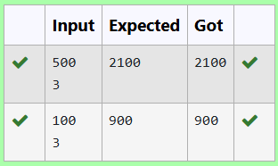

|  |  |
| --- | --- |
| **EXP.NO:1(f)** | **BASIC C PROGRAMMING-PRACTICE** |
|  |

**QUESTION:**

Two numbers M and N are passed as the input. A number X is also passed as the input. The program must print the numbers divisible by X from N to M (inclusive of M and N).

Input Format:

The first line denotes the value of M  
The second line denotes the value of N  
The third line denotes the value of X

Output Format:  
  
Numbers divisible by X from N to M, with each number separated by a space.

Boundary Conditions:

1 <= M <= 9999999  
M < N <= 9999999  
1 <= X <= 9999

Example Input/Output 1:

Input:  
2  
40  
7

Output:  
35 28 21 14 7

**PROGRAM:**

#include<stdio.h>

int main()

{

int m,n,x;

scanf("%d\n%d\n%d",&m,&n,&x);

for(int i=n;i>=m;i--){

if(i%x==0){

printf("%d ",i);

}

}

}

**OUTPUT:**

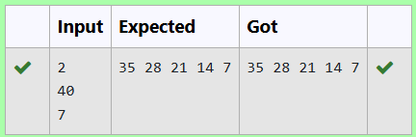

|  |  |
| --- | --- |
| **EXP.NO:1(g)** | **BASIC C PROGRAMMING-PRACTICE** |
|  |

**QUESTION:**

Write a C program to find the quotient and reminder of given integers.

**For example:**

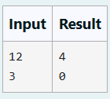

**PROGRAM:**

#include<stdio.h>

int main(){

int a, b;

scanf("%d\n%d", &a, &b);

printf("%d\n%d", a/b, a%b);

return 0;

}

**OUTPUT:**

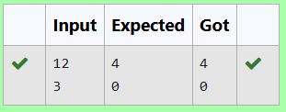

|  |  |
| --- | --- |
| **EXP.NO:1(h)** | **BASIC C PROGRAMMING-PRACTICE** |
|  |

**QUESTION:**

Write a C program to find the biggest among the given 3 integers?

**For example:**

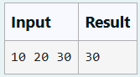

**PROGRAM:**

#include<stdio.h>

int main()

{

int a,b,c,g;

scanf("%d %d %d",&a,&b,&c);

if(a>b && a>c)

g=a;

else if(b>a && b>c)

g=b;

else

g=c;

printf("%d",g);

}

**OUTPUT:**

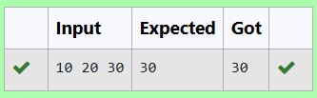

|  |  |
| --- | --- |
| **EXP.NO:1(i)** | **BASIC C PROGRAMMING-PRACTICE** |
|  |

**QUESTION:**

Write a C program to find whether the given integer is odd or even?

**For example:**

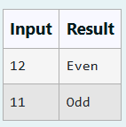

**PROGRAM:**

#include<stdio.h>

int main()

{

int n;

scanf("%d",&n);

if(n%2==0)

printf("Even");

else

printf("Odd");

}

**OUTPUT:**

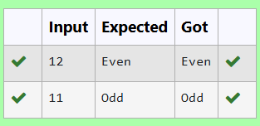

|  |  |
| --- | --- |
| **EXP.NO:1(j)** | **BASIC C PROGRAMMING-PRACTICE** |
|  |

**QUESTION:**

Write a C program to find the factorial of given n.

**For example:**

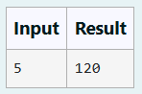

**PROGRAM:**

#include<stdio.h>

int main()

{

int n;

scanf("%d",&n);

int i,f=1;

for(i=1;i<=n;i++)

{

f*=i;

}

printf("%d",f);

}

**OUTPUT:**

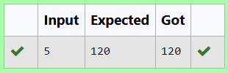

|  |  |
| --- | --- |
| **EXP.NO:1(k)** | **BASIC C PROGRAMMING-PRACTICE** |
|  |

**QUESTION:**

Write a C program to find the sum first N natural numbers.

**For example:**

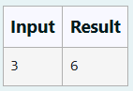

**PROGRAM:**

#include<stdio.h>

int main()

{

int n;

scanf("%d",&n);

int s=0;

for(int i=1;i<=n;i++)

{

s+=i;

}

printf("%d",s);

return 0;

}

**OUTPUT:**

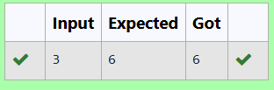

|  |  |
| --- | --- |
| **EXP.NO:1(l)** | **BASIC C PROGRAMMING-PRACTICE** |
| **DATE:** |

**QUESTION:**

Write a C program to find the Nth term in the fibonacci series.

**For example:**

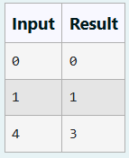

**PROGRAM:**

#include<stdio.h>

int main(){

int n,a,b,c;

scanf("%d",&n);

a=0;

b=1;

for(int i=1;i<=n;i++)

{

c=a+b;

a=b;

b=c;

}

printf("%d",a);

return 0;

}

**OUTPUT:**

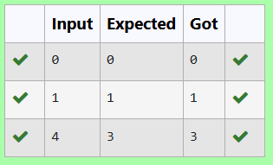

|  |  |
| --- | --- |
| **EXP.NO:1(m)** | **BASIC C PROGRAMMING-PRACTICE** |
| **DATE:** |

**QUESTION:**

Write a C program to find the power of integers.

input:

a b

output:

a^b value

**For example:**

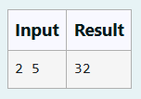

**PROGRAM:**

#include<math.h>

#include<stdio.h>

int main()

{

int a,b;

scanf("%d %d",&a,&b);

int p=pow(a,b);

printf("%d",p);

}

**OUTPUT:**

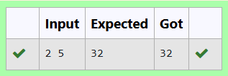

|  |  |
| --- | --- |
| **EXP.NO:1(n)** | **BASIC C PROGRAMMING-PRACTICE** |
|  |

**QUESTION:**

Write a C program to find Whether the given integer is prime or not.

**For example:**

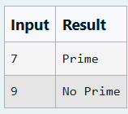

**PROGRAM:**

#include<stdio.h>

int main()

{

int n;

scanf("%d",&n);

int c=0;

for(int i=1;i<=n;i++)

{

if(n%i==0)

c++;

}

if(c==2)

{

printf("Prime");

}

else

{

printf("No Prime");

}

}

**OUTPUT:**

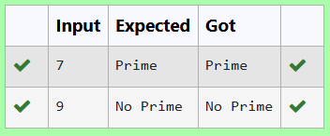

|  |  |
| --- | --- |
| **EXP.NO:1(o)** | **BASIC C PROGRAMMING-PRACTICE** |
|  |

**QUESTION:**

Write a C program to find the reverse of the given integer?

**PROGRAM:**

#include<stdio.h>

int main(){

int n;

scanf("%d",&n);

int r=0;

while(n!=0){

r=(r*10)+(n%10);

n=n/10;

}

printf("%d",r);

}

**OUTPUT:**

