CUSTOMER SEGMENTATION
ANALYSIS REPORT
DataMites Client Project | CDACL-002

1. Project Overview
This project analyzes customer shopping trends in order to understand discount usage, spending patterns across age groups, seasons and locations, and customer segments. The goal is to support data-driven marketing and customer-focused decisions.

2. Dataset Description
The supplied dataset contains 3,900 customer purchase records and 18 columns. The fields include customer demographics, purchased item and category, purchase amount, location, season, review rating, discount and promotion usage, previous purchases, payment method, and purchase frequency.
Data quality check: all columns in the supplied dataset contain complete records (no missing values were reported in the initial inspection).

3. Product Categories and Discount Usage
Discount usage was compared by product category. The discount rate below is the percentage of records in each category where DiscountApplied is Yes.
Category | Customers | Discount Yes | Discount Rate | Avg. Purchase ($)
Accessories | 820 | 416 | 50.73% | $253.74
Clothing | 796 | 378 | 47.49% | $262.28
Electronics | 772 | 362 | 46.89% | $250.88
Home Decor | 760 | 379 | 49.87% | $259.21
Sports | 752 | 362 | 48.14% | $251.14
Accessories has the highest observed discount usage (50.73%), followed by Home Decor (49.87%). Electronics has the lowest observed discount usage (46.89%).
Recommendation: consider targeted, time-limited promotions for categories with comparatively lower discount usage (such as Electronics and Clothing) only after checking margins and whether discounts improve conversion. Accessories and Home Decor already show relatively high discount usage, so avoid blanket discounts and test loyalty bundles or category-specific offers instead. These are recommendations based on observed discount usage, not proof of discount effectiveness; the dataset does not include profit or causal uplift.

4. Spending Analysis by Age, Season, and Location

4.1 Spending by Age Group
Age Group | Customers | Average Spending ($)
18–24 | 553 | $256.64
25–34 | 814 | $255.34
35–44 | 847 | $257.53
45–54 | 878 | $254.76
55–64 | 808 | $253.47
Average spending is similar across age groups, ranging from about $253.47 to $257.53. The 35–44 group has the highest average spending in this dataset, while the 55–64 group has the lowest. The differences are modest, so age alone may not be a strong spending discriminator.

4.2 Spending by Season
Season | Customers | Average Spending ($)
Fall | 987 | $257.30
Spring | 1047 | $259.73
Summer | 905 | $250.98
Winter | 961 | $253.22
Spring shows the highest average spending ($259.73), while Summer shows the lowest ($250.98). Seasonal promotions can be tested around these patterns, while tracking conversion and margin.

4.3 Spending by Location
Location | Customers | Average Spending ($)
Chicago | 777 | $264.36
Miami | 741 | $260.57
New York | 812 | $252.50
Los Angeles | 806 | $251.34
Houston | 764 | $249.05
Chicago has the highest average purchase amount ($264.36), and Houston the lowest ($249.05). Location-based campaigns may be tested, but the observed differences should be validated before allocating significantly different budgets.

5. Customer Clustering
K-Means clustering was applied to divide customers into three groups. The clustering inputs were Age, PurchaseAmountUSD, ReviewRating, and PreviousPurchases. StandardScaler was used to standardize the numeric features before fitting K-Means (k = 3, random_state = 42, n_init = 10). CustomerID was not used as a clustering feature.
The cluster counts and profile averages below are from the clustering output generated in Google Colab.

5.1 Cluster Interpretation and Targeted Marketing
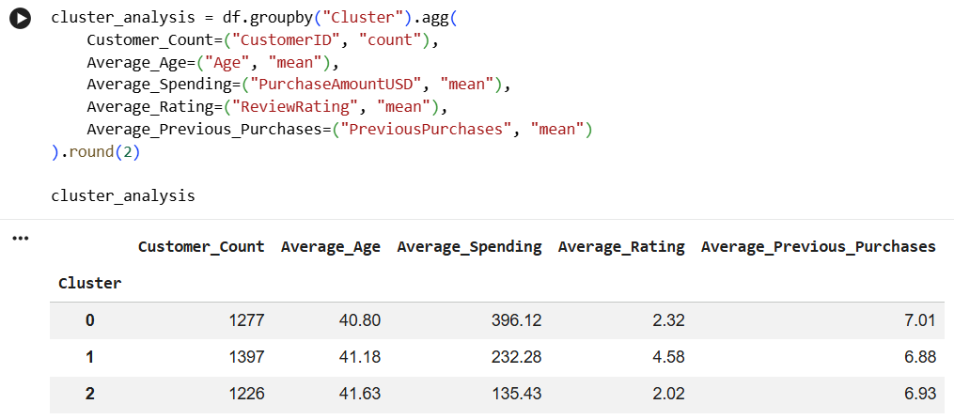
Cluster 0 – High-spending customers: This group has the highest average spending ($396.12) and a lower average review rating (2.32). Consider premium recommendations, exclusive bundles, and loyalty benefits, while also collecting feedback to understand the lower rating.
Cluster 1 – Mid-spending, higher-rated customers: This group averages $232.28 in spending and has the highest average rating (4.58). Consider loyalty rewards, personalized product recommendations, and cross-selling relevant complementary items.
Cluster 2 – Lower-spending customers: This group averages $135.43 in spending and has a lower average rating (2.02). Consider affordable product recommendations and carefully targeted introductory offers, alongside service and product-feedback follow-up.
Average age and previous-purchase counts are similar across clusters. In this clustering, purchase amount and review rating appear to distinguish the groups more clearly than age. These interpretations are descriptive; additional validation and campaign testing are needed.

6. Key Findings
- The dataset contains 3,900 records and has no missing values in the initial data-quality check.
- Accessories has the highest observed discount usage; Electronics has the lowest.
- Average spending is fairly similar across age groups.
- Spring has the highest seasonal average spending; Summer has the lowest.
- Chicago has the highest location-level average purchase amount; Houston has the lowest.
- K-Means produced three customer segments with distinct average spending and rating profiles.

7. Conclusion
Customer segmentation provides a structured way to understand different shopping behaviors. The analysis suggests testing differentiated marketing approaches: premium and feedback-focused offers for Cluster 0, loyalty and cross-selling for Cluster 1, and value-focused campaigns plus service improvement for Cluster 2. Discount and seasonal/location recommendations should be evaluated through controlled campaign tests and business metrics such as conversion, revenue, and profit before broad implementation.

8. Tools and Methodology
Tools: Python in Google Colab, pandas for data handling, scikit-learn for StandardScaler and K-Means clustering. Analysis methods: descriptive aggregation, discount-use percentages, group-wise average spending, and unsupervised customer clustering.

