Module 2 Challenge

# Instructions

Create a script that loops through all the stocks for one year and outputs the following information:

* The ticker symbol
* Yearly change from the opening price at the beginning of a given year to the closing price at the end of that year.
* The percentage change from the opening price at the beginning of a given year to the closing price at the end of that year.
* The total stock volume of the stock. The result should match the following image:

# VBA script files

Attached in github

## VB script written to above instructions is attached in here.

This is a fun project which gave me opportunity to learn VBA. I have written many versions before I came to this. Due to time restrictions, I have not used some cool things in others in this version like Enums. I wasn’t successful in using collections. My thought was to collect all the output arrays into collections and output at once and write into same worksheet. But it kept on giving me errors which I couldn’t resolve. I was able to write onto different worksheets but was trying to write onto same worksheet using Collections and was not successful. So, this version I am not very satisfied as writing on to same worksheets won’t be so robust when we add more worksheets to be analyzed. This code has following modules.

Main Module.

This is the main logic.

1. Call Turnoff : I had to use this to improvise little bit of performance on the code. I have learnt this from youtube videos. This module turns off screen updates , events and makes calculation manual until the last step.
2. Call Turnon: This module turns on the screen,events and calculations back on in the last step.
3. Stock Analysis: This is the main code which reads all the data of the worksheets one by one sheet into dictionary and process final result into arrays
4. Write_data : After processing writes below columns on to the appropriate worksheet
   1. The percentage change from the opening price at the beginning of a given year to the closing price at the end of that year.
   2. The total stock volume of the stock. The result should match the following image:

Class Module.

This module consists of two subroutines.

1. CalculatePercentageChange() : Calculates the difference of the close price for last day and open price for first day of the year by ticker symbol
2. AccumulateVolume : Calculates the Total volume of each Ticker

Complete Excel saved as Macro Enabled

Excel sheet is more than 25 mb din’t allow me to attach.

# Screenshots of the results

Please find the complete work with results.

2018 _Worksheet

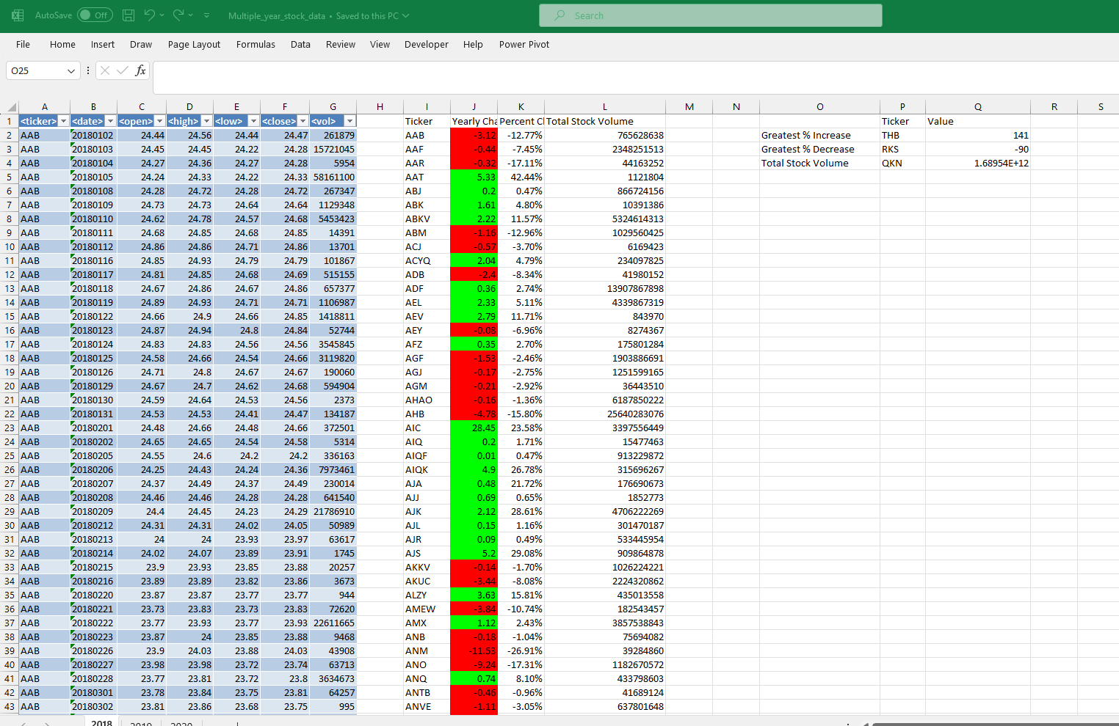

2019 Worksheet

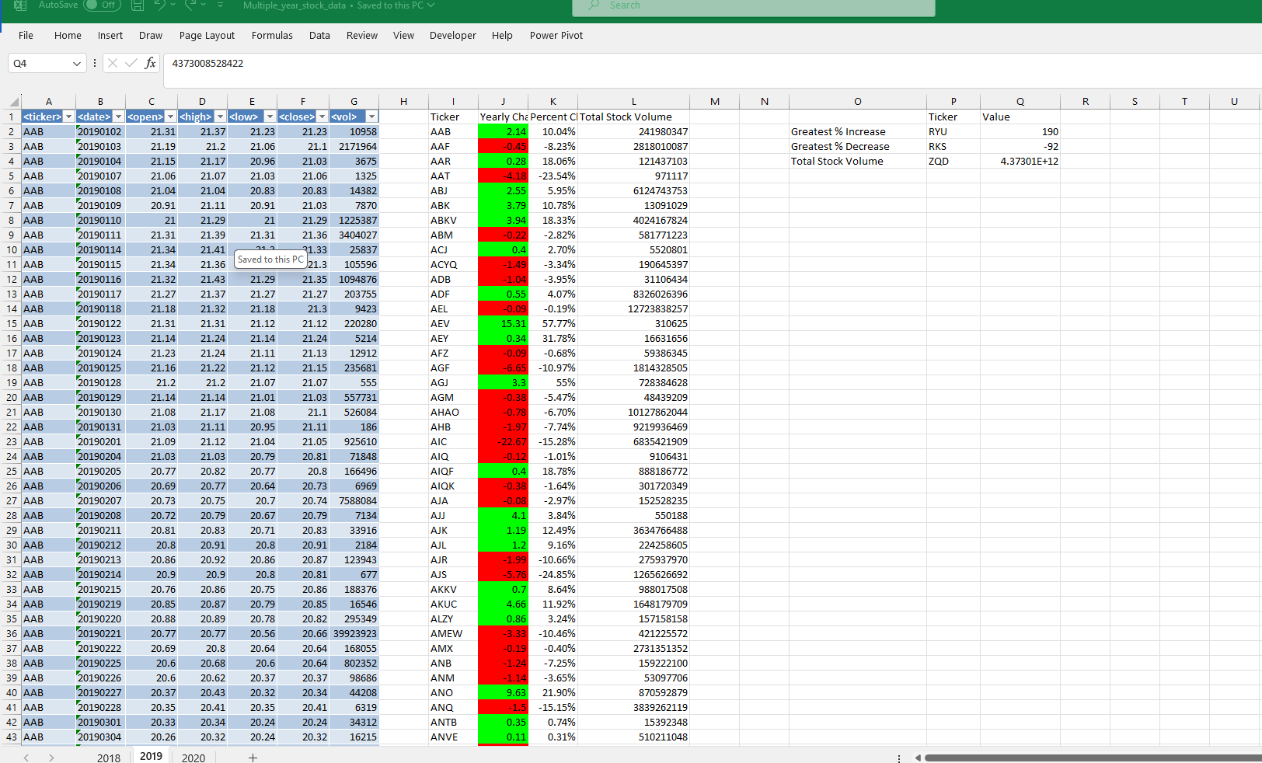

2020 Worksheet

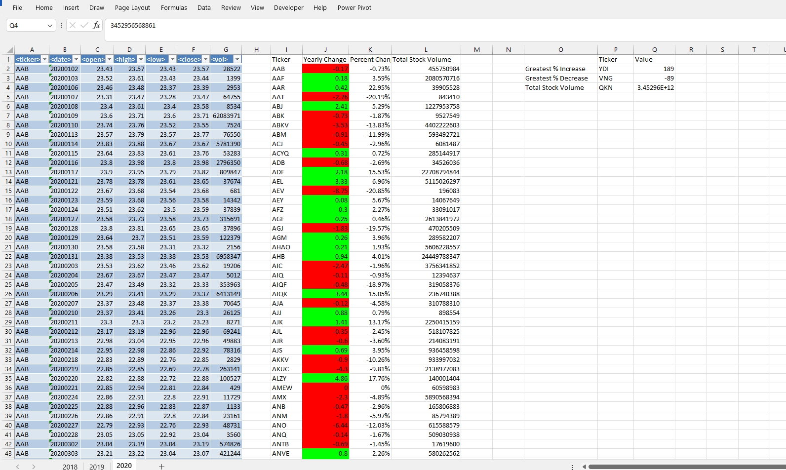

# Final Checklist

|  |  |
| --- | --- |
| **Retrieval of Data (20 points)** | **Status** |
| The script loops through one year of stock data and reads/ stores all of the following values from each row: |  |
| ticker symbol (5 points) | Complete |
| volume of stock (5 points) | Complete |
| open price (5 points) | Complete |
| close price (5 points) | Complete |
| **Column Creation (10 points)** |  |
| On the same worksheet as the raw data, or on a new worksheet all columns were correctly created for: |  |
| ticker symbol (2.5 points) | Complete |
| total stock volume (2.5 points) | Complete |
| yearly change ($) (2.5 points) | Complete |
| percent change (2.5 points) | Complete |
| **Conditional Formatting (20 points)** |  |
| Conditional formatting is applied correctly and appropriately to the yearly change column (10 points) | Complete |
| Conditional formatting is applied correctly and appropriately to the percent change column (10 points) | Complete |
| **Calculated Values (15 points)** |  |
| All three of the following values are calculated correctly and displayed in the output: | Complete |
| Greatest % Increase (5 points) | Complete |
| Greatest % Decrease (5 points) | Complete |
| Greatest Total Volume (5 points) | Complete |
| **Looping Across Worksheet (20 points)** |  |
| The VBA script can run on all sheets successfully. | Complete |
| **GitHub/GitLab Submission (15 points)** |  |
| All three of the following are uploaded to GitHub/GitLab: |  |
| Screenshots of the results (5 points) | Complete |
| Separate VBA script files (5 points) | Complete |
| README file (5 points) | Complete |