Ls:



Pwd:

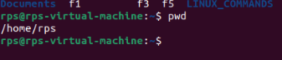

Ls -l:

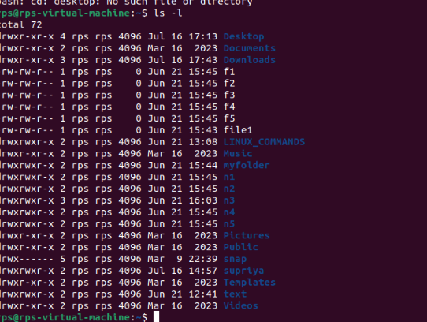

Cd .. :



Rmdir:



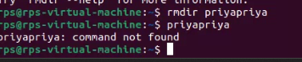

Cat:

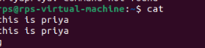

less command

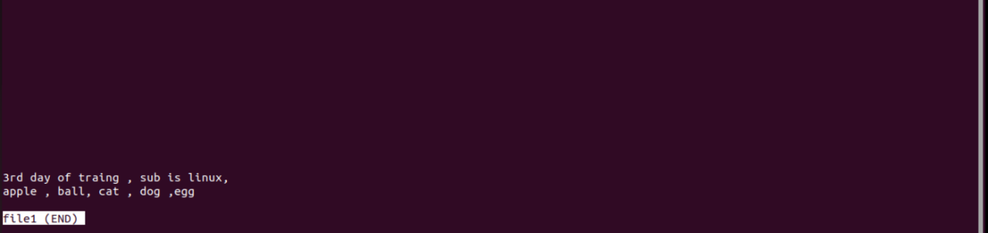

Man:



Ls -a: 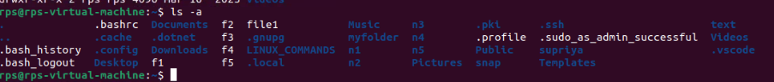

Ls -la:



Ls -fa:



Relative path:

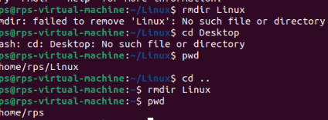

TASK 2: Navigation:

cd (change directory): Moves you between directories.

Exercise: Navigate to your home directory (cd ~), then explore subdirectories like Documents (cd Documents). Use pwd (print working directory) to confirm your location. Try going back a directory with cd ...

pwd (print working directory): Shows your current directory path.

Exercise: After navigating using cd, use pwd to verify the path.

ls (list): Lists files and directories in the current directory.

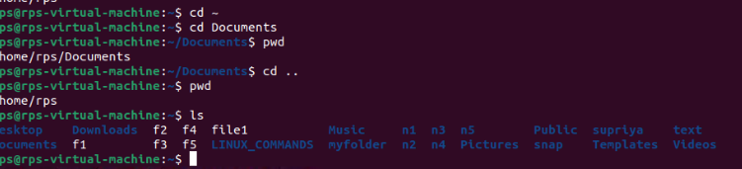

2. Exercise: Use ls in your home directory and note the listed items. Try ls -l (long format) for detailed information like permissions, owner, and size.

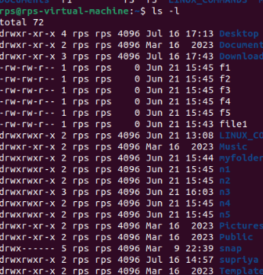

3.f ile and Directory Management:

mkdir (make directory): Creates a new directory.

Exercise: Create a new directory called "Projects" (mkdir Projects). Use ls to confirm its existence.

rmdir (remove directory): Deletes an empty directory.

Exercise: Make a directory named "temp" (mkdir temp). Delete it after verifying its existence with ls (rmdir temp).

touch (create file): Creates an empty file.

Exercise: Create a file called "test.txt" (touch test.txt). Use ls to see it listed.

cp (copy): Copies a file or directory to another location.

Exercise: Copy "test.txt" to your Documents directory (cp test.txt Documents). Verify the copy with ls Documents.

mv (move/rename): Moves or renames a file or directory.

Exercise: Rename "test.txt" to "data.txt" (mv test.txt data.txt). Use ls to confirm the change. You can also move files to a different directory (e.g., mv data.txt Documents).

File Viewing and Permissions:

cat (concatenate): Displays the contents of a text file.

Exercise: Create a text file named "message.txt" with some content (e.g., using a text editor). Then, use cat message.txt to view its contents.

more (pager): Displays a file's contents one screen at a time (useful for long files).

Exercise: Create a larger text file (e.g., "long_text.txt") and use more long_text.txt to navigate through its content page by page.

less (pager): Similar to more, but allows you to move backward in the file.

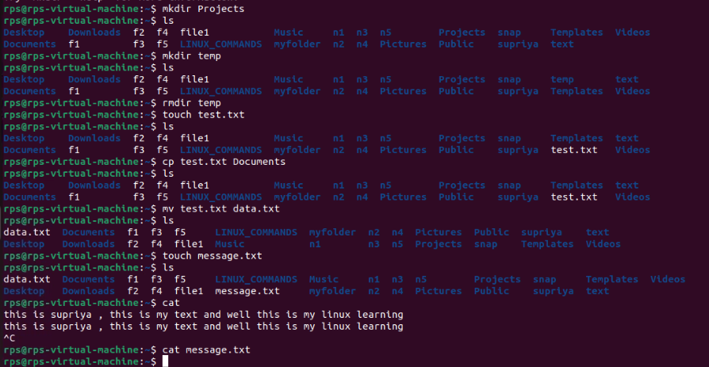

Exercise: Use less with "long_text.txt" to try moving backward using the Up arrow key.

chmod (change mode): Modifies file permissions (owner, group, others) for read, write, and execute access.

Exercise: This requires understanding permissions. Refer to the man chmod page for details. Proceed with caution when modifying permissions.

Getting Help and Information:

man (manual): Provides detailed information about a command.

Exercise: Use man ls or man cd to learn more about these commands.

info (information): Another source of documentation for some commands, often more user-friendly than man.

Exercise: Try info ls or info cd if available on your system.

--help or -h (help flag): Provides a brief overview of a command's usage.

Exercise: Use ls --help or ls -h to see the basic usage options for ls.

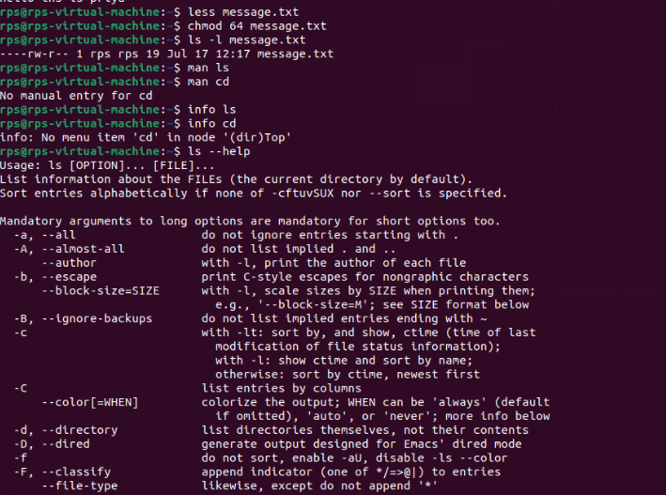

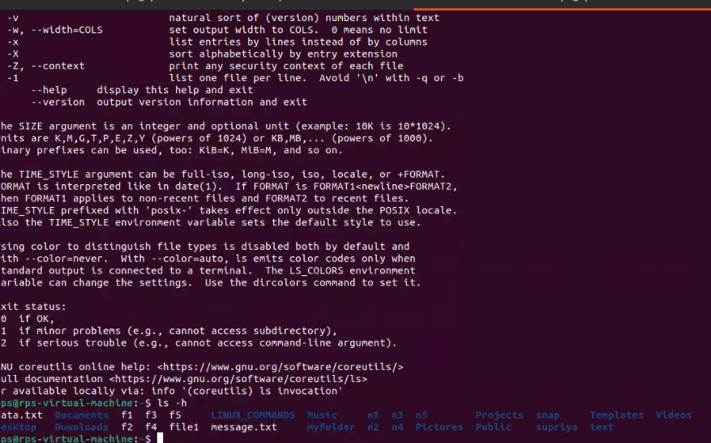

Task 3:NAVIGATION AND FILE MANIPULATION:

Navigation and File Manipulation:

cd ~ && mkdir exercises && cd exercises: Navigate to your home directory, create a new directory named "exercises," and then move into it.

cp ../data.txt . (assuming "data.txt" exists in the parent directory): Copy a file named "data.txt" from the parent directory into your current "exercises" directory.

mv important_file.txt important_data.txt && touch report.md: Rename a file named "important_file.txt" to "important_data.txt" and create a new Markdown file named "report.md" within the "exercises" directory.

cat report.md (assuming the file is empty): View the contents (which should be empty) of the "report.md" file using cat.

echo "This is a report" >> report.md: Append a line of text "This is a report" to the "report.md" file using redirection ('>>').

less report.md: Use less to view the contents of the "report.md" file, which now contains the appended text.

Finding and Organizing Files:

ls -l | grep 'txt$': List all files in the current directory with the long format (-l) and filter the output using grep to only show files ending with the ".txt" extension.

find . -name 'data*': Search for all files starting with "data" (including "data.txt", "data_backup.csv", etc.) recursively within the current directory and its subdirectories using find.

mv data* data_archive/: Move all files starting with "data" into a new directory named "data_archive" (create it if it doesn't exist).

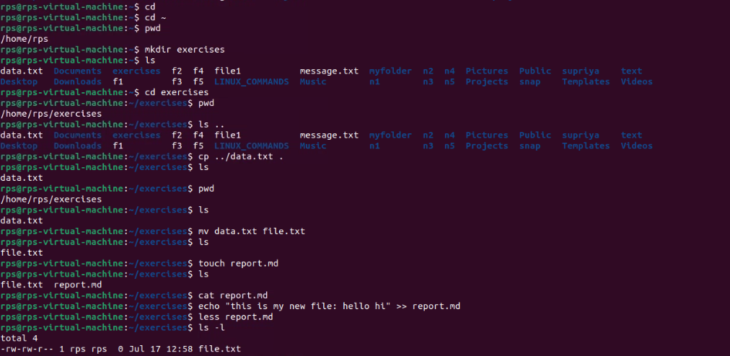

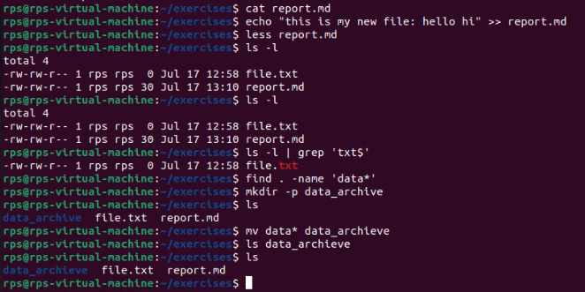

Permissions:

