**PUSL3119 Computing Individual Project**

**Project Initiation Document (PID)**

Food Desire

An Online Food Ordering System

Supervisor: Mr. Pramudya Thilakarathne

Name: Rathnayake M Rathnayake

Plymouth Index Number: 10747887

Degree Program: BSc (Hons) Computer Science

Table of Contents

TABLE OF FIGURE iii

Chapter One INTRODUCTION 1

1.1 Background 1

1.2 Problem statement 1

1.3 Current state of the system 2

1.2 Solution 2

1.3 Project outcome 3

Chapter Two PROJECT OBJECTIVES 4

2.1 Restaurant management system 4

2.2 Web application 5

2.3 Recommendation system 6

Chapter Three BUSINESS CASES 7

3.1 Business needs 7

3.2 Business Objectives 8

Chapter Four LITERATURE REVIEW 9

4.1 Introduction 9

4.2 Self-Ordering 9

4.3 Online Food ordering 10

4.4 AI and Machine Learning in E-Commerce 10

4.5 Supervised Machine Learning 11

Chapter Five METHOD OF APPROACH 13

5.1 Introduction 13

5.2 Design 14

5.2.1 Database 15

5.2.2 Data services 17

5.2.3 Inventory Management System 18

5.2.4 Web Application 20

5.3 Common Design Patterns 21

5.4 Testing 22

5.5 Application Architecture 22

Chapter Six INITIAL PROJECT PLAN 23

6.1 Backend Developmnet 23

6.2 Desktop Application 24

6.3 Web Application 24

6.4 Recommendation System 24

6.5 Unit Testing 24

Chapter Seven RISK ANALYSIS 25

7.1 Choosing Platform 25

7.2 Compatibility 25

7.3 Recommendation System 25

Bibliography 26

# TABLE OF FIGURE

Figure 4. 1 Supervised ML 12

Figure 5. 1 Use case diagram 14

Figure 5. 2 ER Diagram 16

[Figure 5. 3 Repository Usage 17](https://liveplymouthac-my.sharepoint.com/personal/10747887_students_plymouth_ac_uk/Documents/3rd%20year/PUSL3119%20Computing%20Project/Docs/PID/10747887_PID.docx#_Toc121243998)

Figure 5. 4 Data Repository 17

Figure 5. 5 Chef Activity Diagrams 19

Figure 5. 6 Customer Activity Diagram 20

Figure 5. 7 Sketch of Application Architecture 22

# Chapter One INTRODUCTION

## 1.1 Background

Now days it is possible to get anything to doorsteps by ordering goods via the internet, faster and secure. The most important thing is the time that is spared. Because of this people do not want to spend time going to buy the goods by themselves.

Most of the fast-food restaurants in the world are adopting to the online food ordering. This is the latest trend of services that can offered by restaurant. This method allows customers to order food online and delivered to the customer. With an implementation of electronic payment system this method can be achieved. So, from a system like this will enable customers to go online and order their food by paying from their cards.

Because of the technologies that are associated with the food industry many opportunities are coming up due to the amount of internet usage. So many business industries value the use of internet to promote their business. One of such opportunities is an online food ordering system. Many fast-food restaurants have chosen this business opportunity to focus more on food preparation and faster delivery.

## 1.2 Problem statement

Because of the food industry is expanding, people are looking for many more ways to improve the current ways. One such way is the arability of customizing the food as they prefer. But this is somewhat limited to fast food industries such as Pizza restaurants, even though it cannot be customize as expected. Customers only be able to browse through the menu and select the meal and order. Customers are restricted to order the meal as it is. Customers cannot see the amount of ingredients that they would like to consider. No allowing customers to consider about the ingredient in their mela is a big disadvantage in the online food ordering system.

## 1.3 Current state of the system

The online food ordering system sets up a food menu online and customers can easily place the order as per they like. Also, the online customers can easily track their orders(R. *et al.*, 2017). Then the restaurant delivery employees can deliver the meal to the customers. This system also provides a feedback system in which user can rate the food items. Also, the proposed system can recommend hotels, food(R. *et al.*, 2017). This will allow the transparency of the restaurant, so more customers can pay attention to the. The payment can be made online or cash or pay-on-delivery system. For more secured ordering separate accounts are maintained for each user by providing them an ID and a password(R. *et al.*, 2017).

Most of the current online food ordering systems has most secure ways to make payment through online and place order for customers’ orders. Theses system may include booth mobile and web applications improve the user experience.

## 1.2 Solution

The proposed solution is to improve customer experience by adding a feature to the existing online food ordering system that enable customers to see most of the ingredients of their meal and edit amount of ingredient as customers prefer. Customers can browse through the meal items and select a meal that they prefer and increase or decrease the amount of ingredients that contains in the meal. To enable this feature, the inventory management system of the restaurant also needs to be modified. It is up to the restaurant end to make a list of ingredients for each meal items. So, the restaurant end experience also needs an update.

This solution will update both customer and restaurant end to enable this feature. So, the restaurant end can provide which ingredients are used in the meal to the customer, and customers can edit the ingredients as they prefer. Customer will be able to select their preferred meal item, before going to the checkout or cart, customer will be promoted with a page that includes the meal information. Customer can choose either default meal item that is provided by the restaurant or edit the amount of ingredients that contains in the meal. As for an example, if the customer would like to have more “Chicken pieces” in their Fried rice, customer can increase the amount of chicken pieces from the ingredient list.

## 1.3 Project outcome

Implementing this solution in a restaurant will allow their customers to value the food they are eating more than the existing food ordering system. As customer knows that they are paying. This will also enable the transparency between the customer and the food as customer knows what they are having for their meal. This will also be a big health benefit for the customers because they can be aware of the ingredients the are having. Depend on their health needs, customers can enjoy their favorite meals by limiting the amount of ingredient they should not be having too much.

This solution comes up with an upgrade for the inventory management system for the restaurant as well. Restaurant will be able create recipes from the inventory management system directly by accessing the ingredient categories. When a meal is being prepared, the system will update the amount of ingredients that has been consumed depends on the order that received. This will improve the inventory management experience for the restaurant.

Since customer pays for meal item depend on the amount of ingredients for each meal, will benefits booth financial and food reserve, because both customer and restaurant end will save money and limit the food wastage.

# Chapter Two PROJECT OBJECTIVES

This system is for an imaginary restaurant called “Food Desire”. As the name implies, the customer should be able to customize their meal as they desire. To implement the solution the system must be a brand-new system. An inventory management system is mandatory to deliver the system. So, this project will be a distributed system. A recommendation system for the customer, will also be developed.

## 2.1 Restaurant management system

The restaurant management system will contain multiple functionalities. One of the most important functionalities is the inventory management system that enable the main goal of the solution, the availability of allowing customers to edit the amount of ingredient for their meal. Restaurant can manage the recipe from the same system instead of login into the system that customers login and enables the ingredient modification feature by providing the ingredients list. Restaurant should be able to give a threshold limit to avoid users to overdose ingredients. As an example, if a customer increases the amount of sault more than usual, the taste would be terrible. So, the restaurant can limit amount of ingredients for each one. This system will also monitor each ingredient categories in the inventory and update for each order that received for the restaurant. This will help the restaurant to manage every ingredient manually. This functionality will benefit in financial and time management,

Since this system is an enhanced system of an existing food ordering system, this will include all the functionalities of an ordinary online food ordering system. So, there will be multiple type of employees that work for the restaurant, such as chefs, delivery persons, supply persons and system admins who handles this system. So having a feature to manage these employees in the same system will be great opportunity to enhance the system furthermore. All the employees will be categorized into roles and give access to certain features. This will allow employees to work more efficiently.

This system will be developed by using .NET and this will be a desktop application. Desktop platform is chosen, because it is easier to manage by the chef and other general employees as well. .NET is a very optimized developing platform, and it is the most suitable platform to develop this application. WinUi3 will be the framework to develop the application as this is the most modest and newest framework developed on .NET platform. So, the system will be modern looking and well up to dated application.

## 2.2 Web application

A web application will be developed for the customer to order their meal as a usual online food ordering system. A new feature will be added to the proposed system that customers able to customize their meal as they desire. Customers will be able to register and login to the system via web browser and start browsing through menu items. Once the customer selects a meal item, they will be prompted a partial page that shows the ingredients that contain in the meal. As for an example, “Chicken Fried Rice” will contain the following key ingredients.

* Rice
* Chicken pieces.
* Garlic
* Ginger
* Onions
* Type of sauces (soya/ fish)
* Green garnish

Once the list of ingredients is displayed to the customer, they will be able to edit the amount. The unit of amount can be differed to another. Customer can procced in either ways, order the default meal that the restaurant have already made or edit the amount as they want and order the meal. So, if the customer does not want to be bother by the ingredients, they can just order the default meal. Customers are not restricted to order in one way. With this implement, customers have freedom to order their meal as they want.

This web application will also be developed using .NET because the same share libraries that will developed to use in the desktop application can be used in this web application as well. .NET MVC with blazorUI framework will be used to develop this web application as will contains web components that has complex functionalities. With blazorUi it can be overcome by individually program each component

## 2.3 Recommendation system

A recommendation system will also be implemented for the web application to recommend users with meal items that they may like, depend on the data is collected by each user. Implementation of this system will enhance the user experience by suggesting meal items that they might prefer instead the default meals list in the home page. A collaborative filtering Machine Ai will be used to develop this system.

Having a recommendation system in the food ordering system will benefit both customer and the restaurant as customer will be suggested more meal items that they might like, and the restaurant get more orders than usual.

# Chapter Three BUSINESS CASES

## 3.1 Business needs

The modern business industries are involving with the modern technology. Started by ordering goods by telephone, now it is at state that customers can click few buttons to order their needs People can order anything online via internet any time and get them delivered to the doorstep. Having such system in food industry will defiantly improve the industry as well. So, improving these kinds of systems only makes this system more efficient and more valuable.

The ability to customize customers’ meals is a good benefit for both customer and restaurant. Because of the uniqueness of this improvement will benefit in restaurant business, as more and more customers will pay attention to the restaurant more than ever. Since customers can customize their meals according to their taste is a great opportunity that the customers can get.

The proposed improvement will have the following features for the restaurant.

1. Have a good understand of the customer’s taste.
2. Get more customer as the restaurant allowing customers to customize the recipes.
3. Ability to monitor individual ingredients that are consumed more.
4. Having a separate application to manage restaurant and the inventory.
5. Manage employees and work with them in the same system.

As for the customers,

1. Transparency of the meals’ customers having.
2. Make the meal in customer style.
3. Recommend more meal items as customers order depends on the ingredients.

## 3.2 Business Objectives

Since online food ordering systems are in most of the business industries for long time, improving the system according to their customer needs is a great opportunity. As people seeking more ideas this solution is a huge improvement. Having such a system will make a new connection between customers and the restaurant. Customers will have the freedom to have their favorite meal according to their taste.

When customer select a meal, they will see the list of ingredients that are contained in the meal. So, the customer knows what kind of things they are eating. So, this is a good opportunity to promote how trust full the restaurant is. This will bring online food ordering for the people who are concerned about the food they are eating. Meals ordered online for home delivery are typically less healthy than home-made meals, potentially contributing to weight gain(Dana *et al.*, 2021). Having an online food ordering system such, will allow customers to order food by limiting the ingredients that they should not have too much.

When it comes to the recommendation system, most of the e commers businesses have already implemented this as well as food business. The improvement of the proposed system is that the recommendation system can gather more data by analyzing the amount of ingredients in the food items. So, this is a more efficient way to improve the recommendation system, and this will benefit both restaurant and the customer.

# Chapter Four LITERATURE REVIEW

## 4.1 Introduction

Ordering systems can be identified as a set of detailed instructions that are used to handle an ordering process. It could either computerized or manual. Self-ordering means that the customer can order food by themselves.

Self-ordering system can be identified as either computerized or manual system. In computerized system, the system can track the orders that being placed by the customer.

## 4.2 Self-Ordering

This is the main point that Online ordering comes to the industries. Including various types of methods like such as internet, self-ordering systems have become a success in the industry. The evaluability of having such ordering technology is proven by many researchers.

(Ratto *et al.*, 2008)suggests that self-ordering systems are valuable because they can reach a state of maximal overall 'success'. (Gao and Su, 2018)found that self-order techniques can significantly reduce waiting cost and increase demand. People hate waiting to order their needs for so long. It is very time consuming. So, people prefer something like “do it by themselves” Therefore they like self-ordering technology. It can be also done by a text massage, email, telephone call and internet.

(Thomas and Davis, 1978)found that a traditional ordering technique can be replaced by timesaving ordering system. All these findings suggest that self-ordering systems can save businesses money by reducing costs and increasing efficiency. Because of these techniques people can order anything faster and get them delivered to their doorstep. The only waiting cost is wait for the goods to be delivered. In the business prospective, more order will receive for the business as self-ordering does not need to be monitored like manual ordering. This will improve the demand for the business.

When it comes to the online-food ordering, there are more benefits than the common business can be get in the food industry. This is mainly focus on the Internet. (Fujita, Shimada and Sato, 2014) found that the self-ordering system of restaurants can be personalized using the customer's user information. This research also suggests that self-ordering systems may be helpful in the food industry. So, implementing this on the internet/ online completely will improve the entire business.

## 4.3 Online Food ordering

This is the most modern method to implement a self-ordering system for a restaurant. online food ordering is a suitable way for customers to order food. (R. *et al.*, 2017)suggests that online food ordering systems are efficient and easy to use. Customers can browse through the food items that the restaurant provide and order the food with few steps. (Daim *et al.*, 2013)found that customers concern the efficiency of the website, speed of response duration on online services, and the quality of the personnel to be the most important factors when choosing an online food service.

But there are not any major improvements that have been made up to today. The system can be upgraded in many ways. (Zulkarnain *et al.*, 2015)found that website quality and service quality are key success factors of online food ordering services. (Goffe *et al.*, 2021) suggests that online food ordering platforms need to be more human centered. Customers should have been given more freedom when they order their food.

So, therefore the solution in this project will help to improve the existing food ordering system.

## 4.4 AI and Machine Learning in E-Commerce

Artificial Intelligence means the simulation of human intelligence that is programed to think like a human being. Simply, that’s mean “Programming the Unprogrammable”. The Core components of Artificial Intelligence are Machine learning techniques.

So, there are many useful scenarios that Ai and machine learning can be used for E-commerce. E-commerce is a business model that is used to exchange goods and services by the means of internet or other computerized systems. So, any kind of computerized system can include an Ai model.

The most common AI model that is used in E-commerce domain is recommendation system. (Ahrens, 2012)found that recommendation systems keep customers on the business site longer, so they interact with more products, and it suggests more products to customer, so they are likely to purchase or engage with. Recommendation systems are a model of artificial intelligence that are used to predict what users may want to buy or watch. They are used to recommend more items to users based on their past behavior.

(Sarwar *et al.*, 2001)found that item-based collaborative filtering recommendation algorithms provide dramatically better performance than user-based algorithms. This is the algorithm that is initially decided to use in the solution of this project.

## 4.5 Supervised Machine Learning

To understand about recommendation system, having a good understanding on supervised machine learning will help more. (Singh, Thakur and Sharma, 2016)Supervised learning is a process of using known data to predict unknown data. It is also a process of using known data to classify unknown data. Supervised learning is a branch of machine learning that is in use in almost all fields. (Mishra, 2019) Semi-supervised learning is a learning pattern that is agitated by the study of how computers learn as human of both labeled and unlabeled data.

When it comes to label and unlabeled data, are two methods which are used to train an AI. Labeled data means, that the machine learning model knows the values to be predicted so the machine learning model can train itself by modified the model’s variables for each new observation.

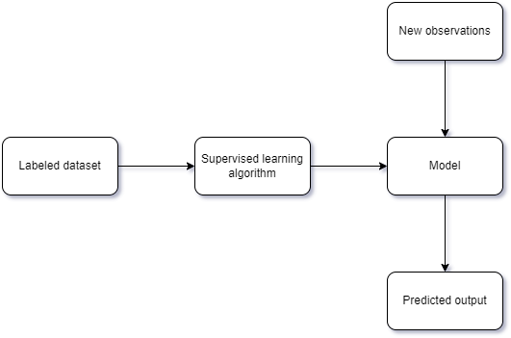

Figure 4. Supervised ML

Supervised machine learning models can be categorized in to two which are Classification model and Regression models. Classification models predict the outputs in binary form such “Yes”, “No”. Regression models are used for problems that predict variables like a number, salary, or weight. So, it is used to predict numerical outputs based on the observations.

# Chapter Five METHOD OF APPROACH

## 5.1 Introduction

The proposed project is a distributed system that contains multiple projects. To develop a distributed system, keeping good design practices can help the development in many ways. The system has an inventory system and a web application. The web application is mostly depending on the inventory system as, the contents that rendered by the web application is dependent on the inventory system. Booth of the system will share multiple libraries to avoid any duplication coding. The project will follow a good application architecture practice to achieve a perfect system.

The entire project is built and deployed on the .NET framework. NET is a developer platform with tools and libraries for building any type of app, including web, mobile, desktop, games, IoT, cloud, and microservices. Throughout the development many share libraries and components will be used. To make the sharable component compatible with another, deciding to develop on the same platform is a good approach.

## 5.2 Design

This distributed system has multiple actors so there are unique types of interactions for each actor.

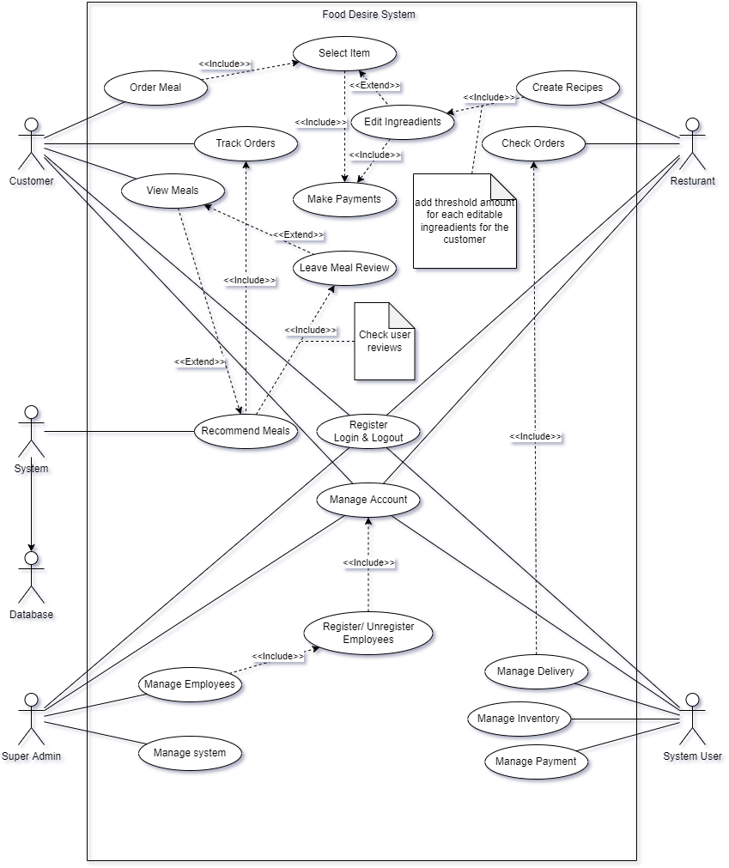

Figure 5. Use case diagram

In the figure 5.1 the customer, and the system actors interact on the web application. All the other actors take apart in the inventory management system. So, the system will remain as 2 separated projects. The restaurant can produce food items by creating the recipes as the figure 5.1 and those food items will be rendered in the web application for the user. The reason for separating restaurant from interaction on creating or editing the food item because the inventory system will help to manage the ingredients real time as the food items are created.

As in the figure 5.1, the system can manage employees too. So, a small potion of restaurant management interactions will also be included in the inventory system. It is not a complete restaurant management system because it will only manage the actors that directly interact with the inventory like Chefs who create recipe items, Delivery persons and supplier persons. Since the main goal of this system is managing the inventory, the project will remain as an inventory management system.

### 5.2.1 Database

The database system will be used to implement the backend of the distributed system. A relational database Microsoft SQL server will be used to make the database system. To configure the database system a Framework called Entity Framework will be used. The Entity Framework is a Microsoft .NET Framework data-access platform that models a relational database as a set of conceptual objects(Garofalo, 2011). Entity Framework can help reduce the impedance mismatch for applications and data services.

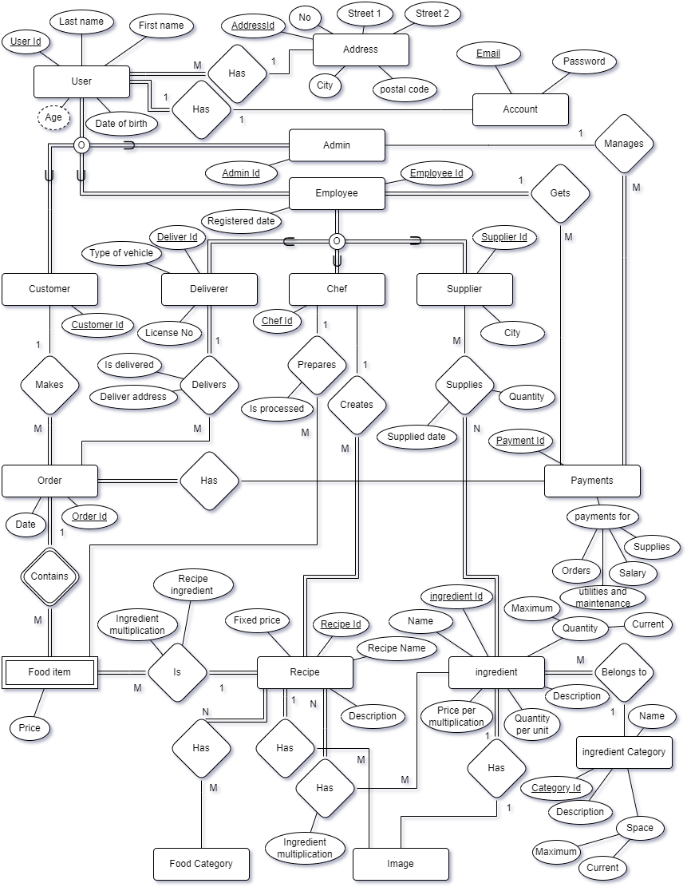

Figure 5. ER Diagram

Figure 5.2 ER diagram assumptions.

1. Every customer, employee is a user.
2. A user can have one account.
3. Multiple users can have the same address.
4. A user can have one default address, another address can be used when ordering food items.
5. Every deliver, chef, supplier is an employee.
6. Every employee gets paid.
7. Payments are managed by the system admin who may be the owner of the restaurant.
8. Food item is dependent of both customer order and the recipe.
9. Food item has ingredient multiplication so the original recipe can be customized.

According to the ER diagram in figure 5.2, a shared class library will be deployed to be share on both Inventory system and the web application. The shared class library will contain all the entities in figure 5.2 as models. These models will be used to generate the database using Entity Framework migrations.

### 5.2.2 Data services

After generating the database, a services layer will be created to interact with the database. Entity Framework allows to use C# OOP methods to handle database operations.

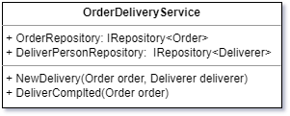

Figure 5. Repository Usage

Figure 5. Data Repository

Repository pattern will be used to handle database operation. The interface in the figure 5.4 will uses a generic type of object, so any entities in the figure 5.2 can implement this interface to do database crud operation. As an example, IRepository<Customer> can be used to do crud operations on Customer entity. For the complex crud operations that includes relation, a service will be deployed for each relation that includes the IRepository as an instance. As an example, figure 5.3.

### 5.2.3 Inventory Management System

After designing the data access layer and the services layer, those layers can be used in other project, like in the inventory management system. The inventory system will be developed including all the use cases of actors Admin, system user, restaurant in the figure 5.1. The main purpose of the inventory system is to manage food items for the web application and allowing customers to customize the food items.

For the Ui development of the project WinUi3 will be used. WinUi3 is a native Ui component in the Windows App SDK. It targets Windows 10 or higher. The fluent design of it matches the modern Windows 11 platform.

These are the major interaction in inventory management system.

1. Employees (as the figure 5.2) are registered in this system.
2. Supply details management.
3. Payment management.
4. Food item recipe creation by chefs.

Mainly, there will be the following views in the inventory system.

1. Home view (Where the business summery shows).
2. Recipe view (Where chefs can create food items).
3. Supply view (Where system users manage supplies and order supplies)
4. Employee view (Where the system user manages employees).

The above views will be limited for each role in the system as some of views will be unnecessary show them, as Chefs do not want to see the employee views.

The Recipe view takes a major part in the system as that is the view where the restaurant enables web users to customize their food items. From that view, chefs can create a recipe by using ingredients that are contained in the inventory. Chef can also restrict the amount of adjustable ingredients to stop customers for overdosing the ingredients.

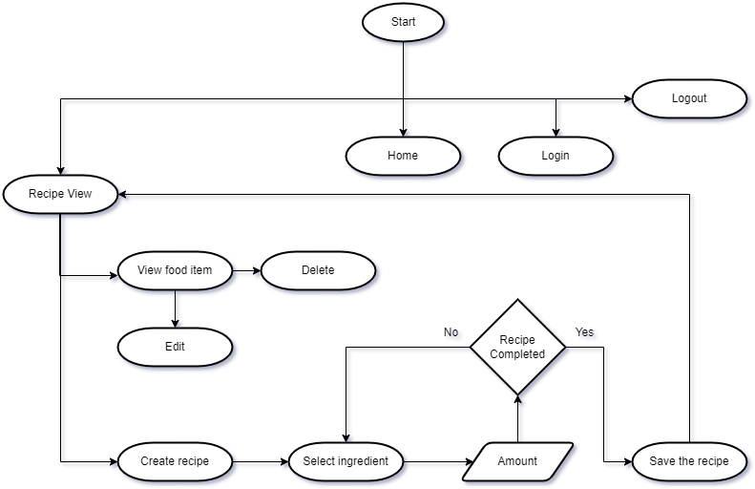

Figure 5. Chef Activity Diagrams

### 5.2.4 Web Application

The goal of developing the web application is to allow the customers of the restaurant to order food via internet. The typical usage of online food ordering system will be followed in this project. Addition to that, the customer can modify the existing recipe for their likings.

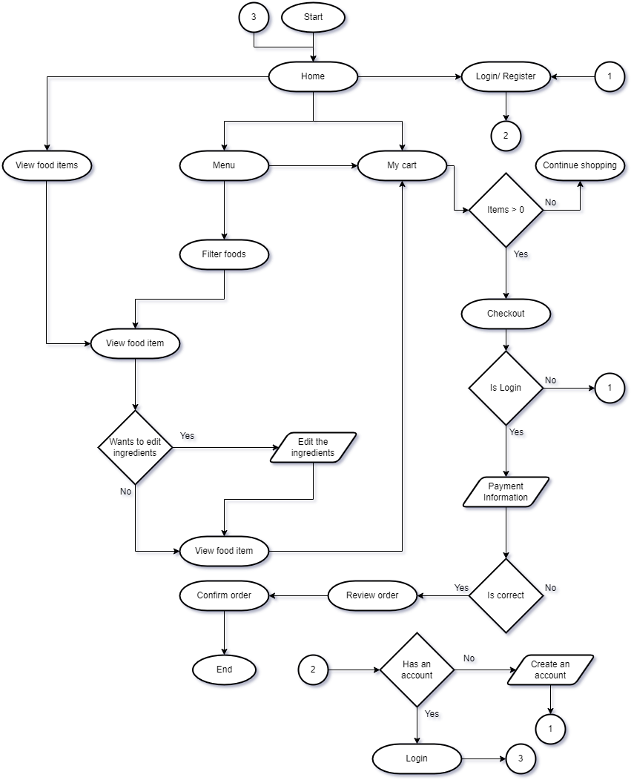

Figure 5. Customer Activity Diagram

The web user will be granted the following views.

1. Home.
2. Sign in/ Sign up.
3. Menu.
4. New food item.
5. Cart.
6. Payment.
7. Food review
8. Account.

New food item view is the main component in this solution. This is the view where the customer customizes their food item by selecting an existing food item from the Food item menu view. After customer customizes their food item customer can order the food from the cart view.

To develop the web application ASP.NET will be used and MVC design pattern will be used to develop the application. The same data and services layers will be used in this project to.

The solution comes with a recommendation system as well. The system will be implemented for the Home view in the web application. To develop the recommendation system ML.NET will be used.

## 5.3 Common Design Patterns

The proposed project is a distributed system. So, following good design patterns and practices will help to manages the development and the after services as well.

A common design pattern that is decided to use in the development is MVVM design pattern. Models, Views, View Models. This design pattern is used to loosely couple each component in the project.

As an example, the models that is discussed in chapter 5.2.1 Models is a component in MVVM design patter. That component is loosely coupled so it can be shared across multiple projects without concerning that, that model component will negatively affect the project. These design patterns promote separation of concern throughout the project, so multiple developers can work on the same project different component without cornering about the other component. This design pattern will also separate the view from view logics. Any views that are developed will not affect directly by its view logics.

## 5.4 Testing

Testing is a mandatory stage of any project. At this stage a lot of faults can be identified. This helps to deliver a perfect product to the customer.

In the proposed system, the project follows separation of concern practices. In that case, developing testing for the project will be a lot easier be case an each of every component can be tested individually.

Unit testing approach will be the best testing methodology of this type of solution. Unit testing will be implemented as soon as the database is created.

## 5.5 Application Architecture

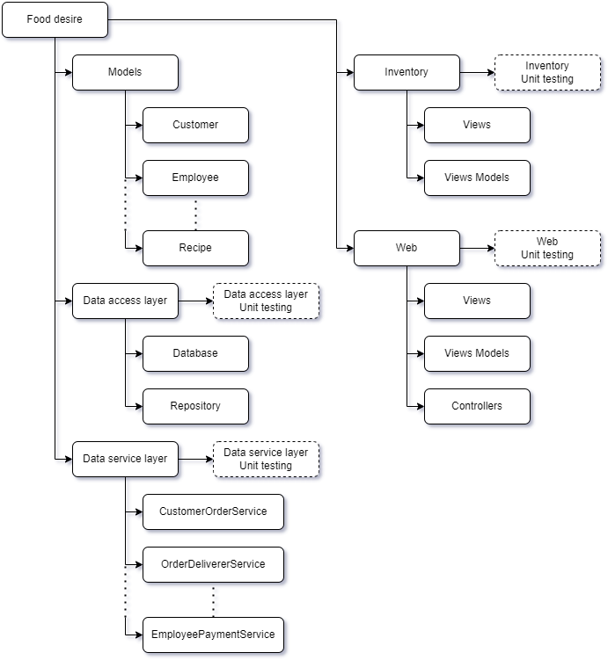

Figure 5. Sketch of Application Architecture

# Chapter Six INITIAL PROJECT PLAN

In the development of there are 4 major phases in the proposed project.

1. Backend development.
2. Desktop application development.
3. Web application development.
4. Recommendation system development.
5. Unit testing.

Figure 6. Initial Time Frame

## 6.1 Backend Developmnet

In this development phase the core structure of application, the database and the data services will be developed for both desktop application and the web application. The backend for both desktop app and the web app use the same backend project where all the services are implemented.

## 6.2 Desktop Application

The desktop application is the Inventory management system in this project. It will be developed as discussed in the Chapter Five. The development of the desktop application can be started after the development of the Backend. Developing the backend first, allows the development of the desktop application development more efficient because there are only view logics to be implemented in the desktop application.

## 6.3 Web Application

The development of the web application can be also started after developing the Backend in chapter 6.1. But in this scenario, it is best to wait for the development of the Inventory system, the desktop application is finished because the core component of the web application in the Chapter 2.2 is depending on the Inventory management system. The same benefits can be achieved as developing the backend first in the desktop application in Chapter 6.2.

Both development of desktop application in the Chapter 6.1 and the web application in Chapter 6.3 are focused on the development of the frontend. As for the backend of each development there are only view logics to be implemented because the main backend for both projects is developed as discussed in chapter 6.1.

## 6.4 Recommendation System

The recommendation system is a key component in the web application. But it minorly effects the development of the web application. The recommendation system can be developed as a completely different project and implement that after the development of the web application.

## 6.5 Unit Testing

Since the projects of the system are completely separated from another, Unit testing for each project, the backend, desktop application, web application and recommendation system, can be implemented at anytime after the development of each project is completed. In this scenario the unit testing will be implemented after the development of each project is completed because some of the projects shares its functionalities across the multiple projects.

# Chapter Seven RISK ANALYSIS

## 7.1 Choosing Platform

To develop the proposed system, the decided development platform is .NET. As for this project, it is proposed to use the up to dated SDK and frameworks. Since these SDKs and frameworks are latest version there may be some lack of community support. But the official documentation provides enough support to develop this application.

## 7.2 Compatibility

After launch of the system client may face incompatibility issue. Most of the restaurants are unlikely to use an up to dated system for their general-purpose activities. Since this project uses the latest developing tools, some of the SDKs require latest Windows platform to support. As an example, WinUI3 require Windows 10 and later.

This risk can be managed if all the hardware components are provided by the developers. Otherwise, the client must be aware of the system requirements.

## 7.3 Recommendation System

One of major risk in the proposed project is the development of the recommendation system. It is an AI that must be trained before the implementation. To train the AI it is required a huge amount of historical data. The risk the system having is the lack of data to be trained.

There are some datasets related to the food industries. But most of the data might be useless as not all the food categories will be used in the project. Filtering out the data might significantly reduce the accuracy of the AI model. But it can be used for the initial launch of the project. After that the AI model can be trained again by using the data that gathered from this system.

# Bibliography

Ahrens, S. (2012) ‘Recommender Systems’, in.

Daim, T.U. *et al.* (2013) ‘Exploring technology acceptance for online food services’, *Int. J. Bus. Inf. Syst.*, 12, pp. 383–403.

Dana, L.M. *et al.* (2021) ‘Factors associated with ordering food via online meal ordering services’, *Public Health Nutrition*, 24(17), pp. 5704–5709. Available at: https://doi.org/10.1017/S1368980021001294.

Fujita, T., Shimada, H. and Sato, K. (2014) ‘Self-ordering system of restaurants for considering allergy information’, *2014 IEEE 11th Consumer Communications and Networking Conference (CCNC)*, pp. 179–184.

Gao, F. and Su, X. (2018) ‘Omnichannel Service Operations with Online and Offline Self-Order Technologies’, *Manag. Sci.*, 64, pp. 3595–3608.

Garofalo, R. (2011) ‘The Entity Framework’, in.

Goffe, L. *et al.* (2021) ‘Appetite for Disruption: Designing Human-Centred Augmentations to an Online Food Ordering Platform’, in *34th British Human Computer Interaction Conference Interaction Conference, BCS HCI 2021*. BCS Learning and Development Ltd., pp. 155–167. Available at: https://doi.org/10.14236/ewic/HCI2021.16.

Mishra, P. (2019) ‘Supervised Learning Using PyTorch’, *PyTorch Recipes* [Preprint].

R., A. *et al.* (2017) ‘Online Food Ordering System’, *International Journal of Computer Applications*, 180(6), pp. 22–24. Available at: https://doi.org/10.5120/ijca2017916046.

Ratto, F. *et al.* (2008) ‘A numerical approach to quantify self-ordering among self-organized nanostructures’, *Surface Science*, 602, pp. 249–258.

Sarwar, B.M. *et al.* (2001) ‘Item-based collaborative filtering recommendation algorithms’, in *The Web Conference*.

Singh, A., Thakur, N. and Sharma, A. (2016) ‘A review of supervised machine learning algorithms’, *2016 3rd International Conference on Computing for Sustainable Global Development (INDIACom)*, pp. 1310–1315.

Thomas, A. and Davis, S.E. (1978) ‘Laboratory ordering: a system which eliminates paperwork.’, *The American journal of medical technology*, 44 10, pp. 1026–7.

Zulkarnain, K. *et al.* (2015) ‘Key success factors of online food ordering services:an empirical study’, in.