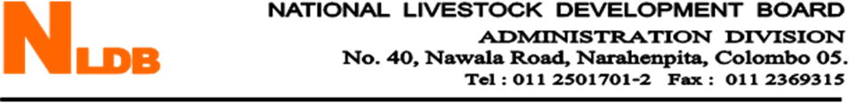

**NATIONAL LIVESTOCK DEVELOPMENT BOARD**

**PROCUREMENT NOTICE**

Sealed bids are invited from Baled Corn Silage Suppliers to supply 500MT of Baled Corn Silage to Ridiyagama Farm of National Livestock Development Board.

Bid documents containing the required quantity of the Baled Corn Silage, specifications & bid conditions can be obtained from the Supplies Manager of the National Livestock Development Board at the under mentioned address, during the normal working hours by producing a request letter.

Bid documents will be issued up to 3.30 p.m on 21st May 2020 and acceptance of bids will be closed at 10.30 a.m on 22nd May 2020. Bids will be opened immediately thereafter at the National Livestock Development Board, at No.40, Nawala Road, Narahenpita, Colombo 05.

Chairman

National Livestock Development Board

No.40

Nawala Road,

Narahenpita

Colombo 05.

011 2501701/2

011 5746308