Exno: 6 | Containerizing a Simple React Application with Docker.
12.09.2025 | Containerizing a Simple React Application with Docker.

Aim:
To containerize a simple React application using Docker to ensure consistent development and deployment environments. This involves creating a Docker image that packages the React app along with all its dependencies, enabling it to run seamlessly across different systems and platforms without compatibility issues.
Requirements:
- Write a Dockerfile that:
  - Uses a Node.js base image to build the React app.
  - Uses Nginx as the production server to serve the built React app.
  - Exposes port 80 inside the container.
- Create a .dockerignore file to exclude unnecessary files such as node_modules and build artifacts.
- Show the steps to:
  - Build the Docker image.
  - Run the container so that the application is accessible on http://localhost:3000.
Structure:

Code:
App.js:
import React, { useState } from "react";
import "./App.css";

function App() {
const [leaves, setLeaves] = useState([]);
const [employee, setEmployee] = useState("");
const [days, setDays] = useState("");
const [reason, setReason] = useState("");

const handleAddLeave = () => {
if (employee && days && reason) {
const newLeave = {
id: leaves.length + 1,
employee,
days,
reason,
status: "Pending"
};
setLeaves([...leaves, newLeave]);
setEmployee("");
setDays("");
setReason("");
} else {
alert("Please fill all fields!");
}
};

const handleApprove = (id) => {
setLeaves(
leaves.map((leave) =>
leave.id === id ? { ...leave, status: "Approved" } : leave
)
);
};

const handleReject = (id) => {
setLeaves(
leaves.map((leave) =>
leave.id === id ? { ...leave, status: "Rejected" } : leave
)
);
};

return (
<div className="app-container">
<h1>Employee Leave Tracker</h1>

<div className="form-container">
<input
type="text"
placeholder="Employee Name"
value={employee}
onChange={(e) => setEmployee(e.target.value)}
/>
<input
type="number"
placeholder="No. of Days"
value={days}
onChange={(e) => setDays(e.target.value)}
/>
<input
type="text"
placeholder="Reason"
value={reason}
onChange={(e) => setReason(e.target.value)}
/>
<button onClick={handleAddLeave}>Apply Leave</button>
</div>

<h2>Leave Applications</h2>
<table>
<thead>
<tr>
<th>ID</th>
<th>Employee</th>
<th>Days</th>
<th>Reason</th>
<th>Status</th>
<th>Action</th>
</tr>
</thead>
<tbody>
{leaves.map((leave) => (
<tr key={leave.id}>
<td>{leave.id}</td>
<td>{leave.employee}</td>
<td>{leave.days}</td>
<td>{leave.reason}</td>
<td>{leave.status}</td>
<td>
{leave.status === "Pending" && (
<>
<button
className="approve"
onClick={() => handleApprove(leave.id)}
>
Approve
</button>
<button
className="reject"
onClick={() => handleReject(leave.id)}
>
Reject
</button>
</>
)}
</td>
</tr>
))}
</tbody>
</table>
</div>
);
}

export default App;
Index.js:
import React from 'react';
import ReactDOM from 'react-dom/client';
import './index.css';
import App from './App';
import reportWebVitals from './reportWebVitals';

const root = ReactDOM.createRoot(document.getElementById('root'));
root.render(
<React.StrictMode>
<App />
</React.StrictMode>
);

// If you want to start measuring performance in your app, pass a function
// to log results (for example: reportWebVitals(console.log))
// or send to an analytics endpoint. Learn more: https://bit.ly/CRA-vitals
reportWebVitals();
.dockerignore:
node_modules
build
.dockerignore
Dockerfile
npm-debug.log

dockerfile:
# Stage 1: Build React app
FROM node:18 AS build

WORKDIR /app
COPY package.json package-lock.json* ./
RUN npm install

COPY . .
RUN npm run build

# Stage 2: Serve with Nginx
FROM nginx:stable-alpine

# Copy React build files to Nginx
COPY --from=build /app/build /usr/share/nginx/html

# Expose port 80
EXPOSE 80

# Run Nginx
CMD ["nginx", "-g", "daemon off;"]

Package.json:
{
"name": "employee-leave-tracker",
"version": "0.1.0",
"private": true,
"homepage": "./",
"dependencies": {
"@testing-library/dom": "^10.4.1",
"@testing-library/jest-dom": "^6.8.0",
"@testing-library/react": "^16.3.0",
"@testing-library/user-event": "^13.5.0",
"react": "^19.1.1",
"react-dom": "^19.1.1",
"react-scripts": "5.0.1",
"web-vitals": "^2.1.4"
},
"scripts": {
"start": "react-scripts start",
"build": "react-scripts build",
"test": "react-scripts test",
"eject": "react-scripts eject",
"predeploy": "npm run build",
"deploy": "gh-pages -d build"
},
"eslintConfig": {
"extends": [
"react-app",
"react-app/jest"
]
},
"browserslist": {
"production": [
">0.2%",
"not dead",
"not op_mini all"
],
"development": [
"last 1 chrome version",
"last 1 firefox version",
"last 1 safari version"
]
},
"devDependencies": {
"gh-pages": "^6.3.0"
}
}

OUTPUT:

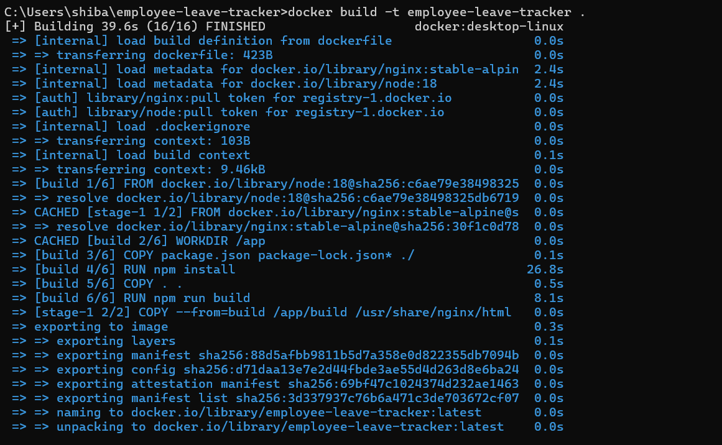

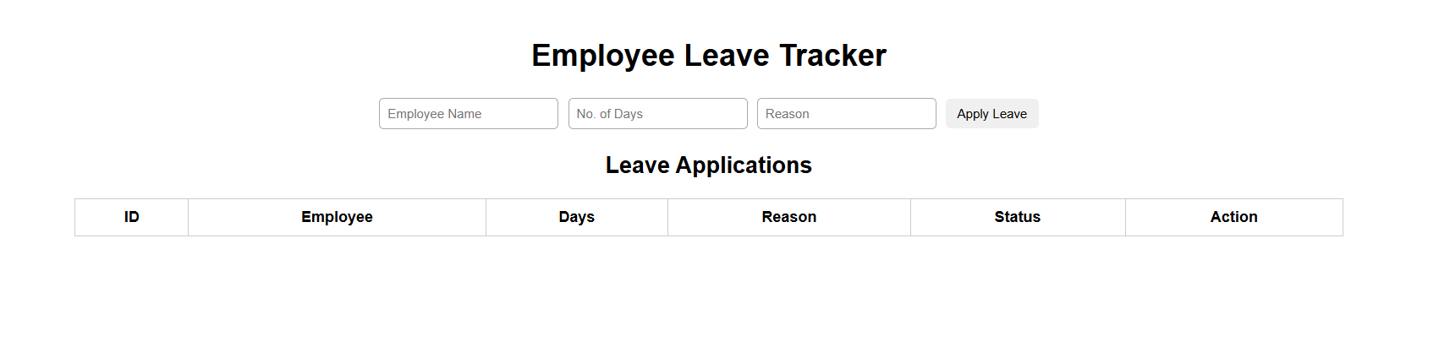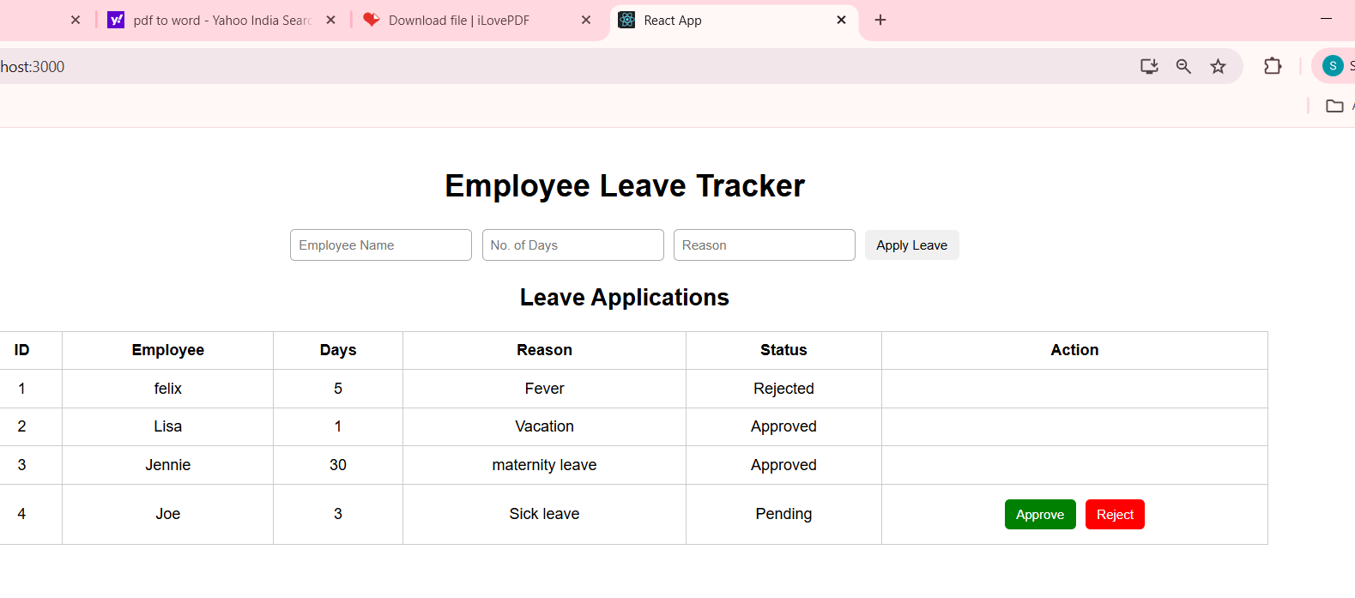

Rubrics:
GitHub commands Syntax & Description (5) | Implementation & Execution (20) | Time management (5) | Viva (10) | Total (40)

Result:
The project successfully demonstrates core Docker operations including container creation ,image management, file transfer , and in-container verification, validating Docker’s efficiency in scalable and portable application deployment.

