1. Virtual Environment creation



2. Activate the virtual Environment



3. Install Flask

Pip install flask

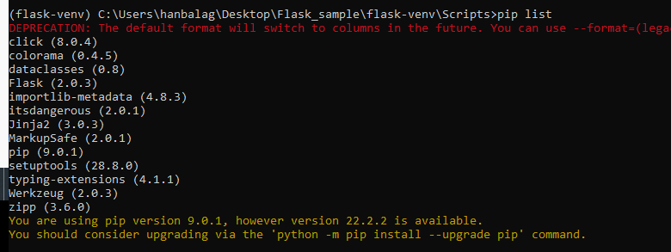

4. Create new app.py

Touch app.py

from flask import Flask

app = Flask(__name__)

@app.route("/")

def hello_world():

    return "<p>Hello, World!</p>"

if __name__ == "__main__":

    app.run(debug=True)

5. To run the app

Python app.py

@app.route("/")

def index():

    return "Hello"

@app.route("/<int:name>")

def greet(name):

    return f"Hello, {name}"

6. To render templates and for forms ,redirect

get 🡪 sending data to client

post 🡪 sending data to server

from flask import Flask, render_template, request, redirect, url_for

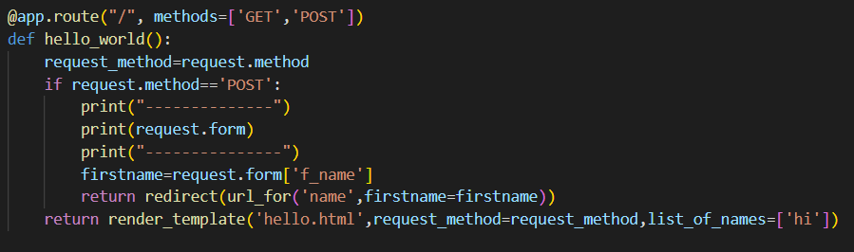

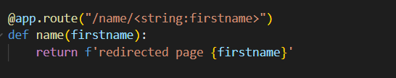

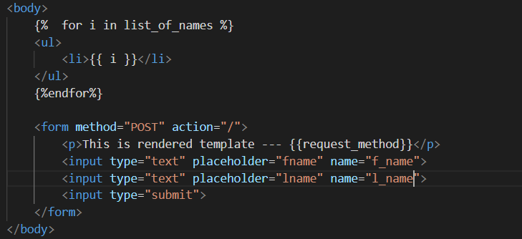

**7. Web forms**

Pip install Flask-WTF

{% extends 'base.html' %}

{% block content%}

    <form method="POST" action="/todo">

        {{form.hidden_tag()}}

        {{form.content}}

        {{form.submit}}

    </form>

{% endblock content%}

from flask_wtf import FlaskForm

from wtforms import TextAreaField,SubmitField

from wtforms.validators import DataRequired

class Todo(FlaskForm):

    content=TextAreaField(validators=[DataRequired()])

    submit=SubmitField('Submit Todo')



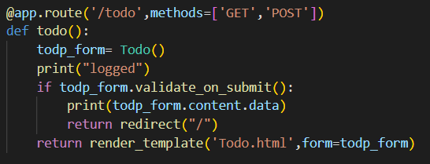

8: **DataBase**

**Pip install Flask-SQLAlchemy**