**EXERCISE – APPENDIX A**

STAFFS

ZON

supervises

comprises

AREA

works

CONTRACTOR

**The following tables are constructed based on the above ER-Diagram**

Table Name: CONTRACTOR

|  |  |  |
| --- | --- | --- |
| **Field Name** | **Field Type** | **Constraint** |
| CONID | NUMBER | Primary Key |
| COMPANYNAME | VARCHAR2(40) |  |
| CONOWNER | VARCHAR2(40) |  |
| CONADDRESS | VARCHAR2(120) |  |
| CONPHONE | VARCHAR2(11) |  |
| CONPRICE | NUMBER |  |

Table Name: STAFFS

|  |  |  |
| --- | --- | --- |
| **Field Name** | **Field Type** | **Constraint** |
| STAFFID | VARCHAR2(6) | Primary Key |
| STAFFNAME | VARCHAR2(40) |  |
| STAFFADDRESS | VARCHAR2(120) |  |
| STAFFPHONE | VARCHAR2(11) |  |
| STAFFMGRID | VARCHAR2(6) |  |
| STAFFZONID | VARCHAR2(1) | Foreign Key (Zon) |

Table Name: CONTRACT_CLASS

|  |  |  |
| --- | --- | --- |
| **Field Name** | **Field Type** | **Constraint** |
| CLASSLEVEL | VARCHAR2(3) | Primary Key |
| MAX_COST | NUMBER |  |
| MIN_COST | NUMBER |  |

Table Name: ZON

|  |  |  |
| --- | --- | --- |
| **Field Name** | **Field Type** | **Constraint** |
| ZONID | VARCHAR2(1) | Primary Key |
| DESCRIPTION | VARCHAR2(10) |  |

Table Name: AREA

|  |  |  |
| --- | --- | --- |
| **Field Name** | **Field Type** | **Constraint** |
| AREAID | VARCHAR2(4) | Primary Key |
| AREANAME | VARCHAR2(40) |  |
| AREA_ZONID | VARCHAR2(1) | Foreign Key (Zon) |
| AREA_TYPE | VARCHAR2(20) |  |
| AREA_COST | NUMBER |  |
| AREA_CONID | NUMBER | Foreign Key (Contractor) |

TABLE NAME: **CONTRACTOR**

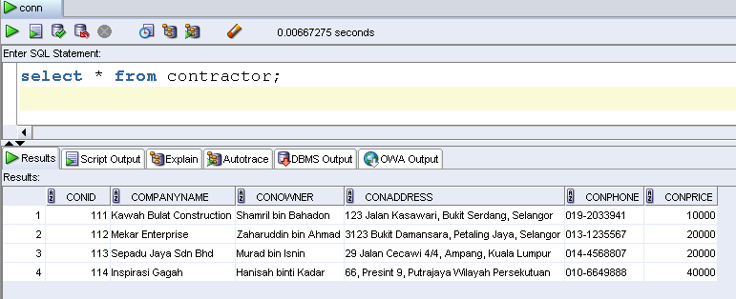

TABLE NAME: **STAFFS**

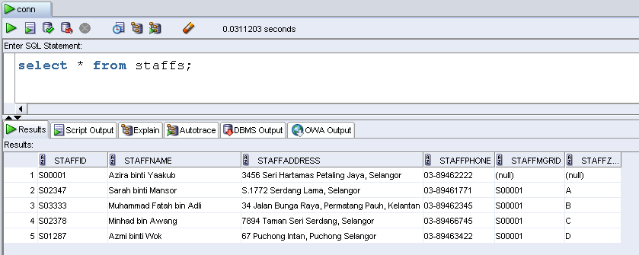

TABLE NAME: **CONTRACTOR_CLASS**

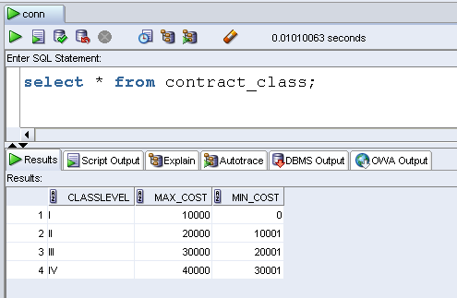

TABLE NAME: **ZON**

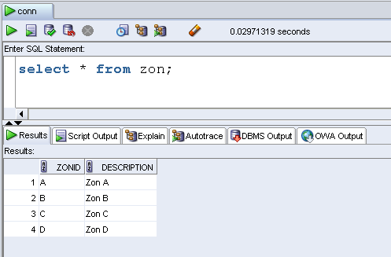

TABLE NAME: **AREA**

