Assignment Wireframe for Appetite for life application

Student Name: | Harit Kumar
Student ID: | 99187408
Course: | BCIT388 Mobile Technology
Assignment: | Practical Assignment 1
Tutor(s): | Dr Bernard Otinpong

Word Count: | If relevant, click or tap here to enter the number of words.
Date: | Friday, 10rd May

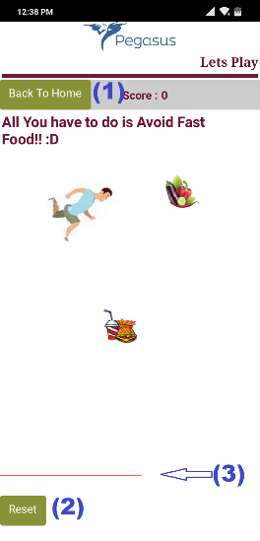
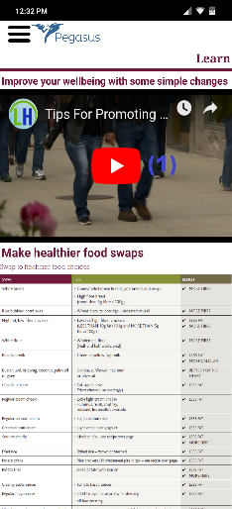
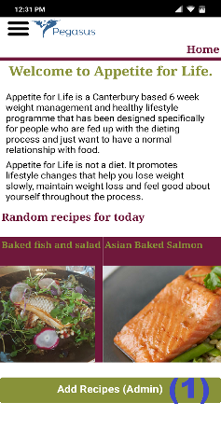
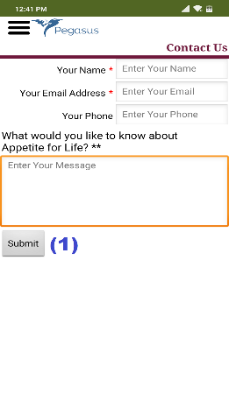
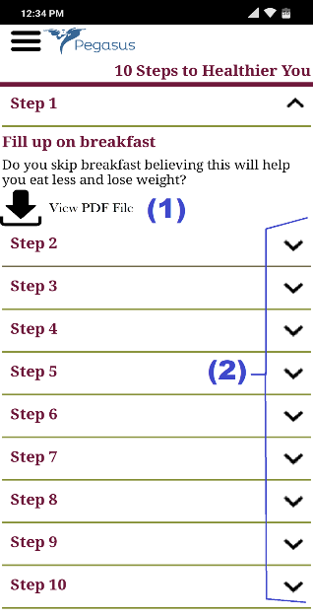
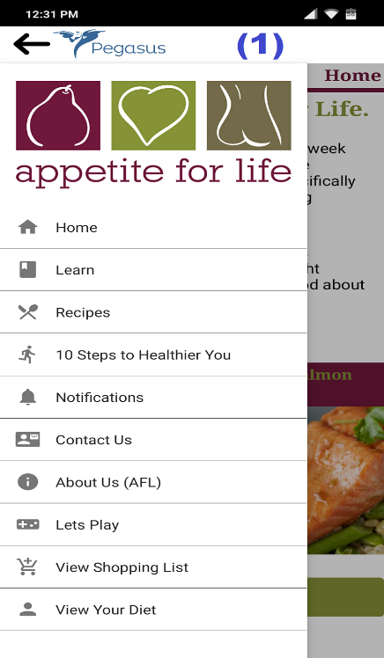
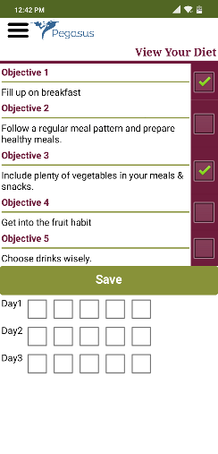
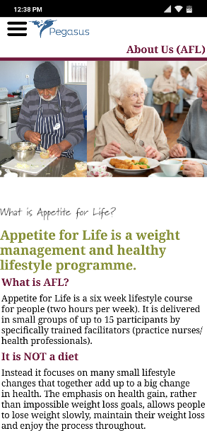
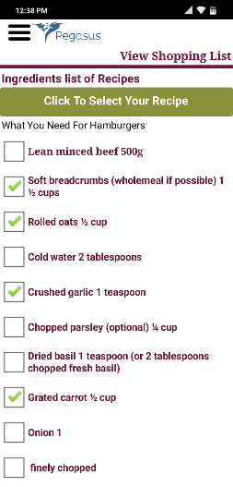

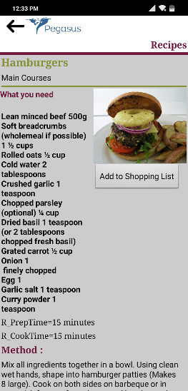
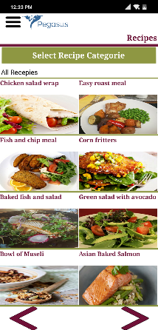

The app starts with Appetite for life logo

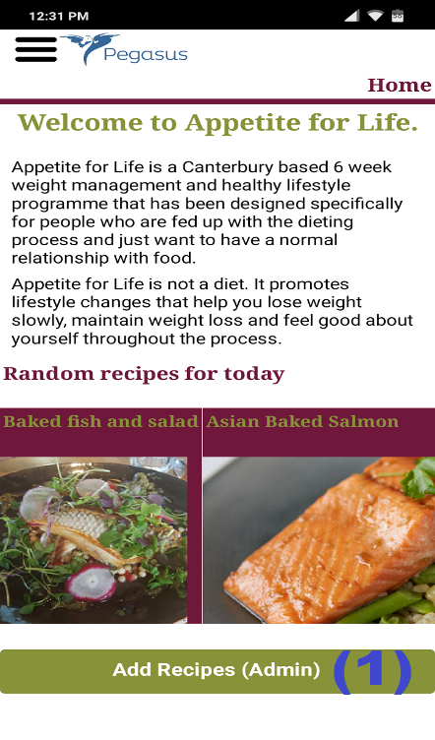
When app opens Home screen shows welcome information.
- – Redirect to Add_recipe screen.
- – hamburger bar icon opens on the sidebar.

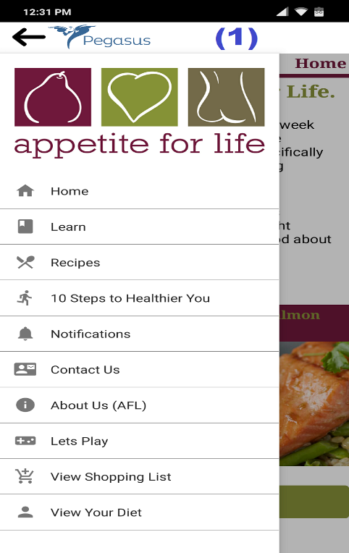
When hamburger icon is pressed
- Home – hide all tabs and make Home tab visible.
- Learn – hide all tabs and make Learn tab visible.
- Recipes – hide all tabs and make Recipes tab visible.
- 10 Steps to Healthier You – hide all tabs and make 10 steps tab visible.
- Notifications – hide all tabs and make Nortification tab visible.
- Contact Us – hide all tabs and make Contactus tab visible.
- About us – hide all tabs and make about us tab visible.
- Let’s Play – Open up the LetsPlay screen
- View Shopping List – hide all tabs and make shopping list tab visible.
- View Diet – hide all tabs and make diet tab visible

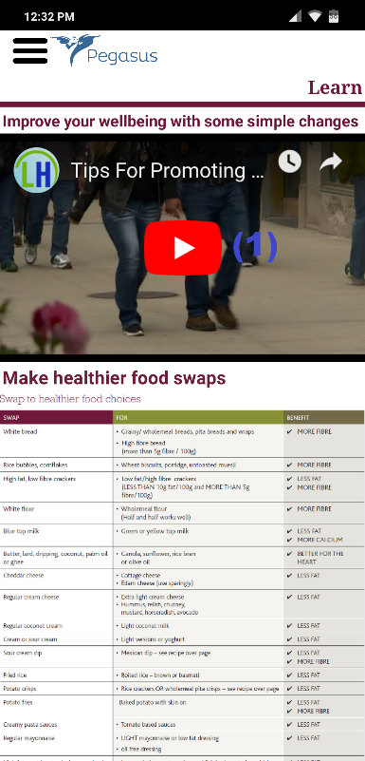
Learn Tab shows Some information’s and embedded video.

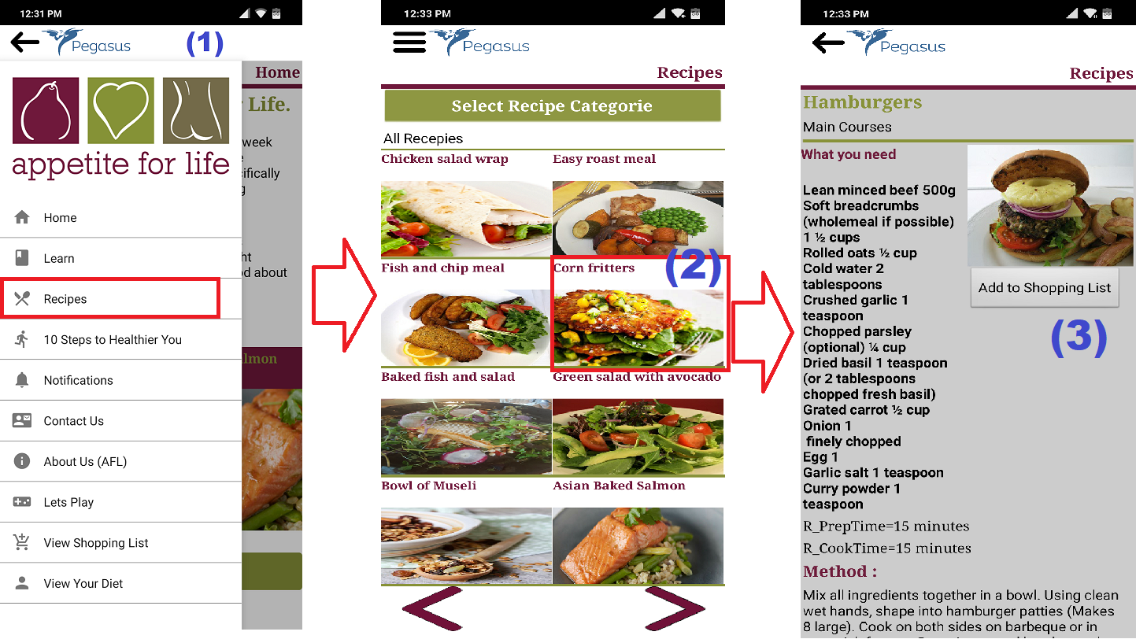

Recipes shows the recipe screen visible and it contain labels and buttons and all data is coming from cloud database. At a time, you can view only 8 Recipes and to view next 8 recipes back and next button is at the bottom.

- Menu – shows sidebar.
- Any Buttons will redirect you to another single recipe screen.
- Add the recipe ingredients to shopping list (can be access from sidebar)
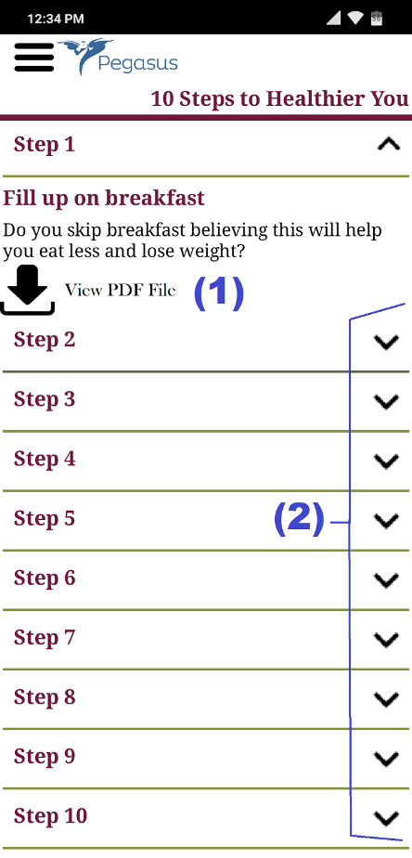
All the 10 steps from appetite for life website in displayed.
- Allows you to download the PDF file.
- All the steps show and hide.

Contact Us
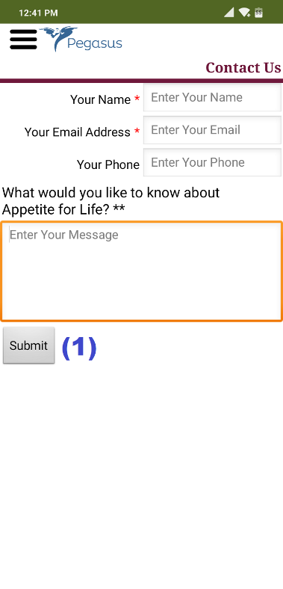
Contact Us view
Empty the text and show message sent alert


About us view shows information from website.

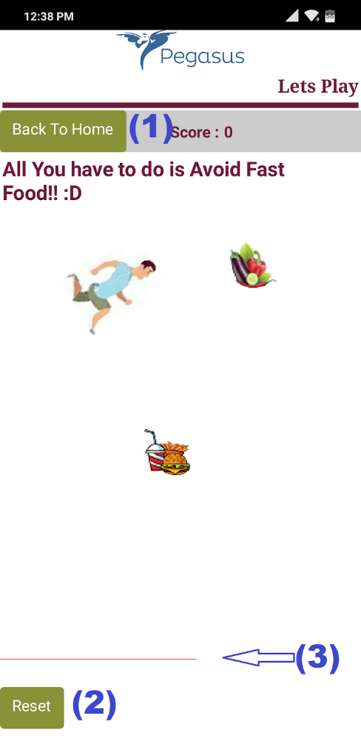
LetsPlay option open the game and redirect the LetsPlay screen.
- Take back to Home screen
- Reset the score and game.
- Show the health bar

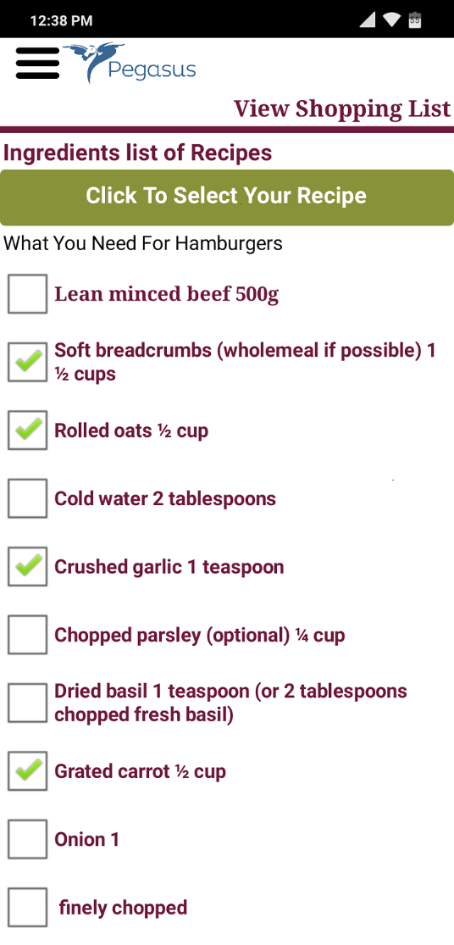
The shopping tab shows the ingredient list.

It has list picker which picks the added recipes ingredients from the Add to shopping list button in singleRecipeView tab.

Check Box if the item is in the inventory.

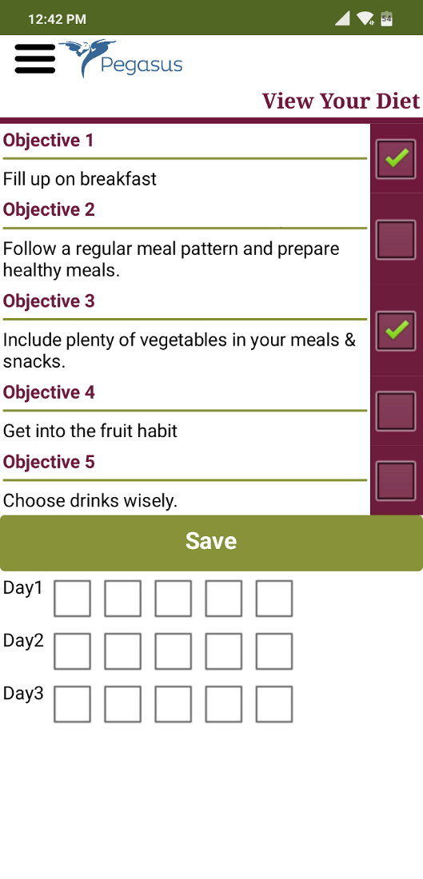
The View diet tab view shows the daily checklist.
The objectives need to be checked manually.
The objective stores into the TinyDb.

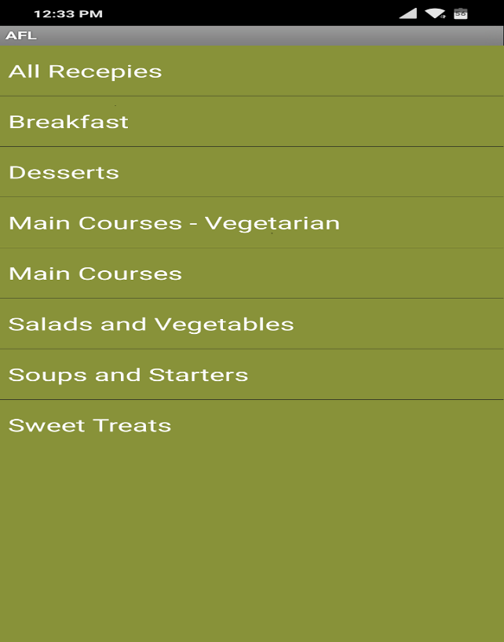
In the Recipe tab shows the a list of category and based on selection it shows the recipes.

