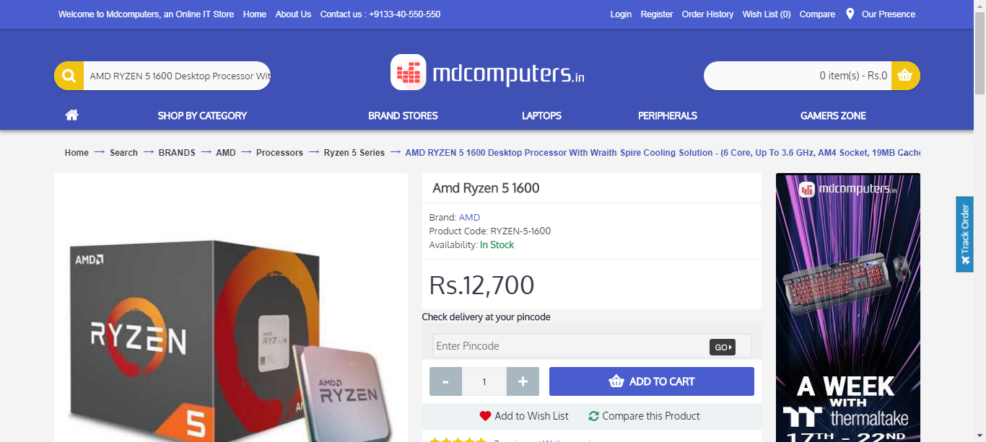  
mdcomputer_processor_20_09_2018_10_07

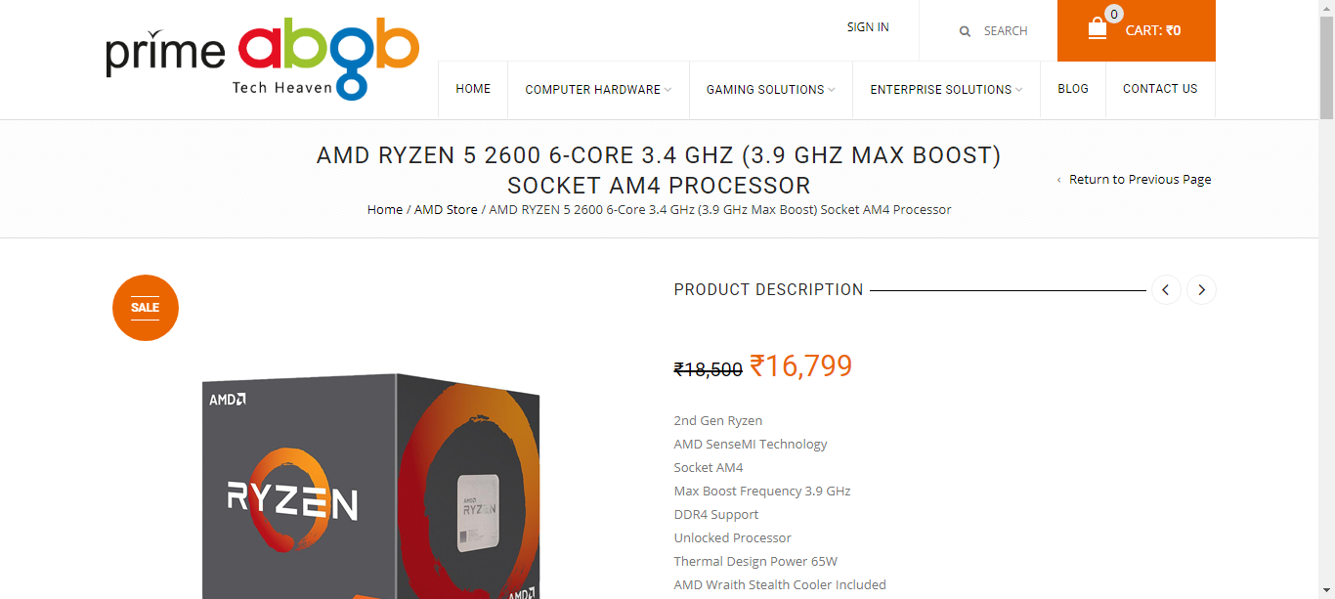  
primebgb_processor_20_09_2018_10_07