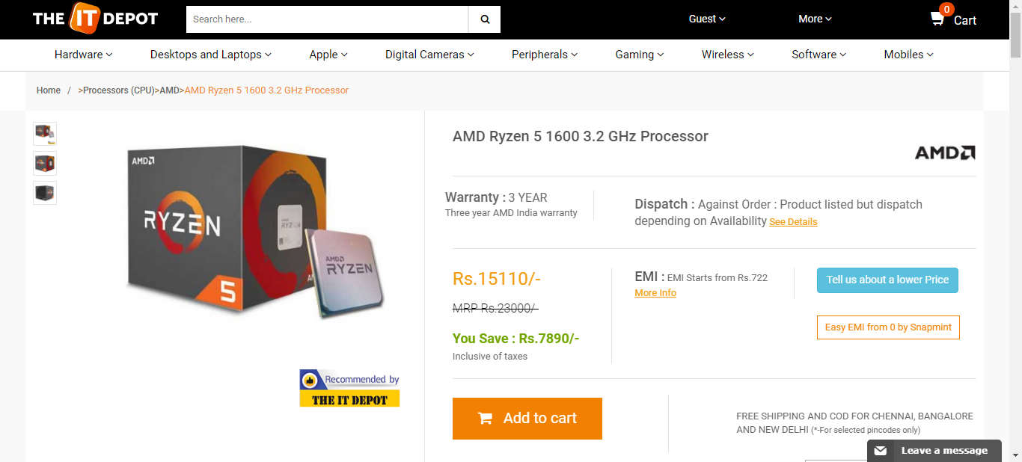  
theitdepot_processor_19_08_2018_09_01