**Implement Software Development and Database Fundamentals Through Agile**

QA to QE: Lab Guide - Phase 1



This section will guide you to:

* Use practice labs for executing all the demos included in this course

This lab has two subsections, namely:

* + 1. Starting practice labs on LMS
    2. Using different IDEs and software required for Phase 1

**Step 1:** Starting practice labs on LMS

* Log in to the Simplilearn LMS
* Navigate to the respective course and click on it
* You will see the course table of contents page on the left side of the screen. Click on **PRACTICE LABS**

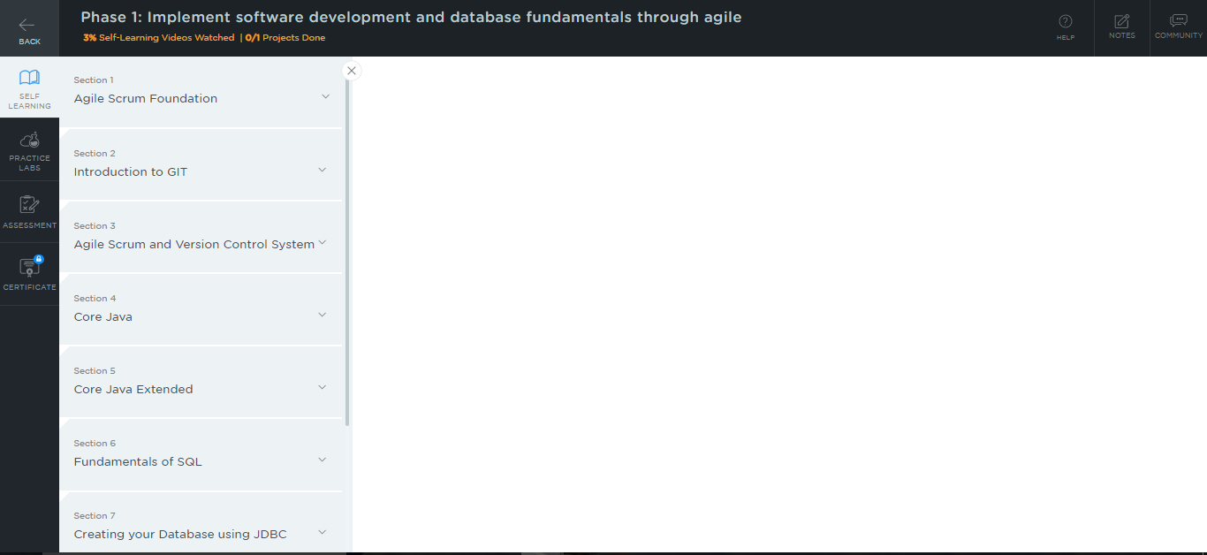

* A new window will open. Read the instructions and click on **LAUNCH LAB.** This will launch the practice labs for this course.

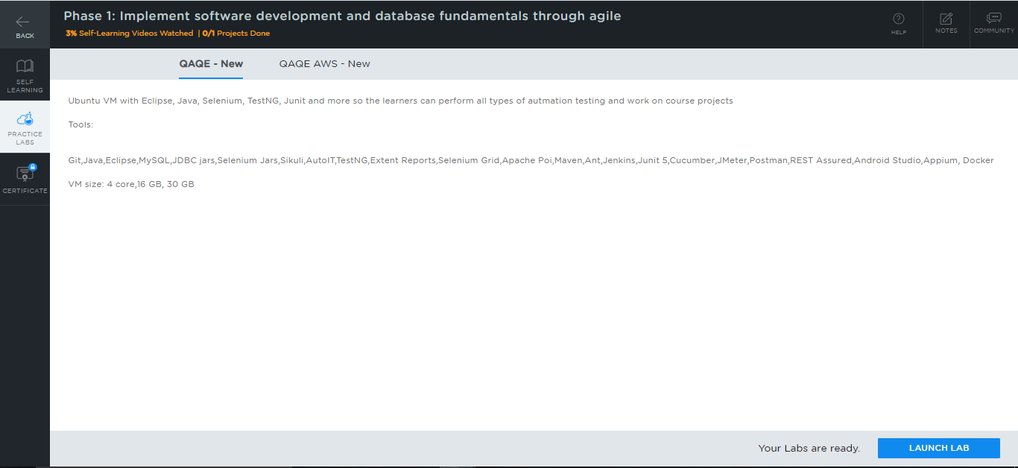

* You will be able to access IDEs and softwares which are present in the labs.

**Step 2:** Using different IDEs and software required for Phase 1

**Phase 1:**

**Git:**

* Git is already installed in the labs.
* To check whether Git is installed properly or not:
  + Create a folder named **Demo_Git** on your desktop and open it
  + Create the files: **index.html** and **helloWorld.java**
  + Open the terminal and navigate to the folder that you have created
  + Execute the following command to initialize .git repository:

*git init*

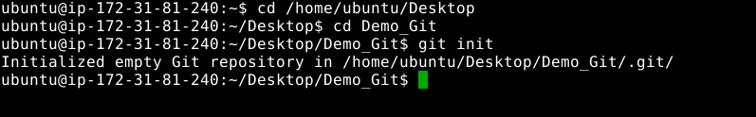

**Java:**

* Java 1.8 is already installed in the labs.
* Open the terminal and type **java -version** to find whether Java is installed or not

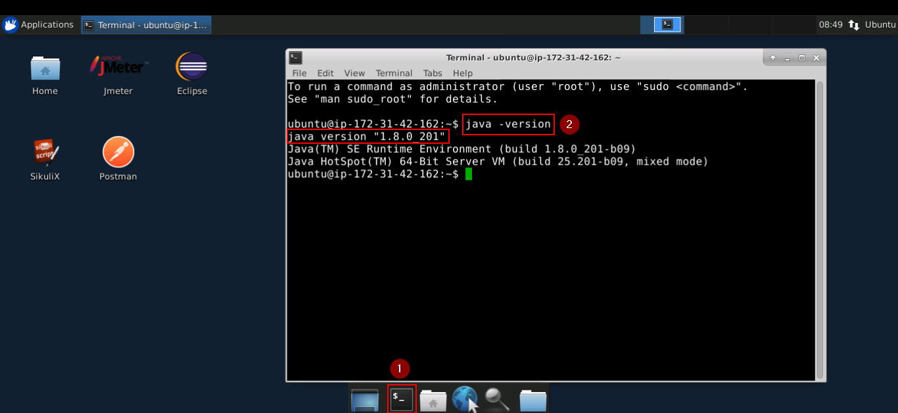

* If Java is not installed in your system, then type the following commands:

*sudo apt-get install openjdk-8-jdk*

*sudo apt-get install openjdk-8-jre*

### **MySQL:**

* To verify the installation:

1. Open the command-line interface
2. Type the command:

*$mysql --version*

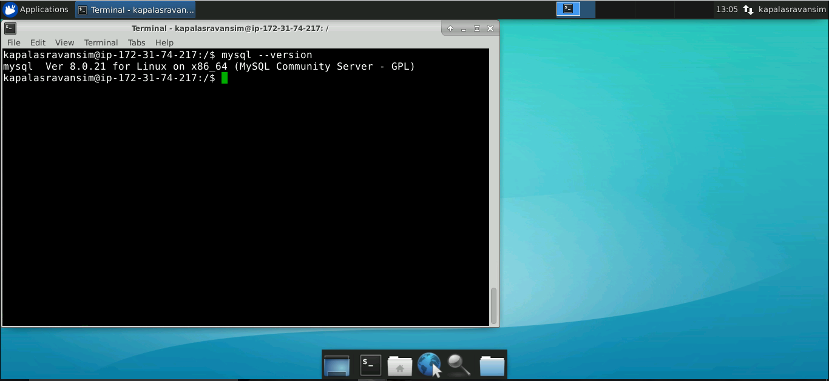

* In case MySQL is not installed in your practice lab, you can install it using the following commands:

*sudo apt-get update*

*sudo apt-get install mysql-server*

**Selenium:**

* You will find Selenium in the directory ***usr/share/selenium***. The same is shown in the screenshot below:

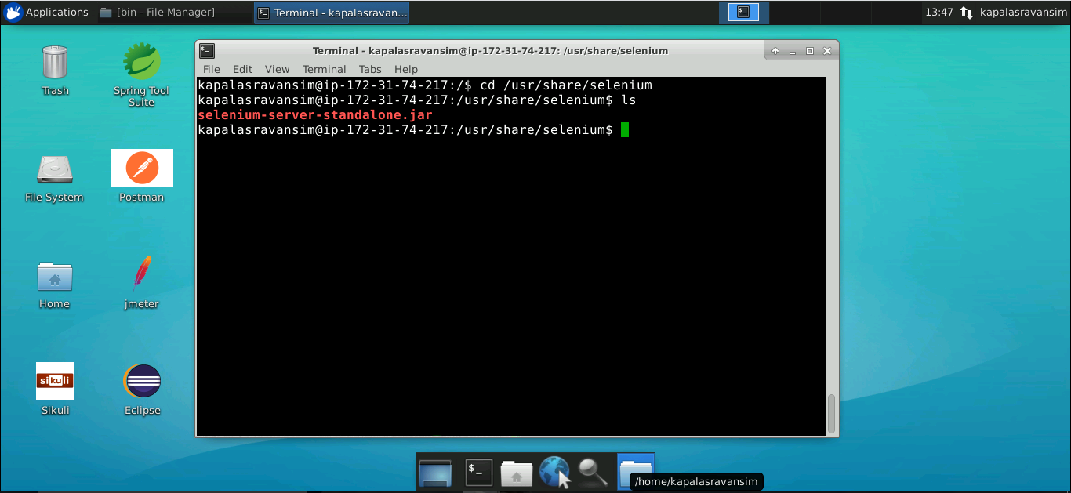

* In case Selenium is not installed in your practice lab, you can install it using the following command:

*sudo npm install selenium-standalone@latest -g*

**Sikuli:**

* You will find Sikuli in the directory **/*opt*/**. The same is shown in the screenshot below:

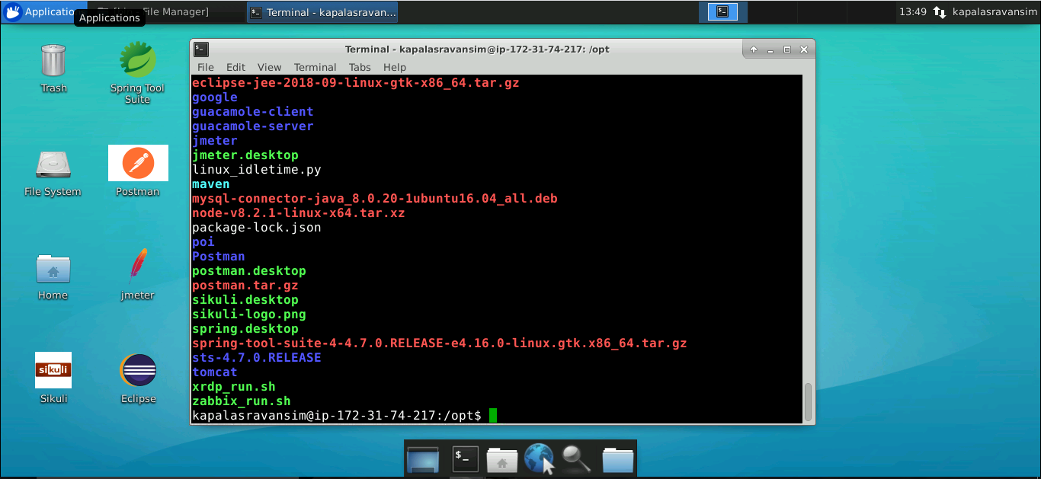

**Eclipse:**

* Double click on the Eclipse icon
* Choose a directory where you want to save your programs. Select the **Use this as the default and do not ask again** checkbox, and then click on **Launch**

