## **CUSTOMER CHURN PREDICTION**

In this data analysis and machine learning project, we aim to predict customer churn, identifying customers likely to discontinue using a service. The entire process involves careful handling of data, exploring patterns, transforming features, and training machine learning models for accurate predictions.

**KEY STEPS:**

1. **Data Loading and Inspection:**

* Loaded customer data from a file into a structured format (DataFrame).
* Checked basic statistics to understand the characteristics of the dataset and identified any missing values.

1. **Noisy Data Handling:**

* Addressed noisy data, such as outliers or irregularities.
* Employed sophisticated techniques like binning, regression, and clustering to enhance data quality.

1. **Missing Values Management:**

* Investigated and managed missing values within the dataset.

1. **Exploratory Data Analysis (EDA):**

* Conducted a comprehensive exploration of the dataset to discern underlying patterns and relationships between different features.

1. **Outlier Detection:**

* Utilized advanced techniques, including the DBSCAN algorithm, to identify and manage outliers effectively.

1. **Model Training and Evaluation:**

* Split the data into training and testing sets for model development.
* Trained three distinct classifiers (Logistic Regression, Random Forest, Gradient Boosting).
* Evaluated each model's performance using key metrics like accuracy, precision, recall, and F1 score.
* Visualized model performance through confusion matrices.

1. **ROC-AUC Curve Analysis:**

Generated ROC-AUC curves to visually assess how well the models differentiate between customers who churn and those who do not.

1. **Data Transformation Techniques:**

Applied various data transformation techniques, including generalization, normalization, and encoding, to optimize data for model learning.

1. **Feature Engineering:**

Utilized techniques for enhanced feature creation.

1. **Dimensionality Reduction and Normalization:**

* Reduced the dimensionality of the data using Principal Component Analysis (PCA).
* Ensured standardized numerical attributes for consistent model input through normalization techniques.

1. **Generalization and Encoding:**

* Derived generalized insights by computing mean balance for different geography groups.
* Encoded categorical features into numerical representations, facilitating model training.

**Summary:**

This comprehensive approach, blending data exploration, feature engineering, and model development, equips us to make informed predictions about customer churn, aiding in strategic decision-making for customer retention. The ROC-AUC curves serve as a visual testament to the models' effectiveness in distinguishing potential churners.

Top of Form

In [1]: !nvidia**-**smi *# this should display information about available GPUs*

Sun Jan 14 18:32:44 2024

+------------------------------------------------------------------------------------

---+

| NVIDIA-SMI 535.104.05 Driver Version: 535.104.05 CUDA Version: 12.2 |

|-----------------------------------------+----------------------+---------------------+

| GPU Name Persistence-M | Bus-Id Disp.A | Volatile Uncorr. E

CC |

| Fan Temp Perf Pwr:Usage/Cap | Memory-Usage | GPU-Util Compute M. |

| | | MIG M. | |=========================================+======================+===================

===| | 0 Tesla T4 Off | 00000000:00:04.0 Off |

0 |

| N/A 47C P8 10W / 70W | 0MiB / 15360MiB | 0% Defau lt |

| | |

N/A |

+-----------------------------------------+----------------------+-------------------

---+

+------------------------------------------------------------------------------------

---+

| Processes:

|

| GPU GI CI PID Type Process name GPU Memo ry |

| ID ID Usage

|

|====================================================================================

===|

| No running processes found |

+------------------------------------------------------------------------------------

---+

In [ ]: !pip install cudf**-**cu12 **--**extra**-**index**-**url**=**https:**//**pypi**.**nvidia**.**com

In [3]: **import** cudf *# this should work without any errors*

In [ ]: !pip install plotly**-**express

# Importing Libraries

|  |
| --- |
| **import** pandas **as** pd **import** numpy **as** np  **import** matplotlib.pyplot **as** plt **import** seaborn **as** sns **from** sklearn.model_selection **import** train_test_split **from** sklearn.linear_model **import** LogisticRegression |

In [5]:

**from** sklearn.ensemble **import** RandomForestClassifier, GradientBoostingClassifier **from** sklearn.metrics **import** accuracy_score, precision_score, recall_score, f1_score, c **from** sklearn.preprocessing **import** StandardScaler **from** sklearn.impute **import** SimpleImputer **from** sklearn.cluster **import** DBSCAN **from** sklearn.decomposition **import** PCA **from** sklearn.preprocessing **import** MinMaxScaler

In [7]: *# Load your dataset*

df **=** pd**.**read_csv("/content/Churn_Modelling.csv")

# Data Preprocessing

**Data Statistics**

In [9]: data_statistics **=** df**.**describe() print(data_statistics)

RowNumber CustomerId CreditScore Age Tenure \ count 10000.00000 1.000000e+04 10000.000000 10000.000000 10000.000000 mean 5000.50000 1.569094e+07 650.528800 38.921800 5.012800 std 2886.89568 7.193619e+04 96.653299 10.487806 2.892174 min 1.00000 1.556570e+07 350.000000 18.000000 0.000000 25% 2500.75000 1.562853e+07 584.000000 32.000000 3.000000

50% 5000.50000 1.569074e+07 652.000000 37.000000 5.000000 75% 7500.25000 1.575323e+07 718.000000 44.000000 7.000000 max 10000.00000 1.581569e+07 850.000000 92.000000 10.000000

Balance NumOfProducts HasCrCard IsActiveMember \ count 10000.000000 10000.000000 10000.00000 10000.000000 mean 76485.889288 1.530200 0.70550 0.515100 std 62397.405202 0.581654 0.45584 0.499797 min 0.000000 1.000000 0.00000 0.000000 25% 0.000000 1.000000 0.00000 0.000000

50% 97198.540000 1.000000 1.00000 1.000000 75% 127644.240000 2.000000 1.00000 1.000000 max 250898.090000 4.000000 1.00000 1.000000

EstimatedSalary Exited count 10000.000000 10000.000000 mean 100090.239881 0.203700 std 57510.492818 0.402769 min 11.580000 0.000000 25% 51002.110000 0.000000

50% 100193.915000 0.000000 75% 149388.247500 0.000000 max 199992.480000 1.000000

In [10]: missing_values **=** df**.**isnull()**.**sum() print(missing_values)

RowNumber 0

CustomerId 0 Surname 0

CreditScore 0

Geography 0

Gender 0 Age 0

Tenure 0

Balance 0

NumOfProducts 0 HasCrCard 0

IsActiveMember 0

EstimatedSalary 0 Exited 0 dtype: int64

In [42]: *# dropping unnecessary columns* drop_cols **=** ['CustomerId','Surname','RowNumber'] df**.**drop(drop_cols, axis**=**1, inplace**=True**) df**.**head()

Out[42]: **CreditScore Geography Gender Age Tenure Balance NumOfProducts HasCrCard IsActiveMem**

**0** 619 France Female 42 2 0.00 1 1

|  |  |  |  |  |  |  |  |  |  |  |  |
| --- | --- | --- | --- | --- | --- | --- | --- | --- | --- | --- | --- |
| **1** |  | 608 | Spain | Female | 41 | 1 | 83807.86 |  | 1 |  | 0 |
| **2** |  | 502 | France | Female | 42 | 8 | 159660.80 |  | 3 |  | 1 |
| **3** |  | 699 | France | Female | 39 | 1 | 0.00 |  | 2 |  | 0 |
| **4** |  | 850 | Spain | Female | 43 | 2 | 125510.82 |  | 1 |  | 1 |

In [43]: print(df['Geography']**.**unique()) df['Geography']**.**value_counts()

|  |  |
| --- | --- |
|  | ['France' 'Spain' 'Germany'] |
| Out[43]: | France 5014 Germany 2509  Spain 2477  Name: Geography, dtype: int64 |

|  |
| --- |
| *# Identify outliers using Interquartile Range (IQR)* **def** detect_outliers_iqr(data, column): Q1 **=** data[column]**.**quantile(0.25)  Q3 **=** data[column]**.**quantile(0.75) IQR **=** Q3 **-** Q1  lower_bound **=** Q1 **-** 1.5 **\*** IQR upper_bound **=** Q3 **+** 1.5 **\*** IQR  outliers **=** data[(data[column] **<** lower_bound) **|** (data[column] **>** upper_bound)] **return** outliers  *# Assume 'Balance' is the column you want to check for outliers* numeric_column **=** 'Balance' outliers **=** detect_outliers_iqr(df, numeric_column) |

In [14]:

*# Display the outliers* print("\nOutliers:") print(outliers)

Outliers:

Empty DataFrame

|  |
| --- |
| **from** sklearn.cluster **import** DBSCAN  **from** sklearn.preprocessing **import** StandardScaler  *# Assuming 'df' is your DataFrame, and you want to use certain columns for clustering* selected_columns **=** ['CreditScore', 'Age', 'Balance', 'NumOfProducts', 'EstimatedSalary  *# Extract the features (X) from the DataFrame* X **=** df[selected_columns]  *# Standardize the features (important for DBSCAN)* scaler **=** StandardScaler()  X_scaled **=** scaler**.**fit_transform(X)  *# Now, you can use X_scaled with DBSCAN* outlier_detector **=** DBSCAN(eps**=**3, min_samples**=**2) outliers **=** outlier_detector**.**fit_predict(X_scaled) print(outliers)  num_outliers **=** len(outliers[outliers **==** **-**1]) print(f"Number of outliers: {num_outliers}") |

Columns: [RowNumber, CustomerId, Surname, CreditScore, Geography, Gender, Age, Tenur e, Balance, NumOfProducts, HasCrCard, IsActiveMember, EstimatedSalary, Exited] Index: [] In [20]:

[0 0 0 ... 0 0 0]

Number of outliers: 0

# Exploratory Data Analysis EDA

In [21]: sns**.**countplot(x**=**'Geography', hue**=**'Exited', data**=**df) plt**.**show()

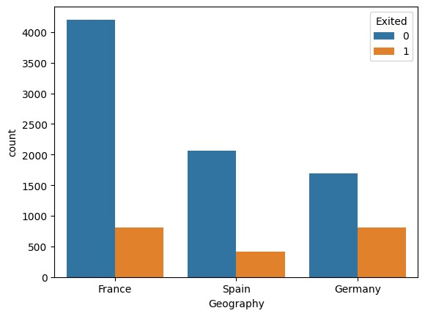

|  |
| --- |
| *# Distribution of the target variable 'Exited'* plt**.**figure(figsize**=**(8, 6)) sns**.**countplot(x**=**'Exited', data**=**df) plt**.**title('Distribution of Exited') plt**.**show() |

In [22]:

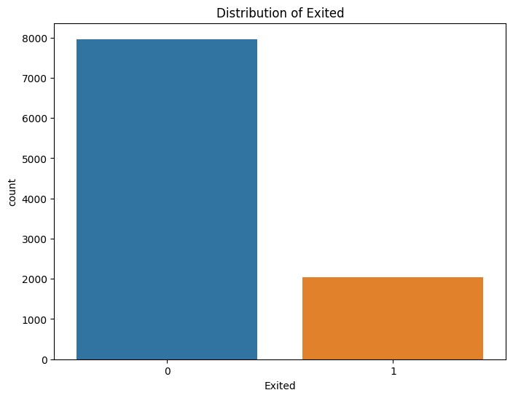

|  |
| --- |
| sns**.**countplot(x**=**'Gender', hue**=**'Exited', data**=**df) plt**.**show() df['Exited']**.**value_counts()**.**plot(kind**=**'bar') plt**.**xlabel('Exited') plt**.**ylabel('Count') plt**.**show() |

In [36]:

|  |
| --- |
| *# Distribution of categorical features* plt**.**figure(figsize**=**(15, 10)) plt**.**subplot(2, 3, 1)  sns**.**countplot(x**=**'Geography', hue**=**'Exited', data**=**df) plt**.**title('Geography vs. Exited') |

In [23]:

Text(0.5, 1.0, 'Geography vs. Exited') Out[23]:

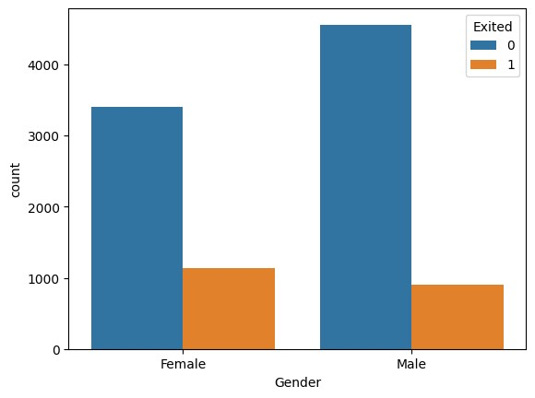

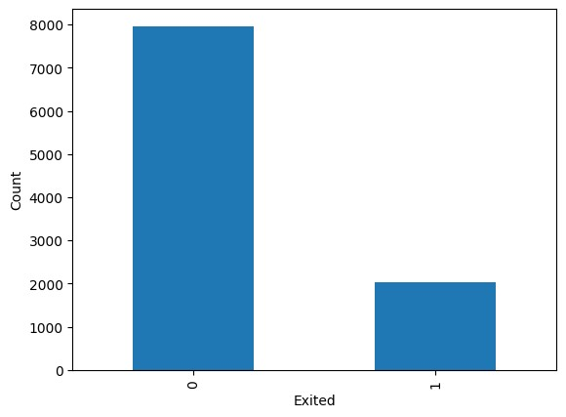

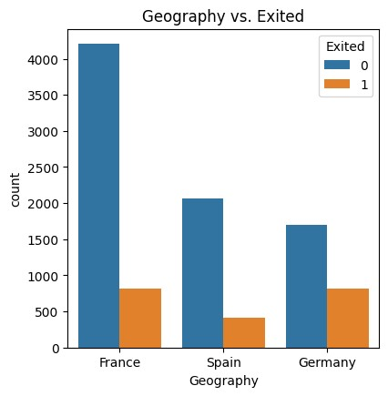

In [24]: plt**.**subplot(2, 3, 2) sns**.**countplot(x**=**'Gender', hue**=**'Exited', data**=**df) plt**.**title('Gender vs. Exited')

Text(0.5, 1.0, 'Gender vs. Exited') Out[24]:

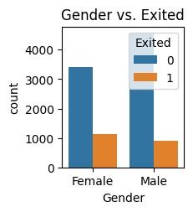

In [25]: plt**.**subplot(2, 3, 3) sns**.**countplot(x**=**'HasCrCard', hue**=**'Exited', data**=**df) plt**.**title('Has Credit Card vs. Exited')

Text(0.5, 1.0, 'Has Credit Card vs. Exited') Out[25]:

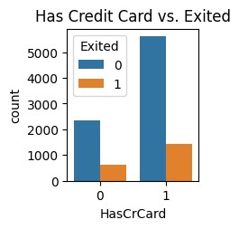

In [26]: plt**.**subplot(2, 3, 4) sns**.**countplot(x**=**'IsActiveMember', hue**=**'Exited', data**=**df) plt**.**title('Active Member vs. Exited')

Text(0.5, 1.0, 'Active Member vs. Exited') Out[26]:

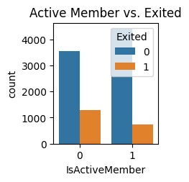

In [27]: plt**.**subplot(2, 3, 4) sns**.**countplot(x**=**'IsActiveMember', hue**=**'Exited', data**=**df) plt**.**title('Active Member vs. Exited')

Text(0.5, 1.0, 'Active Member vs. Exited') Out[27]:



|  |
| --- |
| plt**.**subplot(2, 3, 5)  sns**.**countplot(x**=**'NumOfProducts', hue**=**'Exited', data**=**df) plt**.**title('Number of Products vs. Exited') plt**.**tight_layout() plt**.**show() |

In [29]:

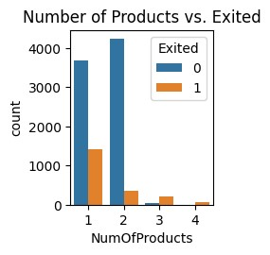

|  |
| --- |
| *# Distribution of numerical features* plt**.**figure(figsize**=**(15, 10)) plt**.**subplot(2, 3, 1) sns**.**histplot(df['Age'], bins**=**30, kde**=True**) plt**.**title('Distribution of Age') |

In [30]:

Text(0.5, 1.0, 'Distribution of Age') Out[30]:

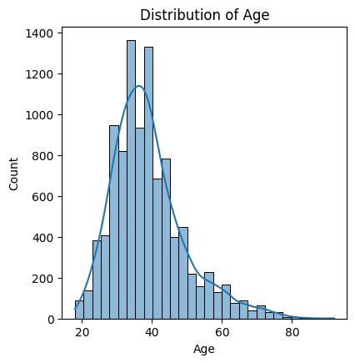

In [31]: plt**.**subplot(2, 3, 2) sns**.**histplot(df['CreditScore'], bins**=**30, kde**=True**) plt**.**title('Distribution of Credit Score')

Text(0.5, 1.0, 'Distribution of Credit Score') Out[31]:

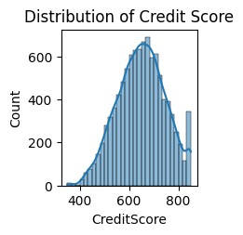

In [32]: plt**.**subplot(2, 3, 3) sns**.**histplot(df['Balance'], bins**=**30, kde**=True**) plt**.**title('Distribution of Balance')

Text(0.5, 1.0, 'Distribution of Balance') Out[32]:

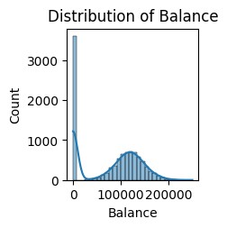

|  |
| --- |
| plt**.**subplot(2, 3, 4)  sns**.**histplot(df['Tenure'], bins**=**10, kde**=True**) plt**.**title('Distribution of Tenure') |

In [33]:

Text(0.5, 1.0, 'Distribution of Tenure') Out[33]:

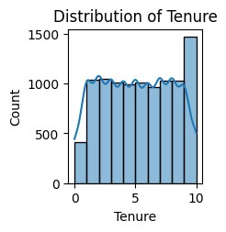

|  |
| --- |
| plt**.**subplot(2, 3, 5) sns**.**histplot(df['EstimatedSalary'], bins**=**30, kde**=True**) plt**.**title('Distribution of Estimated Salary') plt**.**tight_layout() plt**.**show() |

In [34]:

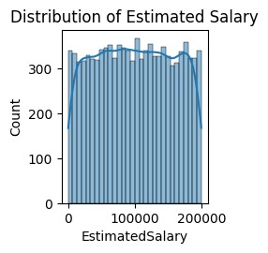

|  |
| --- |
| *# Correlation matrix* plt**.**figure(figsize**=**(10, 8)) sns**.**heatmap(df**.**corr(), annot**=True**, cmap**=**'coolwarm', fmt**=**'.2f') plt**.**title('Correlation Matrix') plt**.**show() |

In [35]:

<ipython-input-35-01f47f28811d>:3: FutureWarning: The default value of numeric_only i n DataFrame.corr is deprecated. In a future version, it will default to False. Select only valid columns or specify the value of numeric_only to silence this warning.

sns.heatmap(df.corr(), annot=True, cmap='coolwarm', fmt='.2f')

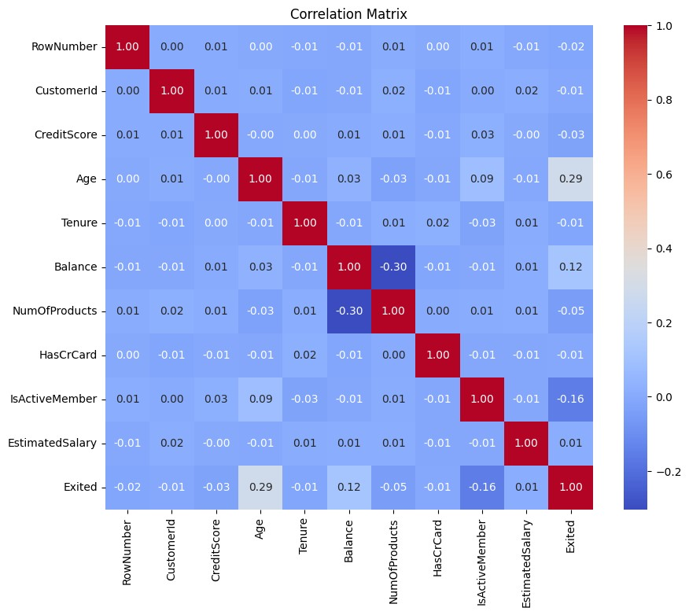

# Data Transformation Techniques

Imagine you have a dataset with information about bank customers, including their gender and the country they are from (categorical features). Machines often find it easier to work with numbers than words, so this code helps convert these categorical features into a numerical format.

The **pd.get_dummies() function** is used to create new columns for each category in the original categorical columns. For instance, it creates columns like 'Gender_Female',

'Gender_Male', 'Geography_France', 'Geography_Germany', 'Geography_Spain', assigning 1 or 0 based on the presence of that category.

Finally, the code reorganizes the columns to have a specific order, and the resulting DataFrame becomes a mix of original and new columns. This transformed dataset is now more suitable for machine learning algorithms that require numerical input. The .head() function is just used to show the first few rows of the transformed dataset for a quick look.

# Encoding Categorical Features

|  |
| --- |
| df **=** pd**.**get_dummies(df, columns**=**['Gender','Geography'])  order **=** ['CreditScore', 'Age', 'Tenure', 'Balance', 'NumOfProducts',  'HasCrCard', 'IsActiveMember', 'EstimatedSalary', 'Gender_Female',  'Gender_Male', 'Geography_France', 'Geography_Germany', 'Geography_Spain', 'Exi df **=** df[order] df**.**head() |

In [44]:

Out[44]: **CreditScore Age Tenure Balance NumOfProducts HasCrCard IsActiveMember EstimatedSalary**

**0** 619 42 2 0.00 1 1 1 101348.88

|  |  |  |  |  |  |  |  |  |  |  |
| --- | --- | --- | --- | --- | --- | --- | --- | --- | --- | --- |
| **1** |  | 608 | 41 |  | 1 | 83807.86 | 1 | 0 | 1 | 112542.58 |
| **2** |  | 502 | 42 |  | 8 | 159660.80 | 3 | 1 | 0 | 113931.57 |
| **3** |  | 699 | 39 |  | 1 | 0.00 | 2 | 0 | 0 | 93826.63 |
| **4** |  | 850 | 43 |  | 2 | 125510.82 | 1 | 1 | 1 | 79084.10 |

|  |  |
| --- | --- |
| X **=** | df**.**drop(columns**=**['Exited']) |
| y **=** | df['Exited'] |
|  |  |
| print(X**.**shape)  y**.**shape | |

In [45]:

In [46]:

(10000, 13)

(10000,) Out[46]:

# Generalization

Imagine you have a big list of customers with their locations and bank balances. This code helps organize this information by regions, like grouping people from the same city or country together.

So, it calculates the average bank balance for each group, creating a summary that's easier to understand. It's like saying, "On average, people in City A have this much money in their bank accounts, people in City B have this much, and so on."

Finally, the code displays this summarized information, making it easier to compare the average bank balances in different regions.

|  |
| --- |
| generalized_data **=** df**.**groupby('Geography')['Balance']**.**mean()**.**reset_index()  *# Display the generalized data* print("\nGeneralized Data:") print(generalized_data) |

In [37]:

Generalized Data:

Geography Balance 0 France 62092.636516

1. Germany 119730.116134
2. Spain 61818.147763

# Normalization

Imagine you have a big list of information about customers, like their credit scores, ages, and more. This code is like organizing and adjusting these details to make them more comparable and easier to understand.

There are two methods used here:

**Min-Max Normalization:** It's like making sure all the numbers fit into a similar scale, so they are easy to compare. Think of it like converting scores from 1 to 100 into a scale from 0 to 1, where 0 is the lowest and 1 is the highest.

**Z-Score Normalization (Standardization):** This is another way of making things comparable. It's like adjusting the numbers to show how far each value is from the average. Imagine everyone's scores being adjusted so that they're like how many 'average' units away from the typical score.

So, the code takes these customer details and transforms them in these two ways, making the information more straightforward and comparable, just like making sure everyone speaks the same language when discussing their details.

In [38]: *# Assuming 'df' is your DataFrame and you want to normalize certain columns* columns_to_normalize **=** ['CreditScore', 'Age', 'Balance', 'NumOfProducts', 'EstimatedSa

In [39]: *# Min-Max Normalization* min_max_scaler **=** MinMaxScaler() df_min_max_normalized **=** df**.**copy() df_min_max_normalized[columns_to_normalize] **=** min_max_scaler**.**fit_transform(df[columns_

|  |
| --- |
| *# Z-Score Normalization (Standardization)* z_score_scaler **=** StandardScaler() df_z_score_normalized **=** df**.**copy()  df_z_score_normalized[columns_to_normalize] **=** z_score_scaler**.**fit_transform(df[columns_ |

In [40]:

In [41]:

# Display the original and normalized DataFrames

print("Original Data:")

print(df[columns_to_normalize]**.**head())

print("\nMin-Max Normalized Data:")

print(df_min_max_normalized[columns_to_normalize]**.**head())

print("\nZ-Score Normalized Data:") print(df_z_score_normalized[columns_to_normalize]**.**head()) Original Data:

CreditScore Age Balance NumOfProducts EstimatedSalary 0 619 42 0.00 1 101348.88

1. 608 41 83807.86 1 112542.58
2. 502 42 159660.80 3 113931.57
3. 699 39 0.00 2 93826.63
4. 850 43 125510.82 1 79084.10

Min-Max Normalized Data:

CreditScore Age Balance NumOfProducts EstimatedSalary 0 0.538 0.324324 0.000000 0.000000 0.506735

1. 0.516 0.310811 0.334031 0.000000 0.562709
2. 0.304 0.324324 0.636357 0.666667 0.569654
3. 0.698 0.283784 0.000000 0.333333 0.469120
4. 1.000 0.337838 0.500246 0.000000 0.395400

Z-Score Normalized Data:

CreditScore Age Balance NumOfProducts EstimatedSalary 0 -0.326221 0.293517 -1.225848 -0.911583 0.021886

1. -0.440036 0.198164 0.117350 -0.911583 0.216534
2. -1.536794 0.293517 1.333053 2.527057 0.240687
3. 0.501521 0.007457 -1.225848 0.807737 -0.108918
4. 2.063884 0.388871 0.785728 -0.911583 -0.365276

In [ ]: print(X**.**shape)

y**.**shape

# Dimensionality Reduction

**Principal Component Analysis**

|  |
| --- |
| *# Assuming 'X' is your feature matrix with the listed columns*  selected_columns **=** ['CreditScore', 'Age', 'Tenure', 'Balance', 'NumOfProducts', 'HasCr  *# Extract the features (X) from the DataFrame* X **=** df[selected_columns]  *# Standardize the features before applying PCA* scaler **=** StandardScaler()  X_standardized **=** scaler**.**fit_transform(X)  *# Apply PCA with 2 components* pca **=** PCA(n_components**=**2)  X_reduced **=** pca**.**fit_transform(X_standardized)  *# Create a DataFrame with the reduced features*  df_reduced **=** pd**.**DataFrame(data**=**X_reduced, columns**=**['Principal Component 1', 'Principal  *# Display the reduced features DataFrame* print("Reduced Features:") print(df_reduced**.**head()) |

In [47]:

Reduced Features:

Principal Component 1 Principal Component 2 0 0.137838 0.977294

1. -0.918809 1.307642
2. 0.873885 -1.150707
3. 1.256769 0.258700
4. -1.246896 1.325233

Imagine you have a lot of information about customers, like their credit score, age, and more. This code is like using magic glasses to simplify and highlight the most important information. It takes all the details about customers and transforms them into just two key things, like the main ingredients in a recipe.

These two things, called 'Principal Components,' capture the essence of the customer information. They are like a summary that keeps the crucial parts but makes everything much simpler. The code prints out these two key components, making it easier to see and understand the main patterns in the customer data. It's like turning a complex story into a short and sweet summary!

# Feature Selection

|  |
| --- |
| **import** pandas **as** pd  **from** sklearn.feature_selection **import** SelectKBest, f_classif **from** sklearn.model_selection **import** train_test_split **from** sklearn.ensemble **import** RandomForestClassifier **from** sklearn.metrics **import** accuracy_score  *# Assuming 'df' is your DataFrame and 'Exited' is the target variable*  X **=** df**.**drop(columns**=**['Exited']) *# Features* y **=** df['Exited'] *# Target*  *# Attribute Subset Selection using SelectKBest* selector **=** SelectKBest(f_classif, k**=**5)  X_selected **=** selector**.**fit_transform(X, y)  *# Get the selected feature names*  selected_feature_names **=** X**.**columns[selector**.**get_support()] print(selected_feature_names) |

In [52]: Index(['Age', 'Balance', 'IsActiveMember', 'Gender_Female',

'Geography_Germany'], dtype='object')

This code is all about finding the most important information from a dataset to help predict whether customers will leave a service or not. Imagine you have a lot of information about customers, like their age, how much money they have, and so on. We want to **figure out which pieces of information (features) are the most helpful in making predictions.**

The code uses a **technique called 'SelectKBest' to choose the top 5 most important features from all the available information**. It's like **selecting the most important ingredients to make a delicious dish**. In this case, the dish is a model (like a smart system) that can predict if a customer will leave the service. The **selected features are the most influential factors that contribute to making accurate predictions**. The code prints out the names of these selected features, so it's easier to understand what information is most important for predicting customer behavior.

**Discretization**

|  |
| --- |
| **from** sklearn.preprocessing **import** KBinsDiscretizer **from** sklearn.model_selection **import** train_test_split **from** sklearn.ensemble **import** RandomForestClassifier **from** sklearn.metrics **import** accuracy_score  *# Assuming 'df' is your DataFrame and 'Exited' is the target variable*  X **=** df**.**drop(columns**=**['Exited']) *# Features* y **=** df['Exited'] *# Target*  *# Discretization using KBinsDiscretizer*  discretizer **=** KBinsDiscretizer(n_bins**=**5, encode**=**'ordinal', strategy**=**'uniform') X_discretized **=** discretizer**.**fit_transform(X)  *# Convert the discretized features back to a DataFrame*  X_discretized_df **=** pd**.**DataFrame(X_discretized, columns**=**X**.**columns)  *# Split the data into train and test sets for model evaluation*  X_train, X_test, y_train, y_test **=** train_test_split(X_discretized_df, y, test_size**=**0.2  *# Train a model using the discretized features*  rf_model **=** RandomForestClassifier(n_estimators**=**100, random_state**=**42) rf_model**.**fit(X_train, y_train)  *# Make predictions on the test set* y_pred **=** rf_model**.**predict(X_test)  *# Evaluate the model*  accuracy **=** accuracy_score(y_test, y_pred) print("Model Accuracy with Discretized Features:", accuracy) |

Model Accuracy with Discretized Features: **0.841**

This code is about training a machine learning model to predict whether customers will exit a service or not. The features used for prediction are first divided into five different intervals using a technique called discretization. Imagine sorting these features into five bins like sorting items into different shelves based on their size. Then, a model, specifically a RandomForest, is trained using these discretized features. This trained model is like a smart assistant that learns patterns from the past behavior of customers.

After the model is trained, it is tested on a set of data it has never seen before (like a final exam). The accuracy of the model, which indicates how well it predicts whether customers will exit or not, is then printed out. In simpler terms, this code is a part of building a smart system to predict if customers are likely to leave a service based on their behavior. The better the accuracy, the smarter and more reliable the system is at making predictions.

# Model Training

**Data Validation**

|  |
| --- |
| *# Model Training* lg **=** LogisticRegression()  rf **=** RandomForestClassifier(n_estimators**=**50, random_state**=**2) gb **=** GradientBoostingClassifier(n_estimators**=**50, random_state**=**2) |

|  |
| --- |
| clfs **=** { 'lg': lg,  'rf': rf, 'gb': gb  }  **def** train_clfs_and_predict(clfs, X_train, X_test, y_train, y_test):  acc **=** [] prec **=** [] recall **=** [] f1 **=** [] conf_mat **=** []  **for** clf **in** clfs:  model **=** clfs[clf] model**.**fit(X_train, y_train) y_pred **=** model**.**predict(X_test)  acc**.**append(accuracy_score(y_test, y_pred)) prec**.**append(precision_score(y_test, y_pred)) recall**.**append(recall_score(y_test, y_pred)) f1**.**append(f1_score(y_test, y_pred))  conf_mat**.**append(confusion_matrix(y_test, y_pred)) **return** acc, prec, recall, f1, conf_mat |

In [55]: X_train, X_test, y_train, y_test **=** train_test_split(X, y, test_size**=**0.2, random_state**=** In [56]: In [57]:

This code defines a few machine learning models (**logistic regression, random forest, and gradient boost**) and puts them into a **dictionary called clfs**. Then, there's a **function called train_clfs_and_predict that trains these models on a training dataset (X_train, y_train)** and **evaluates their performance on a testing dataset (X_test, y_test)**. It **computes and collects various metrics such as accuracy, precision, recall, F1 score, and confusion matrix for each model**. These **metrics help understand how well the models are making predictions and are crucial for comparing and selecting the best-performing model**. Overall, this code is part of the process to assess and choose the most effective machine learning model for a specific task.

In [58]: accuracy, precision, recall, f1, conf_mat **=** train_clfs_and_predict(clfs, X_train, X_te

performance **=** {

'classifiers': list(clfs**.**keys()),

'accuracy': accuracy,

'precision': precision,

'recall': recall,

'f1_score': f1,

'confusion_matrix': conf_mat,

|  |
| --- |
| **from** sklearn.metrics **import** roc_curve, auc **import** matplotlib.pyplot **as** plt  **from** sklearn.preprocessing **import** label_binarize **from** sklearn.multiclass **import** OneVsRestClassifier  *# Binarize the labels if you have a multi-class classification problem*  y_bin **=** label_binarize(y_test, classes**=**[0, 1, 2]) *# Adjust the classes based on your*  *# Initialize a figure for the ROC-AUC curves* plt**.**figure(figsize**=**(10, 8))  *# For each classifier, calculate ROC curve and AUC* **for** i, classifier **in** enumerate(perf_df['classifiers']):  model **=** clfs[classifier]  y_score **=** model**.**predict_proba(X_test)[:, 1]  *# Compute ROC curve and ROC area*  fpr, tpr, _ **=** roc_curve(y_bin[:, 1], y_score) roc_auc **=** auc(fpr, tpr)  *# Plot ROC curve*  plt**.**plot(fpr, tpr, label**=**f'{classifier} (AUC = {roc_auc:.2f})')  *# Plot the random guessing line*  plt**.**plot([0, 1], [0, 1], color**=**'navy', linestyle**=**'--')  *# Set labels and title*  plt**.**xlabel('False Positive Rate') plt**.**ylabel('True Positive Rate')  plt**.**title('Receiver Operating Characteristic (ROC) Curve') plt**.**legend(loc**=**'lower right') plt**.**show() |

} perf_df **=** pd**.**DataFrame(performance)**.**sort_values(by**=**'accuracy', ascending**=False**)

# ROC-AUC Curve

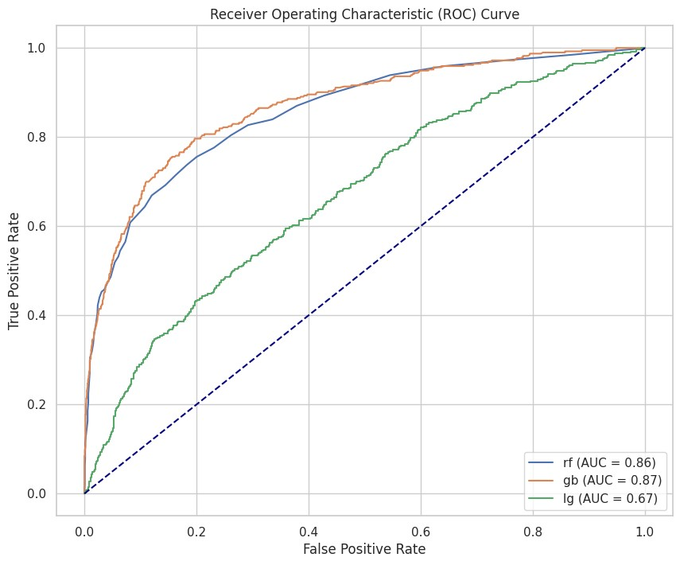

|  |
| --- |
| *# Plotting confusion matrices of classifiers* num_classifiers **=** len(conf_mat) fig, axes **=** plt**.**subplots(1, num_classifiers, figsize**=**(20, 5))  **for** i, (matrix, classifier) **in** enumerate(zip(conf_mat, list(clfs**.**keys()))):  sns**.**set(font_scale**=**1)  sns**.**heatmap(matrix, annot**=True**, fmt**=**"d", cmap**=**"Blues",  xticklabels**=**["Predicted Negative", "Predicted Positive"], yticklabels**=**["Actual Negative", "Actual Positive"], ax**=**axes[i])  axes[i]**.**set_title(f"Confusion Matrix for {classifier}") axes[i]**.**set_xlabel("Predicted Label") axes[i]**.**set_ylabel("True Label")  *# Comparison graph of accuracy scores* sns**.**set(style**=**"whitegrid")  sns**.**barplot(x**=**perf_df**.**classifiers, y**=**perf_df**.**accuracy, palette**=**"viridis") plt**.**title("Comparison of Accuracy Scores by Classifiers") plt**.**xlabel("Classifiers") plt**.**ylabel("Accuracy Score") plt**.**show() |

In [59]:

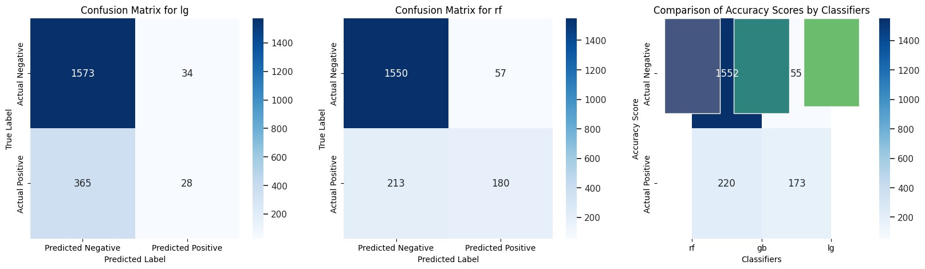

**This code creates two visualizations to assess the performance of different machine learning models. The first set of visualizations consists of confusion matrices for each model. A confusion matrix helps to understand how well a model is at predicting positive and negative outcomes. The second visualization is a bar plot comparing the accuracy scores of various models. Each bar represents the accuracy of a specific model, indicating how often the model's predictions are correct. These visualizations offer a clear and concise way to evaluate and compare the effectiveness of different machine learning classifiers.**

|  |
| --- |
| Models **=** ['LogisticRegression', 'DecisionTree', 'RandomForest', 'KNeighbors', 'Gaussia scores **=** accuracy *# Replace with your actual accuracy scores* fig, ax **=** plt**.**subplots() x **=** np**.**arange(len(Models))  *# Use the minimum length between Models and scores* min_length **=** min(len(Models), len(scores))  ax**.**bar(x[:min_length], scores[:min_length], width**=**0.2) ax**.**set_xticks(x[:min_length]) ax**.**set_xticklabels(Models[:min_length]) ax**.**set_xlabel('Models') ax**.**set_ylabel('Accuracy Score')  ax**.**set_ylim(0, 1.0) *# Adjust the y-axis limit based on your data range*  **for** index, value **in** enumerate(scores[:min_length]): plt**.**text(x**=**index, y**=**value **+** 0.01, s**=**str(round(value, 5)), ha**=**'center')  plt**.**tight_layout() plt**.**show() |

In [70]:

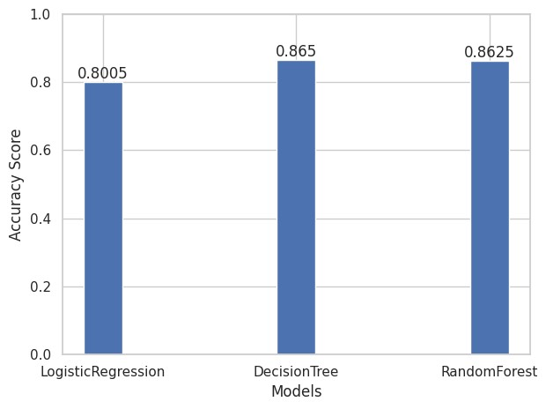

**The code creates a visual representation of the performance of different machine learning models. The models include Logistic Regression, Decision Tree, Random Forest, K-Nearest Neighbors, and Gaussian Naive Bayes. Each bar in the plot represents the accuracy score of a specific model, showing how well each model performed in terms of making correct predictions. The higher the bar, the better the model accuracy. This type of visualization helps in easily comparing and understanding which machine learning model is more effective for a given task.**