Flipkart.java

package com.suite1;

import java.util.concurrent.TimeUnit;

import org.openqa.selenium.Alert;

import org.openqa.selenium.By;

import org.openqa.selenium.WebDriver;

import org.openqa.selenium.WebElement;

import org.openqa.selenium.firefox.FirefoxDriver;

import org.openqa.selenium.interactions.Actions;

import org.testng.annotations.AfterClass;

import org.testng.annotations.BeforeClass;

import org.testng.annotations.Test;

public class Flipkart{

WebDriver driver = new FirefoxDriver();

String username = ""; // Change to your username and passwrod

String password = "";

// This method is to navigate flipkart URL

@BeforeClass

public void init() {

driver.manage().window().maximize();

driver.manage().timeouts().implicitlyWait(60, TimeUnit.SECONDS);

driver.navigate().to("https://www.flipkart.com");

}

// To log in flipkart

@Test

public void login() {

driver.findElement(By.partialLinkText("Login")).click();

driver.findElement(

By.cssSelector(".fk-input.login-form-input.user-email"))

.sendKeys(username);

driver.findElement(

By.cssSelector(".fk-input.login-form-input.user-pwd"))

.sendKeys(password);

driver.findElement(By.cssSelector(".submit-btn.login-btn.btn")).click();

}

// Search For product

@Test

public void searchAndSelectProduct() {

driver.findElement(By.id("fk-top-search-box")).sendKeys("moto g3");

driver.findElement(

By.cssSelector("search-bar-submit.fk-font-13.fk-font-bold"))

.click();

// select the first item in the search results

String css = ".gd-row.browse-grid-row:nth-of-type(1) > div:nth-child(1)>div>div:nth-child(2)>div>a";

driver.findElement(By.cssSelector(css)).click();

}

@Test

public void buyAndRemoveFromCart() {

driver.findElement(

By.cssSelector(".btn-express-checkout.btn-big.current"))

.click();

driver.findElement(By.cssSelector(".remove.fk-inline-block")).click();

Alert a = driver.switchTo().alert();

a.accept();

}

@Test

public void logout() {

Actions s = new Actions(driver);

WebElement user = driver.findElement(By.partialLinkText(username));

s.moveToElement(user).build().perform();

driver.findElement(By.linkText("Logout")).click();

}

@AfterClass

public void quit() {

driver.close();

}

}

SnapDeal.java

package com.suite2;

import java.util.concurrent.TimeUnit;

import org.openqa.selenium.Alert;

import org.openqa.selenium.By;

import org.openqa.selenium.WebDriver;

import org.openqa.selenium.WebElement;

import org.openqa.selenium.firefox.FirefoxDriver;

import org.openqa.selenium.interactions.Actions;

import org.testng.annotations.AfterClass;

import org.testng.annotations.BeforeClass;

import org.testng.annotations.Test;

public class SnapDeal {

WebDriver driver = new FirefoxDriver();

String username = ""; // Change to your username and passwrod

String password = "";

String pinCode = "";

// This method is to navigate flipkart URL

@BeforeClass

public void init() {

driver.manage().window().maximize();

driver.manage().timeouts().implicitlyWait(60, TimeUnit.SECONDS);

driver.navigate().to("https://www.snapdeal.com");

}

// To log in flipkart

@Test

public void login() {

driver.findElement(By.xpath("//button[text()='Login']")).click();

driver.switchTo().frame("loginIframe");

driver.findElement(By.cssSelector("div[onClick='getLoginForm()']"))

.click();

driver.findElement(By.id("j_username")).sendKeys(username);

driver.findElement(By.id("j_password_login")).sendKeys(password);

driver.findElement(By.id("signin_submit")).click();

driver.switchTo().defaultContent();

}

// Search For product

@Test

public void searchAndSelectProduct() {

driver.findElement(By.cssSelector(".col-xs-20.searchformInput.keyword"))

.sendKeys("iphone 6s");

driver.findElement(By.cssSelector(".sd-icon.sd-icon-search")).click();

// select the first item in the search results

String css = ".product_grid_row:nth-of-type(1)>div:nth-child(1)";

driver.findElement(By.cssSelector(css)).click();

}

@Test

public void buyAndRemoveFromCart() {

driver.findElement(By.xpath("//li[contains(text(),'Silver')]")).click();

driver.findElement(By.id("pincode-check")).sendKeys(pinCode);

driver.findElement(By.id("buy-button-id")).click();

driver.findElement(By.cssSelector("i[title='Delete Item']")).click();

Alert a = driver.switchTo().alert();

a.accept();

}

@Test

public void logout() {

driver.findElement(By.linkText("START SHOPPING NOW")).click();

Actions s = new Actions(driver);

WebElement user = driver.findElement(By.cssSelector(".sd-icon.sd-icon-user"));

s.moveToElement(user).build().perform();

driver.findElement(By.linkText("Logout")).click();

}

@AfterClass

public void quit() {

driver.close();

}

}

TestNg.xml

<!DOCTYPE suite SYSTEM "http://testng.org/testng-1.0.dtd">

<suite thread-count="1" verbose="1" name="Gmail Suite" annotations="JDK" parallel="tests">

<test name="flipkart">

<classes>

<class name="com.suite1.Flipkart"/>

</classes>

</test>

<test name="Myntra">

<classes>

<class name="com.suite2.SnapDeal"/>

</classes>

</test>

</suite>

Final project structure looks like below,

[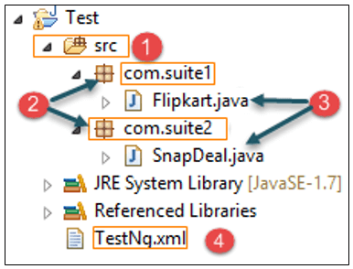](https://cdn.guru99.com/images/jsp/030116_0948_TestNGExecu1.png)

**Parallel execution in TestNG**

After creating xml file as shown above, in next step, we will execute the parallel test. Below is the code.

[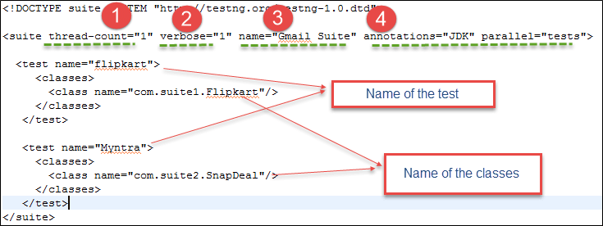](https://cdn.guru99.com/images/jsp/030116_0948_TestNGExecu2.png)

**1)** **thread-count**: This is used for parallel execution, based on the number script. It will execute in parallel or sequential order.

**2)** **verbose**: It is used to log the execution details in the console. The value should be 1-10. The log details in the console window will get more detailed and clearer as you increase the value of the verbose attribute in the testng.xml configuration file.

**3)** **name**: Name of the suite. Here it is "Gmail Suite"

**4)** **Parallel**: To run scripts parallel, value can be tests/classes/methods/suites. Default value is **none**

Right click on the testing.xml and select run as testing, once successful you'll see all the results

When you execute the above code, you will get the following output.

**Output:**

[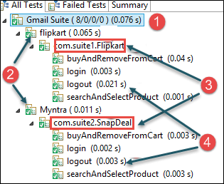](https://cdn.guru99.com/images/jsp/030116_0948_TestNGExecu3.png)

1 name of the suite given in testng.xml

[TestNG: Execute multiple Test Suites](https://cdn.guru99.com/images/jsp/030116_0948_TestNGExecu4.png)

2 name of the test given in testng.xml

[TestNG: Execute multiple Test Suites](https://cdn.guru99.com/images/jsp/030116_0948_TestNGExecu5.png)

3 name of the class given in testng.xml

[TestNG: Execute multiple Test Suites](https://cdn.guru99.com/images/jsp/030116_0948_TestNGExecu6.png)

4 method names annotated with @Test in .java file

[TestNG: Execute multiple Test Suites](https://cdn.guru99.com/images/jsp/030116_0948_TestNGExecu7.png)

Likewise, it will execute test suite for snap deal as well.

**Conclusion:**

Here we have seen how to use[Testng](https://www.guru99.com/all-about-testng-and-selenium.html)to execute parallel test. TestNG gives an option to execute multiple test in parallel in a single configuration file (XML).

* [Prev](https://www.guru99.com/test-case-priority-testng.html" \o "TestNG Priority in Test Cases)