|  |  |
| --- | --- |
| **Logo_Baru-Rasmi_UUM_02** | STIW2044: Mobile Programming Semester A201School of Computing, CAS, UUM |
| Lab 1 | |
| Date given: 24/10/2020  Submission date :**28/10/2020** | |

Instruction:

Develop a mobile application for **Lean Body Mass (Metric Unit)** Calculator based from the following web application: <https://www.calculator.net/lean-body-mass-calculator.html>.

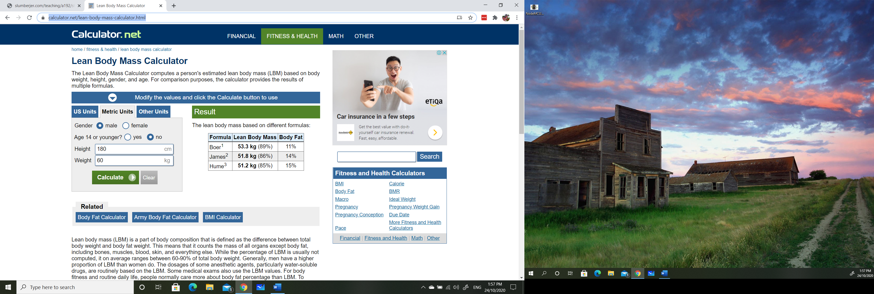

Submission:

1. Your document should have the following content:
   1. Interface screen shot
      1. input
      2. output
2. Screen record your app to show how the app function and upload to YouTube. Short video less than 5 minutes video.
3. Upload your document to: <http://slumberjer.com/teaching/a201/stiw2044/upload/>

Fill all the required information correctly.

Rubric will be based on the following:

* Interface Design (evaluation based on youtube video + Interface screen shot
* Flutter code – Github link
* Output - (evaluation based on youtube video + Interface screen shot)

**Late submission will be not accepted and will not be tolerated and given 0.**