**Assignment – 1**

1. Install Power BI Desktop and share report view page.

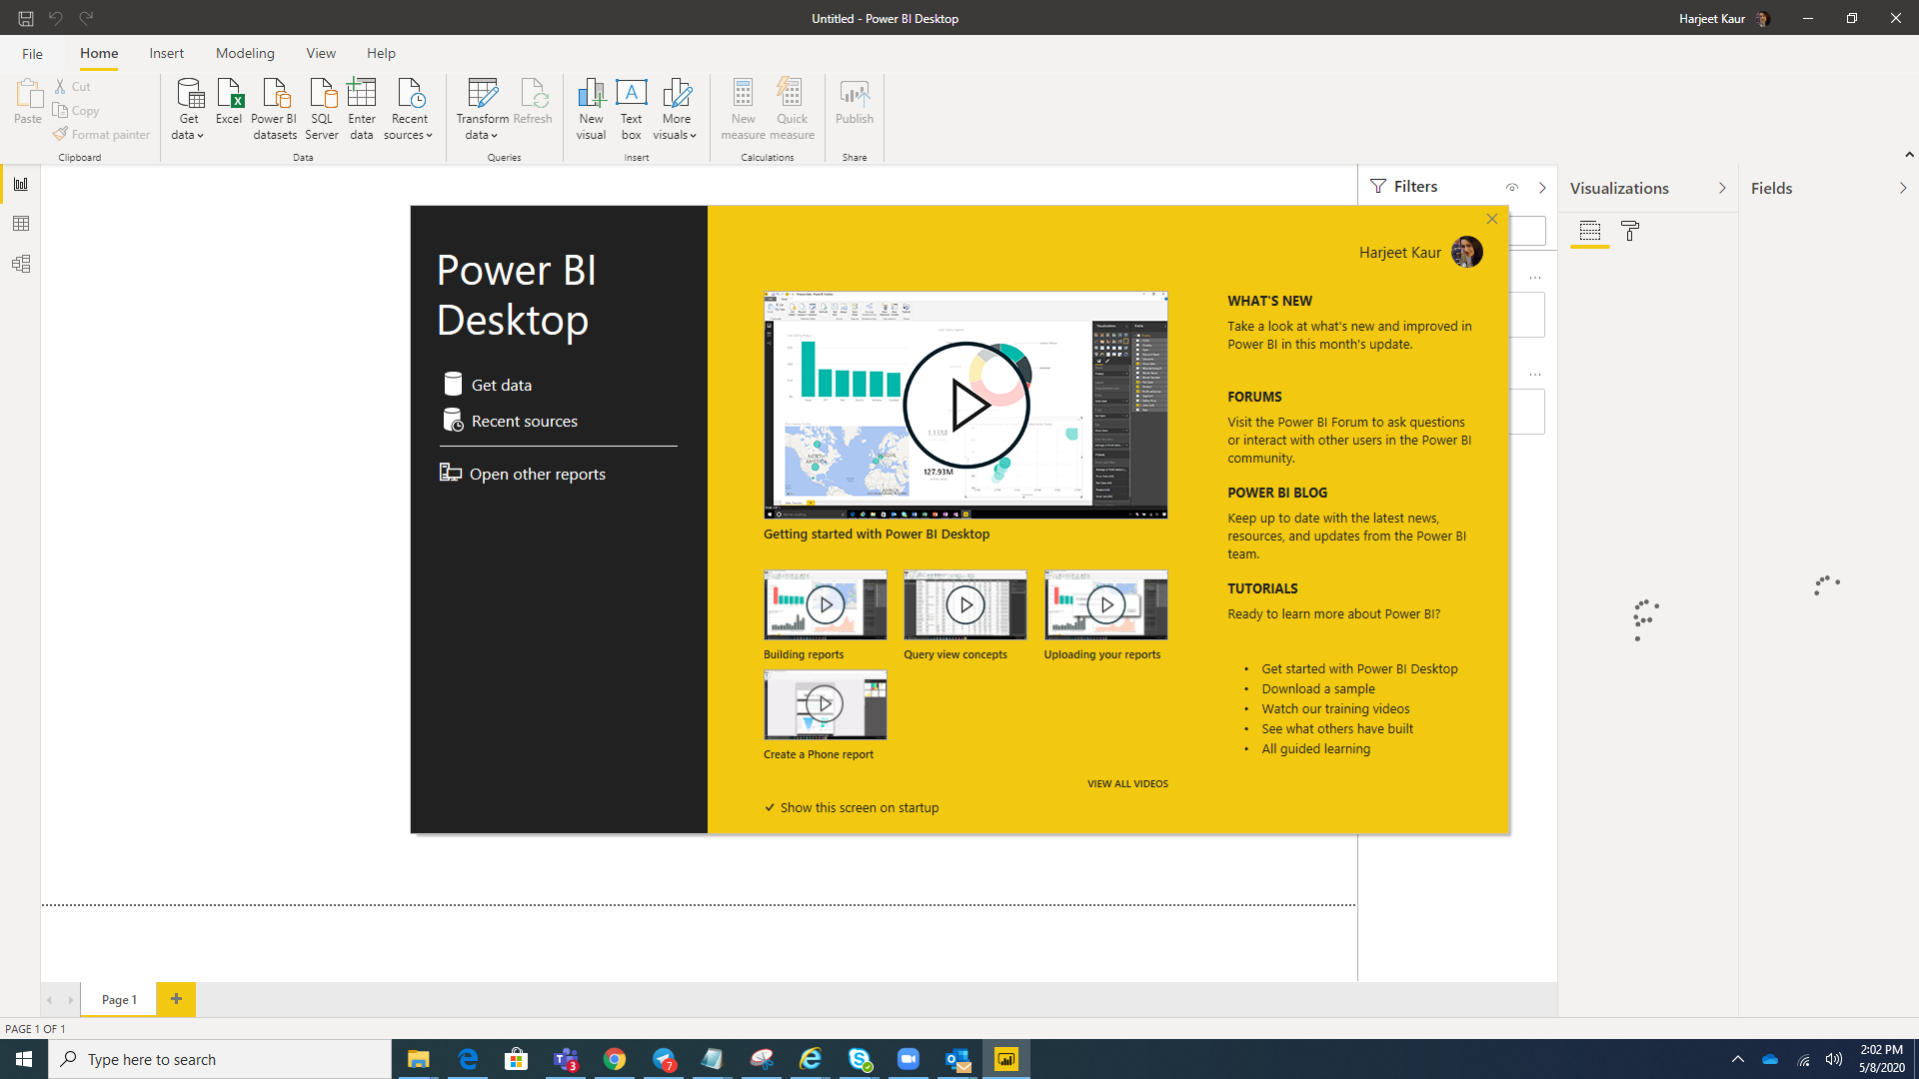

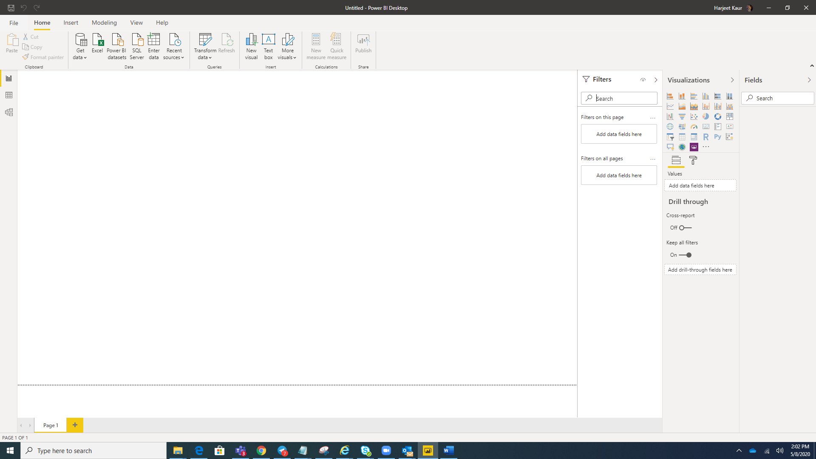

1. Different View Page of PowerBI
   1. **Report View**

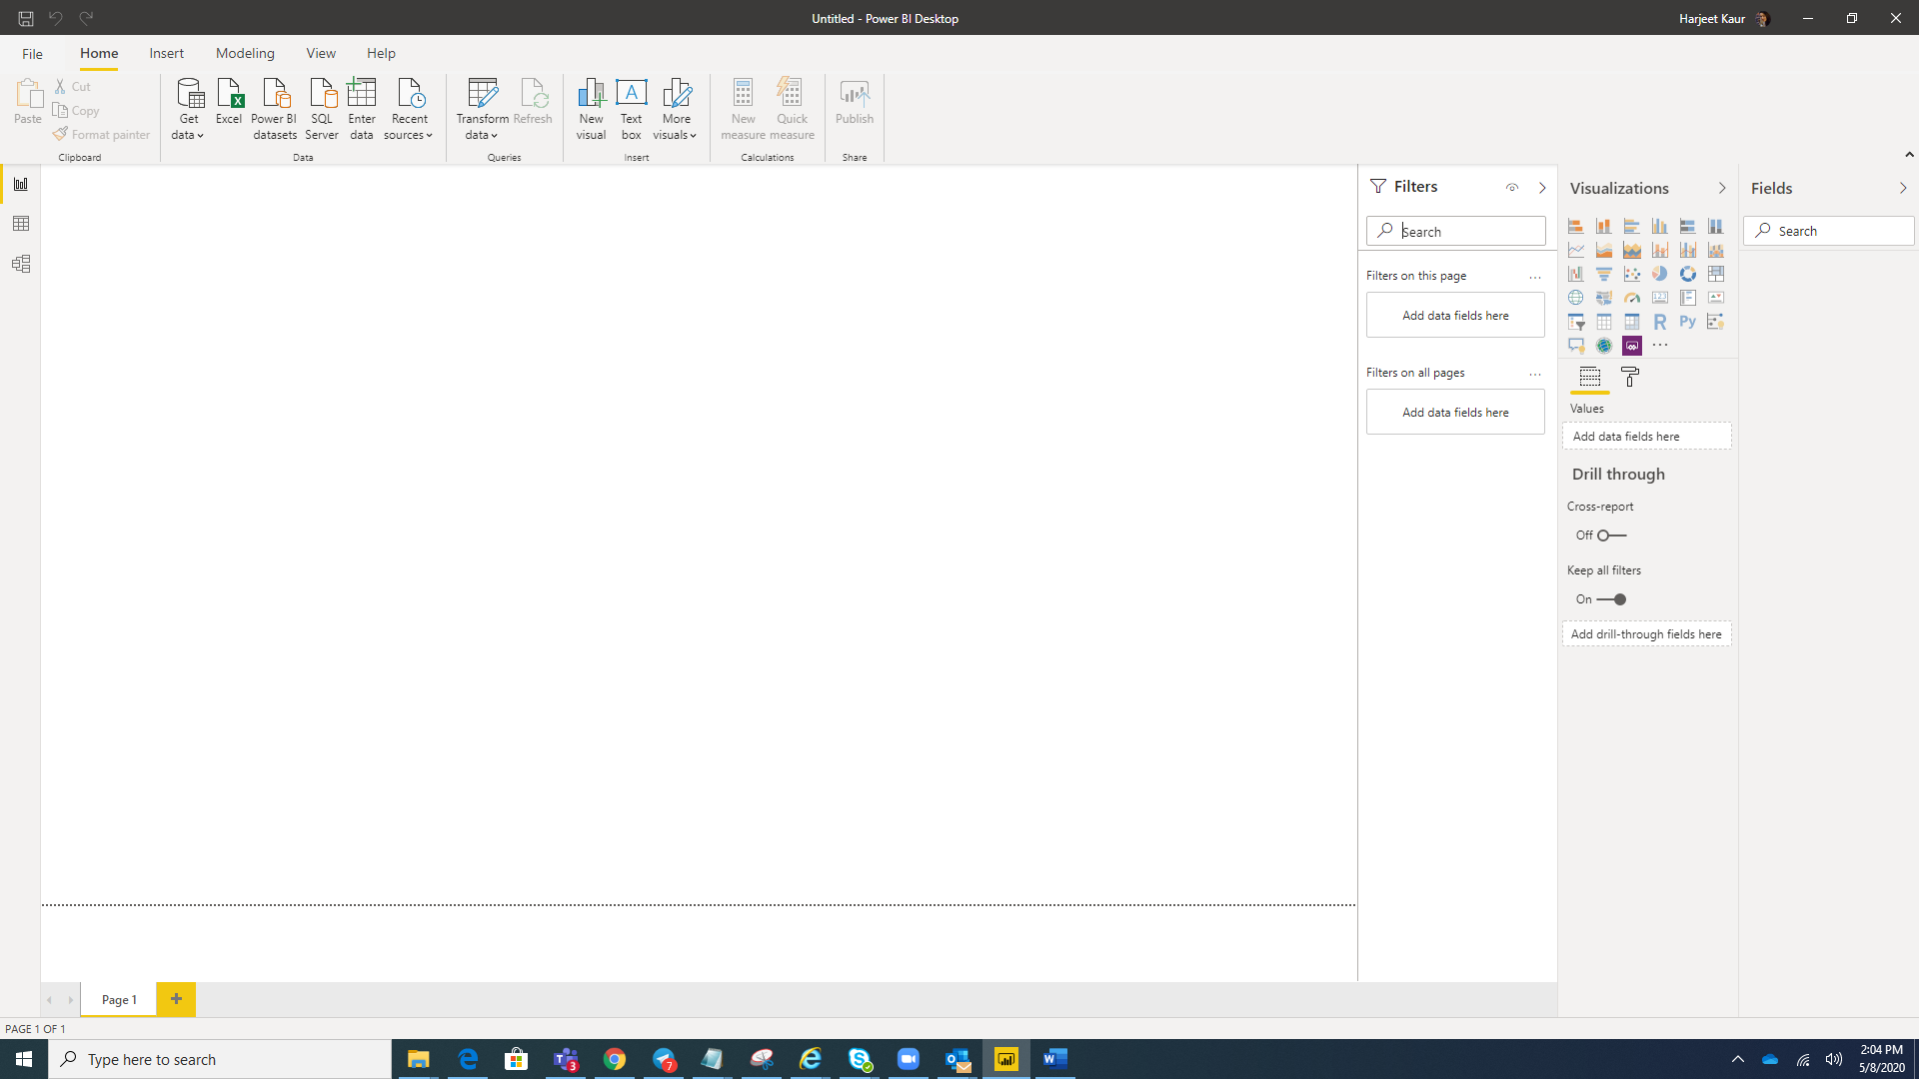

* 1. **Data View**

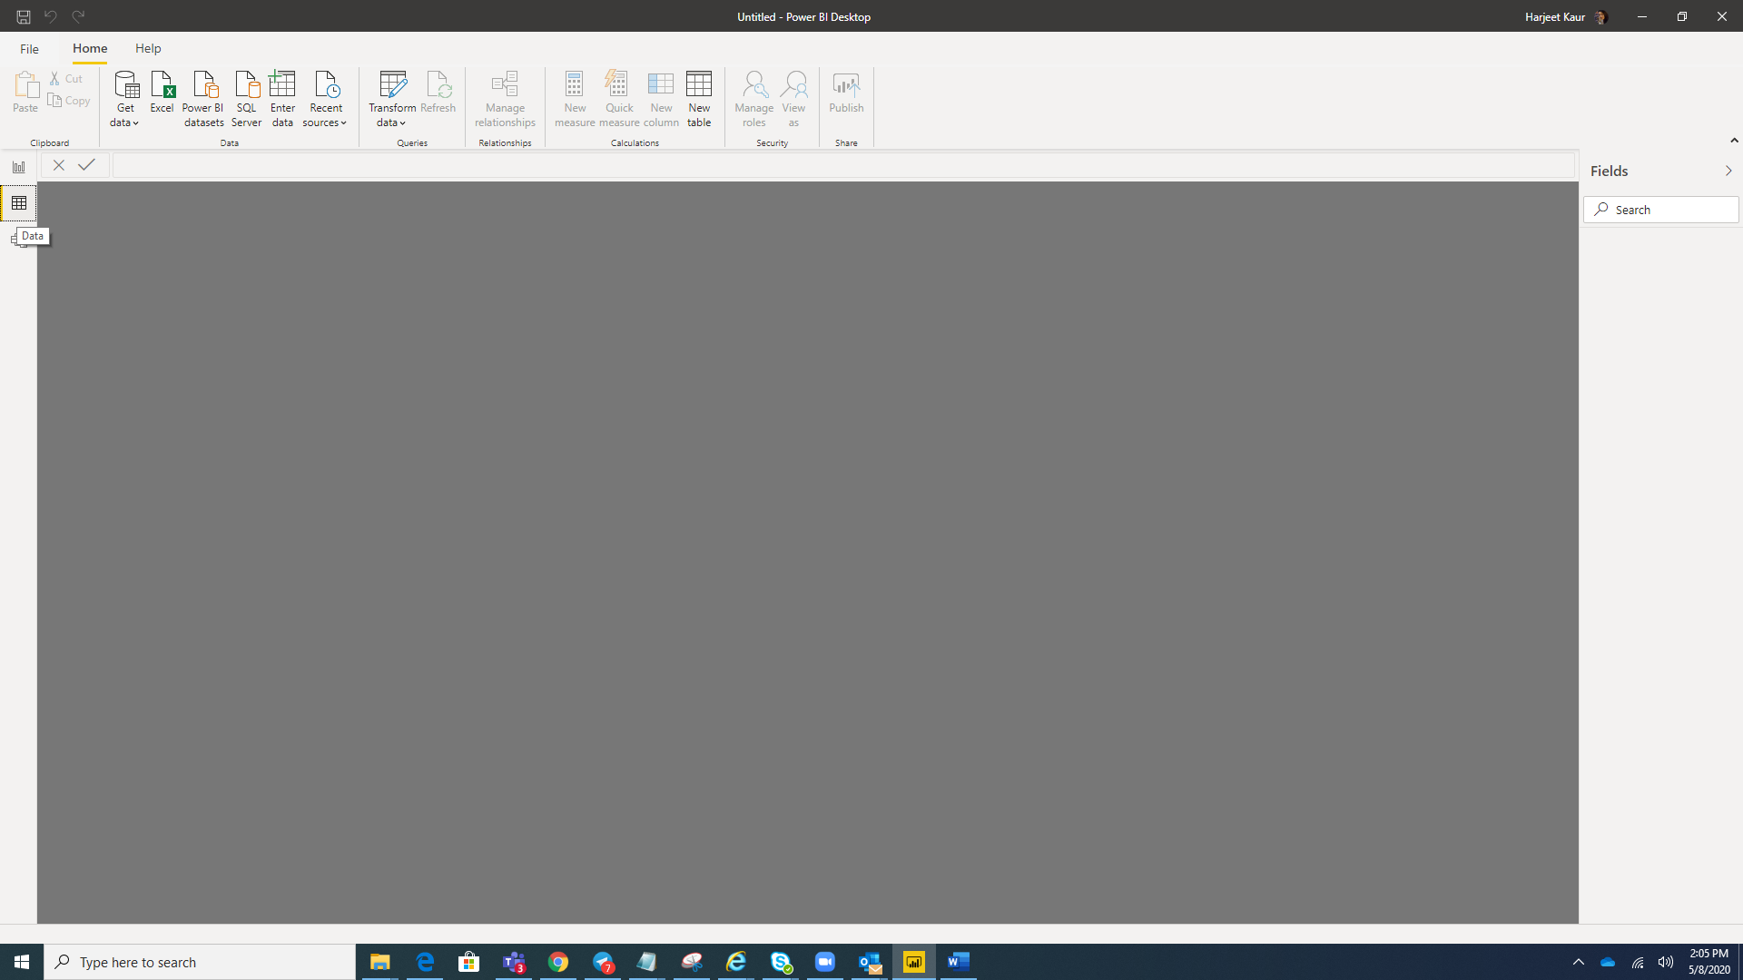

* 1. **Model View**

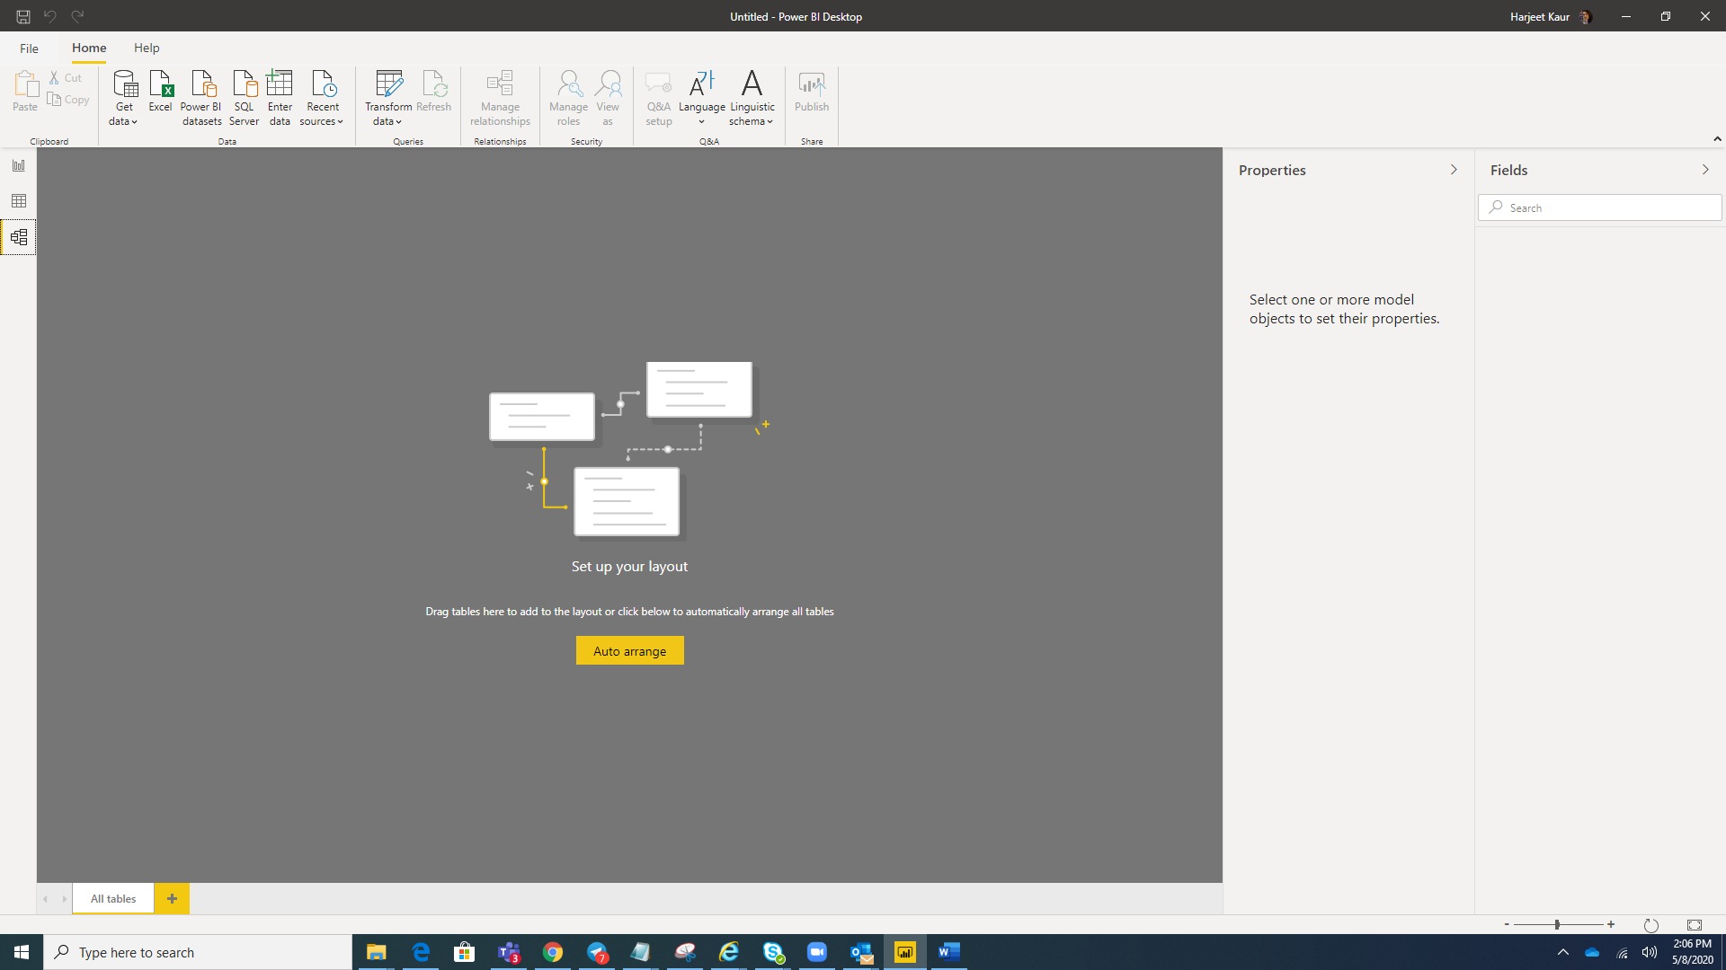

* 1. **Power Query Editor**

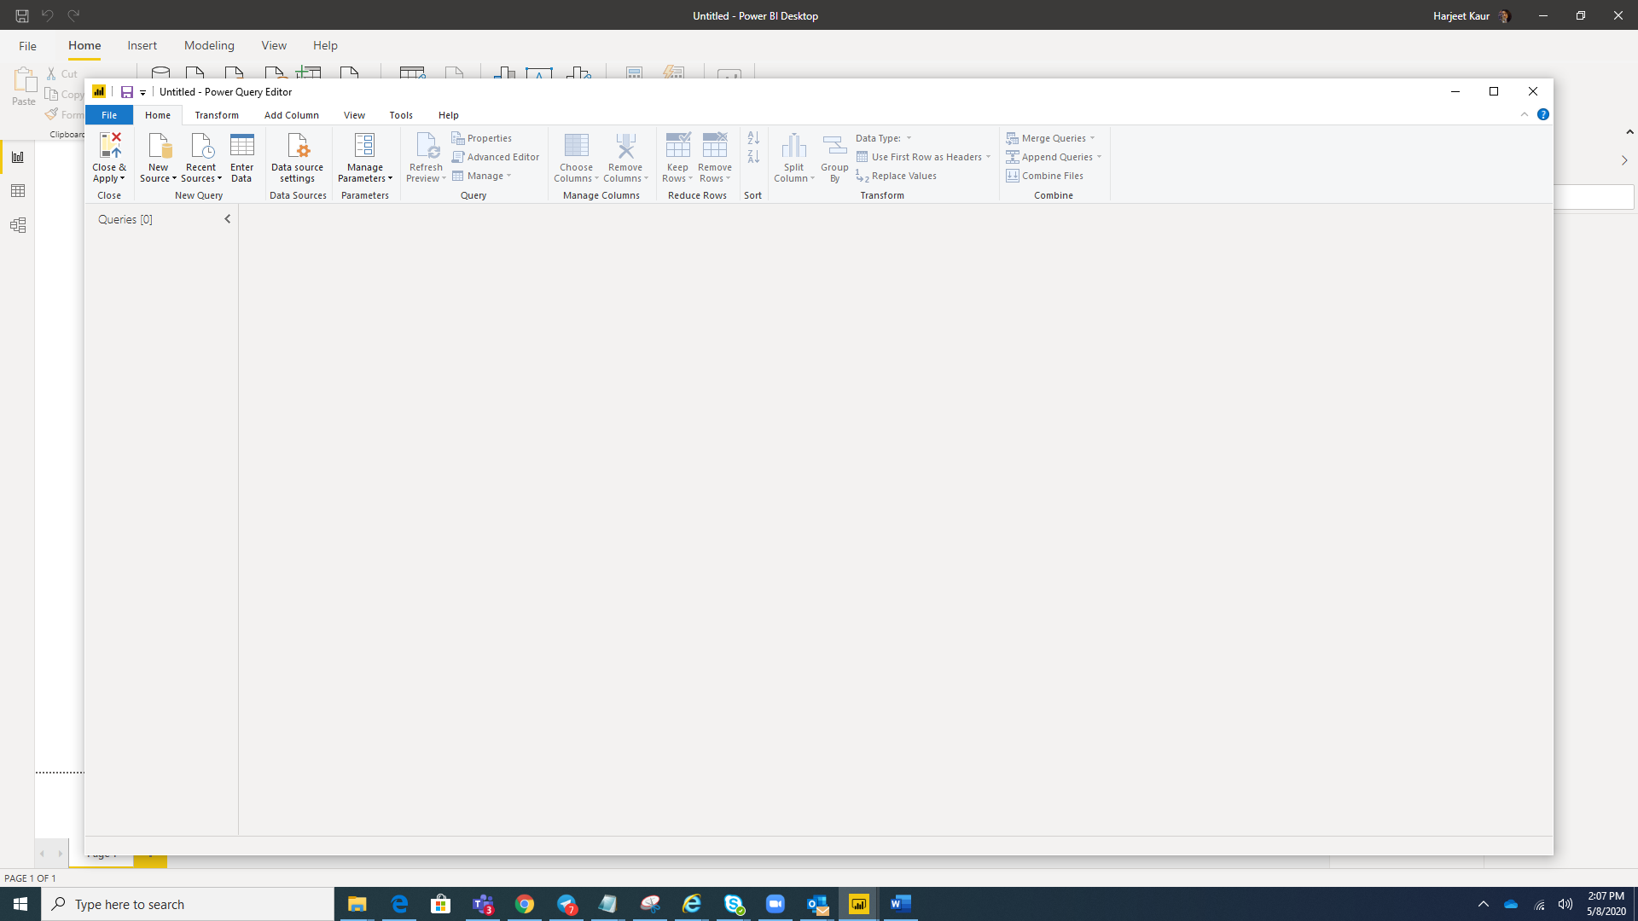

* 1. **Advance Editor**

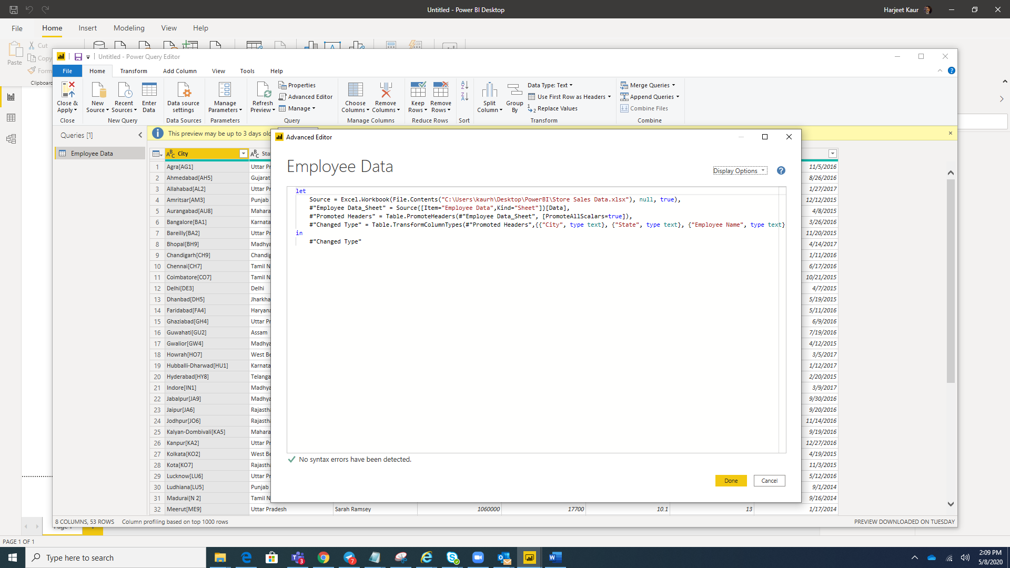

1. Details of different Power BI version
2. **Power BI Desktop** – Its **FREE**

Power BI Desktop is a free application you install on your local computer that lets you connect to, transform, and visualize your data. With Power BI Desktop, you can connect to multiple different sources of data, and combine them (often called modeling) into a data model. This data model lets you build visuals, and collections of visuals you can share as reports, with other people inside your organization. Most users who work on business intelligence projects use Power BI Desktop to create reports, and then use the Power BI service to share their reports with others.s

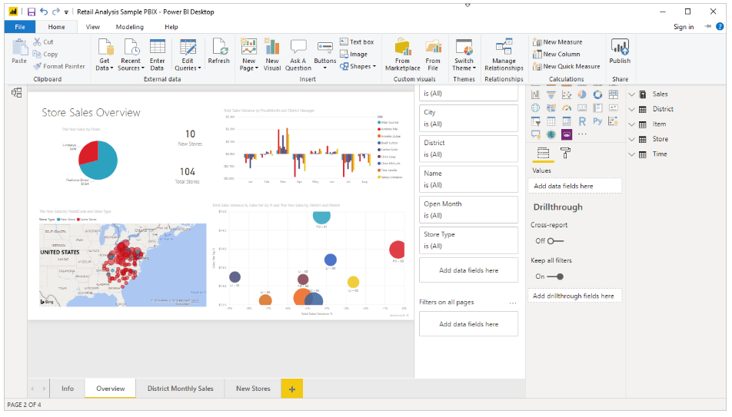

The most common uses for Power BI Desktop are as follows:

* Connect to data
* Transform and clean that data, to create a data model
* Create visuals, such as charts or graphs, that provide visual representations of the data
* Create reports that are collections of visuals, on one or more report pages
* Share reports with others by using the Power BI service

People most often responsible for such tasks are often considered *data analysts* (sometimes referred to as *analysts*) or business intelligence professionals (often referred to as *report creators*). However, many people who don't consider themselves an analyst or a report creator use Power BI Desktop to create compelling reports, or to pull data from various sources and build data models, which they can share with their coworkers and organizations.

There are three views available in Power BI Desktop, which you select on the left side of the canvas. The views, shown in the order they appear, are as follows:

* **Report**: In this view, you create reports and visuals, where most of your creation time is spent.
* **Data**: In this view, you see the tables, measures, and other data used in the data model associated with your report, and transform the data for best use in the report's model.
* **Model**: In this view, you see and manage the relationships among tables in your data model.

**Power BI Pro Vs Power BI Premium**

